**CAN = ΕΓΩ ΜΠΟΡΩ**

**ΚΑΤΑΦΑΣΗ**

I can you can he can she can it can we can you can they can

**ΕΡΩΤΗΣΗ**

Can I ? Can you? Can he? Can she? Can it? Can we? Can you? Can they?

**ΑΡΝΗΣΗ**

I cannot **I can’t** you cannot **you can’t** he cannot **he can’t** she cannot **she can’t** it cannot **it can’t** we cannot **we can’t** you cannot **you can’t** they cannot **they can’t**



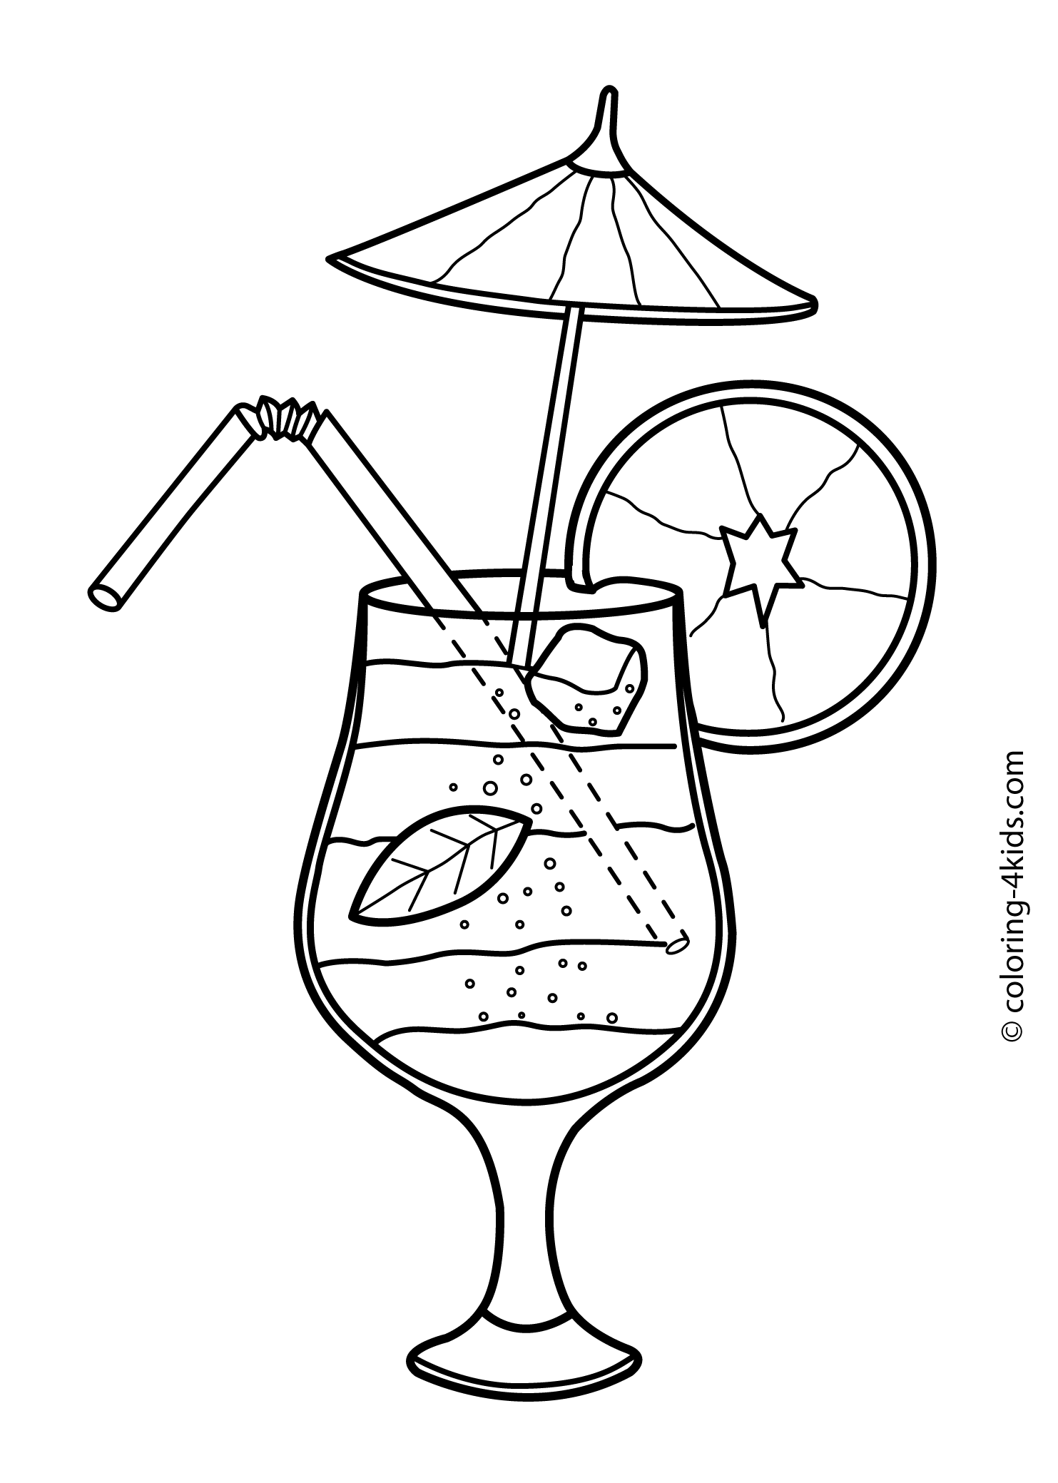

**I AM = ΕΓΩ ΕΙΜΑΙ**

**ΚΑΤΑΦΑΣΗ**

I am = I’m you are = you’re **he is = he’s she is = she’s it is = it’s** we are = we’re you are = you’re they are = they’re

**ΕΡΩΤΗΣΗ**

Am I? Are you? **Is he? Is she? Is it?** Are we? Are you? Are they?

**ΑΡΝΗΣΗ**

I am not = I’m not

You are not = you aren’t

**He is not = he isn’t**

**She is not = she isn’t**

**It is not = it isn’t**

We are not **=** we aren’t

You are not **=** you aren’t

They are not **=**they aren’t

