**UNIT 9= THE SCHOOL PARTY**

**1.**healthy eating habits ………………….

**2.** unhealthy ……………………

**3.** peanuts ………………………

**4.** sausages …………………….

**5.** ham …………………………..

**6.** restaurant owner ………….

**7.** price ………………………….

**8.** starters ……………………….

**9.** main course …………………

**10.** pour ………………………….

**11.** yoghurt ……………………..

**12.** boil ……………………………

**13.** Χαρτοπετσέτα ……………..

**14**. Φέτα …………………………..

**15.** Προσθέτω …………………..

**16.**Τρίβω στον τρίφτη ……………

**17.** Στραγγίζω …………………….

**18.** Ξεφλουδίζω …………………

**19.** Μαϊντανός …………………..

**20.** Μαγιονέζα ……………………

**21.** Συστατικά ……………………

**22.** Συνταγή ……………………

**23.**Τηγάνι …………………….

**24.** Κρεμμύδι ……………………

**25.** Αλμυρός …………………….

**26.** Αλοίφω το βούτυρο ……………

**REVISION**

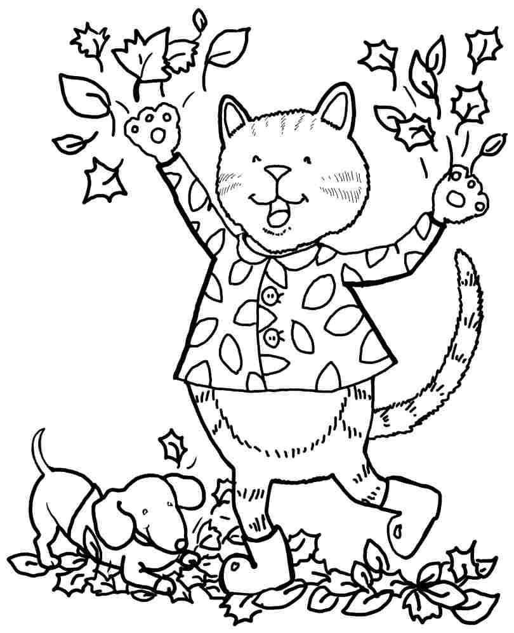



**1.** We **n**eed some lemonade, some crisps, some peanuts, some sausages

and some biscuits. **……………………………………………………….**

**………………………………………………………………………………….**

**2.** And we also need some bread, some butter, some ham, some cheese

and some eggs for the sandwiches. **…………………………………….**

**…………………………………………………………………………………**

**3.** Can you boil an egg or make an omelette? Which is your favourite food?

**…………………………………………………………………………………**

**4.** I can spread the butter and put the ham on the **b**read.

**…………………………………………………………………………………**

**5.** And then,Sophia can add the cheese and Betty can boil and slice the eggs.

**…………………………………………………………………………………**

**6.**  Let's not forget the paper c**u**ps and the paper plates.

**…………………………………………………………………………………**

**7.** Mix all the ingredients in a bowl. Peel and cut the potatoes.

**…………………………………………………………………………………**

**8.**  **S**o, what are you waiting for, guys? Hurry up!!

**…………………………………………………………………………………**

