**UNIT 8 = AROUND THE CITY**

**1.** rules ………………………….

**2.** regulations ………………….

**3.** road safety …………………

**4.** instructions ………………….

**5.** order ………………………….

**6.** sign ………………………….

**7.** keep off the grass ………………..

**8.** Don’t litter ……………………

**9.** pick flowers …………………

**10.** feed …………………………..

**11.** follow the paths ………………

**12.** stretch ……………………….

**13.** Λυγίζω ……………………….

**14.** Χειροκροτώ ………………..

**15.** Φανάρια …………………….

**16.** Διασχίζω το δρόμο ……………

**17.** Τροχονόμος …………………

**18.** Ζώνη ασφαλείας ……………

**19.** Διάβαση ……………………….

**20.** Πεζοδρόμιο ………………….

**21.** Πεζός ………………………….

**22.** Επικίνδυνες στροφές ………….

**23.** Κορνάρω …………………….

**24.**Κυνήγι θησαυρού….…………..

**25.** Πήγαινε ίσα μπροστά

**……………………………………..**

**REVISION**

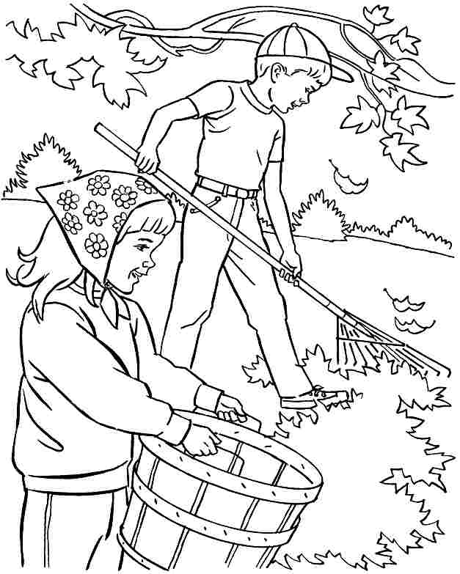

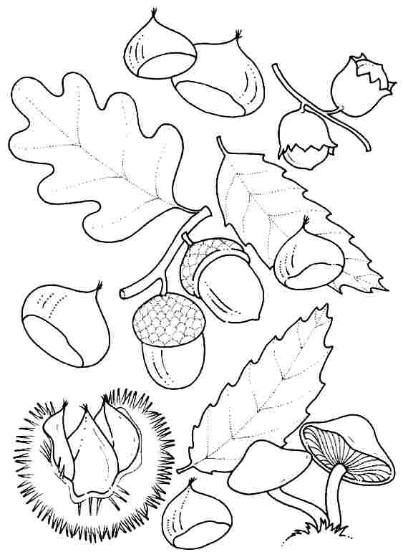

**1.** And don’t forget children You can play in the park but keep off the

grass and don’t litter. **……………………………………………………..**

**………………………………………………………………………………...**

**2.** Come on,Betty,let’s pick some flowers.There are some beautiful

flowers over there! **………………………………………………………**

**………………………………………………………………………………...**

**3.** Today a traffic warden is going to talk to you about road signs and

what you must know when you cross the street.

**……………………………………………………………………………….**

**……………………………………………………………………………….**

**4.** You can’t drive your car or bus fast, children cross the road here.

**………………………………………………………………………………..**

**5.** Don’t turn left here. Be careful, there are pedestrians here.

**………………………………………………………………………………..**

**6.** You must go straight ahead. Be careful,there are dangerous turns ahead.

**………………………………………………………………………………..**

**7.** Don't cross the street when the light is red. Always wear your seat belt.

**………………………………………………………………………………..**

**8.** Don't run across the street**.** Cross the street at a crossing.

**………………………………………………………………………………..**

 