**UNIT 7 = WHAT ARE YOU DOING?**

**1.** beat the eggs …………………

**2.** sweep ………………………..

**3.** washing machine ……………

**4.** set the table ………………….

**5.** wash the dishes ……………….

**6.** water the plants ……………….

**7.** it seems ………………………….

**8.** examine ………………………….

**9.** patient …………………………..

**10.** hairdresser …………………….

**11.** beauty salon ………………..

**12.** waiter ……………………………

**13.** shop assistant .………………..

**14.** Πελάτης …………………………

**15.** Δημοσιογράφος ……………….

**16.** Φούρναρης …………………….

**17.** Φάρμακο ……………………….

**18.** Σερβίρω …………………………

**19.** Συνέντευξη …………………….

**20.** Πυροσβέστης …………………

**21.**Πυροσβεστικός σταθμός **…………**

**22**.Πυροσβεστικό όχημα …………………

**23.** Σβήνω φωτιά ………………….

**24.** Στολή ……………………………

**25.Περιπλανώμενος φωτογράφος**

**……………………………………… .**

**REVISION**

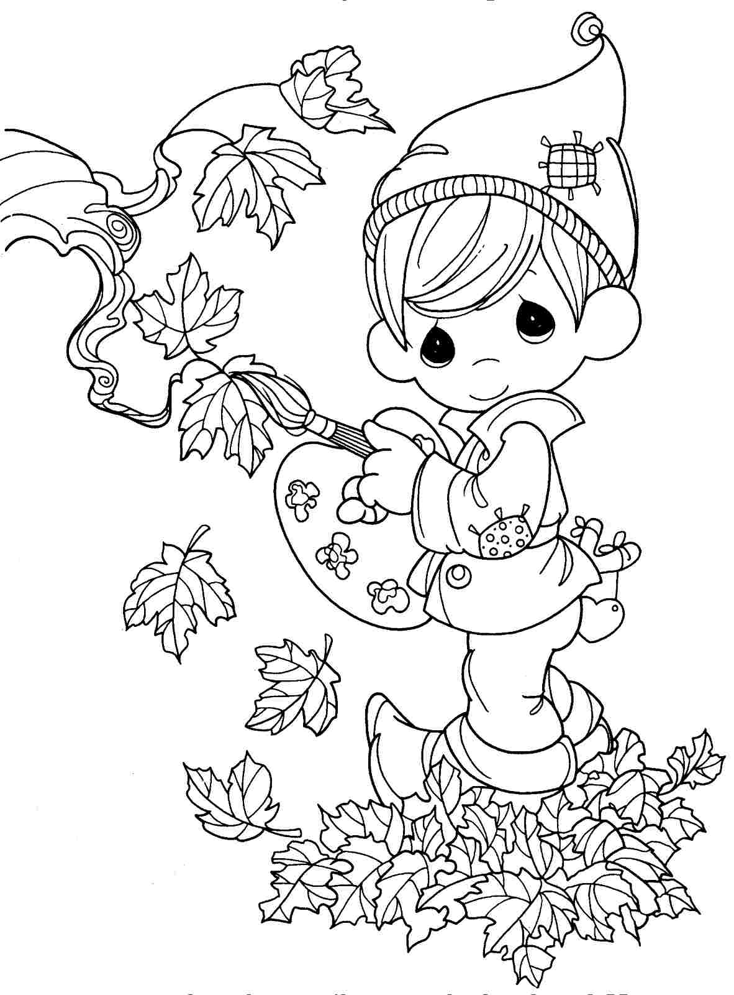

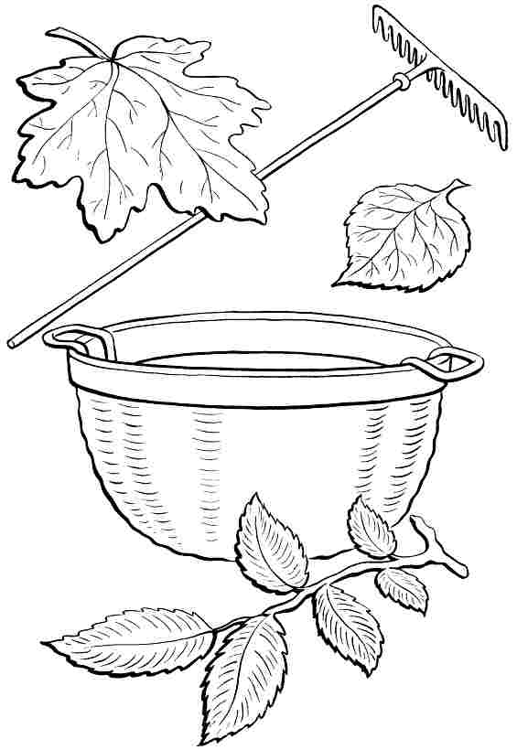

**1.** Do you help around the house? What kind of things do you do?

**……………………………………………………………………....**

**2.** I’m coming mum, just a minute, I’m finishing a Maths exercise.

**………………………………………………………………………………...**

**3.** Can you beat the eggs? No problem. By theway,where’s Dad?

**………………………………………………………………………………...**

**4.** I’m setting the table,I’m sweeping the floor,I’m helping in the house.

**…………………………………………………………………………........**

**5.** Well it seems that everybody needs to help around the house.

**………………………………………………………………………………..**

**6.** What would you like to do when you grow up?

**………………………………………………………………………**

**7.** My dad’s a doctor and works in a hospital. He is examining a patient.

**………………………………………………………………………………...**

**8.** My mum is a hairdresser and works in a beauty salon.She is cutting a

woman’s hair. **………………………………………………………..**

**……………………………………………………………………….**

