**REVISION=UNIT 5**

**1.** Explore ……………………….

**2.** Cave ………………………

**3.** Realize ………………………

**4.** Dream ………………………

**5.** Habits ……………………..

**6.** Personal ……………………..

**7.** National .…………………….

**8.** Customs ……………………..

**9.** Decorate ……………………..

**10.** Carols ……………………..

**11.** Roast turkey ………………..

**12.** Beef ……………………..

**13.** Fried potatoes ………………..

**14.**Brussels sprouts ………………

**15.** Mince pies …………………..

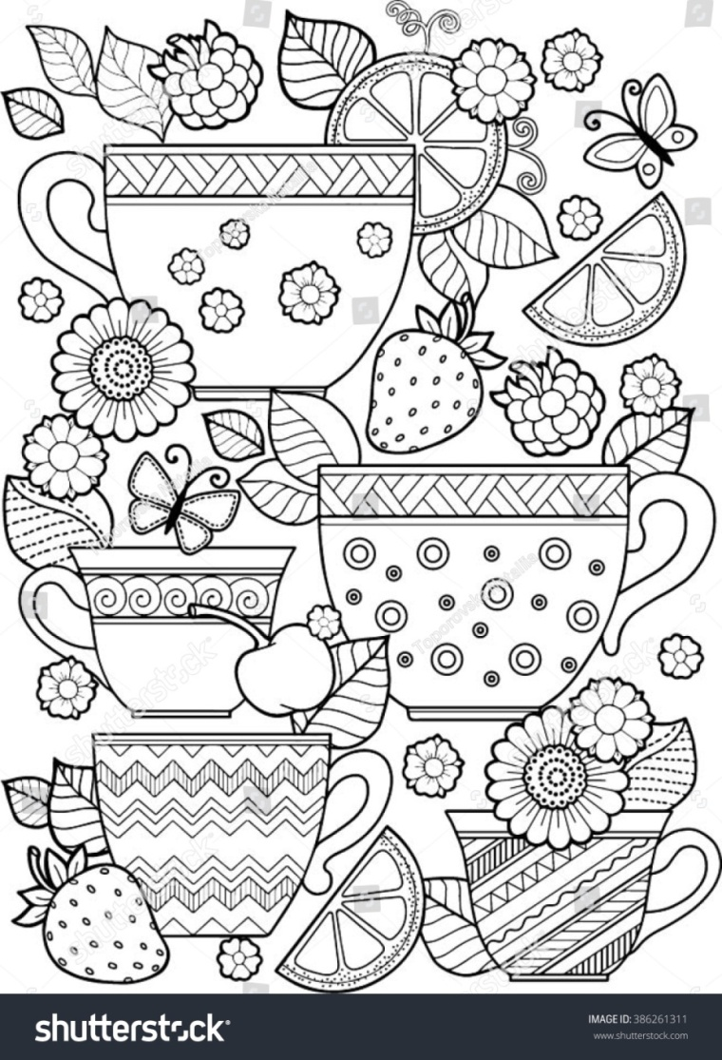

**HABITS AND CUSTOMS**

**16.** Πιάτο ……………………….

**17.** Αίνιγμα ……………………….

**18.**Φάρσα ή κέρασμα …………….

**19.** Στοιχειωμένο ..………………

**20.** Κολοκύθα …………………….

**21.** Μάγισσα …………………….

**22.** Φάντασμα ……………………

**23.** Καραμέλα ……………………

**24.** Πυροτεχνήματα ………………

**25.** Ομοίωμα …………………….

**26.**Υπαίθρια φωτιά ……………..

**27.** Γιορτάζω ……………………

**28.** Θρησκευτικές ……………….

**29.** Γιορτές ……………………

**30.** Επιδόρπιο ……………………

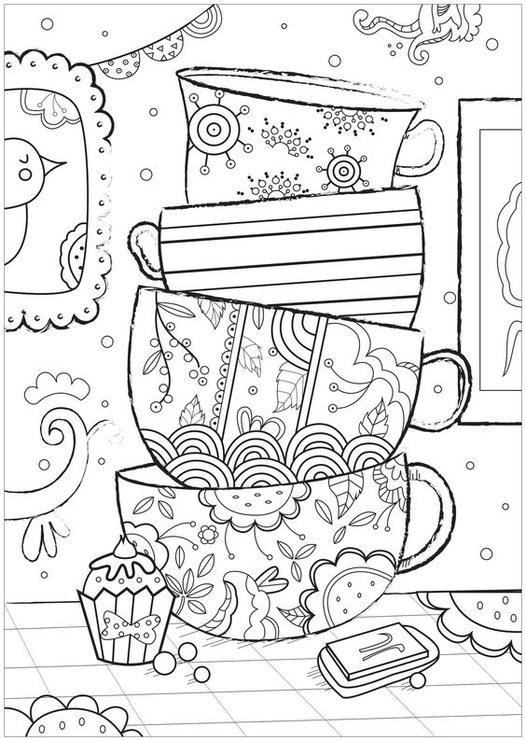

**1.**I sometimes have this dream.In my dream I live in Netherland.

…………………………………………………………………………………………

…………………………………………………………………………………………

**2.** I often play games with the Lost Boys,Peter Pan’s friends.

…………………………………………………………………………………………

**3.** We sometimes explore the island together and come back

late at night. ….………………………………………………………………

………………………………………………………………………………….......

**4.** I really like this life but then I wake up and I realize it’s only a dream.

……………………………………………………………………………………………………

……………………………………………………………………………………………………

**5.** At home children have got a stocking and Father Christmas

puts presents in it. ………………………………………………………………….

………………………………………………………………………………………………….

**6.** At Christmas people often send cards to each other and

children sing carols in the street.

……………………………………………………………………………………………………

……………………………………………………………………………………………………

**7.** On Halloween,children dress up in fancy costumes and

they go “Trick or treat” from door to door.

……………………………………………………………………………………….

……………………………………………………………………………………….

**8.** Halloween is a time of pumpkins,candies,ghosts and witches

and people decorate their houses with “Jack-o-Lanterns”.

……………………………………………………………………………………….

……………………………………………………………………………………….

