**UNIT 2 = WHAT’S YOUR**

1. Popular sports ..…………….

2. Favourite hobby …………….

3. Climbing ……………………

4. Horse riding …………………..

5. Cycling ……………………

6. Sailing ……………………

7. Windsurfing …………………..

8. swimming …………………..

9. Sporty fellow …………………

10. Olympic games ……………..

11. Collection …………………..

12. Strange hobbies …………….

13. Same ……………………

14. Board games …………………

15. Tree leaves …………………

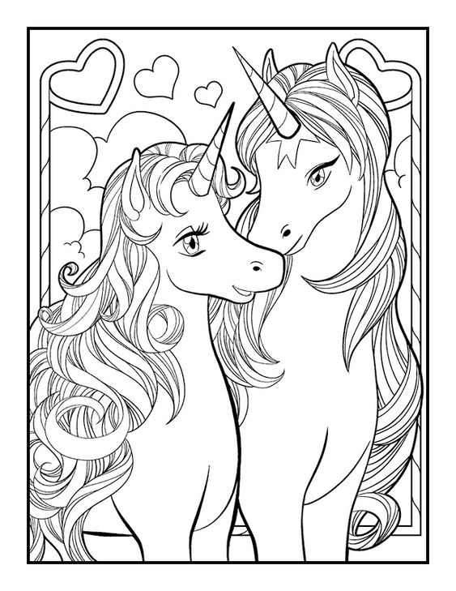

FAVOURITE HOBBY OR SPORT?

**16.** Πληροφορίες .……………….

**17.** Συλλέγω …………………….

**18.** Χρυσό μετάλιο ………………

**19.** Ασημένιο …………………..

**20.** Χάλκινο …………………..

**21.** Άρση βαρών …………………

**22.** Μαραθώνιος ………………..

**23.** Τραγούδι …………………..

**24.** Χορός ………………….

**25.** Ενδιαφέρον ………………….

**26.** Βαρετό ………………….

**27.** Χειροτεχνία ………………….

**28.** Γράψου στο κλαμπ …………..

**29.** Ίδια χόμπυ ………………….

**30.** Βουνό …………………..

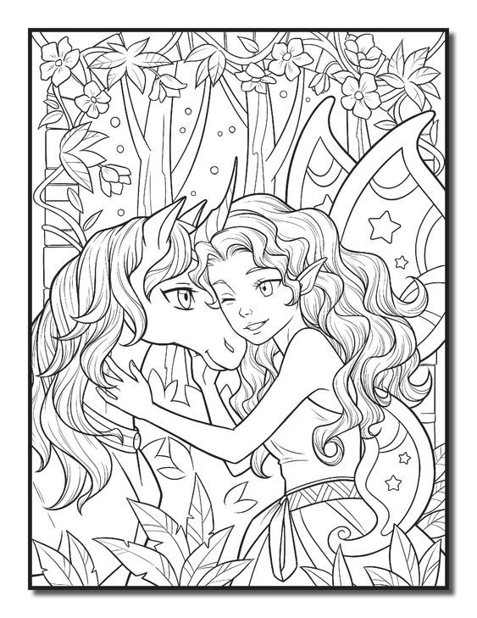

**1.** Ready? So, what do you want to play?

…………………………………………………………………………………………

**2.** Ok kids ! Today is free day for sports.

…………………………………………………………………………………………

**3.** I’m a sporty fellow and that’s who I am!

………………………………………………………………………………………..

**4.** She likes painting, dancing and reading books.

………………………………………………………………………………………..

**5.** She doesn’t like collecting things.

…………………………………………………………………………………………

**6.** She can speak and write English.Have you got a pen friend ?

………………………………………………………………………………………..

………………………………………………………………………………………..

**7.** Do you like collecting tree leaves?

……………………………………………………………………………………….. **8.** He doesn’t like collecting football cards.

…………………………………………………………………………………………

