**MAGIC BOOK 2 : UNIT 8**

1. Ready …………………

2. Escape …………………

3. Dangerous …………………

4. Safe …………………

5. Guards …………………

6. Right away …………………

7. Leave …………………

8. Harm …………………

9. Huge maze …………………

10. Of course not! ………………

11. Early ….……………..

12. Greedy …………………

13. Nobody …………………

14. Brilliant idea …………………

15. Let’s rest first …………………

16. Wax …………………

17. Together ………………..

18. We need …………………

19. Tiny ………………..

20. Be careful ………………..

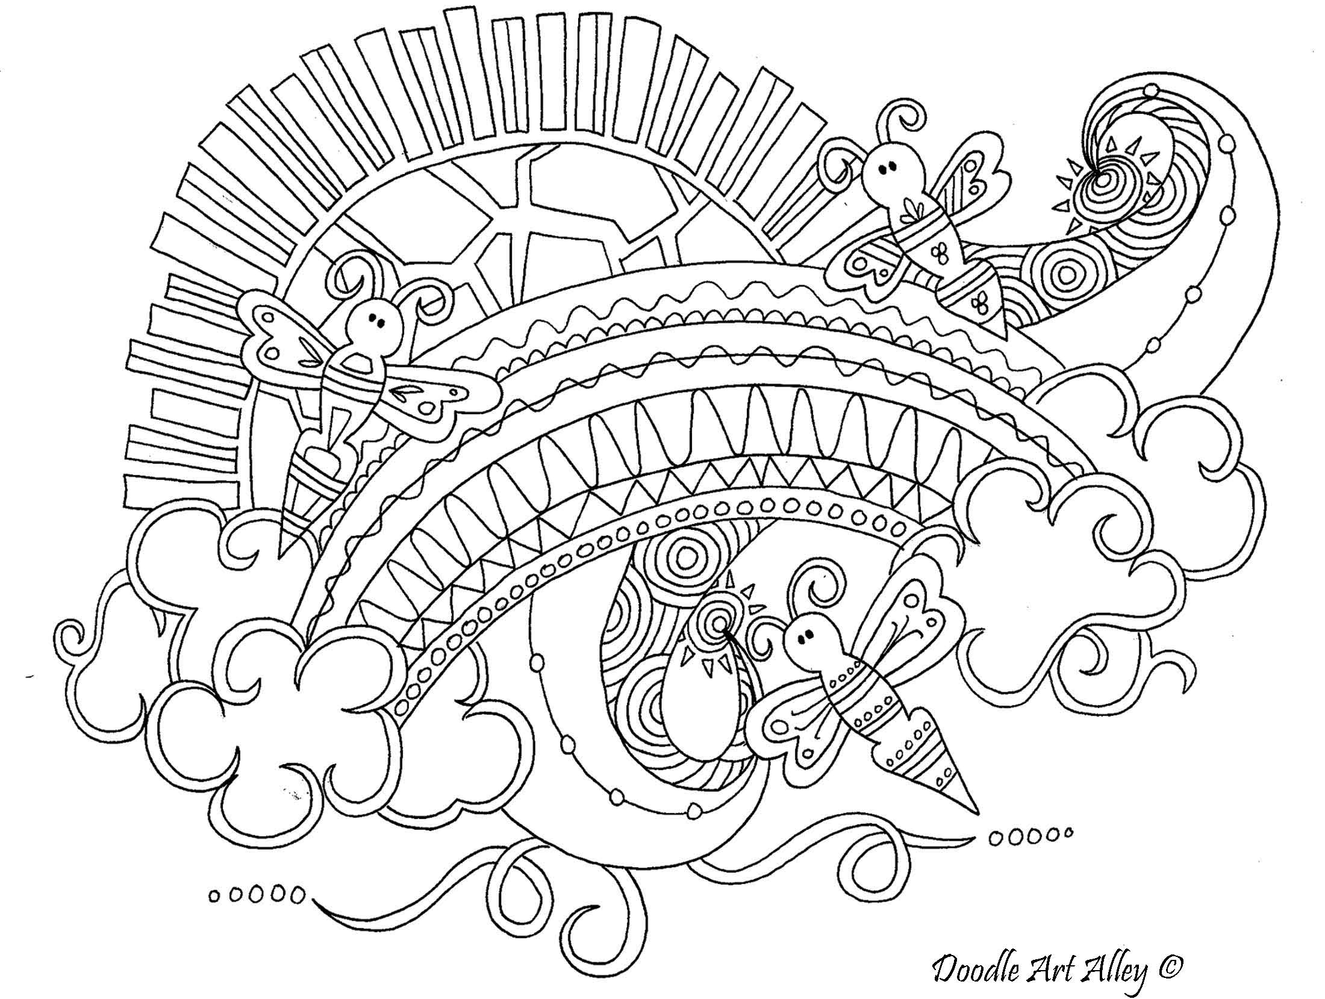

**DAEDALUS AND ICARUS**

21. Ελληνική μυθολογία ……………..

22. Παλάτι ……………………

23. Βασιλιάς …………………..

24. Tέρας ……………………

25. Φυλακή ……………………

26. Ταύρος .………………….

27. Σώμα ……………………

28. Μαϊμού ……………………

29. Κεφάλι ……………………

30. Παράθυρο ……………………

31. Φτερά ……………………

32. Πούπουλα …………………….

33. Θυμήσου …………………….

34. Λιώνω …………………….

35. Μείνε κοντά μου …………….

36. Τόσο μικρό ...…..…………….

37. Γιε μου ..………………….

38. Πέφτω κάτω ………………….

39. Πουλί …………………

40. Μην πετάς ……………………

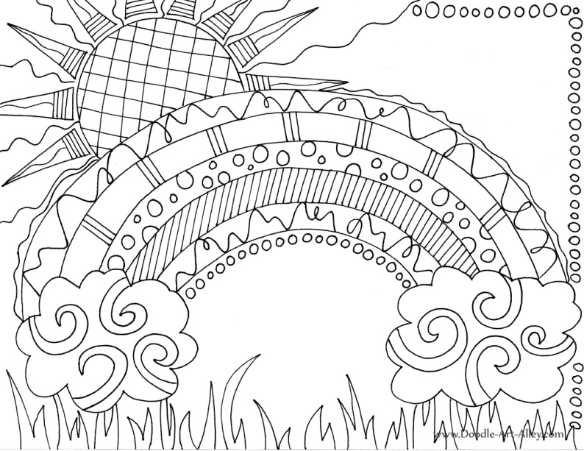

**ΜΕΤΑΦΡΑΣΤΕ ΤΙΣ ΠΡΟΤΑΣΕΙΣ ΣΤΑ ΕΛΛΗΝΙΚΑ**

1. Minos, the king of Crete, is looking at his new palace.

…………………………………………………………………………………………………………

2. That monster is so dangerous.He’s got a bull’s head and a man’s body.

…………………………………………………………………………………………………………

3. Guards! Put them in prison right away !

…………………………………………………………………………………………………………

4. The people of Crete are safe now.You don’t need me anymore.

…………………………………………………………………………………………………………

5. No one can escape from that huge maze.

…………………………………………………………………………………………………………

6. Look! We can escape through that huge window.

…………………………………………………………………………………………………………

7. It’s too high! Only birds can get away from here.

…………………………………………………………………………………………………………

8. Our wings are ready. We can fly now.

…………………………………………………………………………………………………………

9. Icarus ! Be careful ! You’re getting close to the sun.

…………………………………………………………………………………………………………

10. What’s happening ? I’m falling down. Help! The wax is melting.

…………………………………………………………………………………………………………

