**UNIT 7 = REVISION**

1. Village ……………………..

2. Busy ……………………..

3. Often …………………….

4. Listen ……………………..

5. Usually ……………………..

6. Always ………………………

7. Help ………………………

8. Favourite places ……………

9. Pond ……………………….

10. Swim ……………………….

11. Playground ………………….

12. Find ……………………….

13. Lunch ………………………..

14. Alone ……………………….

15. We know …………………….

16. Hide and seek ……………….

17. Unique ……………………….

18. Drawing ……………………….

19. Walking .……………………….

20. It is true ……………………….

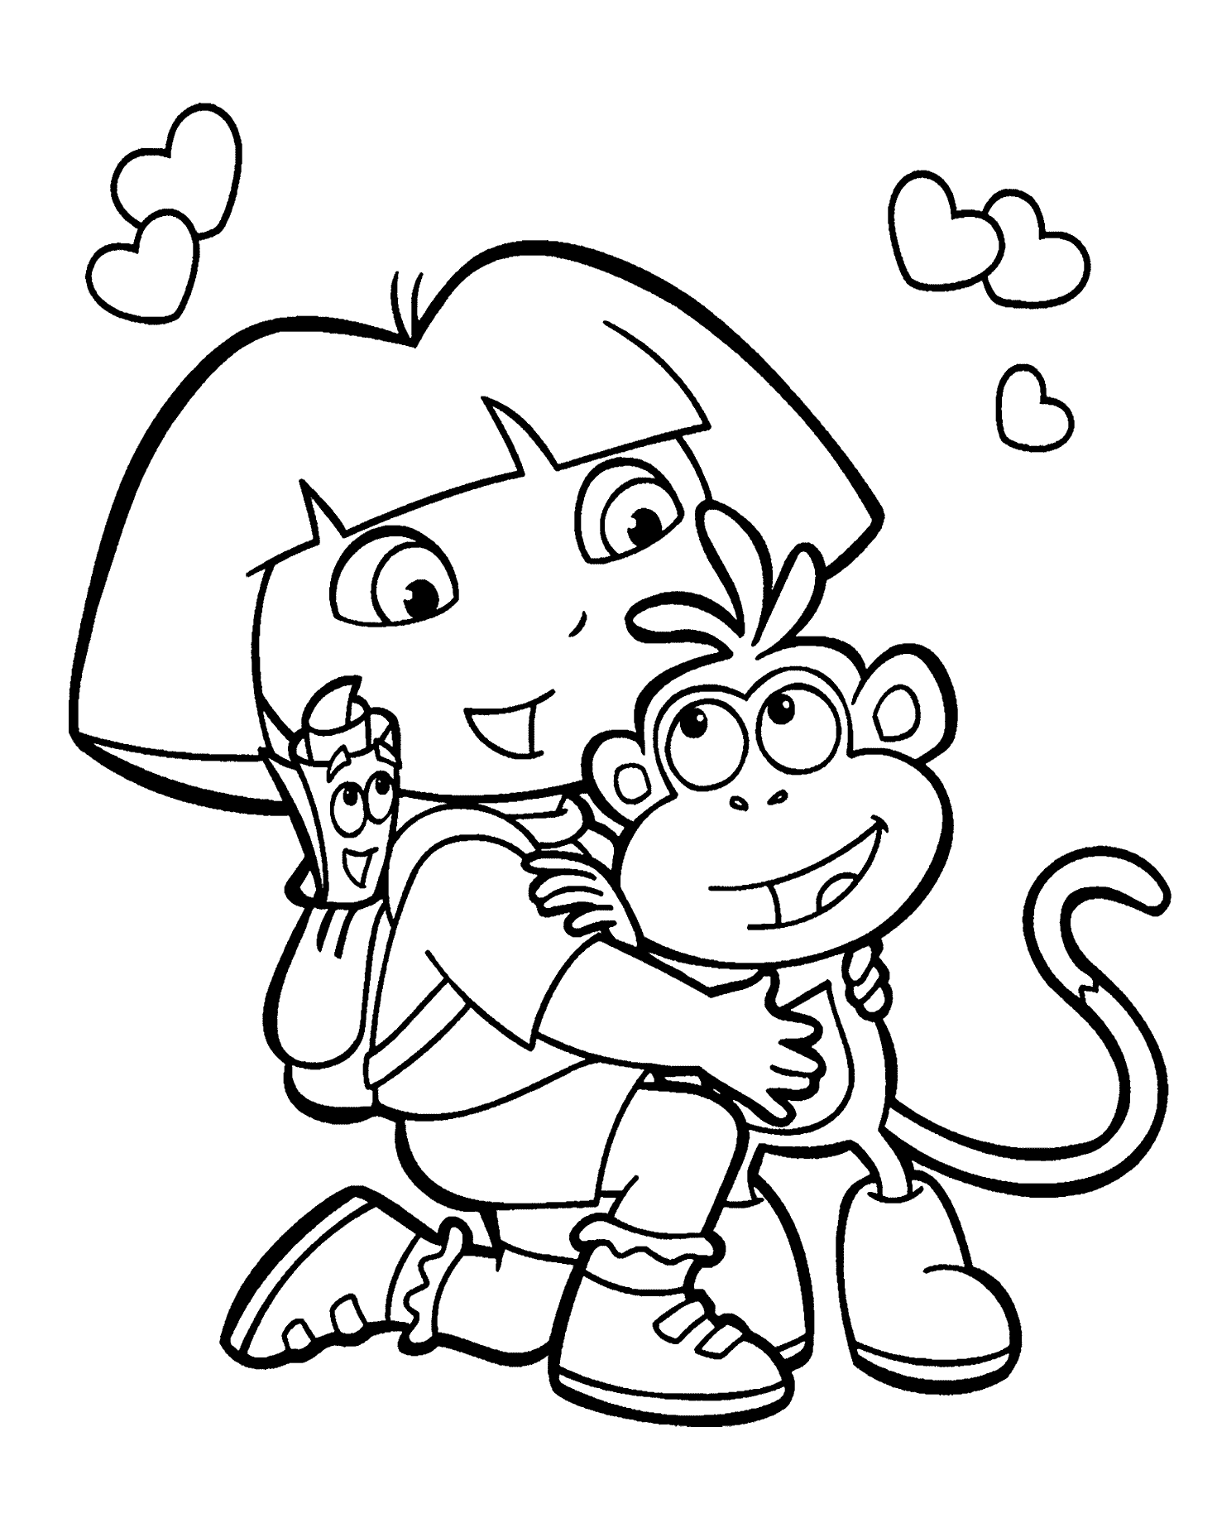

**ARTHUR AND HIS FAMILY**

21. Ξωτικό ……………………

22. Οικογένεια ……………………

23. Αγαπημένα βιβλία ………….

24. Σπουδαία ιδέα ……………….

25. Παππούς …………………..

26. Γυαλιά …………………..

27. Φίλοι …………………..

28. Κάθε μέρα ………………….

29. Κήπος …………………..

30. Ποδήλατο .………………….

31. Σαλόνι …………………..

32. Τσουλήθρα ………………….

33. Κούνια …………………..

34. Χαρταετός ………………….

35. Παίζω …………………..

36. Ιστιοπλοΐα ……………………

37. Σκεφτείτε όλοι ………………

38. Σκαρφάλωμα ……………….

39. Μαγειρεύω ………………….

40. Χορός ……………………

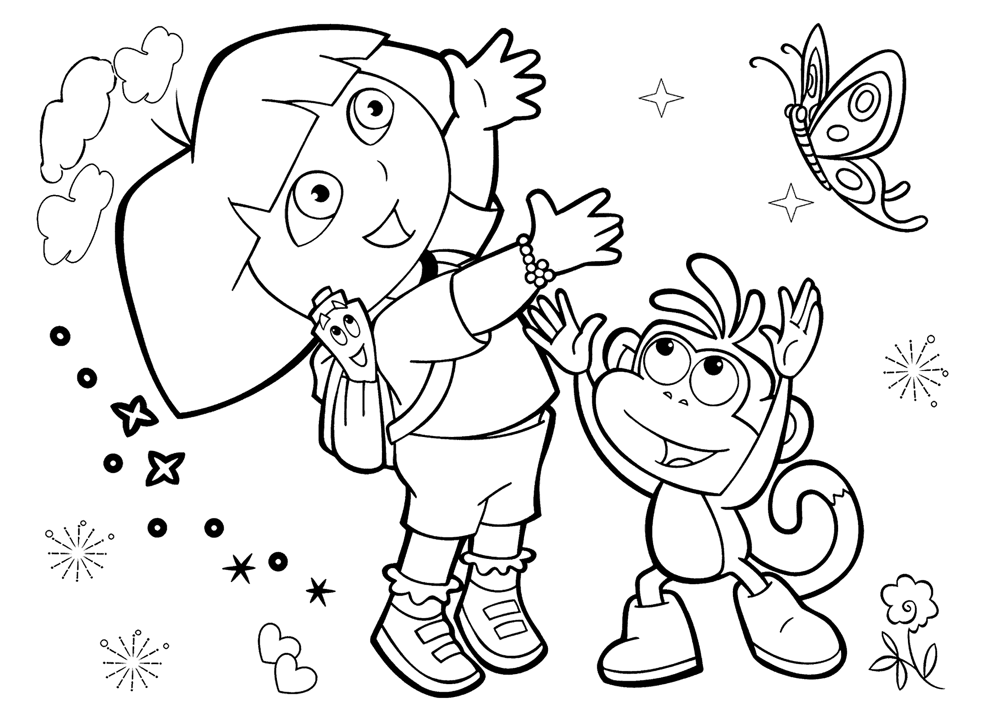

**1.** Little Arthur wants to play with his family.

……………………………………………………………………………………….

**2.** Mother elf **often** plants flowers in the garden.

…………………………………………………………………………………………

**3.** Wise elf, we can’t find little Arthur. Can you help?

……………………………………………………………………………………….

**4.** Is he in the playground? He plays on the slide and swing

every evening.

………………………………………………………………………………………

**5.** Does he ride his bike there? Yes, he does!

……………………………………………………………………………………….

**6.** What Arthur likes most is playing hide and seek.

………………………………………………………………………………………

**7.** He likes running, he likes jumping but he doesn’t like dancing.

……………………………………………………………………………………….

**8.** This is my sister, she climbs trees and she cooks!

………………………………………………………………………………………

**9.** This is my family and it’s unique!

………………………………………………………………………………………

**10.** Does he like sailing, reading books or drawing?

………………………………………………………………………………………

