**UNIT 5 =THE ANIMAL SCHOOL**

1. Animal school ………………..

2. Start ..…………………

3. Learn …………………..

4. Everything …………………..

5. Everybody …………………..

6. Excited .…………………..

7. Hard .…………………..

8. Easy …………………….

9. Together …………………...

10. Weak …………………….

11. I need ……………………

12. Different …………………….

13. Nobody …………………….

14. What a shame! ……………..

15. What a pity! ………………….

16. My rights .………………….

17. Respect …………………..

18. The same …………………..

19. So bright …………………..

20. Let try me ……………………

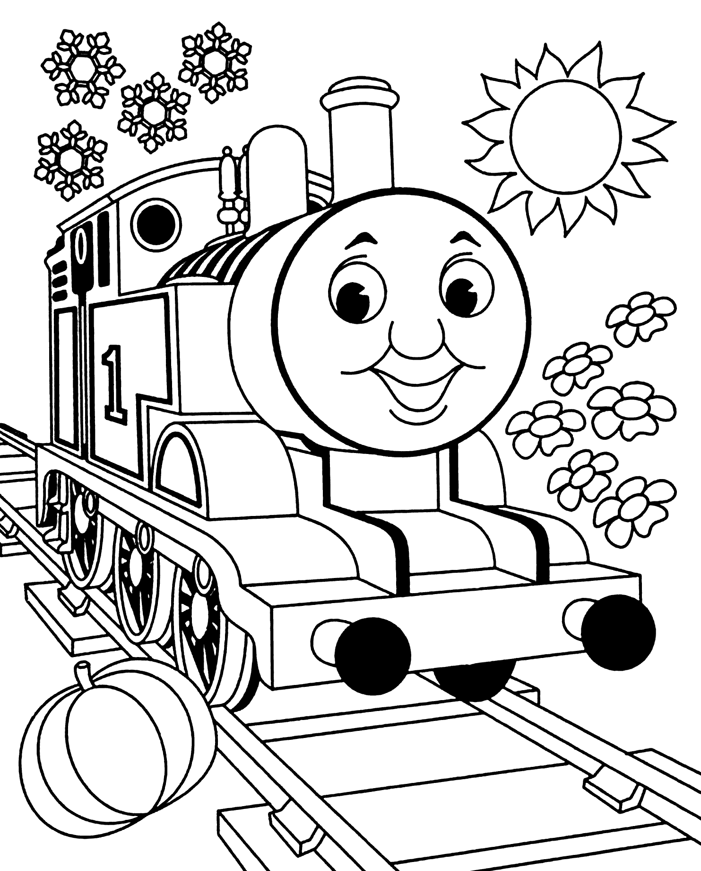

**REVISION=ΕΠΑΝΑΛΗΨΗ**

21. Σχολική τσάντα ……………..

22. Κασετίνα ……………………..

23. Σβύστρα ……………………..

24. Τετράδιο ……………………..

25. Πίνακας ……………………..

26. Κολύμπι …………………….

27. Σκαρφάλωμα …………………

28. Καλός φίλος .………………..

29. Διάβασμα .…………………

30. Περπάτημα .………………..

31. Βαρετός .…………………

32. τεμπέλης ………………….

33. κουκουβάγια …………………

34. μοναδικός …………………

35. Είσαι έτοιμος; ………………

36. Μην νευριάζεις ………………

37. Πάρε …………………….

38. Φυσικά …………………….

39. Ο κόσμος …………………….

40. Iστιοπλοΐα ……………………

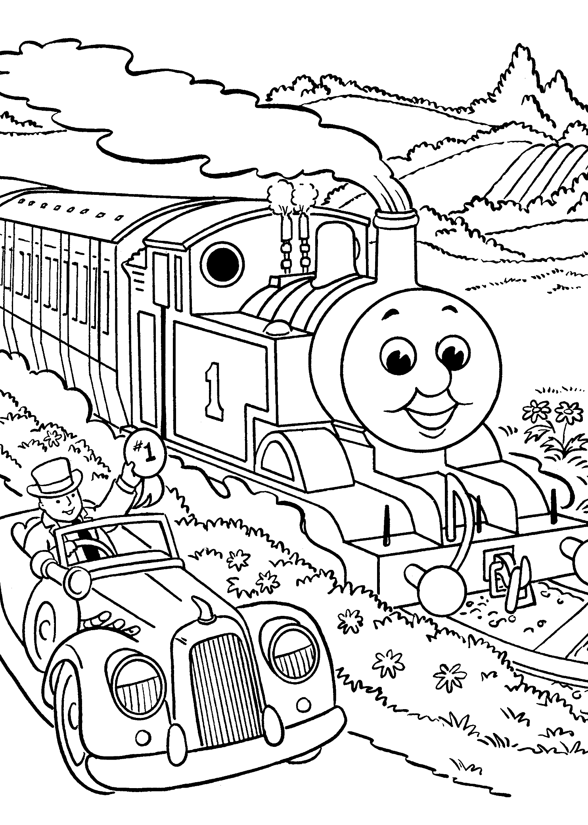

**1.** We want to start a school. We want to learn. School is fun.

…………………………………………………………………………………………….

**2.** At the animal school. We learn everything. It’s cool.

…………………………………………………………………………………………….

**3.** Running and climbing, swimming and flying.

…………………………………………………………………………………………….

**4.** Swimming starts at 9 o’clock. Are you ready?

…………………………………………………………………………………………….

**5.** Everybody can do something but together we can do everything.

…………………………………………………………………………………………….

**6.** It’s 10 o’clock. You must go to the running class now.

…………………………………………………………………………………………….

**7.** Don’t be lazy, of course you can run! I love running.

……………………………………………………………………………………………

**8.** Oh,no! I can’t climb. Don’t be sad.I can help you.Join me Cole.

…………………………………………………………………………………………….

**9.** It’s cool to be different, everybody is unique.

…………………………………………………………………………………………….

10.Respect my likes,respect my rights and the world will be so bright.

………………………………………………………………………………………………….

