**UNIT 4**:THE WEASEL AND THE MOLE

1. Weasel …………………………

2. Mole ………………………..

3. But why? ……………………….

4. I am running ……………………….

5. Empty ………………………

6. Today ………………………

7. His tummy ………………………

8. Very tall ……………………..

9. this wall ……………………..

10. hole ……………………..

11. so small ………………………

12. Cellar ………………………

13. I am eating ………………………

14. I am drinking ……………………..

15. lollipops ………………………

16. My friend ………………………

17. Bread ………………………

18. Ham ………………………

19. Cheese ………………………

20. cookies ……………………….

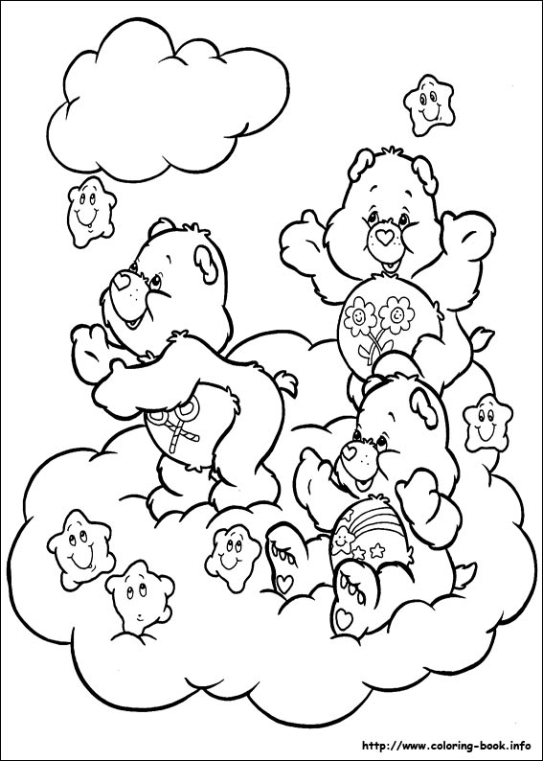

**REVISION = ΕΠΑΝΑΛΗΨΗ**

21. σοκολάτα ………………………….

22. γλυκά …………………………

23. Νόστιμα κεράσια ………………….

24. Μούρα …………………………

25. Δαμάσκηνα …………………………

26. Καρύδια ………………………..

27. Μέλι …………………………

28. Μαρούλι …………………………

29. Σήμερα ………………………….

30. Γύρω και γύρω …………………….

31. Πεινασμένος ………………………..

32. Λαχανικά ………………………..

33. Άπληστος ………………………..

34. Δευτέρα ………………………..

35. Τρίτη ………………………..

36. Τετάρτη …………………………

37. Πέμπτη ………………………..

38. Παρασκευή ………………………..

39. Σάββατο ..……………………….

40. Κυριακή …………………………

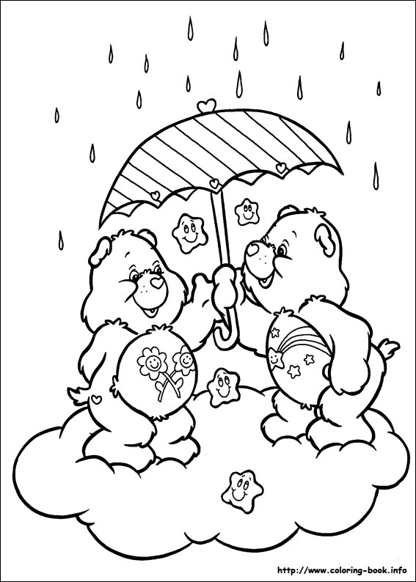

1. The weasel is running. His tummy is empty but the cellar is full.

…………………………………………………………………………………………………………..

2. This wall is very tall. Oh,but look! A hole so small.

…………………………………………………………………………………………………………..

3. Run little weasel! Quick! Run through the hole!

…………………………………………………………………………………………………………..

4. Eat your vegetables and fruit. That’s the right kind of food.

…………………………………………………………………………………………………………..

5. Eating right can make you happy. ……………………………………………………

6. Monday,Tuesday,tasty cherries. Wednesday,Thursday,plums and berries.

…………………………………………………………………………………………………………..

7. I’m so fat. I’m so big.I can’t Cole .……………………………………………………..

8. Chocolate,lollipops,sweets and cookies. Easel is having all the goodies.

…………………………………………………………………………………………………………..

9. Friday and Saturday, nuts and honey. Sunday lettuce is so yummy !

…………………………………………………………………………………………………………..

10. Round and round the cellar wall runs the greedy weasel.

………………………………………………………………………………………………………….

