**SIMPLE PRESENT**

**ΚΑΤΑΦΑΣΗ**

I read you read he read**s** she read**s**  it read**s**  we read you read they read

**ΕΡΩΤΗΣΗ**

Do I read ? do you read ? **does he read ? does she read ?**

**does it read ?** do we read ? do you read ? do they read ?

**ΑΡΝΗΣΗ**

I do not read you do not read he **does not** read she **does not** read it **does not** read we do not read you do not read they do not read

**ΑΠΛΟΣ ΕΝΕΣΤΩΤΑΣ**

**ΚΑΤΑΦΑΣΗ**

I wash you wash he wash**es** she wash**es** it wash**es**  we wash you wash they wash

**ΕΡΩΤΗΣΗ**

Do I wash ? do you wash ? **does he wash? does she wash? does it wash?** do we wash ? do you wash ? do they wash ?

**ΑΡΝΗΣΗ**

I do not wash you do not wash he **does not** wash she **does not** wash it **does not** wash we do not wash you do not wash they do not wash

**ΚΑΤΑΦΑΣΗ**

I study you study he stud**ies** she stud**ies** it stud**ies**  we study you study they study

**ΕΡΩΤΗΣΗ**

Do I study ? do you study ? **does he study? does she study? does it study?** do we study ? do you study? do they study?

**ΑΡΝΗΣΗ**

I don’t study you don’t study he **doesn’t** study she **doesn’t** study it **doesn’t** study we don’t study you don’t study they don’t study

**He, she, it στην κατάφαση**

b,d,e,k,l,m,n,p, t,w,z 🡺🡺🡺 **-s**

walk-s read-s

stop-s speak-s

eat-s come-s

join-s cook-s

swim-s rub-s

**=========**

-ss,-ch,-sh,-x,-o 🡺🡺🡺 -es

Brush-**es** kiss-**es** teach-**es** fix-**es** go-**es** mix-**es**

**=========**

Σύμφωνο + **-y**

🡺🡺🡺 **-ies**

Cry 🡺🡺 cries try 🡺🡺 tries study 🡺 studies carry 🡺 carries

**=========**

Φωνήεν + **-y**

🡺🡺🡺 **- s**

He play**s,**she say**s**

**=========**



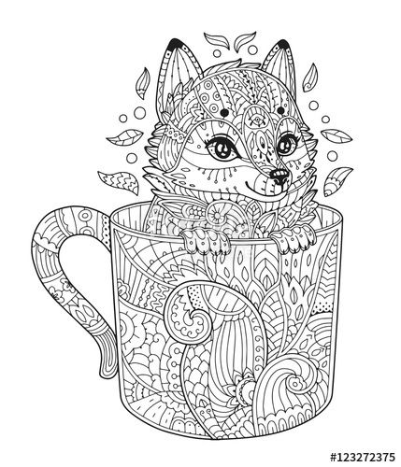



**=========ΕΠΙΡΡΗΜΑΤΑ ΣΥΧΝΟΤΗΤΑΣ** Always = πάντα, usually = συνήθως, never = ποτέ, often = συχνά, sometimes=μερικές φορές ,



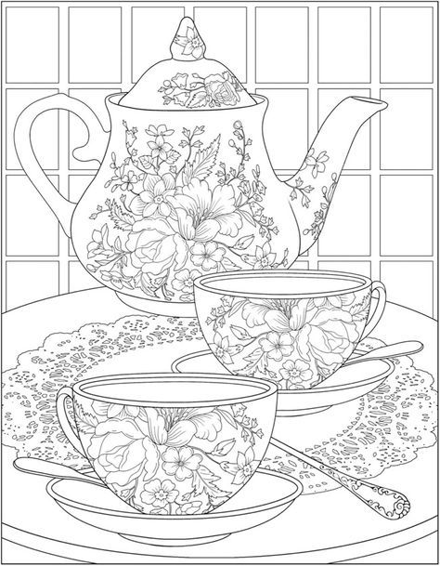



Seldom=σπάνια

every day /week month /year……