Alexander Fleming

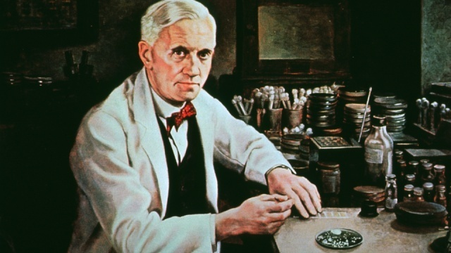
‘The scientist who discovered penicillin and saved millions”

A. Watch the video titled “The story of Alexander Fleming and penicillin” and fill in the gaps with the right word. You can also use the words from the word bank below. [ Παρακολούθησε το βιντεάκι “The story of Alexander Fleming and penicillin” και συμπλήρωσε τα κενά με την σωστή απάντηση. Μπορείς επίσης να χρησιμοποιήσεις και το λεξιλόγιο που ακολουθεί. ]
Alexander Fleming was a 1) d…………………………….who discovered 2) p……………………………………
Today, If you go to a doctor when you’re feeling ill s/he will probably give you 3) a…………………
Before Fleming’s discovery even a little cut on the knee, if it got badly infected, could 4) k…………………you.

Fleming’s family and studies
Fleming was born οn a 5) f…………………………………… in 6) S……………….., E……………..........
His father was a 7) f………………………………….. and his mother was a farmer’s daughter.
Fleming followed in his 8)b …..…………………………………………………………..footsteps.
He 9) s……………………………in St. Mary’s Hospital and started working in a 10) L……………………
His professor was 11) s………………… and 12 ) s………………….but he helped him to understand germs.

WORD BANK

antibiotics : αντιβιοτικά
bacteria: βακτήρια
cure: θεραπεία
curative: θεραπευτικός
germs: μικρόβια
infect: μολύνω
infection: μόλυνση
laboratory: εργαστήριο
mold: μούχλα
penicillin: πενικιλίνη

wounds: πληγές
therapeutic:θεραπευτικός
e

therapeutic

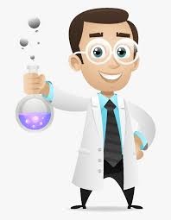

His experiments and discovery
B. Watch the video again and write TRUE or FALSE for the following sentences. [ Παρακολούθησε ξανά το βίντεο και σημείωσε ΣΩΣΤΟ ή ΛΑΘΟΣ ]

1. Fleming was a very tidy kind of person and his laboratory was always very clean.
2. He discovered penicillin by accident.

3. Ιf you don’t wash your cereal dish for some days it will go green due to mold.

4. As the mold grows, it actually releases penicillin to its surroundings.
5. Penicillin can kill germs.

6. His fellow scientists immediately accepted his ideas with great excitement.
7. In the 2nd World War in 1945 hundreds of soldiers died because of their infected wounds.
8. Ernst Chain and Howard Florey developed penicillin for therapeutic reasons.
9. They tested penicillin in guinea pigs.
10.Penicillin has become the most widely used antibiotic in the world

WRITING

C .Read this extract from an old newspaper and explain in your own words why Alexander Fleming was awarded the Nobel Prize. [Διάβασε αυτό το απόσπασμα μιας παλιάς εφημερίδας και εξήγησε γιατί απονεμήθηκε το βραβείο Nobel στον Sir Alexander Fleming]
“The Nobel Prize in Physiology or Medicine 1945 was awarded jointly to Sir Alexander Fleming, Ernst Boris Chain and Sir Howard Walter Florey "for the discovery of penicillin and its curative effect in various infectious diseases."
……………………………………………………………………………………………………………………………………………………………………………………………………………………………………………………………………………………………………………………
- Ιf you could ask him one question what would that be?
[Αν είχες την ευκαιρία να του κάνεις μία ερώτηση ποια θα ήταν αυτή;]
……………………………………………………………………………………………………………………………………………………………………………………………………………………………………….

