Γ' ΓΥΜΝΑΣΙΟΥ • ENGLISH READING WORKSHEET
How Our Environment Shapes Us
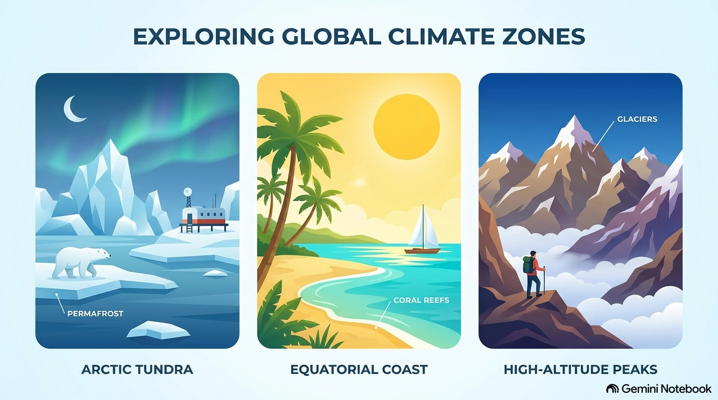
Figure 1: Earth's diverse environments—from freezing cold regions to sunny equator coasts and high mountains—shape human physical traits.
Reading Text: How Our Environment Shapes Us
Have you ever wondered why people from different parts of the world look or live differently? Science and history show that human bodies and habits adapt remarkably well to the places we call home. Our environment—whether it is freezing cold, high in the mountains, or baking in the sun—gradually shapes our physical characteristics over generations.
Take people living in extremely cold regions, like the Arctic. Traditional indigenous populations often have shorter, stockier bodies. Why? A compact body shape helps retain body heat more efficiently than a tall, thin frame. Similarly, people whose ancestors lived in very hot, sunny climates near the equator often developed darker skin. This is a natural defense mechanism; extra melanin protects the skin from intense ultraviolet rays from the sun.
High-altitude regions, such as the Andes in South America or the Himalayas in Asia, present a different challenge: less oxygen in the air. Over thousands of years, populations native to these high regions developed larger chest cavities and higher red blood cell counts. These traits allow them to breathe easier and process oxygen much better in thin mountain air than visitors from sea level.
Even today, our immediate surroundings influence our daily physical habits and fitness. Teens growing up in coastal towns might spend their afternoons swimming and surfing, building strong upper-body strength, while those living in mountainous areas might naturally develop strong leg muscles from constant hiking and climbing. Ultimately, our world leaves its mark on who we are, proving that humans are truly connected to the landscapes around us.

Reading Comprehension Questions
Part 1: Multiple Choice (Questions 1–4)
1. According to the text, why do people in very cold regions often have stocky bodies?
A) They eat a diet rich in heavy fats.
B) A compact body shape retains heat better.
C) They wear thick winter clothing all year.
D) They do less running than people in warm places.
2. What is the primary function of extra melanin in hot, sunny climates?
A) To help the body absorb more vitamins
B) To keep the body cool during heatwaves
C) To protect the skin from intense UV rays
D) To make the skin look more attractive
3. What physical adaptation occurred in populations living at high altitudes?
A) Taller height and longer limbs
B) Larger chest cavities and more red blood cells
C) Lighter skin and smaller noses
D) Slower heart rates and lower body temperatures
4. According to the final paragraph, how do modern teens living in different areas differ physically?
A) Coastal teens are taller than mountain teens.
B) Mountain teens have stronger leg muscles from hiking.
C) City teens are healthier than rural teens.
D) Coastal teens have higher red blood cell counts.
Part 2: Written Response (Question 5)
5. In your own words, describe one way your own local environment or lifestyle affects your daily physical habits or health. Write 2 to 3 sentences.

