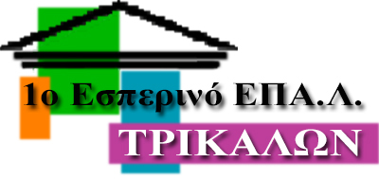**1st Evening Vocational High School of Trikala**

**School Year: 2020 - 2021**

**The Verb To Be**

|  |  |  |  |
| --- | --- | --- | --- |
| **Positive**  **Καταφατικά-**  **Short form**  **(Σύντομος Τύπος)** | **Questions**  **Ερωτήσεις** | **Negatives**  **Άρνηση** | **Short negative**  **Σύντομη Άρνηση** |
| I am - I’m | Am I? | I am not | I’m not |
| You are - You’re | Are you? | You are not | You aren’t - You’re not | |
| He is - He’s | Ishe ? | He is not | He isn’t - He’s not | |
| She is - She’s | Is she? | She is not | She isn’t - She’s not | |
| It is - It’s | Is it? | It is not | It isn’t - It’s not | |
| We are - We’re | Are we? | We are not | We aren’t - We’re not | |
| You are - You’re | Are you? | You are not | You aren’t - You’re not | |
| They are - They’re | Are they? | They are not | They aren’t - They’re not | |

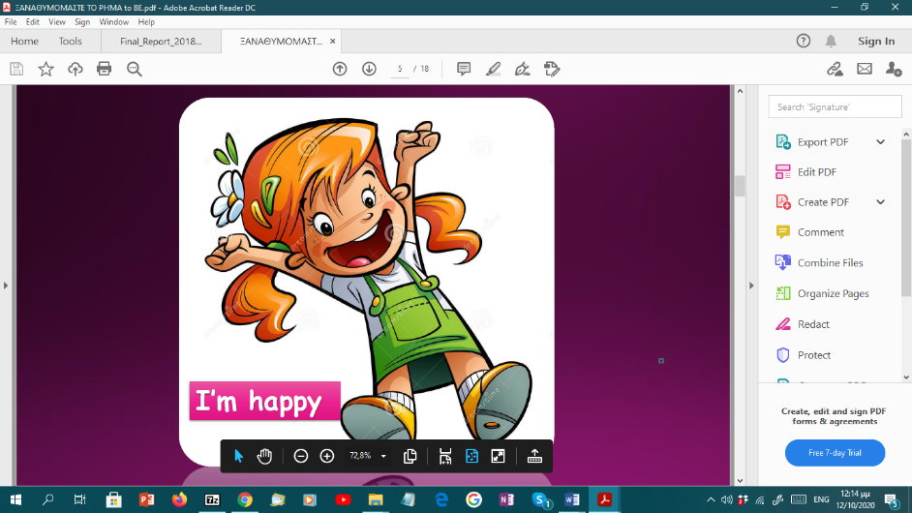

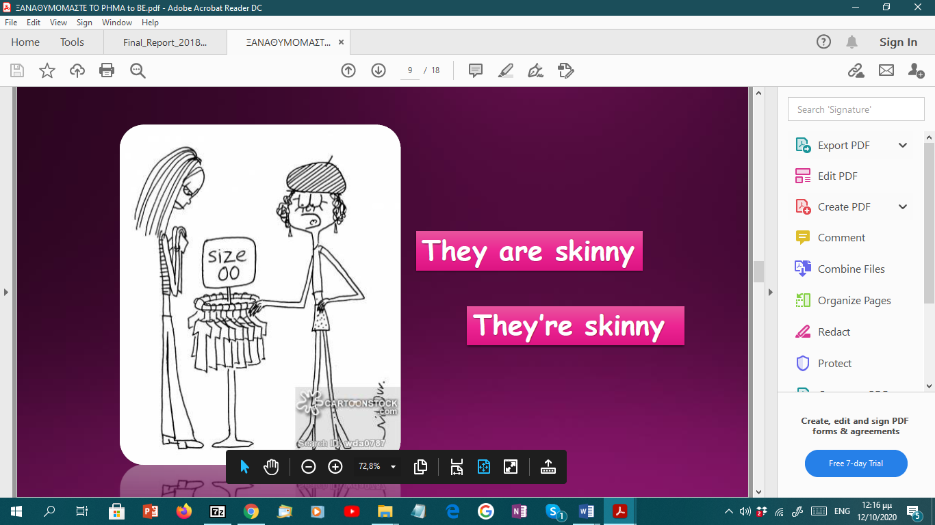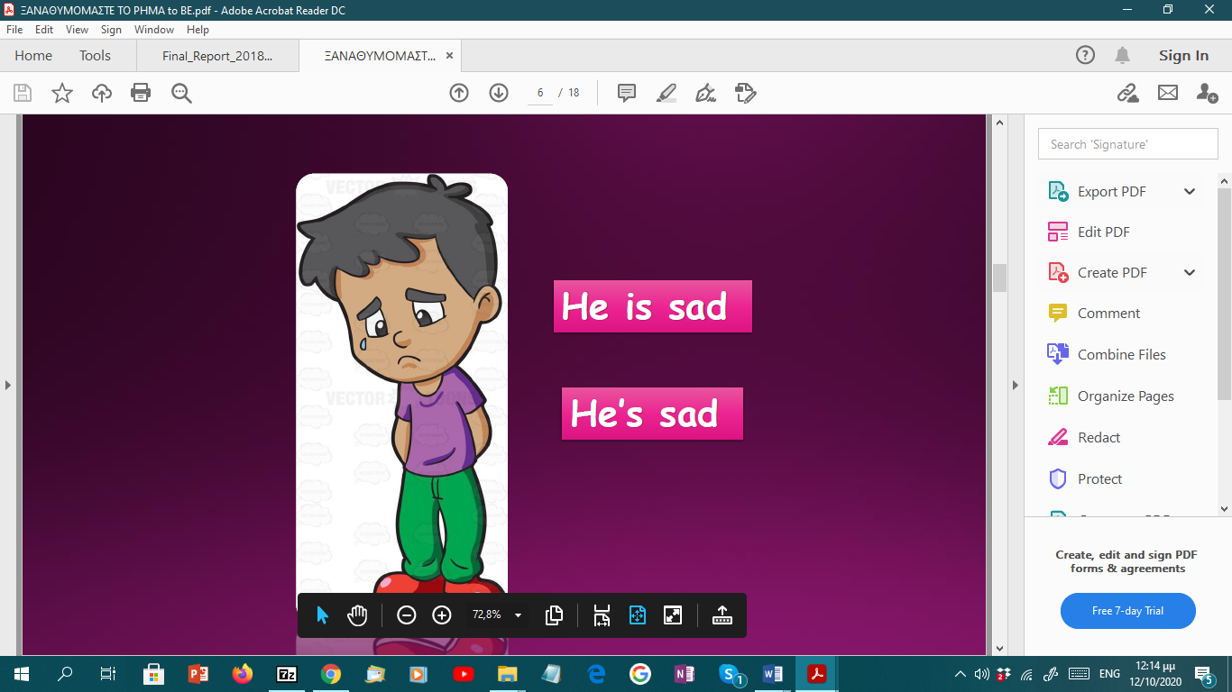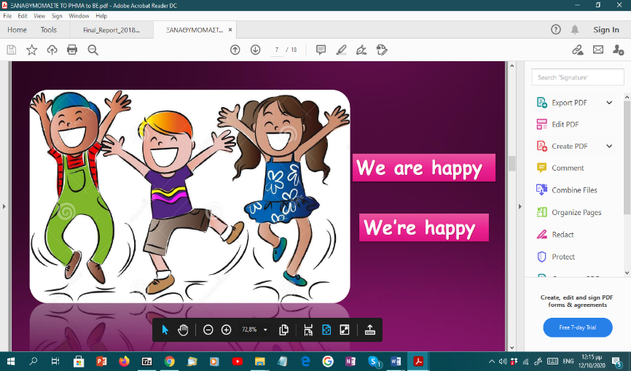**SHORT ANSWERS–ΣΥΝΤΟΜΕΣ ΑΠΑΝΤΗΣΕΙΣ**

|  |  |  |
| --- | --- | --- |
| a) Are you a doctor?  Yes, I am.  No, I’m not | b) Am I beautiful?  Yes, you are.  No, you aren’t. | c) Is he a mechanic?  Yes, he is.  No he isn’t. |

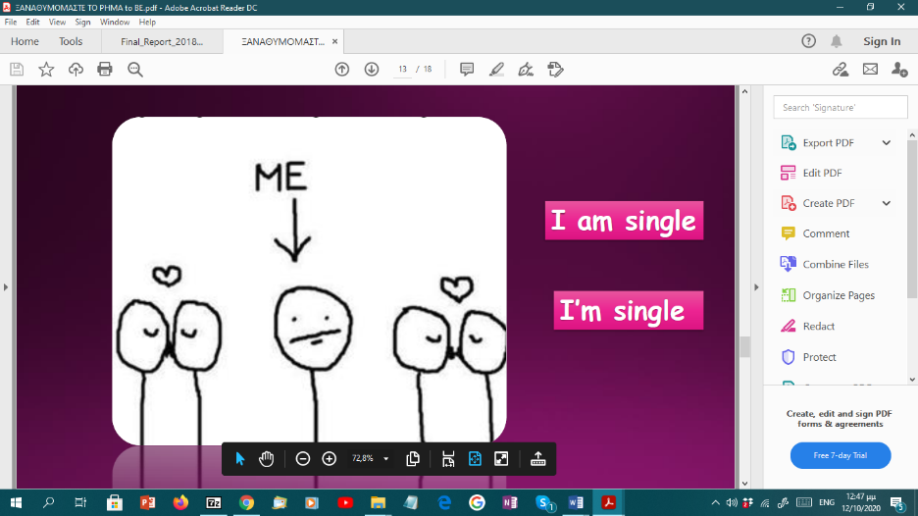

**We’re happy**

**They’re skinny**

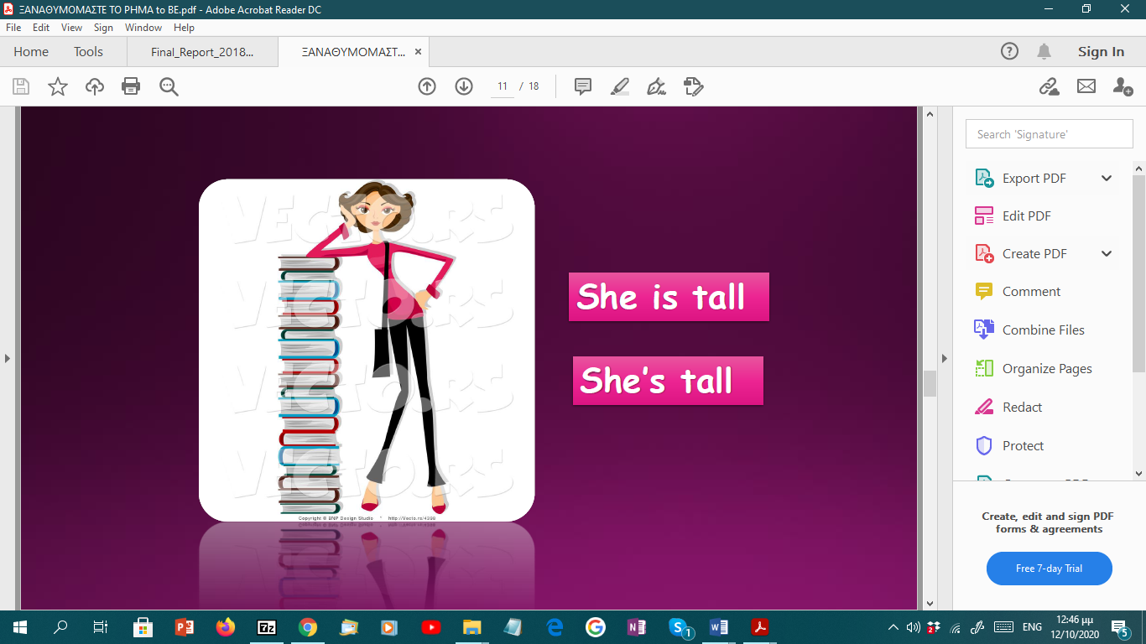

**He’s sad**

**I’m single**

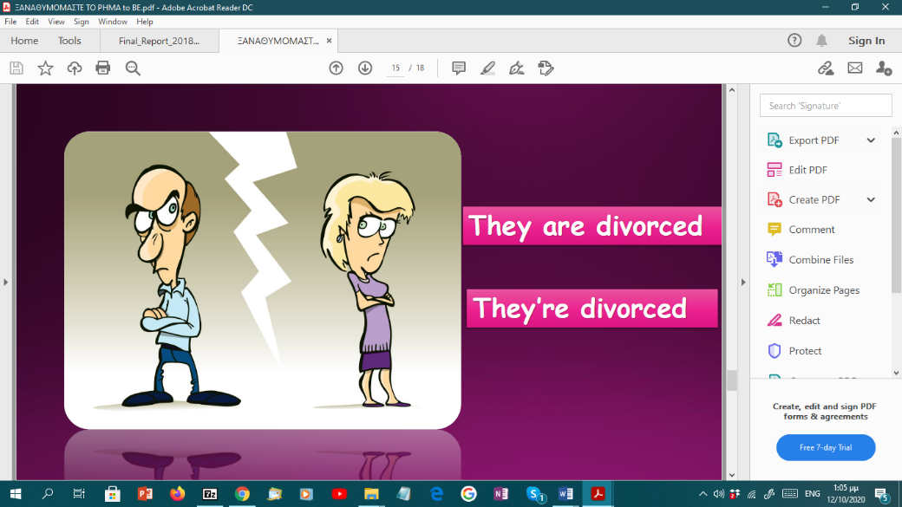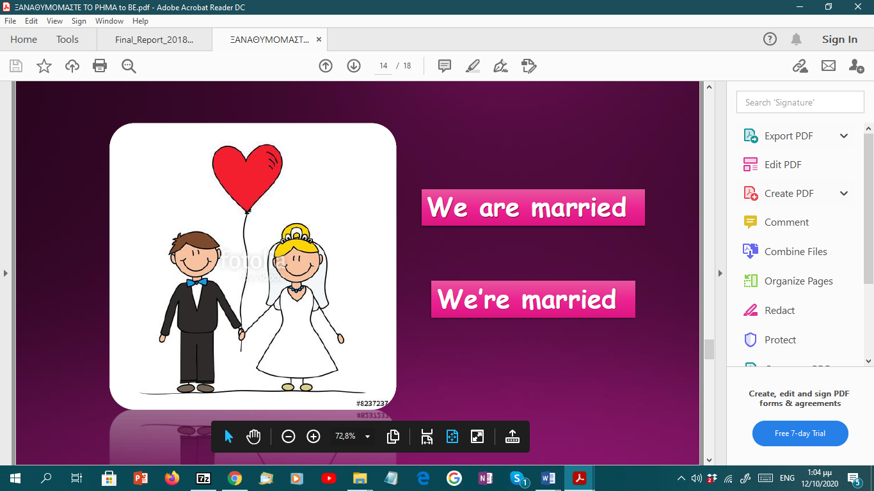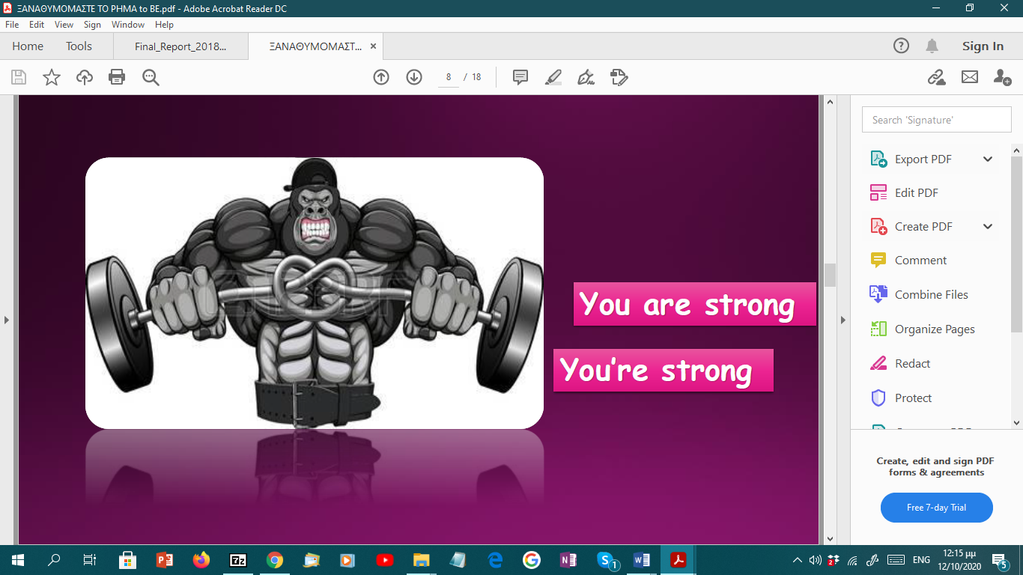

**She’s tall**

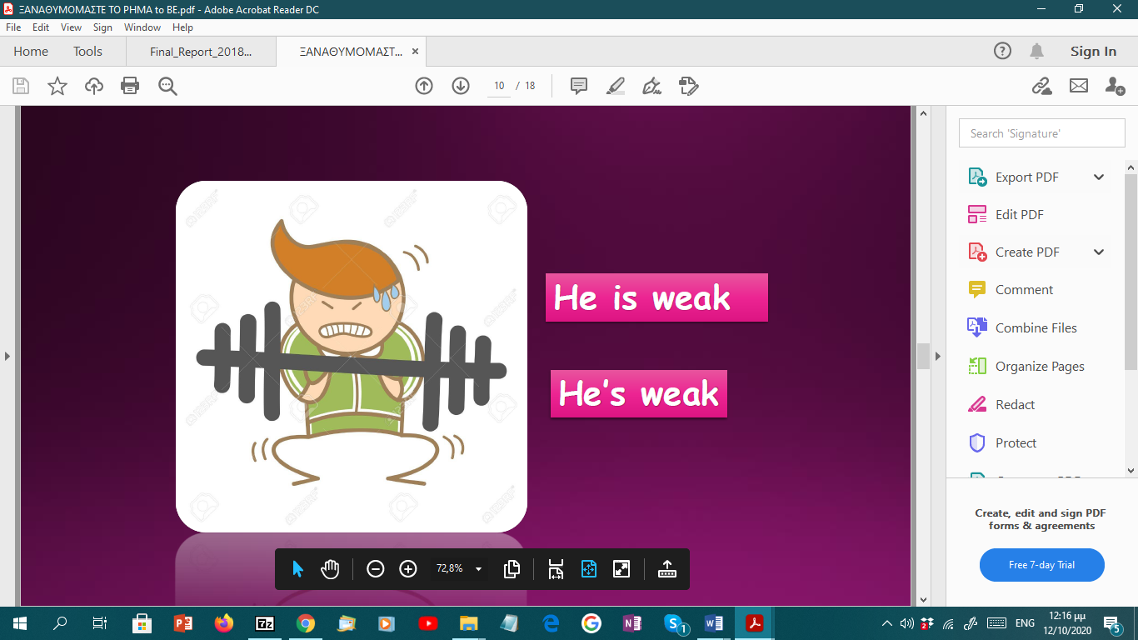

**He’s weak**

**They’re divorced**

**They’re married**

**You’re strong**

EXERCISES:

A. Pick three adjectives from the ones below and make true sentences about yourself:

happy – sad – strong – skinny - weak - tall – single – married - divorced

……………………………………………………………………………………………………………………………………………………………………………………………………………………………………………………………………………………………………………………………………………………………………………………………………………………………………………………………………………………………………………………………………………………...

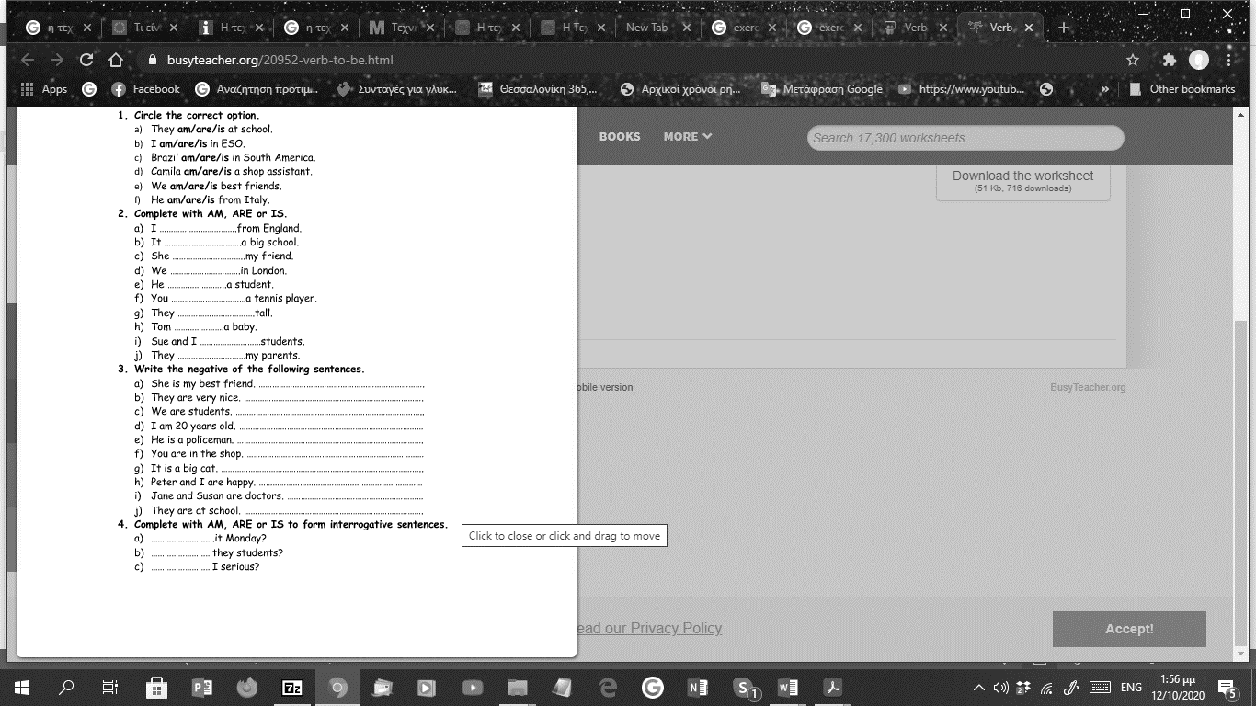B. Fill in the blanks with the right form of the verb To Be

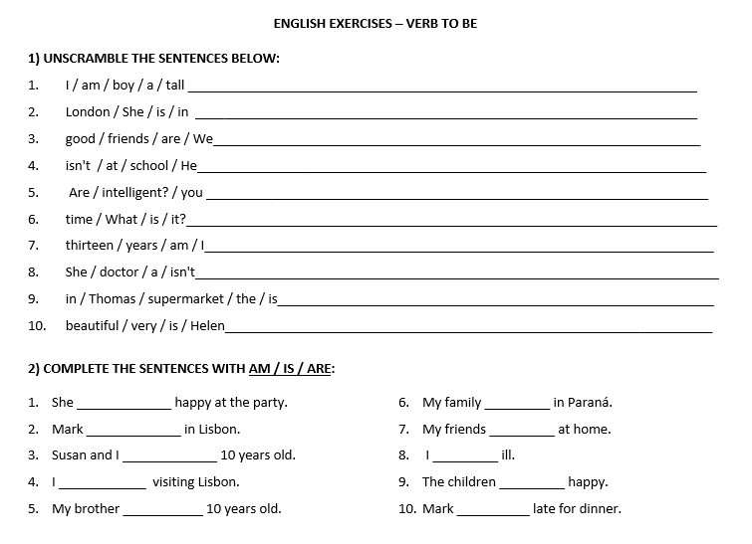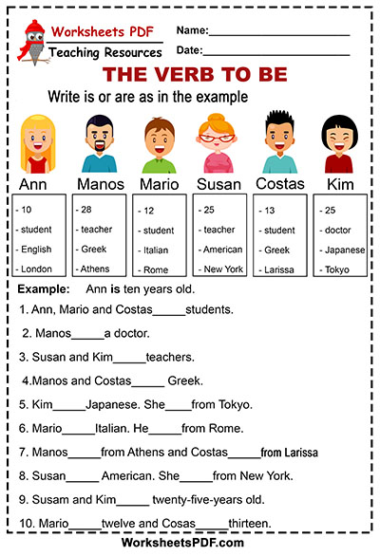



**THE VERB ‘TO HAVE GOT’ = ΕΧΩ**

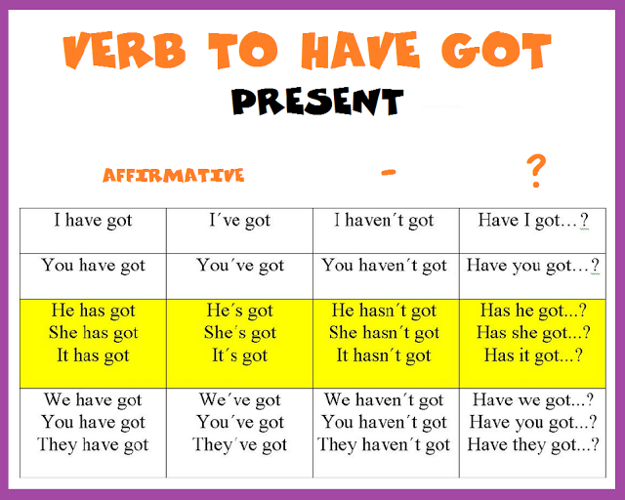

SHORT ANSWERS:

Yes, I/you/we/they have. No, I/you/we/they haven’t.

Yes, he/she/it has. No, he/she/it hasn’t.

