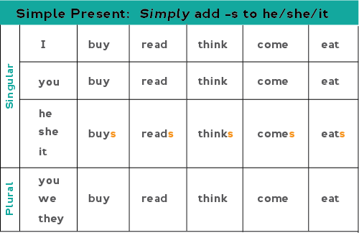**Introducing the SIMPLE PRESENT**

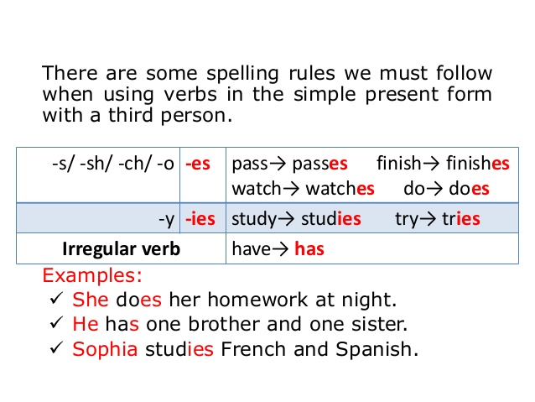



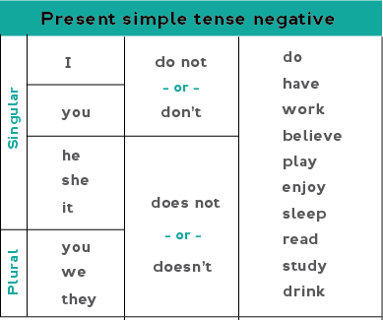

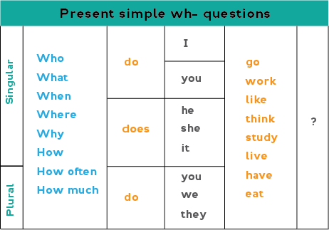

# SIMPLE PRESENT TENSE EXERCISES

**A. Give the *present tense form* of the verb in parentheses.**

1. We …………………….. (read) the newspaper in class every day.
2. He…………………….. (come) to school by bus.
3. I always …………………….. (walk) to school.
4. The children…………………….. (play) in the park every afternoon.
5. I …………………….. (eat) lunch in the cafeteria every day.
6. Helen …………………….. (work) very hard.
7. I …………………….. (like) to sit in the sun.
8. The dog …………………….. (chase) the cat all around the house.
9. Mr. Smith …………………….. (work) for Eastern Airlines.
10. Helen generally …………………….. (sit) at this desk.

B. Supply **do** or **does** to complete the following *present tense* questions.

1. Where __________ John live?
2. How often __________ you go to the movies?
3. What time __________ the plane leave?
4. What language besides English __________ your teacher speak?
5. What time _________ you get up every morning?
6. What time _________ the rest of your family get up?
7. Where ________ you hang your hat and coat during the lesson?
8. How well __________ Mary speak French?
9. Where _________ you usually meet Mary after the lesson?
10. How much _________ it cost to fly from New York to Paris?

**C. Make the following sentences negative.**

1. William plays chess.

_______________________________________________________

2. They go jogging every morning.

_______________________________________________________

3. I play computer games every day.

_______________________________________________________

4. Harry and Ben use their laptops for their school projects.

_______________________________________________________

5. Helen helps her family with the housework.

_______________________________________________________

Read the following paragraph about Sam. Classify the activities he does in the morning, in the afternoon and in the evening.

|  |  |
| --- | --- |
| Teenage Boy Clipart Png, Transparent Png , Transparent Png Image - PNGitem | In the morning Sam wakes up at 6.00 a.m. Then, he takes a shower and gets dressed. Later, he has breakfast. He doesn’t take the bus, he walks to school instead. In the afternoon, Sam does his homework. After that, he plays basketball at 5.00 p.m. or video games with his friends. In the evening, he has dinner with his family and watches TV. He goes to bed at 11.00 p.m. |

Sam’s activities:

|  |  |  |
| --- | --- | --- |
| In the morning  ……………………………………………..  ……………………………………………..  ……………………………………………..  ……………………………………………..  …………………………………………….. | In the afternoon  ……………………………………………..  ……………………………………………..  ……………………………………………..  ……………………………………………..  …………………………………………….. | In the evening  ……………………………………………..  ……………………………………………..  ……………………………………………..  ……………………………………………..  …………………………………………….. |

What about your daily routine?

How do you spend your day?

What do you do in the morning, afternoon or evening?

…………………………………………………………………………………………………………………………………………………………………………………………………………………………………………………………………………………………………………………………………………………………………………………………………………………………………………………………………………………………………………………………………………………………………………………………………………………………………………………………………………………………………………………………………………………………………………………………………………………………………………………………………………………………………………………………………………………………………………………………………………………………………………………………………………………………………………………………………………………………………………………………………………………………………………………………………………………………………………………………………………………………………………………………………………………………………………………………………………………………………………………………………………………………………………………………………………………………………………………………………………………………………………………………………………………………………………………………………………………………………………………………

Read the paragraph and answer the questions that follow:

|  |  |
| --- | --- |
| Painter Clipart Png, Vector, PSD, and Clipart With Transparent Background  for Free Download | Pngtree | One of the things I like best about my school is my art class. We have a great teacher named Mrs. Brown. She is a wonderful artist. I love to watch her draw and paint. She teaches us how to mix paint to make the right colours for our paintings.  We draw and paint almost every day. It’s interesting to do this. It helps me think of the images I want to paint and draw. We have an art exhibition at our gym in May. We are inviting people from our community to see it. I’m working on three different paintings now. I hope one of them will be chosen for the exhibition. |

Choose the correct answer:

|  |  |
| --- | --- |
| **1. What is the student’s favourite class?**  a. math  b. reading  c. art  d. music  **2. What is Mrs. Brown like?**  a. a nice lady  b. a wonderful artist  c. a sweet person  d. a beautiful person  **3. What does Mrs. Brown teach the class to do?**  a. bake chocolate cakes  b. write great stories  c. mix paint  d. copy painters’ work | **4. Why is it interesting to see the works of other artists?**  a. to learn to draw  b. to mix the colours  c. to think about what she wants to paint  d. to be a good art student  **5. Where is the exhibition?**  a. at the school gym  b. at the community centre  c. in the school yard  d. in the art classroom |

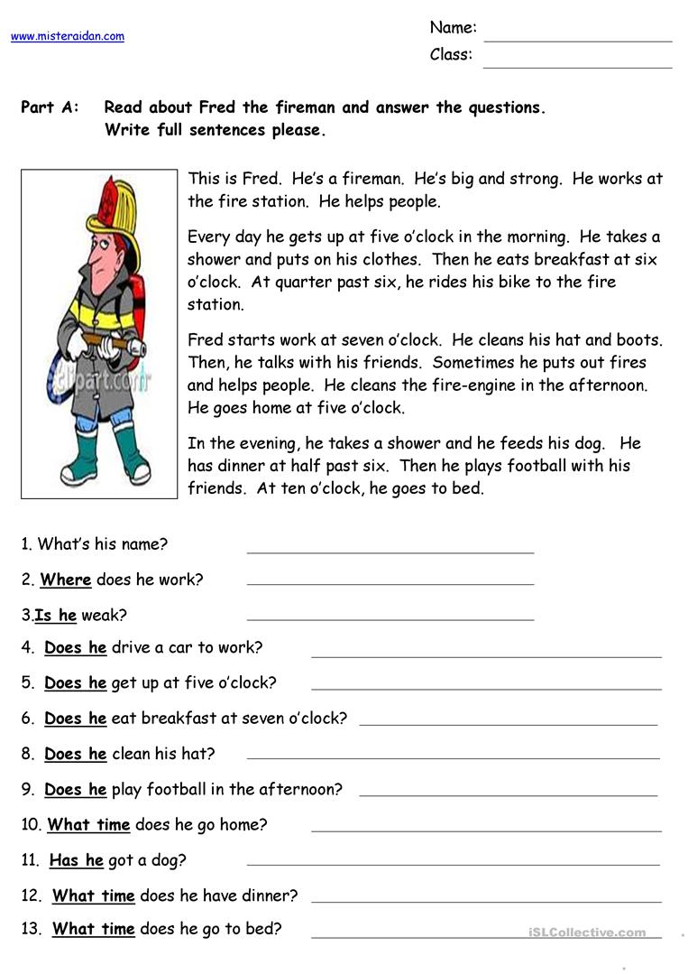

1. What is his name? _____________________________________________________________

2. Where does he work? _____________________________________________________________

3. Is he weak ______________________________________________________________

4. Does he drive a car to work? _____________________________________________________________

5. Does he get up at 5 o’clock? _____________________________________________________________

6. What time does he have breakfast? _____________________________________________________________

7. What does he do at work? _____________________________________________________________

8. When does he go home? _____________________________________________________________

9. Has he got a pet? _____________________________________________________________