Going to (plans & intentions)

+going to + (verb)

**am is are**

|  |  |  |  |  |  |  |  |  |  |  |  |  |  |
| --- | --- | --- | --- | --- | --- | --- | --- | --- | --- | --- | --- | --- | --- |
| + | | | |  | | | | ? | | | | SHORT ANSWERS | |
| + | - |
| I | am | going to | speak | I | am not | going to | speak | Am | I | going to | speak? | Yes, I am. | No, I’m not. |
| You | are | going to | speak | You | aren’t | going to | speak | Are | you | going to | speak? | Yes, you are. | No, you aren’t. |
| He | is | going to | speak | He | isn’t | going to | speak | Is | he | going to | speak? | Yes, he is. | No, he isn’t. |
| She | is | going to | speak | She | isn’t | going to | speak | Is | she | going to | speak? | Yes, she is. | No, she isn’t. |
| It | is | going to | speak | It | isn’t | going to | speak | Is | it | going to | speak? | Yes, it is. | No, it isn’t. |
| We | are | going to | speak | We | aren’t | going to | speak | Are | we | going to | speak? | Yes, we are. | No, we aren’t. |
| You | are | going to | speak | You | aren’t | going to | speak | Are | you | going to | speak? | Yes, you are. | No, you aren’t. |
| They | are | going to | speak | They | aren’t | going to | speak | Are | they | going to | speak? | Yes, they are. | No, they aren’t. |

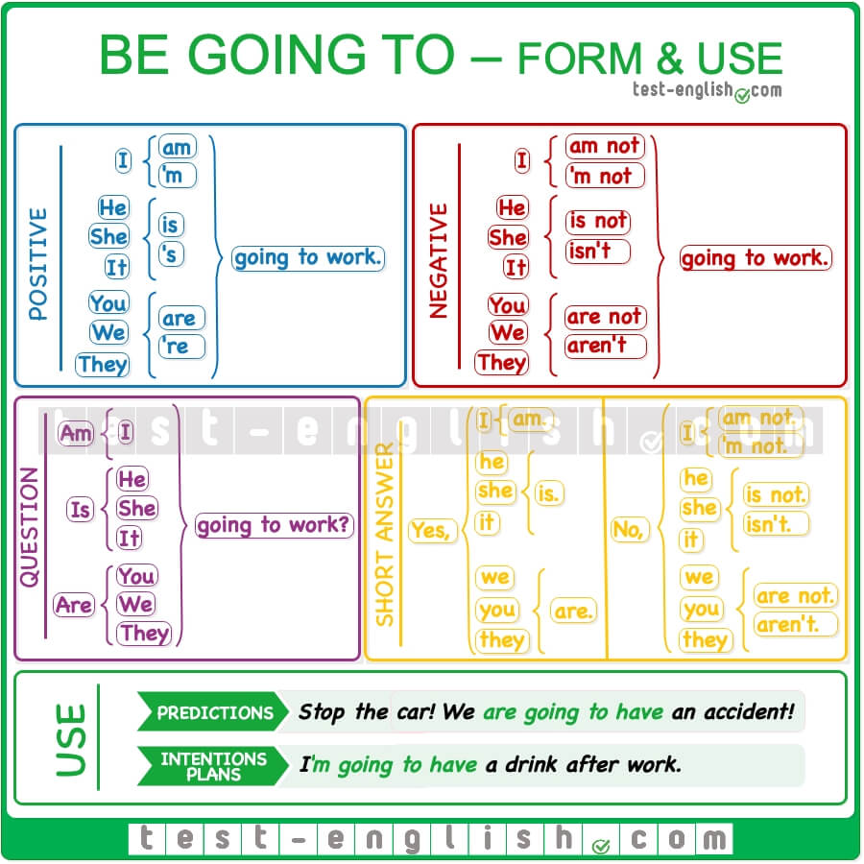

|  |
| --- |
| **Προβλέψεις για το πολύ κοντινό μέλλον** |
| **Έχω πρόθεση να …/ Σκοπεύω να …** |

EXERCISES:

**A. Put the verbs in brackets into the BE GOING TO form.**

1. I’m hungry. I ________________________ (make) a sandwich.

2. It’s cold outside. I _________________________ (put on) my coat.

3. Lucy has a terrible toothache. She ______________________________ (see) her dentist.

4. My friends are excited. They ________________________________ (have) a party.

5. It’s our teacher’s birthday We _______________________________ (buy) him a present.

6. My sister is very tired but she ________________________________ (not/have) a rest.

7. Julian ___________________________ (do) the washing up today.

8. We ____________________________ (practise) these exercises.

9. Philip and I _________________________________ (not/win) the football match tomorrow.

10. Martha _______________________________ (visit) her parents.

11. The girls ____________________________ (buy) some food for the party.

12. Tony ___________________________(not drink) alcohol because he ______________________ (drive) his car.

13. What _____________________________ (you/ have) for dinner tonight?

14. ___________________________________ (they/study) at university next year?

15. Hurry up! You ________________________ (miss) the train!

**DO SOME MORE PRACTICE HERE:** <https://www.liveworksheets.com/worksheets/en/English_as_a_Second_Language_(ESL)/To_be_going_to/Going_to_jz837842ro>