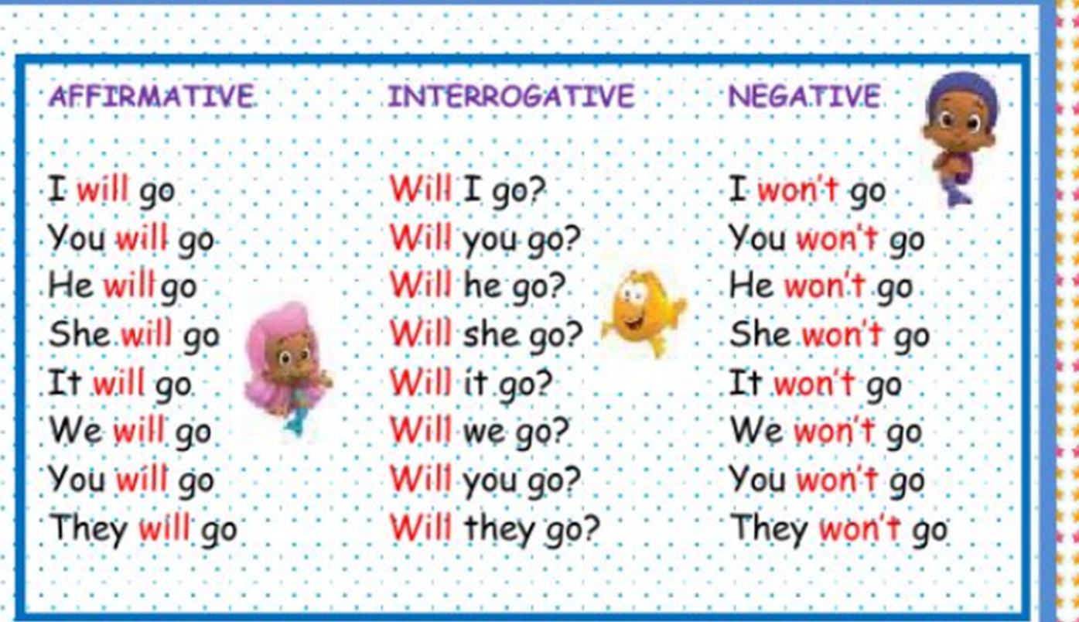**SIMPLE FUTURE**

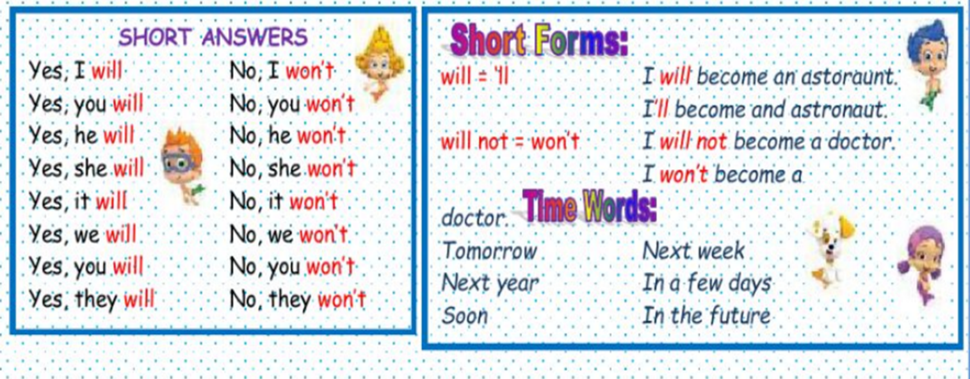

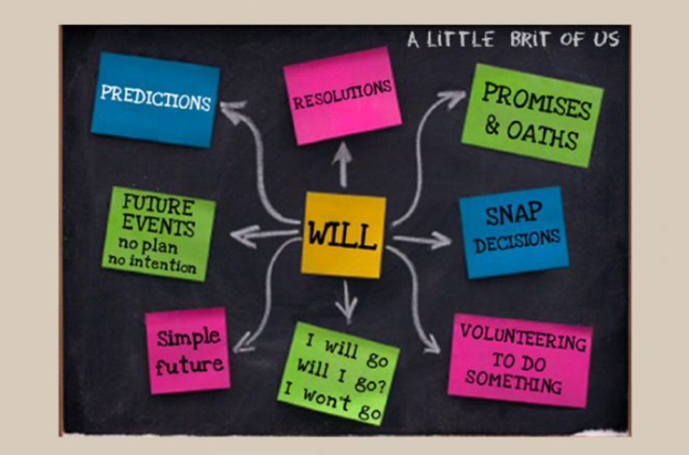

PRACTISE your Simple Future here:

<https://www.liveworksheets.com/worksheets/en/English_as_a_Second_Language_(ESL)/Future_-_will/Future_simple_yi170470tx>

<https://www.liveworksheets.com/worksheets/en/English_as_a_Second_Language_(ESL)/Future_-_will/Future_simple_nx652893yv>