**1st Evening Vocational High School of Trikala**

**Grade C**

**General English**

**A, READING TEXT**

**WHAT IS HAPPENING TO OUR WEATHER?**

What is ‘extreme’ weather? Why are people talking about it these days? ‘Extreme’ weather is very unusual rain, heat, storms etc. These days, extreme weather events are more frequent.

The opposite situation is drought, when no rain falls. It affects countries like Australia, Russia and East Africa. Another example of extreme weather is a heat wave, such as in the summer of 2003. In Europe, 35,000 people died from heat-related problems.

Are these extreme events part of a natural cycle? Are they happening because human activity affects the Earth’s climate? Probably both. On the one hand, the most important influences on weather events are natural cycles in the climate. Two of the most famous cycles are called El Niño and La Niña. They start in the Pacific Ocean, but they affect weather all around the world. On the other hand, the Earth’s oceans are changing: their temperatures are increasing. And this is a result of human activity. The greenhouse gases we produce mean the atmosphere warms up. Warmer oceans produce more water vapour. Information from satellites tells us that there is four percent more water vapour in the atmosphere than 25 years ago. This warm, wet air turns into rain, storms, hurricanes and typhoons.

We need to accept reality. Our weather is changing and we need to act to save lives and money.

**I. Read the article and choose the correct option.**

|  |  |
| --- | --- |
| 1 The article says that extreme weather is ...   1. more common nowadays. 2. not natural. 3. more unusual nowadays.   2 Examples of extreme weather include ...   1. warm, wet air. 2. El Niño and La Niña. 3. very hot weather in Europe.   3 One cause of extreme weather is ...   1. floods across large areas. 2. very hot summers. 3. water vapour in the atmosphere.   4 What caused many deaths in 2003?   1. hot weather 2. floods 3. a drought | 5 The article says that extreme weather events are the result of ...   1. natural cycles. 2. human activity. 3. natural cycles and human activity.   6 What is happening to the oceans?   1. They are getting bigger. 2. They are getting hotter. 3. They are producing greenhouse gases.   7 Satellites can measure ...   1. the temperature of the Pacific Ocean. 2. the number of hurricanes. 3. the amount of water vapour in the air. |

**II. Are the following statements True or False?**

1. Australia, Russia and East Africa often suffer from dry periods. **_____________**
2. Modern people do not bother about extreme weather conditions. _____________
3. Weather in present times is not the same as it used to be. ­­­­_____________

**B. VOCABULARY PRACTICE**

**a) Name the pictures with the following words / phrases:**

**drought, water vapour, hurricane, satellite, storm,**

**greenhouse gases, heat, heatwave, rain,**

|  |  |  |
| --- | --- | --- |
| _____________________________ | _____________________________ | _____________________________ |
| _____________________________ | _____________________________ | _____________________________ |
| _____________________________ | _____________________________ | _____________________________ |

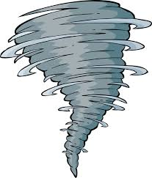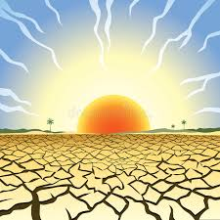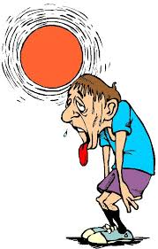

**b) Match the following words / phrases with their meanings**

|  |  |
| --- | --- |
| 1. temperature  2. frequent  3. climate  4. human  5. measure  6. activity  7. increase  8. floods  9. nowadays | a. get bigger  b. at the present time  c. find the size or amount of something  d. relating to a person or people  e. when water covers a place  f. happening often  g. when a lot of things are happening or people are moving around  h. the general weather conditions in a place  i. the amount of heat in a place/body |

PRACTISE YOUR WEATHER VOCABULARY HERE:

<https://www.liveworksheets.com/worksheets/en/English_as_a_Second_Language_(ESL)/Weather/Weather_multiple_choice_lr130tm>

<https://www.liveworksheets.com/worksheets/en/English_as_a_Second_Language_(ESL)/Weather/Kermit's_Weather_Calendar_vo20999xv>

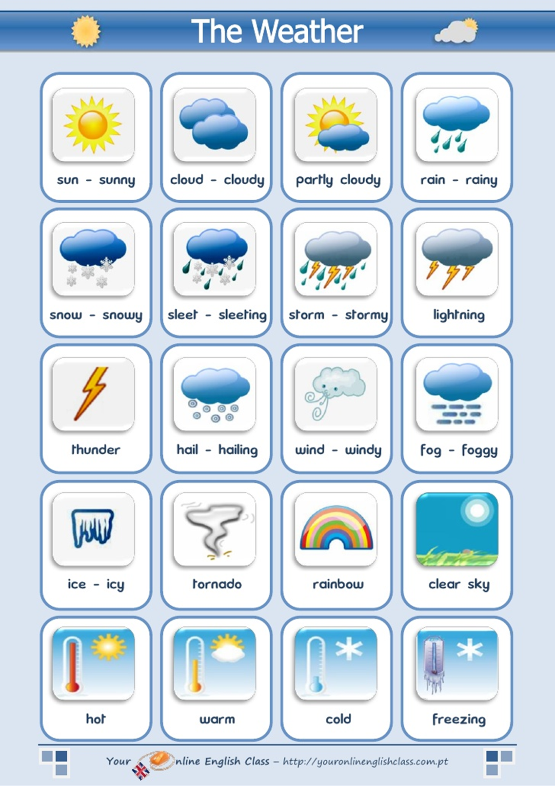**WEATHER VOCABULARY**

VOCABULARY

|  |  |
| --- | --- |
| TEXT  extreme = ακραίος  weather = καιρός  unusual = ασυνήθιστος  usual = συνηθισμένος  usually = συνήθως  heat = ζέστη  storm = καταιγίδα, τρικυμία, φουρτούνα  frequent = συχνός  frequently = συχνά  frequency = συχνότητα  drought = ξηρασία  affect = επηρεάζω, πλήττω  effect = επίδραση, συνέπεια  heat wave = καύσωνας  related = που σχετίζεται  natural cycle = φυσικός κύκλος  human(s) = ανθρώπινος, άνθρωποι  activity = δραστηριότητα  climate = κλίμα  probably = πιθανόν  both = και οι δύο  on the one hand = από τη μια μεριά  on the other hand = από την άλλη μεριά  influence = επηρεάζω, επιρροή  Pacific Ocean = Ειρηνικός Ωκεανός  temperature = θερμοκρασία  increase = αυξάνω, αύξηση  decrease = μειώνω, μείωση  result = αποτέλεσμα  greenhouse = θερμοκήπια  gas – gases = αέριο - α  produce = παράγω  mean = εννοώ  warm up = αρχίζω να ζεσταίνομαι, | water vapour = εξάτμιση νερού  satellite = δορυφόρος  per cent = τοις εκατό (%)  wet = υγρός  turn into = μετατρέπω -ομαι  hurricane = τυφώνας, θύελλα (a storm with a very violent wind)  typhoon = τυφώνας  QUESTIONS  article = άρθρο  common = κοινός, συνηθισμένος  nowadays = στις μέρες μας  include = συμπεριλαμβάνω  cause = αιτία, προκαλώ  floods = πλημμύρες  measure = μετρώ  amount = ποσό |