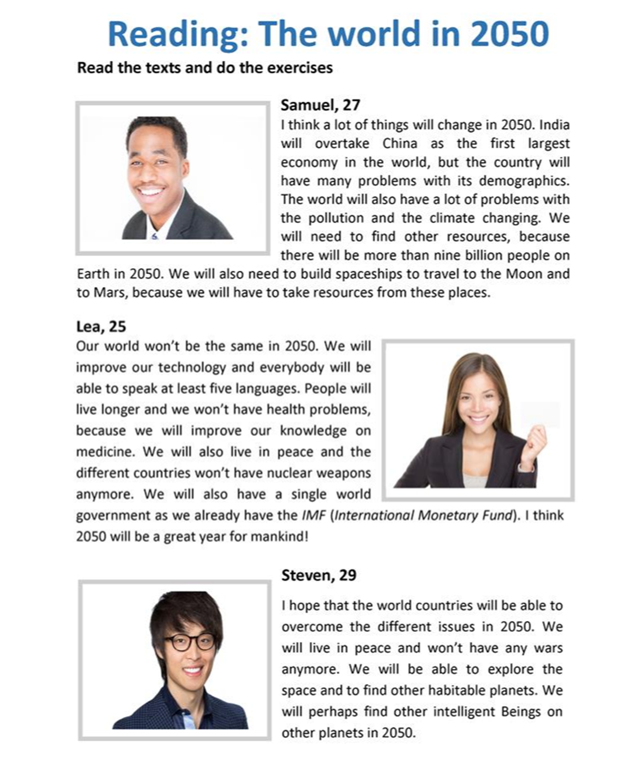A. Read the text below to find out what 3 young people predict about the future.

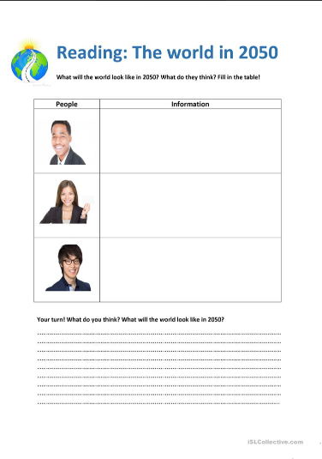B. Read the text again and try to fill in some information.

Your turn!

* What do you think the world will look like in 2050?
* Try to predict changes in world economy, population, government, war and peace, poverty and wealth, technology, space exploration, medicine, academic knowledge etc… ________________________________________________________________________________________________________________________________________________________________________________________________________________________________________________________________________________________________________________________________________________________________________________________________________________________________________________________________________________________________________

**VOCABULARY – ΛΕΞΙΛΟΓΙΟ**

|  |  |
| --- | --- |
| SAMUEL  overtake = ξεπερνώ, κυριεύω, προσπερνώ  country = χώρα  the largest = ο μεγαλύτερος – η - ο  demographics = δημογραφικά στοιχεία  the world = ο κόσμος, (σαν επιθ. παγκόσμιος)  pollution = ρύπανση  climate change = κλιματική αλλαγή  I need to = πρέπει να  find = βρίσκω  resources = πόροι  billion = δισεκατομμύριο  build = κατασκευάζω, χτίζω  spaceships = διαστημόπλοια  Moon = Σελήνη  Mars = Άρης  Martian Arts = πολεμικές τέχνες  LEA  the same = ο ίδιος – α- ο  improve = βελτιώνω  be able to = μπορώ, είμαι ικανός  at least = τουλάχιστον  live longer = ζω περισσότερο  health problems = προβλήματα υγείας  medicine = ιατρική  live in peace = ζω ειρηνικά  nuclear = πυρηνικός  weapons = όπλα  a single = μοναδικός  world government = παγκόσμια διοίκηση  government = κυβέρνηση  IMF (International Monetary Fund) =  Διεθνές Νομισματικό Ταμείο  mankind = το ανθρώπινο γένος | STEVEN  we will be able to = θα μπορέσουμε  overcome = υπερνικώ, ξεπερνώ  different = διάφορος, διαφορετικός  issues = θέματα  war = πόλεμος  anymore = πια  explore= εξερευνώ  space = διάστημα  habitable = κατοικήσιμος  perhaps = ίσως  intelligent = έξυπνος  beings = όντα  AFTER READING  population = πληθυσμός  poverty = φτώχεια  wealth = πλούτος  space exploration = εξερεύνηση διαστήματος  academic knowledge = ακαδημαϊκές γνώσεις |