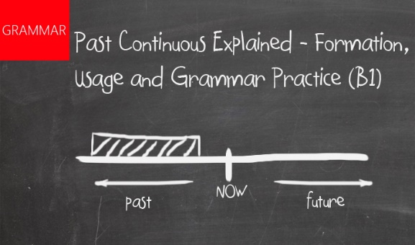**PAST CONTINUOUS**

**POSITIVE NEGATIVE**

|  |  |  |  |  |  |  |  |  |
| --- | --- | --- | --- | --- | --- | --- | --- | --- |
| Subject | To Be | Verb + ing |  |  | Subject | To Be | Verb + ing |  |
| I | was | babysitting | my niece. |  | I | was not (wasn’t) | babysitting | my niece. |
| You | were | running. | in the park. |  | You | were not (weren’t) | running. | in the park. |
| He | was | cooking | dinner. |  | He | was not (wasn’t) | cooking | dinner. |
| She | was | ordering | takeaway. |  | She | was not (wasn’t) | ordering | takeaway. |
| It | was | barking. |  |  | It | was not (wasn’t) | barking. |  |
| We | were | arguing. |  |  | We | were not (weren’t) | arguing. |  |
| You | were | checking | your homework. |  | You | were not (weren’t) | checking | your homework. |
| They | were | smiling. |  |  | They | were not (weren’t) | smiling. | **Usage**  **We use past continuous:** **1. to talk about an action or a situation which lasted for some time in the past.** e.g. Last night my wife and I were watching TV. **2. When one action in progress was interrupted by another action.** e.g. Tom was reading a book when Jane knocked on the door. **3. to talk about many activities happening at the same time in the past.** e.g. Peter was washing the dishes while Sue was cleaning the floor |

**INTERROGATIVE (Question)**

|  |  |  |  |
| --- | --- | --- | --- |
| To Be | Subject | Verb + ing |  |
| Was | I | babysitting | my niece? |
| Were | you | running | in the park? |
| Was | he | cooking | dinner? |
| Was | she | ordering | takeaway? |
| Was | it | barking? |  |
| Were | we | arguing? |  |
| Were | you | checking | your homework? |
| Were | they | smiling? |  |

.

**Past Continuous Grammar Practice:**

**2. Underline the correct word.**

1. I **was/ were** trying to make you laugh.
2. He **was/ were** studying English when I called him.
3. Vanessa and I **was/ were** travelling together.
4. He **was/ were** running a catering business when we moved to town.
5. Gary **was/ were** painting the walls, while we **was/ were** putting a new carpet.
6. My dog **was/ were** barking.

**1. Write down the correct present participle.**

e.g. stand → standing

sit →

play →

smoke →

breathe →

achieve →

marry →

control →

swim →

push →

win →

**3. Put the words in order to make a sentence.**

1. the wallpaper/ saw her/ changing/ when you/ yesterday?/ was Sally/

-----------------------------------------------------------------------------------------------

1. was/ a lot of/drinking/ Stella / water/

-----------------------------------------------------------------------------------------------

1. travelling/ was/ north/ family/ my/

-----------------------------------------------------------------------------------------------

1. was fishing/ having/ Sunday/ we/ were/ a tea party/ on/ while/ John/

-----------------------------------------------------------------------------------------------

1. looking/ were/ a new / car?/ you/ to buy/

-----------------------------------------------------------------------------------------------

1. they/ were/ their/ homework?/ finishing/

-----------------------------------------------------------------------------------------------

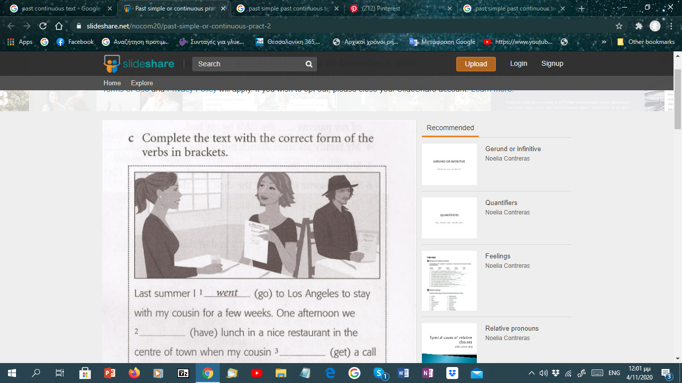

**4. Write the correct form of Past Simple or Continuous.**

*e.g. They* ***were watching*** *(watch)**a famous movie when he* ***entered*** *(enter) the room.*

*Her heart* ***was beating*** *(beat) fast when she* ***saw*** *(see) him.*

1. We ________________ (go) down the road at 100 km/h when the wheel _________________ (fall) off.
2. She nearly __________________ (have) a heart attack when she _______________(see) the lion.
3. My mother ____________________(get) dressed when she ________________ (feel) a pain in her chest.
4. She _________________ (fill) a questionnaire when the pen________________ (run) out of ink.
5. Susan __________________ (not/see) her friend because she ________________ (face) the other way.
6. Mike __________________ (fall) off the ladder while he ________________ (paint) the ceiling.
7. While Ann ____________________ (cook) dinner, the phone __________________ (ring).

**5. Complete the text with the**

**correct form of the verbs in brackets.**

Last summer I 1 went (go) to Los Angeles to stay with my cousin for a few weeks. One afternoon we 2________________ (have) lunch in a nice restaurant in the centre of town, when my cousin 3_____________ (get) a call on her mobile phone and went outside to talk. While she 4________________ (speak) to her friend I 5 _________________ (notice) a man in a black hat who 6 ______________ (sit) at the next table. It was the actor Johnny Depp! He was alone, and I 7 _______________ (decide) to take my chance. So I got up and 8 ________________ (go) to his table.

‘Excuse me, could I have my photo taken with you? I asked. He 9 _______________ (say) yes, so I 10 __________________(stop) a waitress who  11______________________ (pass) by and gave her my camera. She 12_____________________ (take) the photo of me and Johnny. I thanked them both, and I returned to my table. When my cousin 13  ______________ (come) back, I 14 ________________ (smile). ‘Why are you looking so pleased with yourself?’ she asked.

‘I had my photo taken with Johnny Depp’.

‘Johnny Depp? Where is he?’

‘He’s sitting over there. Look!’

She turned around to look and then 15 ___________________ (start) to laugh. ‘That’s not Johnny Depp!’ I 16 ____________________ (look) at the man in the black hat – he 17_________________________ (laugh) too.