**1st Evening Vocational High School of Trikala**

**School Year 2020-2021**

**Agriculture, Food and Environment Department**

**PLANT and ANIMAL PRODUCTS**

|  |  |
| --- | --- |
| The sources of food are broadly classified into two groups, **plants** and **animals** and their related **products**.  **Food From Plants**  Humans use every part of a plant for food and consume everything from fruits, flowers, even the leaves and stem (like lettuce, celery), roots of some plants (like carrots, beetroot) and seeds (like wheat, rice, etc.).  All food comes from plants. Even animals depend on plants. We obtain food from plants directly or indirectly. Consumption of fruits and vegetables on a daily basis is a source of rich nutrient that keep the human body in perfect working condition.  Plants provide us with vegetables, coffee, cereals, pulses, fruits, sugar, spices, oil, etc. Different parts of the plants provide different food materials.  Let us have a look at some of the food obtained from different parts of the plant.  **Vegetables** are nutrient-rich. Roots, leaves, and stem of some plants are also **edible**:  **Roots** fromradish, turnip, carrot, beetroot etc  **Stem – Tubers** from potato and ginger  **Leaves** fromSpinach, cabbage, lettuce  **Flowers** frombroccoli and cauliflower  **Fruits** are a healthy source of food from plants. Orange, mango, apple, grapes are some of the fruits consumed by humans.  **Cereals** include rice, wheat, maize, barley, etc. These are a rich source of nutrients provided by the plants.  **Tea and Coffee** are widely grown in the southern parts of India. **Sugar** is also obtained from the plants. It is processed from the sugarcane plant.  **Oil** can be extracted from the seeds and leaves of the plants. Some of the plants producing oil are castor, mustard, and sunflower.  **Spices:** Cinnamon, cardamom, pepper, clove, cumin seeds, and ginger are obtained from the plants and used for cooking purposes.  There are also **industrial crop** **products** or **non-food crops**, grown to produce goods for manufacturing, for example fibre for clothing, Algae and switchgrass for biofuels and bioenergy, hemp for clothes and shoes, cotton for fabric, bamboo as a construction material, lavender for essential oils etc.  **ANIMAL PRODUCTS**  **(More than a meal)**  We rely on animals for a number of products. Some are more obvious than others. Animals’ **meat** and **milk** provide us with **protein**. We make clothing and furniture with **wool** and **leather**. In addition, there is a long list of animal **by-products**. We use them every day. But we don’t always know it.  We **render** **fat**, or **tallow**, into tires, soaps and candles. Marshmallows, buttons and tape include **bones** and **hooves**. **Wool** is often used in carpet. Even baseballs use animal products.  Animal by-products are found in unexpected places. Thanks to **rendering**, very little goes to waste.  **Meat** is just one of the many products that we take from animals. It is rich in proteins, vitamins, zinc, phosphorus and iron. There are two types: **red meat** and **white meat**.  The meat of cow, goat, sheep and pigs has a lot of fat and is called red meat. White meat contains less fat and is obtained from chicken and fish. White meat is healthier and can be easily digested as compared to the red meat.  **Milk**  Cows, buffaloes, sheep, goat, and camels are a great source of milk. Milk is also called as an ideal food. It is rich in vitamins, minerals, proteins, carbohydrates and fats.  **Eggs**  Chickens, ducks, geese, and quails are raised for eggs and meat. The egg is a rich source of protein and vitamin. The yolk of the egg is mostly made up of egg. It also contains vitamins, phosphorus, calcium and iron. | 10 Valley Farmers Markets to Check Out Right Now - PHOENIX magazine**Farmers’ market**  **Tubers**  102,040 Tubers Photos and Premium High Res Pictures - Getty Images  **Health Benefits of Legumes - Tufts Health & Nutrition LetterLegumes**  **Cereal**  Post Holdings to acquire TreeHouse Foods' R.-T.-E. cereal business |  2019-05-02 | Food Business News  **Vegetables**  Go Vegetable Heavy!  **Meat**  I Ate Nothing but Meat for 2 Weeks. Here's What It Was Like | Inc.com  **Leather**  Leather Bag Manufacturer in Mumbai Maharashtra India by Zainab Bag | ID -  3675764  **Wool**  DROPS Big Merino - Superwash treated extra fine merino wool |

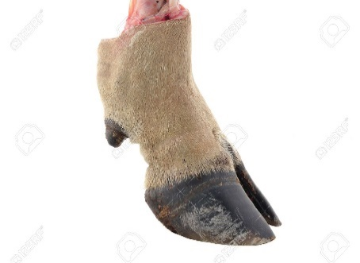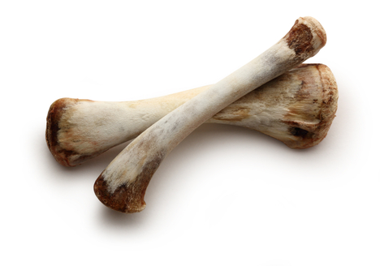 **Hooves Bone**

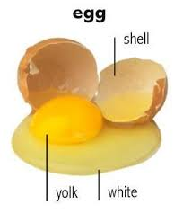 **Milk**

