**1st Evening Vocational High School of Trikala**

**School Year 2020 – 2021**

**Class B ΓΕΩ**

**REVISION**

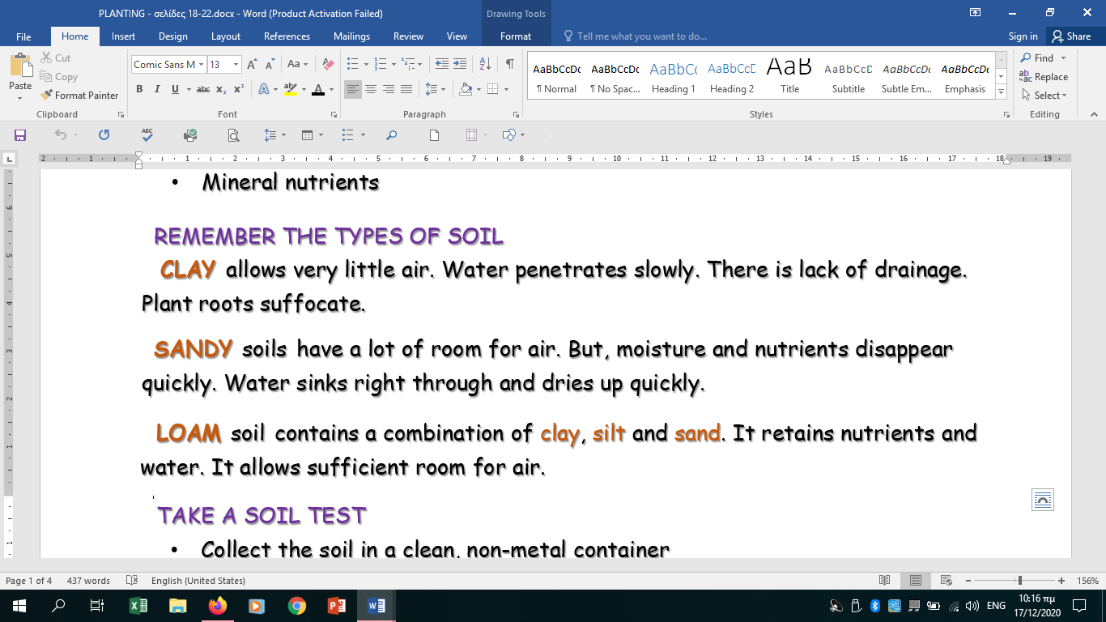**A.** Read the information provided below and select the true sentences that follow.

|  |  |
| --- | --- |
| Clay soils are good for the plant roots. |  |
| Loam soil keeps nutrients. |  |
| Loam soil is the best choice for your plants. |  |
| Sandy soil does not keep water. |  |

**B. Read the text below and select the sentences that are true according to it.**

Plants are a source of nutrients required to keep the human body in perfect working condition. People use every part of a plant for food and consume everything from fruits, flowers, stems, even the leaves, roots and seeds. Plants provide us with vegetables, coffee, cereals, pulses, fruits, sugar, spices, oil etc. Different parts of the plants provide different food materials.

We also rely on animals for a number of products. Some are more obvious than others. Animals’ meat and milk provide us with protein. We make clothing and furniture with wool and leather. In addition, there is a long list of animal by-products. We use them every day. But we don’t always know it. They are found in unexpected places. Thanks to rendering very little goes to waste.

|  |  |
| --- | --- |
| 1. According to the text we get our body’s basic nutrients from plants. |  |
| 2. All parts of the plants can be edible. |  |
| 3. Leaves, roots and seeds are plant products. |  |
| 4. Animal products are also good for the human body. |  |
| 5. Animal by-products are not useful. |  |
| 6. Rendering is a process of manufacturing clothes. |  |

**C. VOCABULARY**

Fill in the blanks with the correct form of the words in capital letters.

1. Your plants need extra attention in order to become _________________. (HEALTH)

2. My parents were __________________ . (FARM)

3. Greece exports many _____________________ products. (AGRICULTURE)

4. ____________________ crops are not eaten. (INDUSTRY)

5. _____________________ soils need organic matter. (SAND)

6. When there is enough ____________________ the crops are excellent. (IRRIGATE)

7. We ______________________ rice. (CULTIVATION)

8. You need to wait long until crops are mature to start _________________ . (HARVEST)

9. The land in the valley is ___________________ and lots of crops are grown. (FERTILITY)

10. For proper ________________________ plants need air in the soil. (GROW)

11. With a soil test you can estimate the amounts of ___________ you need to add. (NUTRITION)

**D. GRAMMAR**

**Choose the word or phrase which best completes each of the sentences below:**

* + - 1. The River Nile _______________ ***(floods / is flooding)*** every year.
      2. These new fertilizers _____________ ***(is / are****)* a revolution in agriculture.
      3. Vegetable producers _____________ ***(may / must)*** be strong enough to work in hard conditions.
      4. You _______________  ***(mustn’t / don’t have to)*** buy new farm machinery. I will lend you mine.
      5. I see that they _____________ ***(dig / are digging)*** the earth to plant new seeds.
      6. Why does the tractor _______________ ***(make / makes)*** this strange noise?
      7. I work for a food company which __________________ ***(is supplying / supplies)*** a lot of restaurants and supermarkets with fruit and vegetables.
      8. The workers are downstairs. They __________________ ***(are preparing / prepare)*** the garden tools for today’s work.
      9. You ________________***(should / may)*** take extra care of your crops if you want to harvest soon.
      10. If he wants to produce better crops he ____________________***(has to/ have to)*** getmore training.