1st Evening Vocational High School of Trikala

School Year 2020-2021

**A. Read the text below and answer the questions that follow:**

**The history of engineering**

Engineering is the application of mathematics and scientific, economic, social, and practical knowledge in order to invent, design, build, maintain and improve structures, machines, tools, systems, components, materials, processes, solutions, and organizations.

The word “engineer” was unknown in ancient times. It first appeared in the Middle Ages. It comes from the Latin word “ingenium”, meaning cleverness, mental power, intelligence, talent.

The Babylonians, Egyptians and Greeks were the first great engineers of the ancient world. The most famous among them was Archimedes, a great scientist, mathematician and inventor who lived in the 3rd century BC in Sicily. He invented many kinds of military engines and the screw pump, a device for transferring water from a low-lying body of water into irrigation ditches. Water is pumped by turning a screw-shaped surface inside a pipe.

The Romans were excellent engineers. They exploited the knowledge and experience of the Greeks and made lots of roads, bridges and large public buildings.

Engineering was greatly developed in the 17th and 18th century when some great scientists made lots of important discoveries in the field of mechanics. Among these were Galileo, Hook, Newton, Pascal, etc. French and English engineers of the 17th and 18th century set the basis of modern engineering science.

In the 19th and 20th century, scientists have made wonderful discoveries and inventions, indeed, but engineers have achieved great technological miracles.

1st Evening Vocational High School of Trikala

school year 2020-2021

***\*Please provide full answers to the questions below:***

1. Does the article explain what kind of knowledge Engineering combines?

…………………………………………………………………………………………………………………………………………………………………………………………………………………………………………………………………………………………………………………………

2. Where do engineers apply this kind of knowledge?

…………………………………………………………………………………………………………………………………………………………………………………………………………………………………………………………………………………………………………………………

3. What is the origin of the word ‘engineer’?

…………………………………………………………………………………………………………………………………………………………………………………………………………………………………………………………………………………………………………………………

4. What information do you get about the Archimedean screw pump from the article?

………………………………………………………………………………………………………………………………………………………………………………………………………………………………………………………………………………………………………………………

5. Who were the ones who developed the existing knowledge and became great constructors?

…………………………………………………………………………………………………………………………………………………………………………………………………………………………………………………………………………………………………………………………

6. Does the article support that scientists are more important than engineers?

…………………………………………………………………………………………………………………………………………………………………………………………………………………………………………………………………………………………………………………………

**WORD FORMS**

Complete the following table:

|  |  |  |
| --- | --- | --- |
| **VERB** | **NOUN** | **NOUN PERSON / OBJECT** |
| connect | connection | connector |
| design |  |  |
| employ |  |  |
|  |  | transporter |
|  | generation |  |
| produce |  |  |
| maintain |  |  |
|  | operation |  |
| install |  |  |
| adjust |  |  |
| measure |  |  |
| develop |  |  |
|  | construction |  |
| repair |  |  |
|  | equipment |  |
| manufacture |  |  |

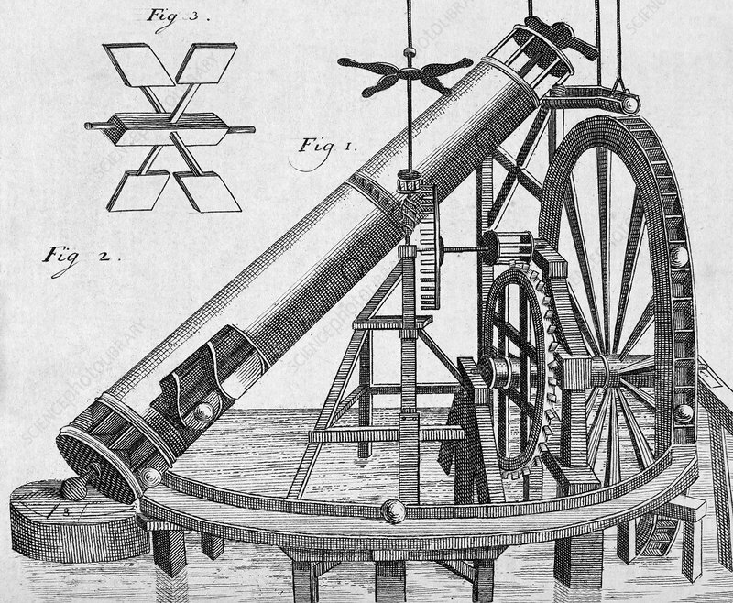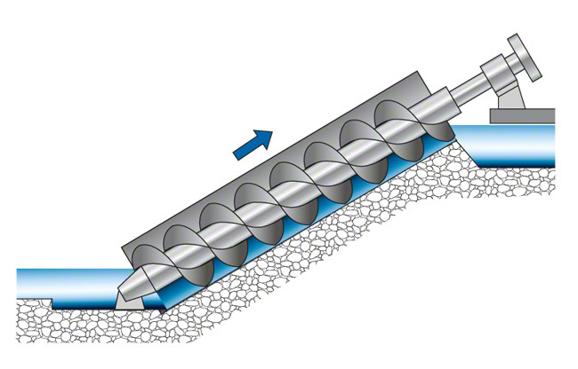

1st Evening Vocational High School of Trikala

school year 2020-2021

**Mechanical Engineering technicians are specialized as:**

1. bench workers
2. sheet-metal workers
3. machinists
4. CNC machine tool operators
5. machine shop supervisors
6. welders
7. plumbers
8. heating, refrigeration and air-conditioning systems installers and maintenance technicians
9. car mechanics
10. aircraft engineers
11. ship engineers

**Look at some of the tasks they perform below and match them with the corresponding specialization**

