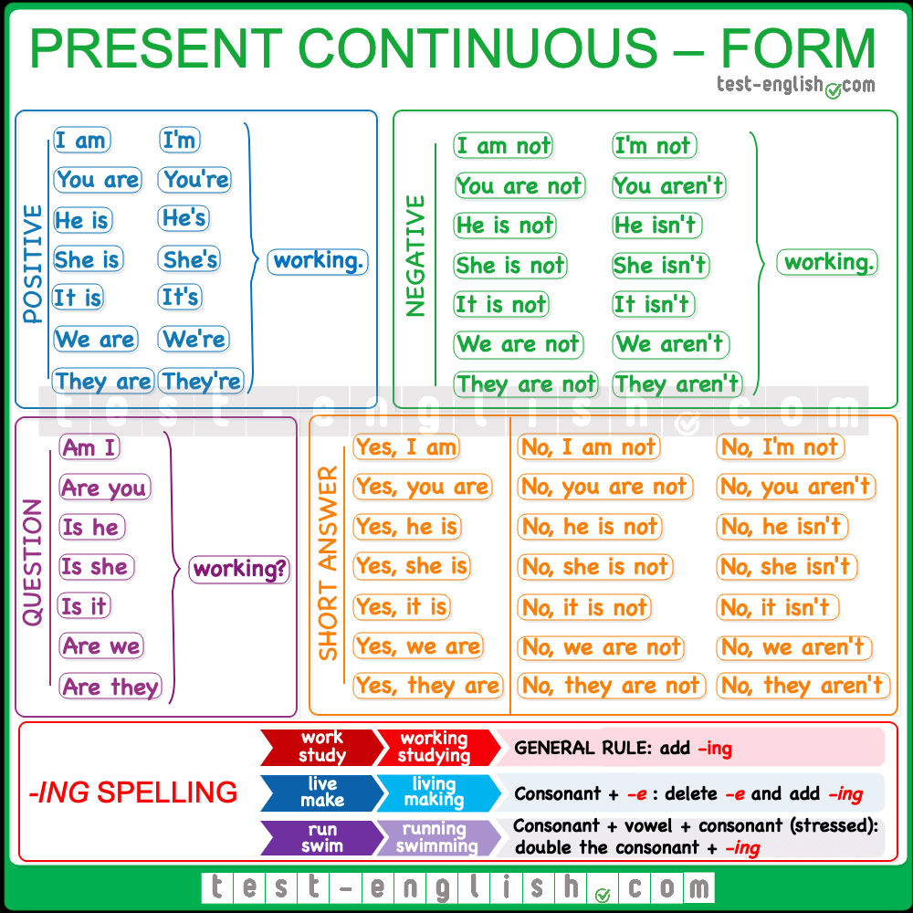

|  |
| --- |
| **Level: beginner**  We use the present progressive tense:  **1.** When somebody is doing something **at this moment.**   * Sarah **is changing** her clothes right now. * Her boyfriend **is waiting** for her. * We **are learning** the progressive tense in English.   **2.** When something**is happening at this moment**. When the action has started but hasn't finished.  It is snowing at the moment.   * The economy is growing at an exponential rate. * The children are sleeping so please be quiet.   **3.** To talk about something that is happening **around the time of speaking** but not necessarily at that exact moment.   * + Alfredo is studying a lot for his exam.   + I'm reading a great book. (Not necessary right at this moment)   + We are planning a trip to Jamaica.   **4. future plans or arrangements:** Mary **is going** to a new school **next term**. What **are** you **doing** **next week**? |
| Stative verbs We do**not** normally use the continuous **with stative verbs**. Stative verbs include:   * verbs of **thinking and feeling**:  |  |  |  |  | | --- | --- | --- | --- | | *believe dislike know like* | *love hate prefer realise* | *recognise remember suppose think*(= believe) | *understand want wish* |  * verbs of the **senses**:  |  |  |  |  | | --- | --- | --- | --- | | appear feel | look seem | smell sound | taste |  * others:  |  |  |  |  | | --- | --- | --- | --- | | agree be | belong disagree | need owe | own possess |   We normally **use the simple  present** instead:  I understand you. (NOT I ~~am understanding~~ you.) This cake tastes wonderful. (NOT This cake ~~is tasting~~ wonderful.) |
| **Level: intermediate**  We also use the present continuous to talk about:   * something which is happening **before** **and** **after** **a specific time**:   *At eight o'clock we****are****usually****having****breakfast. When I get home the children****are doing****their homework.*   * something which**we think is temporary**:   *Michael is at university. He****'s studying****history. I****'m working****in London for the next two weeks.*   * something which is **new** and **contrasts** with a previous state:   *These days most people****are using****email instead of writing letters. What sort of clothes****are****teenagers****wearing****nowadays? What sort of music****are****they****listening****to?*   * something which is **changing, growing or developing**:   *The children****are growing up****quickly. The climate****is changing****rapidly. Your English****is improving****.*   * something which happens **again and again ( or to express annoyance)**:   It**'s always raining** in London. They **are always arguing**. George is great. He**'s always laughing**.  Note that we normally use ***always***with this use. |
| **Level: advanced**  We can use the present continuous to talk about the [past](https://learnenglish.britishcouncil.org/english-grammar-reference/talking-about-the-future) when we are:   * **telling a story**:   The other day I**'m**just**walking** down the street when suddenly this man comes up to me and asks me to lend him some money. Well, he**'s carrying** a big stick and he looks a bit dangerous, so I**'m wondering** what to do …   * **summarising** a book, film or play:   Harry Potter is a pupil at Hogwarts school. One day when he**is playing** Quidditch he sees a strange object in the sky. He wonders what **is happening** … |

PRACTISE YOUR PRESENT CONTINUOUS HERE: <https://www.liveworksheets.com/kl43870lq>

<https://www.liveworksheets.com/worksheets/en/English_as_a_Second_Language_(ESL)/Present_continuous/PRESENT_CONTINUOUS_(01)_or1434on>

<https://www.liveworksheets.com/worksheets/en/English_as_a_Second_Language_(ESL)/Present_Continuous/Present_Continuous_-_Video_ig26997lo>

<https://www.liveworksheets.com/worksheets/en/English_as_a_Second_Language_(ESL)/Present_continuous/Present_Continuous_ic481867ji>

<https://www.liveworksheets.com/c?a=a&l=sg&i=xods&r=xp>