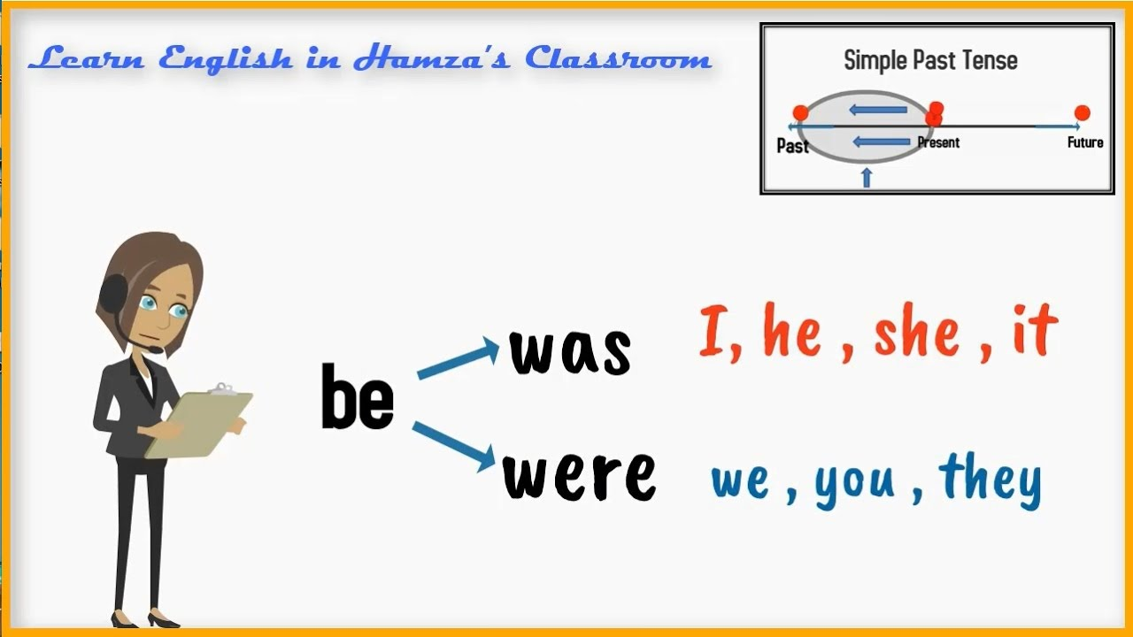

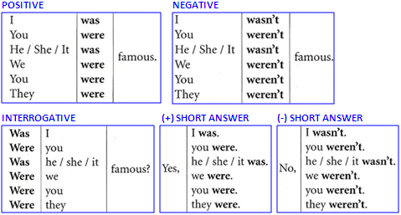

**EXERCISES**

**A. Complete with the correct form of was/were.**

1. I ____________ at your birthday party last year.

2. We ______________ angry with you last night.

3. They ______________ embarrassed with the football score.

4. His parents ___________ a little worries because of the virus.

5. The weather ______________cold and cloudy.

6. You _________________ late for work yesterday.

7. She ________________ in London in 2015.

8. ____________________ (you) happy with our new car?

9. ___________________ (he) scared with the horror movie?

10. She ________________ (not) angry. She ___________ just tired.

11. There ________________ (not) any doughnuts left.

**B. Write the sentences in the past. Use relevant time references.**

1. He is a writer. _____________________________________________

2. The people are in the restaurant. _________________________________

3. She is in the cafeteria. ________________________________________

4. The teacher is nervous today. ___________________________________

5. John and Mary are married. _____________________________________

**C. Write the sentences in the interrogative.**

1. He was here last night. ____________________________________________________________

2. They were in the restaurant. ___________________________________________________

3. Robert was in prison last year. _________________________________________________________

4. My classmates were in the Computer Lab. ______________________________________________

5. The boys were at the cinema last Saturday. _____________________________________________

**D. Write the sentences in the negative form.**

1. His mobile phone was in the living room.

____________________________________________________________

2. My friends were happy with the results.

____________________________________________________________

3. Her car was cheaper than mine.

____________________________________________________________

4. There were some dishes left on the kitchen table.

____________________________________________________________

5. I was happy with the news.

____________________________________________________________