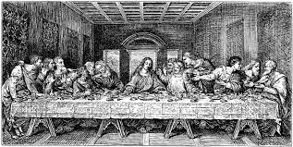  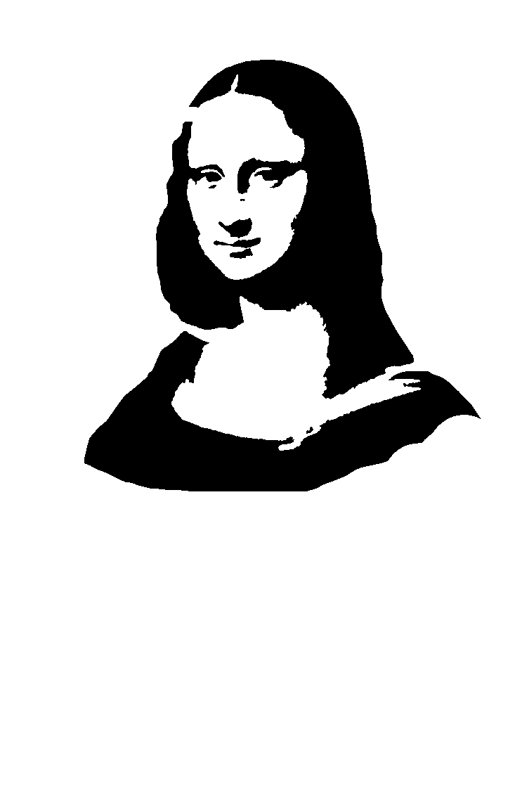  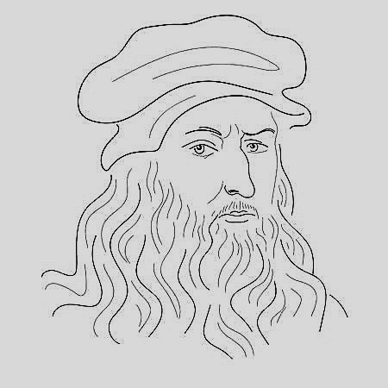 | Leonardo Da Vinci  Leonardo Da Vinci was from a small town called Vinci, near the city of Florence. His father was a very rich and important man. When Da Vinci was 16 years old, he was a dedicated art student. After years of study he was able to paint, draw, make sculptures and play music very well. His most famous paintings are the “Mona Lisa” and “The Last Supper”. The Last Supper was painted on a wall.  But he wasn’t just a painter, a sculptor and musician. He was also an architect, an engineer and an inventor. He could draw flying machines, submarines and mechanical devices. His pictures were usually complex and full of details.  He was good at many other subjects like Anatomy, Biology, Math and Physics. He also studied Meteorology and Geology.  Leonardo was a very intelligent and fascinating man but his inventions were too modern for his time.
A. Complete with was/were or wasn’t/weren’t according to the text.  e.g. Da Vinci was from a small town called Vinci.  1. The airplane _____________ one of Da Vinci’s inventions.  2. His parents _____________ important people.  3. Da Vinci ___________ a doctor.  4. The ‘Mona Lisa’ ____________ an old woman.  5. ______________ he a creative person? Yes, he _________.  6. Da Vinci’s paintings _____________famous.  7. The young Da Vinci ________________ a dedicated student.  8. His inventions ___________ strange.  9. “The Last Supper” _____________ painted on a wall. | B. Are the following True or False?  ____1. Da Vinci was a good musician.  ____2. His pictures were simple.  ____3. Da Vinci was a creative man.  ____4. He painted “the Last Supper”.  ____5. Da Vinci was the inventor of the airplane.  ____6. Da Vinci was the son of a rich man.  ____7. Da Vinci was from a big city.  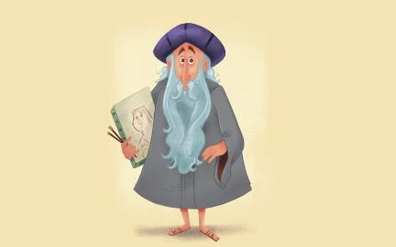  ____8. The ‘Mona Lisa” was painted by him.

