**1st Evening Vocational High School of Trikala**

**School Year 2020-2021**

**The job of Administrative Assistant (Office Assistant)**

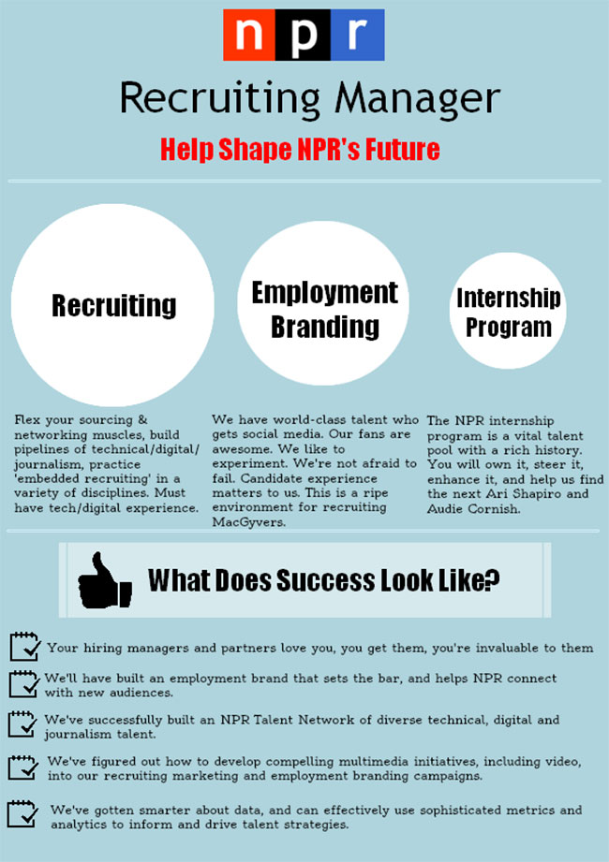

A. - Where do companies advertise jobs?

- How do you search for candidate employees as a company?

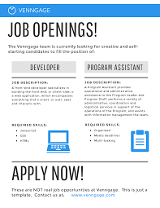

**LinkedIn**

**Your website**

**B.**

**External websites**

**Newsletters**

**Industry Blogs**

**Your own reject pile**

**Ask your team**

**LinkedIn**

**Social Media, paid or unpaid**

**Job referrals**

**Job centers**

**Ask your customers**

**Recruiters**

**Local Press**

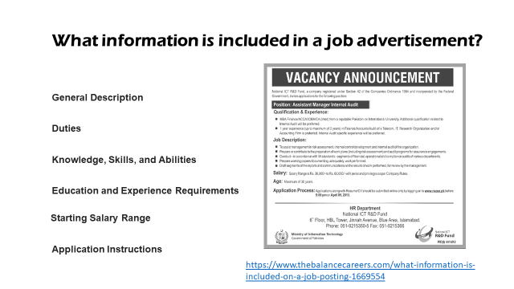

Job Reference Number: RY08/364

Administrative Assistant

C. Here is a job advertisement. It comes from an online recruitment site.

30 **K p.a**. plus 25 days vacation and pension plan.

42 hours per week **approx.** Starting **ASAP**.

This is a great opportunity to join a busy and established business. Our client is a large manufacturing firm based in southwest Chicago, who is looking for an **admin.** assistant to help in the running of its busy office.

**Duties will include:**

* Answering the telephone, transferring calls and taking messages
* Managing stock and stationery
* Filing documents and maintaining the filing system
* Audio/copy typing
* Making travel and accommodation arrangements
* Arranging meetings and diary management

**Essential:**

* A typing speed of at least 50 **wpm**
* Ability to work to deadlines
* Good **IT** skills **esp.** in word processing and spreadsheets

**Desirable:**

* 1 **yrs** admin experience desirable
* **Exp.** in taking meeting minutes and dictation

We are looking for a good communicator with excellent **attention to detail**, a positive attitude and an organized approach. The candidate should have the ability to work both in a team and on his/her own **initiative**. Experience within manufacturing environment would be **beneficial** to your application.

To apply, please email your CV and a **cover letter** to Helen Walker at S.T. Recruitment.

**1. What information do you get from this ad?**

* J_ _ T_ _ _ _ (*Administrative Assistant)*
* S_ _ _ _ _ *(30 K p.a.)*
* H_ _ _ _ p_ _ w_ _ _ *(42)*
* B_ _ _ _ _ _ _ *(25 days vacation and pension plan)*
* L_ _ _ _ _ _ _  *(southwest Chicago)*
* A_ _ _ _ _ _ _ _ _ _ P_ _ _ _ _ _ _ _ *(email your CV and a cover letter**to ….)*

**2. What do these abbreviations stand for**?

K – p.a. – esp. – exp. – yrs – IT – wpm – approx. - ASAP - admin