 **1st Evening Vocational High School of Trikala**

**School Year 2020 – 2021**

**Economy and Administration**

“**Prepare for your job interview”**

Preparing for an interview might seem intimidating, but there are several steps you can take to prepare yourself for a successful interview and secure a job offer.

Here's how to **research the job and company**, how to **practice interview questions and answers**, how to **dress for the interview** and more interview preparation tips.

**01** [**Analyze the Job**](https://www.thebalancecareers.com/job-listing-guidelines-2061395)

Consider what the company is seeking in a candidate. Make a list of the skills, knowledge, and professional or personal qualities required by the employer and critical for success in the job.

**02** [**Make a Match**](https://www.thebalancecareers.com/how-to-match-your-qualifications-to-a-job-2060941)

Make a list of your assets and match them to the job requirements (i.e. skills, qualities, certifications, experiences, professional qualifications, abilities, computer skills). You can bring up some of these assets to explain why you are a great fit for the job.

Think of past work experiences that show you have these qualities and be ready to describe a time when you demonstrated a particular skill or ability.

**03** [**Research the Company**](https://www.thebalancecareers.com/tips-for-researching-companies-before-job-interviews-2061319)

Find out as much as you can about not only the job, but also the company, to help yourself prepare to answer questions about the company and to ask the interviewer questions about the company. You will also be able to find out whether the company and the company culture are a good fit for you.

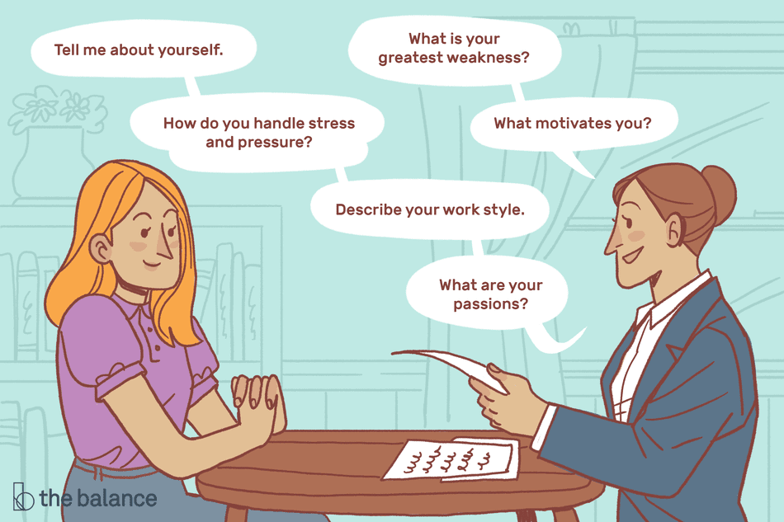Check out the company website, specifically the “About Us” page. Read articles about the company and check out company reviews from clients and current or former employees.

**04** [**Practice Interviewing**](https://www.thebalancecareers.com/practice-interview-tips-and-techniques-2062805)

Practice answering possible interview

questions. Review common job interview

questions and answers and think

about how you will respond.

**05** [**Get Your Interview Clothes Ready**](https://www.thebalancecareers.com/how-to-dress-for-an-interview-2061163)

The first impression should be a great one. When dressing for an interview for a professional position, dress accordingly in business attire. If you're applying for a job in a more casual environment, it's still important to be neat, tidy, and well-groomed, and to present a positive image to the employer.

**06** [**What to Bring to a Job Interview**](https://www.thebalancecareers.com/what-to-bring-to-a-job-interview-2061309)

It's important to know what to bring (and what not to bring) to a job interview. Items to bring include a portfolio with extra copies of your resume, a list of references, a list of questions to ask the interviewer, and something to write with.

Do not bring your cellphone (or at least turn your phone off), a cup of coffee, gum, or anything else beyond yourself and your credentials.

**07** [**Practice Interview Etiquette**](https://www.thebalancecareers.com/body-language-tips-for-your-next-job-interview-2060576)

Proper interview etiquette is important. Remember to greet the receptionist, your interviewer, and everyone else you meet politely, pleasantly, and enthusiastically.

During the interview, watch your body language; shake hands firmly and make eye contact as you articulate your points. Pay attention, be attentive, and look interested.

The more positive an impression you make, the better you'll do during the job interview.

**08 Get Directions**

It's important to know where you need to go for your job interview – ahead of time. That way, you'll avoid running late to the interview. Get directions, find the best route and check on parking, if it's an issue.

**09** [**Listen and Ask Questions**](https://www.thebalancecareers.com/types-of-listening-skills-with-examples-2063759)

During a job interview, listening is just as important as answering questions. Listen to the interviewer, pay attention, and take time to compose an appropriate answer. It's also important to discuss your qualifications in a way that will impress the interviewer.

Also, be ready to engage the interviewer. You want there to be a ‘give and take’ in the conversation.   Have questions of your own ready to ask the interviewer in order to build a kind or relationship with him or her.

Towards the end of the interview, let the recruiter know that you believe the job is an excellent fit and that you are highly interested.

You'll know if the interview went well if it runs longer than 30 minutes, you discuss salary, or you get an invitation for a second interview.

**modified from**:

[**https://www.thebalancecareers.com/how-to-prepare-for-a-job-interview-2061361**](https://www.thebalancecareers.com/how-to-prepare-for-a-job-interview-2061361)

**Find out more about “Job Interview Questions, Answers, and Tips to Prepare”on:**

[**https://www.thebalancecareers.com/job-interview-questions-and-answers-2061204**](https://www.thebalancecareers.com/job-interview-questions-and-answers-2061204)

**Job Interview Questions**

* What circumstance brings you here today?
* How would your best friend describe you?
* What are your strengths? -  What are your weaknesses?
* Why should we hire you?
* What can you do for us that other candidates can't?
* What are your goals?
* Where do you see yourself in five years?
* Why do you want to work here?
* What salary are you seeking?
* How do you alleviate stress?
* What is your typical way of dealing with conflict?
* What strategies would you use to motivate your team?
* What tools or habits do you use to keep organized?
* What was a major obstacle you were able to overcome in the past year?
* Tell me about two memorable projects, one success and one failure. To what do you attribute the success and failure?
* What did you like or dislike about your previous job?
* How do you handle failure?
* How do you handle success?
* Do you consider yourself successful? Why?
* Describe your work ethic.
* Describe your work style.
* Do you work well with other people?
* Do you take work home with you?
* How well do you assimilate into a new environment?
* How would you adjust to working for a new company?
* How would you describe the pace at which you work?
* What motivates you?
* Are you a self-motivator?
* What do you find are the most difficult decisions to make?