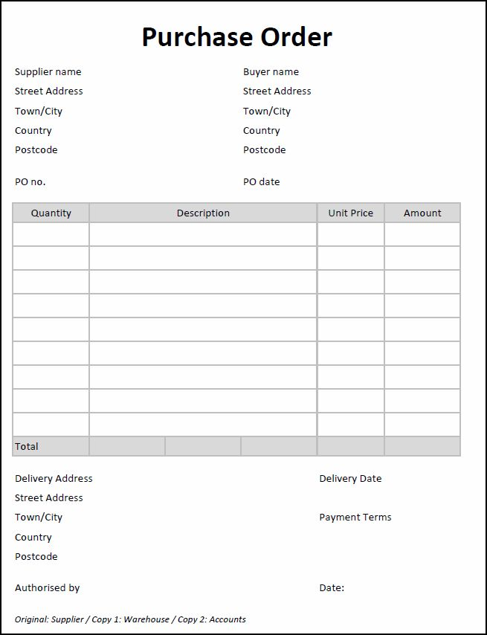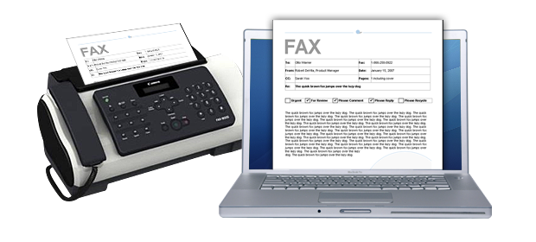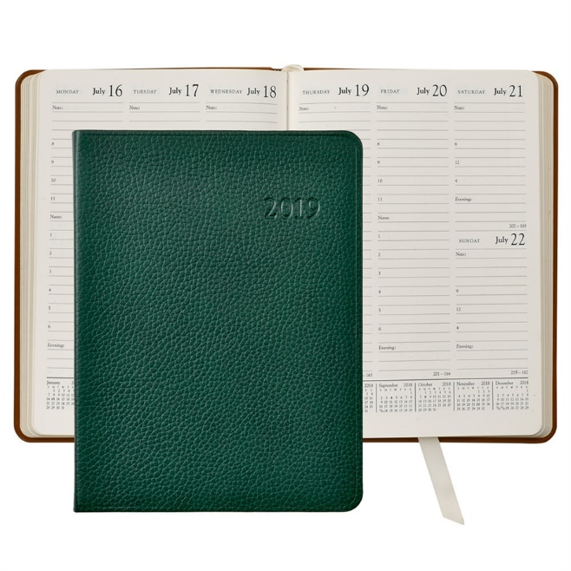**Office documents**

**fax**

**order form**

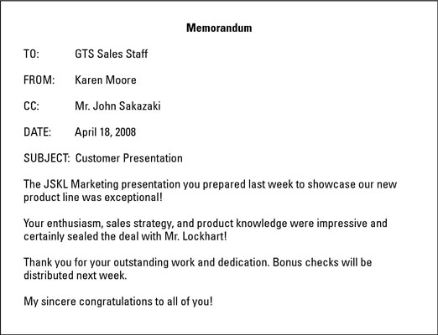

**receipts**

**diary**



**memo**

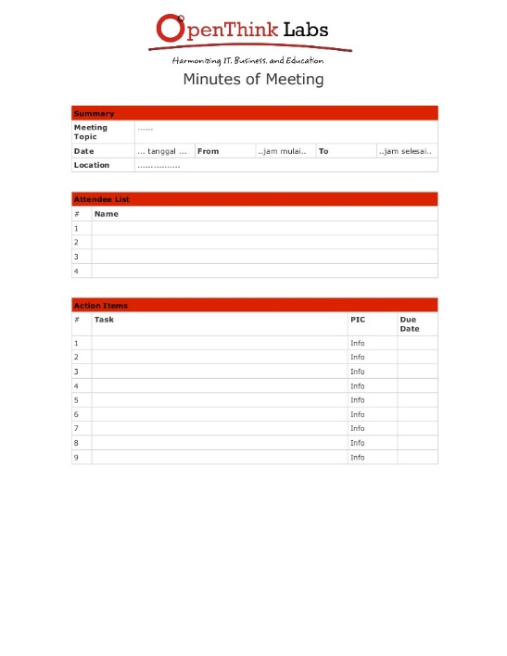

**minutes**

**LegalJobsRUs.com**

**Company: KLS Law Firm**

**Do you want a great job? Here we come with a great offer. We are looking for a secretary with great communicational and computer skills. We need a good employee who can:**

|  |  |
| --- | --- |
| * **prepare legal documents** * **send faxes** * **send out memos** * **write excellent business letters** * **fill out many forms, including order forms for office supplies** | * **keep track of receipts and payments** * **answer queries on the phone** * **maintain filing systems** * **take minutes** * **manage diaries and make appointments** |

**Answering the phone and greeting clients is also important. We would like someone who is friendly and energetic. Interested?**

**Please contact us at** [**klc.office@yourbestlawyer.com**](mailto:klc.office@yourbestlawyer.com)

**Reading activities:**

**1. Read the above job advertisement from a website and mark the following statements as True (T) or False (F).**

a. _____ The law firm has a position available for a lawyer.

b. _____ The law firm needs someone to save and organise receipts.

c. _____ The person who gets the job will be responsible for ordering supplies.

**2. Fill in the blanks with the correct words and phrases from the word bank below:**



**order form – fill out – keep track of – fax – prepare – documents**

**a.** It’s essential to _____________________ important documents so you don’t lose them.

**b.** It is easier and faster to _______________ documents than mail them.

**c.** Complete the ________________ for new office supplies.

**d.** _______________ this form with your name and address.

**e.** Please __________________ this letter for Mr. Bates and put it on his desk.

**f.** Sign these ______________________ documents so I can send them.

**3. Place a check mark (****) next to the correct response:**

1. Can you send out an email about the meeting tomorrow?

A ______ Yes, I just need to turn on my computer.

B ______ Sure, the phone is right there.

**2.**  Can you give me a receipt?

A ______ I’ll take two, please.

B ______ Yes, let me print it out.

**3.** Please type up a business letter for me.

A ______ I’ll read it right away.

B ______ Who shall I address it to?