**1st Evening Vocational High School of Trikala**

**School Year 2020 – 2021**

**Economy and Administration**

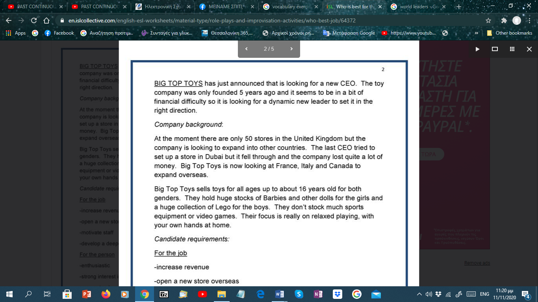

1. What is a CEO?

……………………………………………

2. What is the meaning of the word ‘founded’?

…………………………………………

3. Explain ‘set it in the right direction’?

…………………………………………

4. How can you expand a company?

……………………………………………

5. Give a synonym for ‘set up’.

……………………………………………

6. What is to ‘fall through’ as a company?

……………………………………………

7. What are the ‘candidate requirements’?

……………………………………………

8. Find a word in the requirements which means ‘income’.

……………………………………………

9. What do we mean by ‘track record’?

……………………………………………

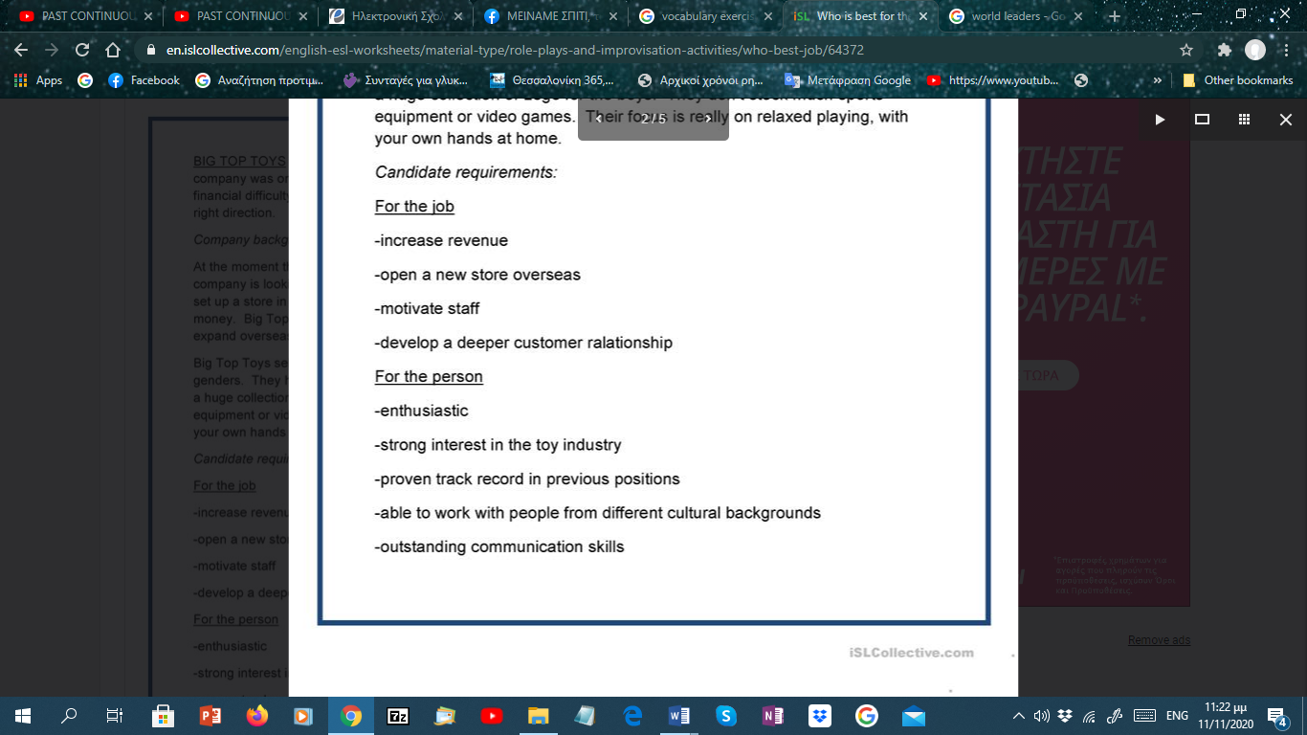

You are going to interview people for the next top position at Big Top Toys. There are 4 candidates who have made it through to the final round of interviews.

You need to review each curriculum vitae (resume) and draw up a list of pros and cons for each one and then decide who will become the future leader of the company.

|  |  |  |
| --- | --- | --- |
|  | PROS | CONS |
| Glenn Roberts |  |  |
| Rachel Rogers |  |  |
| Donald McKenzie |  |  |
| Gabriella Cassano |  |  |

