**1st Evening Vocational High School of Trikala**

**School Year 2020 – 2021**

**Economy and Administration**

**A. Discuss about the following in class before reading the paragraph below:**

* What is a CV / résumé?
* 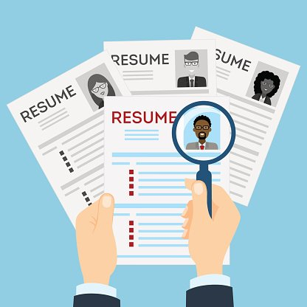What information is in a résumé? What parts does a résumé have?
* Do you have a résumé? Who needs a résumé?
* Why is a résumé important?
* How have résumés changed with technology?
* What makes a “good” résumé?
* How long does an employer typically look at a résumé?

**B. Now read the following and check your answers:**

A résumé is a document that summarizes your skills, experience, and educational

background. Employers look at résumés to find qualified employees. EVERYBODY who wants a job needs a résumé! A résumé is like an “advertisement” that sells you to an employer. It is almost always the first step to getting an interview. Today, résumés must be created with word processing software. Many employers now only accept résumés submitted through e-mail or the web. A good résumé should tell YOUR story. It should demonstrate professional growth and development. A good résumé needs to be thorough yet concise. Why concise? See the next question: How long do you think an employer typically looks at a resume? Well, the answer is “less than 1 minute”! You must make a good first impression. Even the tiniest mistake can mean the difference between an interview or not!

|  |
| --- |
| Σχετική εικόνα**ANATOMY OF A RÉSUMÉ**  A résumé usually has these 5 Sections:  1. Contact Information  2. Professional Summary/Objective/Career Profile  3. Employment History  4. Educational Background  5. Other Skills, Non-Work Experience, and References  **[ [FIRST NAME] [LAST-NAME]**  **[Permanent Address]**  **[Phone number]**  **[E-mail]** |

**SECTION 1: Contact Information**

Things to consider:

• Name should be written in a large bold font

• Use a permanent address that can reliably receive mail.

**INAPPROPRIATE**

crazyhorse240@yahoo.com

• Use an appropriate personal e-mail address.

**APPROPRIATE**

agnes.alderman@gmail.com

**SECTION 2: Professional Summary**

A professional summary has these features:

• about 3~4 sentences

• written in the third-person without “I” or “[your name]”

• uses adjectives, verbs, and other focused keywords that “match” qualifications for the position.

• describes the scope of roles, responsibilities, achievements, career highlights

example **CAREER PROFILE**

* Caring, compassionate Registered Nurse with seven years experience in private practice, hospital, and hospice environments
* Experienced Charge Nurse for cardiac and oncology floors for major teaching hospital
* Strong analytical skills, capable of assessing conditions and implementing appropriate intervention
* Effective trainer and educator for both peers and patients

example **PROFESSIONAL SUMMARY**

Experienced, resourceful and effective retail manager of boutique management, with expert ability in combining innovative display techniques with visual standards and sales strategies in order to achieve optimal retail success. Top-selling sales associate who regularly exceeds client expectations by building quality relationships.



**SECTION 3: Work History**

**Chronological Format**

• List work in reverse chronological order (most recent job first)

• Include measureable accomplishments

• Good for people with steady work history

WORK HISTORY:

Previous/Current Employer Names

Dates worked (optional)

Locations

Job Titles

Responsibilities, skills gained, achievements

**Functional Format**

• Showcases skills and accomplishments first and lists your employers second

• Omits the exact dates worked (divide employers into present and past)

• This format works well for people who have gaps in the work history, older applicants who don’t want to reveal their age, people who have held lots of jobs in a short amount of time, and younger workers who do not have extensive experience.



**CONSIDER the following**:

• How long since graduation?

• Which degrees should you mention?

• Where should you place this section in your resume?

**SECTION 4: Educational Background**

EDUCATION:

School Name, Location

Degree Earned, Graduation Date

Honors, Accomplishments, Relevant Coursework (optional)



**SECTION 5: Other Skills, Non-Work Experience, References**

**AVOID or “Don’t Do This!”**

• Lies

• Multiple fonts

• Pictures

• Overly personal information

• Salary

• Misspellings and other typos

**Other Skills**

• Languages (level of fluency)

• Computer and other technical skills

(typing speed, Microsoft Office, Operating Systems,

industry-specific software, computer languages)

• Professional associations

**Non-Work Experience**

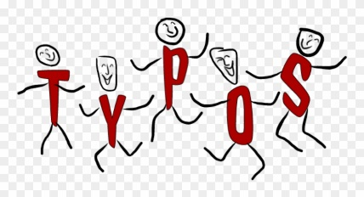• Volunteer service

• Way to demonstrate skills not listed in work experience

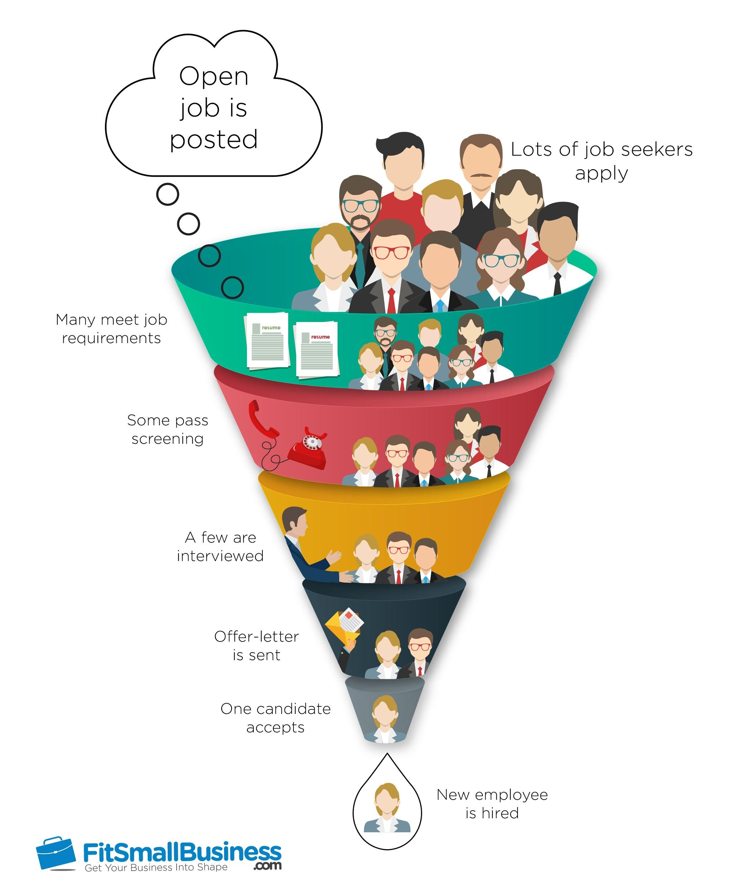

Many meet job requirements

Some pass screening

A few are interviewed

Offer-letter is sent

One candidate accepts

New employee is hired