
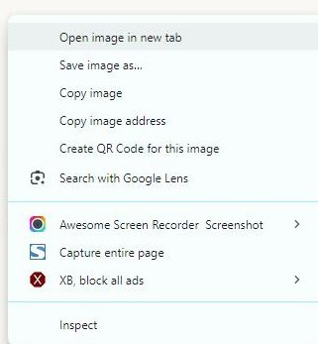

Open a browser Search for an image Copy the
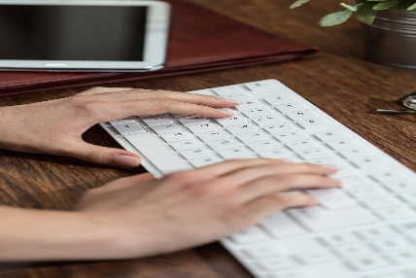
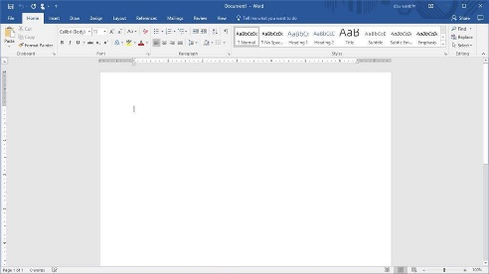
Image
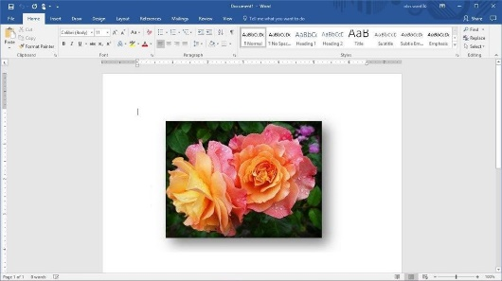

Create a Paste the image Type your
Word document name


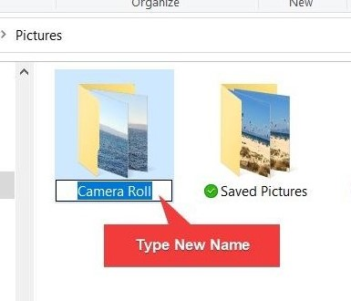
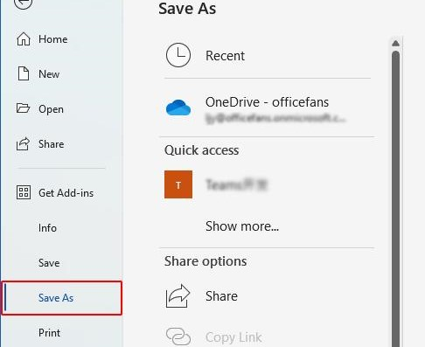

Save the file Delete Rename

Using a computer -Basic steps


- What do you see? _________________________
How often do you use a computer? _________________________

- Vocabulary
Watch and do what your teacher asks you to do.

- Matching
https://learningapps.org/watch?v=pk5bnksht26

- Read the text and underline the words/phrases:
— Alex: Did you finish the assignment for the ICT?
— Chris: Not really… I started by trying to paste the image, but then I realized I didn’t even have one!
— Alex: 😂 That’s because you forgot to search for an image first!
— Chris: I know, I know… so then I had to open a browser and find something.
— Alex: And after that you copy the image, right?
— Chris: Yes, but then I accidentally deleted it and had to do everything again…
— Alex: Wow, that’s messy. Did you at least create a Word document?
— Chris: I did, but I forgot to save the file, so I almost lost everything.
— Alex: Classic mistake! And your name?
— Chris: Oh! I still need to type your name… I mean, my name 😅
— Alex: Don’t forget to rename the file properly before submitting.
— Chris: Yeah… this assignment is harder than I thought!
- paste the image
- search for an image
- open a browser
- copy the image
- delete
- create a Word document
- save the file
- type your name
- rename

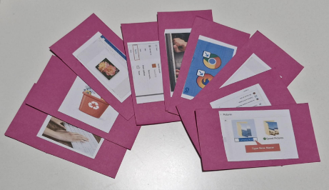
- Put the pictures in the correct order (group work)
Read the text and put the pictures in the correct order.

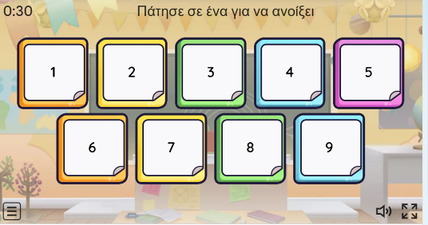
- Open the box
Choose a box, read the phrase and find the correct card.
https://wordwall.net/el/resource/111785196

- Giving orders
Ask one of your classmates to …….

- Say or write a phrase or word you learned.
___________________________________

