Quiz: What will they do?
Choose the correct answer.
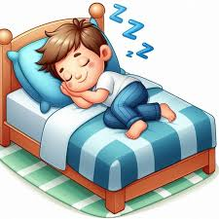

1. What will Tom do?
a. He sleeps.
b. He will sleep.
c. He slept.



2. What will your friends do at the weekend?
a. They will shop online.
b. They are shopping online.
c. They shop online.


3. What will Kelly do on Friday evening?
- She is listening to music.
- She will listen to music.
- She listened to music.



4. What will you do tomorrow?
- I will meeting my friends.
- I met my friends.
- I will meet my friends.


5. What will Nick do in his free time?
a. He plays computer games.
b. He played computer games.
c. He will play computer games.

