Name: __________________________________________
Date: ______________

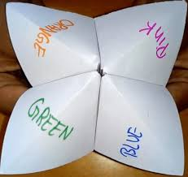
What will happen?
- Fortune teller
Choose a number.
Is this what you will do tomorrow?

- Video


- Questions:

- Which word do we use in all sentences? ___________
- Is it for the future, present or past? ___________
- Are we certain or do we predict? ___________
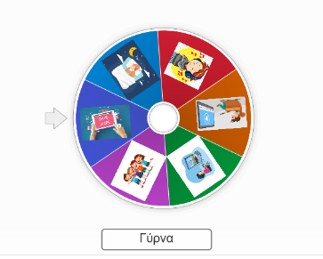
- Wordwall
https://wordwall.net/el/resource/103513447
Spin the wheel and make a sentence about what you will do tomorrow.
Write down your sentence or say it to the class.
___________________________________________________________________

- Let’s play Kahoot
https://kahoot.it/
Pin number 08177762
Write a nickname.

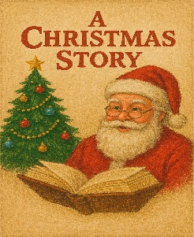
- Our Christmas story
Group work.
Choose 3 pictures to create a story about your Christmas Holidays with a title “Our Christmas story”.
Write one sentence for each picture.
Glue the sentences and the pictures on cardboard to create your story.

- Let’s revise! Write it or say it.
Which word do we use for predictions?
_____________________________________________________
Is will for the future?
_____________________________________________________
Are we certain or do we predict?
_____________________________________________________


- Homework
“Future Survey at Home”
Make a mini survey at home or at your neighbourhood and ask two people: “What will you do tomorrow?”
Option 1: Write the answers.
Examples:
My friend will …
Maria will …
My mum will …
My dad will …

Option 2: Draw the answers or bring pictures and present the answers orally.

