**ENGLISH**

**for**

**C΄ CLASS**

LEVEL B1+

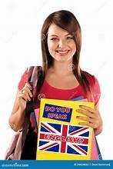

**Cosmas Markis (EFL Teacher)**

**3rd Junior High School of Preveza**

CONTENTS

UNIT 1: GREEN ISSUES……………..…………p.1-11

UNIT 2: IT’S A HIGH TECH WORLD……..… p.12-24

UNIT 3: MONEY & SHOPPING……………..…. p.25-33

UNIT 4: ENTERTAINMENT & THE ARTS ……..p.34-45

UNIT 1: GREEN ISSUES

Let’s Learn: ENVIRONMENTAL PROBLEMS

**Write the problem under the picture**

**global warming water pollution water depletion waste/rubbish**

**deforestation air pollution animal extinction natural recourses depletion**

1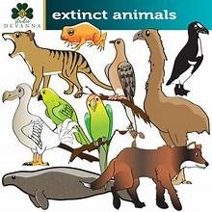 2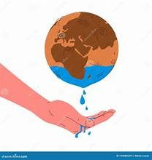 3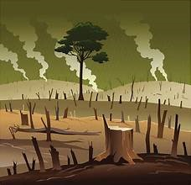 4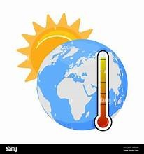

…………………………………………….. …………………………………. ………………………….………….. ……………………………….…………………

5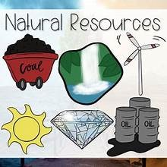 6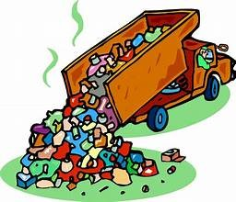 7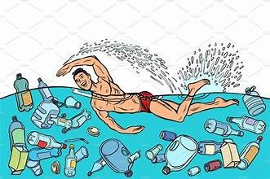 8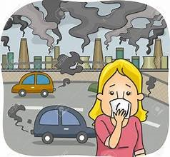

……………………………………….. ………………………………..….. ……………………….……………………… ………………………….……………

**Match 1-8 with a-h. Say which problem they are about.**

1. The ozone layer has been destroyed in many parts of the world. As a result …

2. Factories dispose of their waste into lakes and rivers. Therefore …

3. Underwater reserves are gradually being drained because of the rise in temperature. For this reason…

4. Take unwanted things, such as old newspapers, glass bottles and tins to recycling bins. In this way…

5. Lots of forests and rainforests, which are life giving sources, are burnt or cut by man for profit. Therefore…

6. There are long queues of cars, heavy traffic and traffic jams in big cities. Consequently…

7. Fossil fuels like gas, coal and petrol are running out. So…

8. Several species are in danger of extinction because of poaching and climate change. As a result…

a …people suffer from breathing problems and lung diseases.

b …there are destructive floods with many casualties, the temperature is rising and people suffer from heatwaves.

c … biodiversity is lost.

d … the whole planet will soon suffer from water shortages.

e ….the temperature is rising and the sun has become dangerous for skin cancers.

f …we help conserve energy resources, consume less energy and reduce pollution.

g …most of our planets fresh water is being contaminated and cannot be drunk.

h … we need to turn to alternative resources, such as solar or wind power.

**Fill in with the correct word.**

**preserve / conserve / maintain**

1. We must ………………………………… energy sources for future generations.

2. Museums use special chemicals to ………………………………… old paintings and statues.

3. The two countries need to …………………………… a friendly relationship despite their differences.

**waste / rubbish / litter**

1. Campers should never leave ……………………………. such as paper plates and cans in the forest.

2. Nuclear ………………………………….. should be dealt with carefully. Otherwise, it can be dangerous.

3. Please, take out the …………………………………… on your way to work because the bin is full.

**gas / fumes / fuel**

1. Some airpanes carry just enough ………………………………………. to reach their destination.

2. Heavy traffic and exhaust …………………………………. from cars cause breathing problems to city dwellers.

3. Oxygen is the ………………………………. That enables humans and animals to stay alive. **1**

Let’s Read: Extinct and Endangered Animals

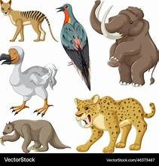There are no more dinosaurs living on the Earth. They are **extinct**, which means there is no longer a certain kind of plant or animal living anywhere in the world. A **species** is a certain group of living organisms, like dinosaurs, humans, birds, and many others. Scientists believe many organisms, along with the dinosaurs, died out when a large asteroid collided with the Earth and caused a **mass extinction**, which occurred at a faster rate over a very short time-period.

There are usually two reasons for the extinction of animals and other living things. The first is **natural extinction**, which may take place when animals do not adapt to natural changes in their environment. For example, if the habitat of a bird suddenly changes, and if the bird does not adapt, it could become extinct.

Examples of natural extinction may take place during a change in the climate. This happened during the Ice Age when the temperature of the Earth was much lower. During a natural extinction, the species may be eliminated by new predators that move into their environment. The food needed to survive may no longer be available. Another example of this type of extinction was the wooly mammoth, a relative of the elephant, which died out 10,000 years ago due to climate change and the disappearance of its habitat.

The second reason for the extinction of animals is **human interaction**, which includes hunting and habitat destruction caused by people. An animal's environment may be destroyed by pollution or deforestation, such as the destruction of parts of a rainforest. Humans also **overhunt** for food or economic benefits, sometimes wiping out an entire species. In addition, the moving of non-native species into an area where they are not usually found may lead to the extinction of another species.

Examples include the Dodo bird that became extinct due to overhunting and other animals moving into its environment. The passenger pigeon died out due to the destruction of its habitat, as well as overhunting. There are many animals that have become extinct, but when animals are in danger of becoming extinct, yet still survive, they are called **endangered animals**.

Endangered means a plant or animal is at risk of becoming extinct. This occurs when the population of a certain animal is so low, that they are in danger of dying out forever and becoming extinct. The reasons for an animal to become endangered are mostly the same as for those that have become extinct. There are many animals in the world today that are on the endangered species list. Some are so in danger of becoming extinct, they can only be found in a zoo or animal reserve.

Some of the endangered animals in the world include the black rhino, found in Africa, where hunting has led to the decline of its population with fewer than 5,000 of them still surviving. The orangutan found in the country of Malaysia is a highly intelligent relative of the ape family, but it too has been endangered due to the loss of their habitat and overhunting. The blue whale is endangered and threatened by climate change, habitat loss, and poisonous substances in the water. Finally, other endangered species examples include the Bengal tiger, giant panda, mountain gorilla, sea lions, and others.

**https://www.softschools.com**

Τέλος φόρμας

**1. What is an example of mass extinction?**

**2. What are the two reasons animals become extinct?**

**3. When does natural extinction occur? Give examples.**

**4. How can human interaction cause animal extinction?**

**5. What is the difference between extinct and endangered animals?**

**6. Give some examples of endangered animals.**

**GROUP WORK: Use the questions to talk about endangered and extinct animals.**

**2**

# C:\Users\pc\AppData\Local\Packages\Microsoft.Windows.Photos_8wekyb3d8bbwe\TempState\ShareServiceTempFolder\th.jpegLet’s Write: Are Zoos Good or Bad for Animals?

***For many people, zoos are the only chance they’ll have in their entire lives to see beautiful animals native to far-flung ecosystems — lions, elephants, pandas, lemurs — the list goes on. And they’re popular — over***[***181 million people visit a U.S. zoo every year***](https://www.americanhumane.org/blog/zoos-wildlife-park-aquariums-touch-the-heart-of-millions/#:~:text=According%20to%20the%20Association%20of,zoos%20and%20aquariums%20each%20year.)***. But***[***zoos face criticism***](https://sentientmedia.org/zoos-cause-animals-far-more-harm-than-good/)***from animal welfare organizations and environmental activists for***[***inhumane treatment of the animals***](https://sentientmedia.org/zoo-animals-are-always-on-lockdown/)***they claim to protect. On the other hand, zoos claim that they are important for conservation and education.***

**Read the following statements and decide which of them are in favour and which are against keeping animals in zoos. Then expand the clues to make full sentences to support the arguments.**

**Animals Often Have Limited Space**

animal species / used to roaming, flying or swimming large distances / in the wild / lack of space / unnatural environments / crowded conditions [/ affect animal behavior](https://experiment.com/u/5YAFfg#:~:text=Stereotypies%20are%20a%20type%20of,et%20al.%2C%202007).)

**Zoos Can Be Important for Researchers**

Biologists and zoologists / benefit from studying animals in zoos / breakthroughs in animal behavior and treatment/ **educational /** learn p**eople to behave “eco-friendlier”**

**Animals Are Trapped in Unnatural Environments**

far from natural habitat / fences, glass or other barriers for visitors to look through / totally artificial.

**Zoos Can Help Educate Children About Animals**

Children learn about animals up-close in a safe environment / school presentations / guided tours / talks / [trigger lifelong love of animals](https://krex.k-state.edu/handle/2097/19110)

**Animals Are Often Mistreated In Zoos**

harmful training techniques / separation from family members / forced to behave in unnatural ways.

some caretakers hit animals who “misbehave,” / not help injured animals

**Animals Don’t Like Being Visited**

presence of humans / sounds and smells negatively affect wild animals

**Conservation: Zoos Can Protect Endangered Species from Extinction**

conservation programs involve [breeding more animals in captivity / then releasing them](https://wildwelfare.org/the-conservation-mission-of-zoos-nabila-aziz/) into the wild / especially important for endangered species like pandas.

**Zoos Don’t Always Help with Conservation** — **Some Wild Animals Are Caught And Brought to Zoos**

born in captivity /  [taken directly from the wild](https://www.onegreenplanet.org/animalsandnature/how-zoos-are-distorting-our-view-of-the-natural-world/) when they are babies

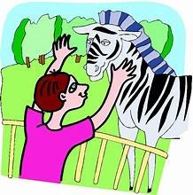***If you do choose to visit a zoo, opt for zoos that have certifications from animal welfare organizations. If you are interested in animal conservation, you’d better donate to a non-zoo animal protection organization instead. And if you do want to visit animals, consider an animal reserve or an ethical safari, where you can see animals in their native environments.***

**Do advantages outweigh disadvantages or is it a win-win situation?**

**Use the clues and the opening and closing paragraphs to write an essay with the title: Should wild animals be kept in zoos? (140-190 words)**

**3**

Let’s Read: DEFORESTATION

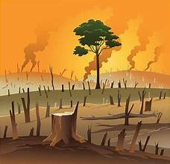

**Deforestation** is one of the most serious problems which threaten the planet. There are a number of reasons why people destroy the forests.

First, **logging** companies cut down trees and sell wood to make profit. Wood is used to heat our houses and make various things like paper and furniture. Also, due to overpopulation, forests are cut down to create more building space. So, buildings and roads appear out of nowhere on what used to be green areas. Even worse, more often than not, during summer fires break out on windy days, especially in tourist areas and resorts and burn down vast expanses of woody areas, where, later, **settlements** appear in no time. In addition, farmers clear the land to **grow crops**.

The effects of deforestation on the environment are destructive. If the rainforests -the **lungs** of the Earth- which produce most of the oxygen on the planet, are **wiped out**, we will have less oxygen, which means more pollution. In fact, global warming and the greenhouse effect are the most serious threat for the planet. Climate changes around the world, with extreme natural phenomena like floods and droughts, are **inevitable**. Moreover, many plant and animal species will become extinct. Flora and fauna will be seriously affected.

However, ‘when there is a will, there is a way’. If measures are taken, we can save our forests from destruction. First and foremost, governments should take immediate action. Those, who cut down trees illegally and do not **comply with the laws and regulations** concerning the protection of the environment, should not only pay strict fines, but also be punished severely. Furthermore, alternative sources of energy, like solar and wind power, should be encouraged. What is more, deforested areas ought to be replanted and citizens should be involved in it. For instance, they should get used to participating in planting expeditions in their areas. Last but not least, wildlife parks should be created and **funded** to protect endangered species.

**1. Take notes and talk about: the reasons of deforestation / the consequences / suggestions**

**2. Complete the summary**

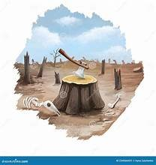The main reason of deforestation is **(1)……………………………..** Companies cut down trees to make **(2)……………………...**. Also, overpopulation demands building space so forests are **(3)……………………**. Even worse, more **(4)……………….……………**than not, during summer fires **(5) ……………………………….** and **(6) …………………….………** vast expanses of woody areas, where, later, **(7) ………..……….……………** or resorts appear in no time.

The rainforests are (8) …………………………. of the Earth and if they are **(9) ………………………….**, we will have less oxygen. **(10) ………………………………..** changes around the world, with extreme natural phenomena are **(11) ……………………………..**. As a result, many plant and animal species will become **(12) ………………….………..**. Flora and **(13) ………………..……..** will be seriously affected.

Governments should take immediate **(14) ……………………….**. There must be strict fines and severe punishment for those who do not **(15) ……………………………..** the laws and regulations concerning environment protection. Deforested areas must be **(16) ………………………….** and alternative **(17) ……………………………** of energy, like **(18) …….…………………** and wind power, should be encouraged. Finally, wildlife parks should be **(19) ………………………………..**to protect endangered species.

## Let’s Read: Water, Air and Soil Pollution

**Pollution** is an environmental concern for people throughout the world. Scientific studies suggest that **pollutants** in the water, air, and soil cause up to 40% of the premature deaths in the world's population. The majority of these deaths occur in **developing countries**.

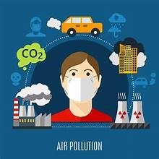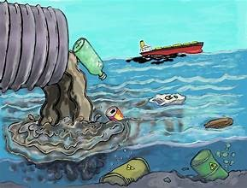Water in many developing countries is **contaminated** with **toxic chemicals**, also known as toxins. The World Health Organization (WHO) estimates that 1.1 billion people have little or no access to clean water. In many of these regions, the water that is used for drinking, cooking, and washing is the same water that is used for **dumping** **sewage** and **hazardous waste**. Most developing countries cannot afford water treatment facilities. Approximately 80% of infectious diseases in the world are caused by contaminated water.

Air pollution is a growing problem throughout the world, which also causes disease and illness, especially in **industrial** cities such as Beijing, China, where cancer is the leading cause of death. China relies heavily on coal, which is considered the dirtiest source of energy. According to the European Union, only 1% of urban dwellers in China breathe clean air on an average day. Neighbouring countries including Japan and Korea receive much of China's pollution in the form of **acid rain**. This pollution results mainly from the coal -powered factories, which produce inexpensive goods for North American and European consumers. Outdoor air pollution is also a concern in many wealthy countries. Those who live and work in urban centres such as Los Angeles or Toronto experience many warm days beneath a layer of **smog caused by car exhaust fumes and factory chimneys**.

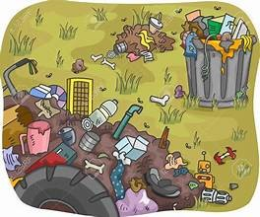 Soil pollution is also a major concern, both in industrial and developing countries. Pollutants such as metals and **pesticides** seep into the earth's soil and contaminate the food supply. Soil pollution causes major health risks to entire ecosystems. This type of pollution reduces the amount of land suitable for agricultural production and contributes to global food shortages. **Dumping** of industrial and **domestic** **waste** products produces much of the world's soil pollution, though natural disasters can also add to the problem. In wealthy countries such as the US, protection agencies monitor the food supply. The public is generally warned before major disease outbreaks occur. Developing countries do not have this luxury. Farmers in poor nations grow food in contaminated soil both to earn a living and to avoid **starvation**.

As more people move to urban centres, **premature deaths** caused by pollution are expected to increase worldwide. Today, the developed nations who achieved their wealth **at the expense of the environment** have to protect the earth's resources for future generations. <https://www.englishclub.com>

**Complete from the text to talk about water, air and soil pollution.**

1. In many developing countries, water is contaminated with ……………………………………………………..…………………..………..

2. In these regions, they use the same water for ………………………………………….………………………………………………………………

3. Most developing countries cannot afford ………………………………………………………………………………… and as a result ……………………………………………………………………………….………………………. by contaminated water.

4. Air pollution is another cause of ……………………………………………………………………………………………………………………………..

5. In industrial countries like China, which rely heavily on ……………………………….. ,only 1% of urban dwellers …………………………………………………………………………………. and cancer is ………………………………………………………… of death.

6. Industrial pollution often comes down on earth in the form of acid ………………………………………………..…………………… .

7. In urban centres , ……………………………………………… from cars and ……………………………………….. chimneys cause smog.

8. Pollutants such as metals and **pesticides** ……………………………………………………………………………………… the food supply.

9. Soil pollution contributes to global food shortages because it ………………………………………………………………………………..

10. **Dumping**………………………………………………..……………………………. is responsible for much of the world's soil pollution.

11. The developed nations who achieved their wealth **………………………………………………………………** must ……………………………………………………………………………………………………. . **5**

Let’s Practise: Passive Voice

1. Fill in the PASSIVE in the appropriate tense:1. (TV / invent / Baird) …….. TV was invented by Baird. ………………………………………………………………...  
2. (Pyramids / build / Egyptians) …………………………………………………………………………………………………….  
3. (milk / produce / cows) ……………………………………………………………………………..……………………………….  
4. (coffee / grow / in Brazil) ……………………………………………………………………………………………………………  
5. (chopsticks / use / in China) …………………………………………………………………………..……………………………  
6. (plants / water / every day) …………………………………………………………………………….…………………………..  
7. (the thief / arrest / yesterday) ……………………………………………..……………………………………………………..  
8. (the injured man / take to a hospital / now) ………………………………………………………………………………..  
9. (the car / repair / tomorrow) ………………………………………………………………………………….……………………  
10. (the letter / send / last week) …………………………………………………………………………………..…………………

2. Turn from ACTIVE into PASSIVE:1. The gardener has planted some trees.  
…. Some trees have been planted by the gardener..  
2. Doctor Brown will give you some advice.  
……………………………………………………………………………………………………………………….…………………………………  
3. A famous designer will redecorate the hotel.  
……………………………………………………………………………………….…………………….……………………………………………  
4. Steven Spielberg directed “E.T.”  
……………………………………………………………………………………………………………………………………………………………  
5. Someone has broken the crystal vase.  
……………………………………………………………………………………………………………………..……………………………………  
6. His parents have brought him up to be polite.  
…………………………………………………………………………………………………………………………….……………………………  
7. Fleming discovered penicillin.  
…………………………………………………………………………………………………………………..………………………………………  
8. They will advertise the product on television.  
………………………………………………………………………………………………………………….…………………………………………  
9. Someone is remaking that film.  
………………………………………………………………………………………………………………………………..……………………………  
10. Picasso painted that picture.  
………………………………………………………………………………………………………………………………………………………………

3. Using the PASSIVE, ask questions to which the bold type words are answers:1. Columbus discovered America. …….. Who was America discovered by………… ?  
2. We keep money in a safe. ……………………………………………………………………….……………………………………… ?  
3. A bee stung him. ………………………………………………………………………………………………………………………………?  
4. They speak Italian in Italy. ……………………………………………………………………..………………………………………… ?  
5. They have taken his aunt to hospital. ………………………………………………….……………………………………………?  
6. The boys damaged the television. ……………………………………………………………..…………………………………….. ?  
7. Da Vinci painted the Mona Lisa. ……………………………………………………………………………………………………….. ?  
8. He invited 30 people to his party. ……………………………………………………………..…………………………………….. ?  
9. They grow bananas in Africa. …………………………………………………………………………….…………………………….. ?

4. Turn from ACTIVE into PASSIVE:1. You must leave the bathroom tidy. …….. The bathroom must be left tidy. ………..  
2. You should water this plant daily. …………………………………………………………………………..…………………….. **6**  
3. Our neighbor ought to paint the garage. ………………………………………………………………………………………………….  
4. I have to return these books to the library. …………………………………………………………..…..………………………………  
5. You must dry-clean this shirt. …………………………………………………………………………………………..……………………….  
7. Someone will pay you in ten days. ………………………………………………………………………………..……………………………

8. You can improve your health with more exercise.………………………………………………..……………………………………..  
9. People must obey the law. ………………………………………………………………………………………………….……………………….  
  
**5. Turn from ACTIVE into PASSIVE:**1. Someone is helping her with the housework.  
…………………………………………………………………………………………………………………………………………………………………….………..  
2. A pickpocket robbed me.  
…………………………………………………………………………………………………………………………………………………..………………………….  
3. The mail-order company sent Mrs. Green a parcel.  
………………………………………………………………………………………………………………………………………………….…………………………….  
4. A dog is chasing the child.  
……………………………………………………………………………………………………………………………………………………..………………………….  
5. My friend sent me an invitation.  
…………………………………………………………………………………………………………………………………………………….…………………………….  
6. The farmer is building a new barn.  
……………………………………………………………………………………………………………………………………………….………………………………….  
7. The secretary has given Mrs. Jones some letters.  
…………………………………………………………………………………………………………………………………………………….…………………………….  
8. The traffic warden had already given him a ticket for illegal parking.  
……………………………………………………………………………………………………………………………………………….…………………………………….  
9. Someone had broken our door down.  
……………………………………………………………………………………………………………………………………………..………………………………………  
10. They chose him as the best actor of the year.  
……………………………………………………………………………………………………………………………………………………………………………..………

6. Turn form ACTIVE into PASSIVE as in the example:1. He gave me a present.  
a) I was given a present.b) A present was given to me.2. The waiter will bring us the bill.  
a) …………………………………………………………………………………………………………………………………..………………………………..  
b) …………………………………………………………………………………………………………………………….…………………………………….…  
3. The Queen presented him with a medal.  
a) ………………………………………………………………………………………………………………………………………………………………………  
b) ……………………………………………………………………………………………………………………………………………………………………….  
4. Her mother bought Mary some sweets.  
a) ………………………………………………………………………………………………………………………………………………………………………..  
b) ………………………………………………………………………………………………………………………………………………………………………..  
5. Bob has sold Ted a second-hand car.  
a) …………………………………………………………………………………………………………………………………………………………………………  
b) ………………………………………………………………………………………………………………………………………………………………………….  
6. Larry is going to send a letter to Tom.  
a) …………………………………………………………………………………………………………………………………………………………………………..  
b) ……………………………………………………………………………………………………………………………………………………………………………  
 **7**

7. Put the following sentences into the PASSIVE VOICE:1. Someone has already paid the electrician for his work.  
………………………………………………………………………………………………………………………………………………………………...  
2. They taught him French and gave him a dictionary.  
………………………………………………………………………………………………………………………………………………………………....  
3. When we first met, they had already offered me a job at the bank.  
…………………………………………………………………………………………………………………………………………………………………...  
4. A man requested the stranger to leave the meeting.  
……………………………………………………………………………………………………………………………………………………………………  
5. A young woman asked the rest of us to be there at eight o’clock.  
…………………………………………………………………………………………………………………………………………………………………..  
6. They had eaten all the dinner before they finished the conversation.  
…………………………………………………………………………………………………………………………………………………………………….  
7. Who wrote it?  
……………………………………………………………………………………………………………………………………………………………………..  
8. The author has written a special edition for children.  
…………………………………………………………………………………………………………………………………………………………………….  
9. Did the idea interest you?  
……………………………………………………………………………………………………………………………………………………………………  
10. Why didn’t they mend the roof before it fell in?  
…………………………………………………………………………………………………………………………………………………………………….  
11. The burglars had cut a huge hole in the steel door.  
……………………………………………………………………………………………………………………………………………………………………..  
12. The organizers will exhibit the paintings till the end of the month.  
………………………………………………………………………………………………………………………………………………………………………..  
13. When did they ring the church bells?  
………………………………………………………………………………………………………………………………………………………………………..  
14. Does listening to music disturb you?  
………………………………………………………………………………………………………………………………………………………………………….

8. Write the correct passive tense.

Hospitals are places where people ……………………………………. (examine) and ……………………………… (bring) back to good health. I’m lucky because I ………………… ……………….……………(never / take) to hospital but my sister …………………………… (hit) by a car last year. Luckily, no bones …………………………….…….. (break) but she ……………………………………… (examine) carefully and x-rays …………………………….……………… (take). She ………….……………….. (keep) there for a night and she ………………………………….. (give) permission to leave the next day.  
Ambulance services are also important. Patients …………………….………… (must / take) to hospital as quickly as possible. A lot of people ………………………………… (kill) in road accidents and a lot more ……………………………………. (injure) but if more ambulances …………………………………. (put) into service, more lives ……………..………………………..(can / save).

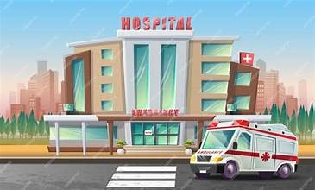 **8**

Let’s watch: Climate Change

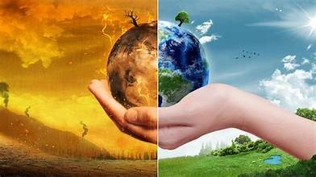

<https://www.youtube.com/watch?v=EuwMB1Dal-4>

**1. Watch the video. What are the effects of global warming? What can we do at home to contribute to solving the problem?**

**2. Watch again and complete the sentences.**

1.Climate change is a …………………………………….. issue and we must work together to save our world.

2. Our planet’s climate has changed throughout history alternating between …….……… ………….. and warmer periods.

3. The last ice age period ended nearly ………………………………………… years ago.

4. The effect of ……………………………… ……………….….. is known as global warming, and is caused by the increase of greenhouse emissions from human activity.

5. Human activities that are responsible for global warming are the burning of ………………………….. fuels, agriculture, deforestation and the decomposition of ………………………………….. in landfills.

6. Greenhouse gases act like a blanket around earth, ……………………….. the heat from the sun’s rays, which is called the greenhouse effect.

7. Thanks to the greenhouse effect, the earth has just the right temperature for ……………………………. to thrive on it.

8. The increased temperatures we are experiencing now are causing the ice in the arctic and antarctica as well as the …………………………………. and snow in the world to ………………………………...

9. The water created by the melting ice pours into the oceans causing sea levels to rise, which puts ……………………

……………………………….. in danger of disappearing.

10. Rising in sea levels also cause devastating ………………………………… in many Asian countries.

11. Apart from being a direct hazard to humans, floods can destroy ……………... and farms used to feed the population.

12. Another effect of global warming is that oceans warm up and evaporate faster than normal, increasing the occurrence of severe storms and ………………………………… …………………………………….

13. Global warming is making the weather more extreme, bringing longer droughts and ……………………………….. and increasing the risk of wildfires.

14. Many animals are forced to migrate to other areas to survive while others are losing their …………………. and dying.

15. Communities must make ………………….. ……….………… and tackle this issue with environmentally friendly actions.

16. One solution can be to switch to …………………………………. energy sources like solar, hydroelectric or wind energy.

17. Also, we should reduce the ………………... caused by industry and transportation by investing in greener technology.

18. Last, we should limit the ………………………………….. of land and invest in more space efficient forms of agriculture.

19. At home, we should try …………………………………., composting organic waste, eating more veggies and fewer meat products, …………………………………… electricity and buying things that last longer or can be reused.

20. The future …………………………….. ……………….. the action we take today.

**Answer the questions**

**1.What is global warming?**

**2. Which human activities are blamed for global warming?**

**3. What are four effects of global warming? Why are they threatening?**

**4. Which three steps should be taken to reverse climate change?**

**5. What can we do as individuals to contribute to reducing global warming? 9**

Let’s write: We can all contribute to make a difference!

**Write an article for an English speaking school magazine in which you explain how individuals can contribute to the protection of our planet. Refer to most environmental problems. Use the pictures and the prompts to get ideas. Take notes next to the pictures if you need to. (120-180 words)**

**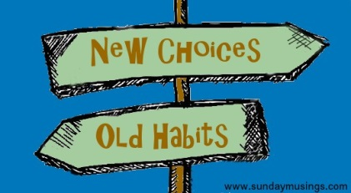**

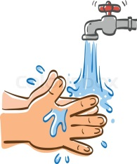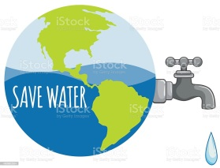

 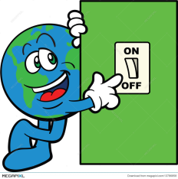 

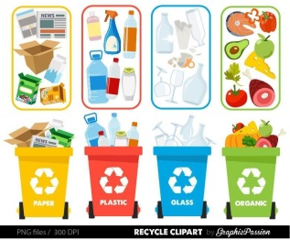 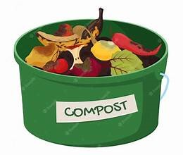

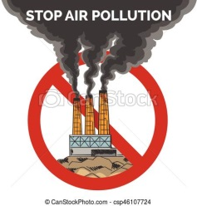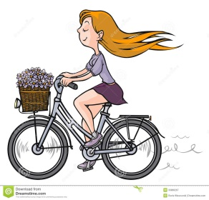 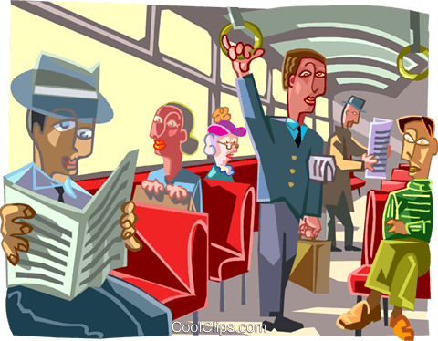 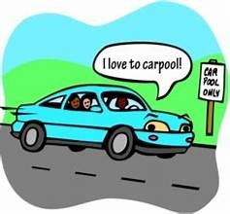

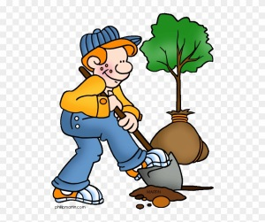 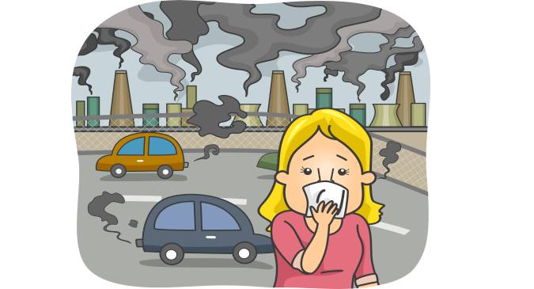 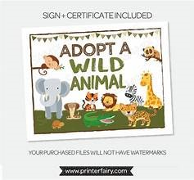

Remember: ‘When there is a will, there is a way.’

**10**

Let’s learn and practice: Phrasal Verbs

go

1 23 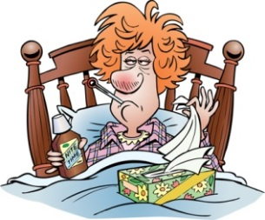 4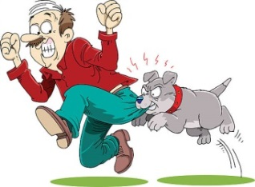5 6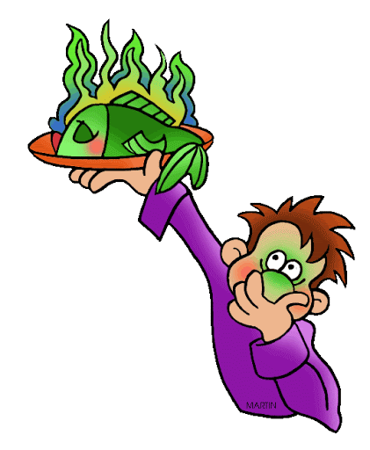7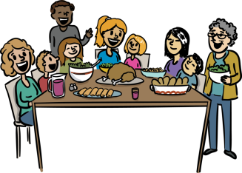

**go back on go down go down with go for go on go off go round**

1. **Match the phrasal verbs with their meanings.**

**a**. (of food) to go bad **b**. to attack **c**. (of prices) to reduce **d** to continue

**e**. to be enough for all **f**. to become ill **g**. to break a promise or agreement

1. **Say and Write: Look at the pictures and answer the questions. Use the phrasal verb.**

1. Did the businessmen sign the contract?

2. Did the house cost a lot of money to buy?

3. Where is Janine today?

4. What did the dog do when someone broke into the house?

5. Did you decide to stop working on the project?

6. Did Joe have fish for dinner?

7. Did you have enough food for everyone at the family dinner?

1. **Now, make your own sentences.**

**give**

**1 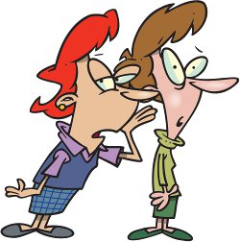 2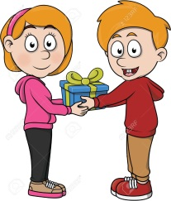 3 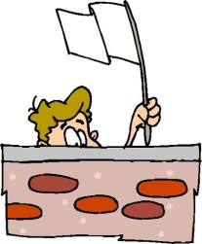 4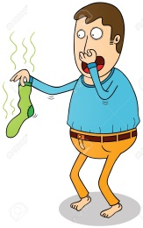 5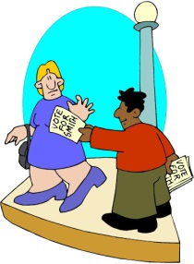6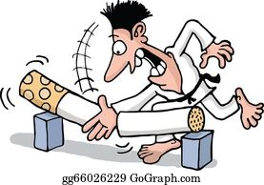7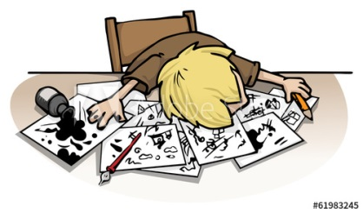**

**give away give away give in give off give out give up give up**

1. **Match the phrasal verbs with their meanings.**

a. to distribute (leaflets) b. to emit (a bad smell) c. to stop trying d. to reveal a secret

e. to give free of charge f. to stop a bad habit g. to surrender

1. **Say and Write: Look at the pictures and answer the questions. Use the phrasal verb.**

1. Did Sue keep your secret?

2. What is the prize of the competition?

3. Did Bob win the battle?

4. Is Rick’s sock clean?

5. What is the man at the corner of the street doing?

6. Is Mark still smoking?

7. Did Frank manage to solve the problem?

1. **Now, make your own sentences.**

**11**

UNIT 2: IT’S A HIGH-TECH WORLD

The 21st century is the age of powerful high-technology and the time of rapid revolutionary changes in all parts of our lives. Robots, computers and ***ingenious / awkward*** gadgets have already ***captured / conquered*** our world and we are gradually becoming slaves to machines. Computers are everywhere.

** Education:** Computer Science is a subject taught in school, since computer skills are considered ***vital / insignificant*** for young people’s future careers. Students know how to operate their personal computers, have access to the Internet, find the information they need and ***interact / interrupt*** with other students online.

**Work:** In the workplace, labour-saving devices, such as computers, ***presume / guarantee*** speed, efficiency and accuracy. This is why they have become ***indisputable / indispensable*** tools dealing with all sorts of time-consuming and tiresome or ***tedious / superficial*** tasks. Computers and the Internet have also made teleworking a common practice.

**Entertainment:** A wide range of entertaining or educational computer programmes are ***currently / generally*** designed for pleasure and self-entertainment. Therefore, exciting and absorbing video games with amazing graphics ***stimulate / terminate*** children’s imagination and take them into the fantasy world of action, magic or mystery. Young players are overjoyed at the idea that they can beat evil aliens or monstrous creatures.

**Telecommunications:** Telecommunications have immensely improved and brought people closer together. E-mails and text messages have ***misplaced / replaced*** letters written by hand and send by post, while our shopping and advertising habits have also been changed due to the Internet.

**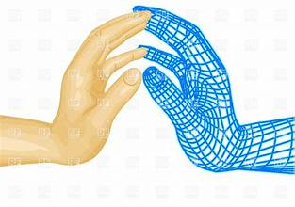Medicine: *Delicate / Slight*** operations are performed with the help of microscopic cameras and computer-operated robot arms without demanding the presence of a surgeon in the operating theatre.

Genetic engineering is making great progress in cloning – a scientific ***plan / technique*** of producing human beings in a totally ***artificial / artistic*** way. It is expected that as soon as scientists manage to break the genetic code, they will be able to ***exterminate / eliminate*** or cure terminal diseases, prevent genetic diseases and lead people to longevity.

**Space Exploration:** Finally, spaceships carrying robots and advanced technological equipment are frequently ***ejected / launched*** into space, looking for possible ***traces / trailers*** of life on distant planets. There is no doubt that soon there will be ***lodges*** ***/ colonies*** on other planets and more and more people will be ***settling / installing*** out there.

Obviously, all these computerized machines have improved our lives tremendously but we should always ***consider / think*** their negative effects on people or the planet itself.

1. **Schoolchildren today**
2. can programme computers. c. learn computer skills for recreational purposes.
3. possess essential computer skills. d. find computer courses irrelevant.
4. **Computers in the workplace**
5. are not as efficient as office workers. c. can only perform a limited amount of tasks efficiently.
6. cut down the workload. d. need to be monitored constantly.
7. **Computer games**
8. are a form of escapism. c. require a developed sense of imagination.
9. are aimed primarily at children. d. encourage realistic thinking.
10. **Surgical operations**
11. can sometimes be performed exclusively by robots. c. always need the presence of real surgeons.
12. can only be carried out by robots if it’s a routine operation d. can all be performed by robots
13. **Technological progress**
14. has affected virtually every section. c. does not have any universal impact.
15. has been slowing down in recent years. d. is something that will benefit younger generations more.

**12**

* **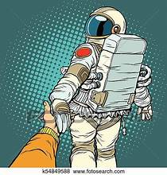Look back in every section of the text and use the notes below to talk about what changes modern technology has brought in each one.**

**Education**

computer skills / vital */*young people’s future careers

operate personal computers / access the Internet / find information / interact /online

**Work**

labour-saving devices / guarantee speed / efficiency / accuracy

indispensable tools / time-consuming and tiresome or tedious tasks

teleworking / a common practice

**Entertainment**

entertaining or educational computer programmes / exciting and absorbing video games / amazing graphics / stimulate imagination / fantasy world of action, magic or mystery

overjoyed / beat evil aliens or monstrous creatures

**Telecommunications**

immensely improved / brought / closer together / e-mails and text messages / replaced letters / hand / post /

shopping and advertising habits / the Internet

**Medicine**

delicate operations / performed / microscopic cameras and computer-operated robot arms / presence of a surgeon / operating theatre

genetic engineering / cloning / human beings / artificial

break the genetic code / eliminate or cure terminal diseases/ prevent genetic diseases / longevity

**Space Exploration**

spaceships carrying robots and advanced technological equipment / launched into space / possible traces ***/*** distant planets / colonies on other planets / people settling

* **Use the words from the text to complete the sentences.**

**ingenious conquered vital operate labour-saving guarantee indispensable**

**time-consuming tedious absorbing stimulate artificial eliminate launched**

1. Receiving and sending mails all day is ……………………………. work. I find it really boring and monotonous.

2. The amazing documentary managed to ………………………………….. the student’s interest on wildlife.

3. Most children know how to ……………………………….. a computer nowadays.

4. Although the flowers at the wedding were ………………………………… they looked natural.

5. A torch is an ………………………………… tool when you go camping.

6. Mark …………………………………. success after hard work and persistence.

7. Hundreds of satellites are ……………………………… into space every year.

8. Talent only doesn’t ………………………. success in show business. Hard work is also necessary.

9. Dan’s ………………………………….. idea brought millions of dollars into his business.

10. Modern medicine has managed to …………………………………….. illnesses that have made people suffer.

11. The book was so ………………………………….. that I didn’t realize I was reading until late at night.

12. Household robots promise to be …………………………………. and do all the tiring chores.

13. Our heart plays the most …………………………….. role in our bodies. Without it we would die.

14. The project was so ………………………………………. that I had no time left for anything else.

* **Complete the sentences with the words.**

**updated sophisticated state-of-the-art invading available virtual**

**isolation addiction excessive appliances devices virus**

1. Computers are blamed to cause social …………………………. since people spend hours alone, in front of a screen.
2. There is endless information ……………………………. on the Internet on every topic. **13**
3. Electrical …………………………….. like the fridge and the washing machine changed people’s lives.
4. Electronic ……………………… such as mobile phones and cameras are widespread nowadays. Everyone has one.
5. Ben’s new ………………..…………………………… smart watch can do amazing things!
6. The ……………………………….…………. use of computers can have a negative effect on our social life.
7. More ………………………………………….. robots will appear in the futurethat will look like humans.
8. Computers have to be regularly ………………………..……………….. to function properly.
9. A ………………………………………. can attack your programmes and destroy your data.
10. Video games can cause an ……………………………..…………. with really harmful effects.
11. ………………………………. reality games make you think that you really take part with all your senses.
12. Video games with aliens ……………………..………………….. the earth can be really absorbing.

* **Look at the title of the following passage. What do you think the text is about?**

**Read the text and complete it with the correct word from the box. Then answer the questions that follow.**

**accuracy / replacing / radically / defuse / threaten / argument / accomplish / accurate / operations / rising / take over**

**ROBOTS VERSUS PEOPLE**

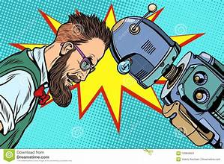 Undoubtedly, robots have **(1) ………………………….** changed our lives and made them easier and more comfortable. But the question is: are they going to **(2) …………………………………..** world? Whatever happens, we should carefully consider both sides of the **(3)………………………………**.

The main advantage of robots is that when these computer-controlled machine tools are programmed, they can carry out the most exhausting, tedious and dangerous tasks with greater speed and **(4) ……………………………..………..**than human beings. They can successfully do assembly line work in factories or patiently perform delicate **(5) ………………………………..…** in hospitals. Moreover, they can **(6)** **…………………………..…….….**dangerous missions in space or can be programmed to **(7) ………………………..……………** bombs.

On the other hand, the presence of robots in the workplace is one of the main causes of unemployment. They keep **(8)………………………….** workers as they are more **(9) …………………………** and cheaper than humans and never get tired. Therefore, unemployment is **(10) ………………………….** tremendously and job vacancies are becoming fewer and fewer.

Summing up, robots have thoroughly improved our lives. Nevertheless, in my view robots along with overpopulation will definitely cause such devastating social changes that will severely **(10) ……………………………** our own existence.

1. 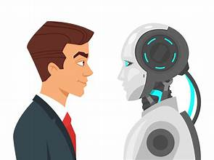In what way have robots changed our lives?
2. What question is puzzling the writer?
3. What is the greatest advantage of robots?
4. In what fields can robots be better than humans?
5. What is the main threat of robots?
6. Can you bring an example of this threat?
7. What is the writer’s view on robots?
8. In which part of the text does he express this view?
9. Do you agree with the writer?

* **Use the questions to talk about the benefits and drawbacks of the use of robots.**
* **Complete the definitions with the correct word.**

**cutting-edge hands-free labour-saving outdated user-friendly voice-activated**

1. …………………………………………. technology is easy for anyone to use.
2. …………………………………………. technology is the most modern and advanced technology. (*or state-of-the-art*)
3. …………………………………………. technology is old-fashioned and out of style. **14**
4. …………………………………………. technology is controlled by someone talking to it.
5. ………………………………………… technology lets you do other things while talking on the phone.
6. …………………………………………. technology cuts down on how much you have to do.

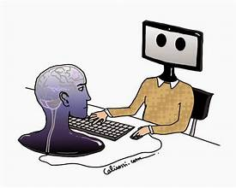

Let’s Write: AN ESSAY

Your school magazine has organized an essay competition and the theme is computers. Write the essay in about 120-180 words using the notes.

**Computers have revolutionized the way we live in a positive way but they have also negative effects on people’s lives. Are you in favour of all this “computerization” or not?**

**Points in favour:** **Think about the positive changes computers bring and take notes. Get help from the texts.**

**In the field of work:** …………………………………………………………………………………………………………………………………………………….

……………………………………………………………………………………………………………………………………………………………………………………..

**In the field of education:** …………………………………………………………………………………………………………………………………………....

……………………………………………………………………………………………………………………………………………………………………………………..

**In the field of medicine:** ………………………………………………………………………………………………………………………………………………

……………………………………………………………………………………………………………………………………………………………………………………..

**LINKERS: On the one hand / One main advantage is / It is an undeniable fact that / Another obvious advantage is**

**Points against:** **Expand the clues to write sentences about the negative changes.**

replace workers / accurate and never get tired / raise unemployment / alarming rate

……………………………………………………………………………………………………………………………………………………………………………………..

misleading information on the Internet / be deceived

……………………………………………………………………………………………………………………………………………………………………………………..

computer games / encourage violent behaviour / cause addiction

…………………………………………………………………………………………………………………………………………………………………………………….

**LINKERS: On the other hand / However there are serious disadvantages to / An undeniable disadvantage is**

**Introduction: Always begin your essay with a general statement that rephrases the topic.**

It is a fact that over the last few years…. (*labour - saving machines / invade / conquer*)

However, … ( *carefully consider / two sides of the argument*)

**Conclusion:** **Always end your essay by revising in one phrase what you have written or giving your point of view.**

In conclusion / All in all / To sum up / In my opinion / In my view / the advantages outweigh the disadvantages

*It is up to us / use computers in a responsible way / can be really beneficial / dominate human activity*

* **Now use your notes to talk about the topic and then write your essay.**

**15**

Let’s Watch: How life will look like in 2050

**Watch the following video that predicts what life will look like in 2050.**

<https://www.youtube.com/watch?v=6_q_LHq85Cs>

**1. After you watch talk about one advance you remember for each of the fields: Nanotechnology, 3D print, medical, transport, space, AI, money and housing.**

**2. Watch again and complete the sentences with the missing word.**

**NANOTECHNOLOGY**

1. Nanotechnology has the ………………………………. to change life as we know it.

2. Nanobots will be fitted in our ………………………… to connect us to the virtual world more readily and faster.

3. With nanotechnology there will be no need for …………………………….. like phones and calculators.

**3D PRINT TECHNOLOGY**

4. In the future, we‘ll be able to print more ……………………………… and perhaps even some modes of transportation.

5. If the current trend of Open Source 3D printable files continues, it won’t be long before everyone prints their own large objects like …………………………………… or weapons.

6. The development of an affordable 3D printer for food could be the end of world ……………. despite global warming.

**MEDICAL**

7. The information stored in our brains will be transferred into a hard disc and then …………………………….. into a robot.

8. Serious ……………………………….. like cancer will be cured.

9. The only downside is that every new technology is very …………………………………. when it first comes out.

**TRANSPORTATION**

10. By 2050, the technology for fully automated …………………………………. will exist.

11. A notable advantage will be a drastic ………………………………….. in traffic-related deaths.

**FUEL**

12. The fuel used in all future transportation modes will be ……………………………….. energy.

13. Hopefully, Blue Rise and their …………………………………… will be successful soon enough to alleviate some of the environmental problems we face.

**SPACE EXPLORATION**

14. Space exploration will help people to live on other ……………………………….. with colonies.

15. Unfortunately, a space trip will be significantly expensive, making it an exclusive trip for the extremely ……………….

**ARTIFICIAL INTELLIGENCE**

16. AI experts believe that AI will surpass the processing power of living …………………………...

17. The rise of AI will change the face of workforce, as half of the world’s current jobs will be ………………………., taken over by AI machines and robots.

**EDUCATION**

18. By 2050, completely ………………………………. schools will be commonplace.

19. Even if there are physically attended schools, they will have no need for ………… using tablets and laptops instead.

**METAVERSE**

20. The metaverse is a virtual reality computer-generated ………………………………. in which you can interact with users through AI enabled software.

21. It seems that the more we are …………………………………, the more we stay apart.

**MONEY**

22. It seems that ……………………………………….. will no longer be used in 2050.

23. Our refridgerators will ……………………………….. our groceries.

**REAL ESTATE**

24. Homes of the 2050 will be completely ………………………………………..

25. Smart homes in the 2050 will have full AI activation functions, allowing the home to sense our moods and requirements without giving it a single ……………………………………..

26. There will be no need to look for the remote control again because you can control the TV with your ………… using nanotechnology. **16**

Let’s practice: Reported Speech

**1. Change the following sentences from DIRECT to INDIRECT SPEECH:**1. Ted said, “I will be here at noon.”…………………………………………………………………………………………………………………………………………………………………..2. Mary said, “The train will probably arrive on time.”  
………………………………………………………………………………………………………………………………………………………………....  
3. Mark said, “I have to finish this report by five o’clock.”  
………………………………………………………………………………………………………………………………..………………………………..  
4. The doctor said, “Mr. Smith has improved quickly.”  
……………………………………………………………………………………………………………………..…………………………………………..  
5. William said to me, “I am leaving in the morning.”  
…………………………………………………………………………………………………………………………………………………………………..  
6. John said, “I saw that movie on Wednesday.”  
…………………………………………………………………………………………………………………………………………………………………..  
7. Helen said, “I have already read that book.”  
………………………………………………………………………………………………….………………………………………………………………..  
8. Mary said to John, “I cannot go to the movie with you.”  
………………………………………………………………………………………………………………………………………….………………………..  
9. Mr. Smith said, “I ‘m going to refuse their offer.”  
…………………………………………………………………………………………………………………………………..………………………………….  
10. John said, “I certainly hope it won’t rain tomorrow.”  
………………………………………………………………………………………………………………………………………………….…………………….

**2. Change the questions from DIRECT to INDIRECT SPEECH:**

**Wh-questions**1. He asked, “How long does it take you to have lunch?”  
……………………………………………………………………………………………………………………………………………………………….……….  
2. He asked me, “What are you doing at the weekend?”  
……………………………………………………………………………………………………………………………….……………………………………….  
3. The teacher asked, “Why are you late, Tom?”  
………………………………………………………………………………………………………………………………..……………………………………….  
4. My mother asked me, “Where is your umbrella?”  
………………………………………………………………………………………………………………………………………………..……………………….  
5. The secretary asked the man, “Who do you want to see, sir?”  
………………………………………………………………………………………………………………………..……………………………………………….  
6. The students asked, “What time does the bell ring?”  
………………………………………………………………………………………………………………………………………………………………………….  
7. Larry asked Tom, “What kind of films do you like watching?”  
………………………………………………………………………………………………………………………………………………………………………….  
8. The teacher asked the girl, “When do you have to be home?”  
………………………………………………………………………………………………………………………………………………………………..……….  
9. The passengers asked, “When did the last train leave?”  
……………………………………………………………………………………………………………………………………..………………………………….  
10. He asked, “What will you do tomorrow, Jane?”  
………………………………………………………………………………………………………………………………………….……………………………….  
**Yes / No questions:**1. She asked, “Do you live with your family, Helen?”  
…………………………………………………………………………………………………………………………………………………………………………..  
2. Tom asked, “Can I borrow your pen, Linda?” **17**   
……………………………………………………………………………………………………………………………………………………………………………..  
3. Phil asked me, “Does your uncle live in England?”  
……………………………………………………………………………………………………………………………………………………………………………..  
4. Mary asked Lucy, “Will you come to my party tomorrow?”  
……………………………………………………………………………………………………………………………………………………………………………..  
5. Mark asked, “Did you phone me last night, John?”  
…………………………………………………………………………………………………………………………………………………………………..………..  
6. Sam asked, “Is this yours or mine, David?”  
……………………………………………………………………………………………………………………………………………………………………………..  
7. Sara always asked me, “Must you always ask me what I’m doing?”  
…………………………………………………………………………………………………………………………………………………………………….……..  
8. The teacher asked, “Are you listening to me?”  
……………………………………………………………………………………………………………………………………..……………………………………..  
9. Mary asked, “Do you want me to help you, Larry?”  
…………………………………………………………………………………………………………………………………..………………………………………..  
10. The officer asked, “Are you a foreigner? Can you spell your name?”  
……………………………………………………………………………………………………………………………………………………………………………..

**3. Report the commands / requests.**

1. Woman to the porter: “Carry my suitcases.”  
……………………………………………………………………………………………………………………………………………………………………………..  
2. Policeman to a suspect: “Describe your car.”  
………………………………………………………………………………………………………………………………………………………………….………….  
3. Mother to the boy: “Don’t hurt yourself.”  
…………………………………………………………………………………………………………………………………………………………………………….  
4. The robber to the man: “Give me your money.”  
……………………………………………………………………………………………………………………………………………………………….…………….  
5. Teacher to the student: “Give me your book.”  
………………………………………………………………………………………………………………………………………………………….………………….  
6. The traffic warden to us: “Don’t park here.”  
…………………………………………………………………………………………………………………………………………………………..………………..  
7. Woman to her husband: “Don’t forget to take your key.”  
………………………………………………………………………………………………………………………………………………………..…………………..  
8. Mr. Smith to her son: “Don’t use your mobile so much.”  
……………………………………………………………………………………………………………………………………………………..……………………..  
9. Boy to his mother: “Please mum, buy me this toy.”  
……………………………………………………………………………………………………………………………………………………………………………..  
10. The man to his son: “Hurry up! Don’t miss the bus!”  
……………………………………………………………………………………………………………………………………………………………………………..  
11. The woman to her daughter: “Tidy your room, don’t waste your time.”  
………………………………………………………………………………………………………………………………………………………………………………..

**Change into INDIRECT SPEECH:  
You can use AND, BUT, BECAUSE, ADD to join the sentences.**1. Brenda said to Jimmy, “Please, turn off the TV. The film is boring.”  
…………………………………………………………………………………………………………………………………………………..……………………………  
2. “Wash your face and get dressed.” Bill’s mother said.  
…………………………………………………………………………  
3. “Do your homework again. There are a lot of mistakes.” the teacher said to Kate.  
……………………………………………………………………………………………………………………………………………………………………….…… **18**  
4. “Don’t waste your time! Finish studying.” Mrs. Dawson said to Barbara.  
…………………………………………………………………………………………………………………………………………………………………….…………  
5. “Brush your teeth. They look very dirty.” Mother said to Fay.  
…………………………………………………………………………………………………………………………………………….…………………………………  
6. “Look out! There is a truck coming.” Kevin said to his daughter.  
…………………………………………………………………………………………………………………………………………………………………….…………  
7. Janet said to David, “This book looks boring. Give me another, please.”  
………………………………………………………………………………………………………………………………………………………………………………  
8. Mrs. Abbot said to Jack, “Your hair is very long. Go and have a haircut.”  
………………………………………………………………………………………………………………………………..………………………………………………  
9. Mrs. Denman said to her son, “It is very hot. Don’t play in the sun.”  
…………………………………………………………………………………………………………………………………………………………………………………  
10. Mr. Newman said to Nicky, “Don’t make a lot of noise. I want to listen to the news.”  
…………………………………………………………………………………………………………………………………………………………….……………………  
11. “Don’t turn it up. I have a headache.” Mother said to us.  
…………………………………………………………………………………………………………………………….……………………………………………………  
12. Sue said to Andy, “Don’t shout! I’m not a deaf.”  
………………………………………………………………………………………………………………………………………………………….………………………  
13. Terry said to Ashley, “Don’t speak German. Speak English. They can’t understand you.”  
…………………………………………………………………………………………………………………………………………….……………………………………  
14. “Please, be quiet! The baby is sleeping.” Mrs. Newton said to the children.  
…………………………………………………………………………………………………………………………………………………………………………….……  
15. “Will you please move aside? I can’t watch television.” John said to his brother.  
…………………………………………………………………………  
16. Mark said to us, “I want to buy a new car. Ours is very old and spends a lot of petrol.”  
…………………………………………………………………………………………………………………………………………………………………………………  
17. Tom said to Carol, “Can I borrow your dictionary. Mine is at home.”  
…………………………………………………………………………………………………………………………………………………..………….…………………  
18. “Your hands are very dirty. Go to the bathroom and wash them.” Mother said to Nicole.  
………………………………………………………………………………………………………………………………………………………………………..………  
19. Sandy said to Danny, “Does your mother work? I see her on the bus every day.”  
…………………………………………………………………………………………………………………………………………………………………………………  
20. Tom said to Jane, “I’m bored. Can we go to the cinema?”  
…………………………………………………………………………………………………………………………………………………………………………………  
21. Sam said to Kate, “I’m broke. Can you lend me some money?”  
…………………………………………………………………………………………………………………………………………………………………………………  
22. Mother said to her son, “Your friends are playing in the garden. Don’t you want to play with them?”  
…………………………………………………………………………………………………………………………………………………………………………………  
23. Jim said to his son, “When will you go? You are very late for school.”  
………………………………………………………………………………………………………………………………………………………………….………………  
24. “What have you cooked? I feel very hungry.” Tony said to his mother.  
……………………………………………………………………………………………………………………………………………………………………..……………  
25. “Why don’t you wash your car? It looks very dirty.” Mrs. Dawson said to John.  
……………………………………………………………………………………………………………………………………………………………………………………

**19**

Let’s Read: SMART PHONES

The smart phone is state-of-the-art ***machinery / device*** and is regarded as a practical, convenient and indispensable communication tool of modern social life. [The development of technology](https://honestproscons.com/what-is-wireless-technology/) for smart phones ***modernized / outdated*** communications. It has paved the ***way / road*** for SMS, text messages, calls, video chat, and applications that allow individuals to connect with others around the world instantly.

**Why is a smart phone useful?**

* You can carry your smart phone wherever you go and use it in case of ***urgency / emergency***. Lots of human lives have been saved thanks to smart phones.
* Smart phones can give us some ***easy / comfortable*** fun when we want to relax. You can watch funny videos, listen to music or play your favourite games. Also, texting is free and offers you a fun way to ***interact / contact*** with others.
* You can go online anytime anywhere and download all sorts of songs and games ***to / on*** your smart phone. What’s more, you can take, store and send photos and videos in a split ***second / moment.***

**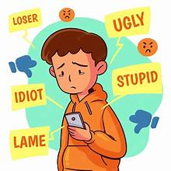 Are people victims of their mobile phones?**

* Lots of people consider mobile phones to be an ***explosion / invasion*** to their privacy. Mobile phones have cameras and so our private life may be videoed and be used for cyber-bullying or even blackmailing. Text bullying has become another serious social problem especially among teenagers.
* Scientists warn that smart phones are a serious ***hazard / warning*** to our health. They can cause eye-strains, headaches and even ***harm / injure*** our brains and cause brain tumors.
* ***Absorbing / Excessive*** games and social media that are available on smart phones can ***contribute / include*** to addiction even for kids under the age of ten.
* They can be a public ***nuisance / problem***. People, especially teenagers, keep using their mobile phones in public places without showing any respect for others.
* They can cause distraction. Texting messages and watching videos all the time distracts students ***of / from*** their schoolwork. Even worse, they are ***accused / blamed*** for distracting drivers and causing accidents.

Smart phones are here to stay and move ***forwards / front***. It’s up to us to consider their careful use.

1. **In what ways have smart phones modernized communications?**
2. **How can smart phones be helpful in case of emergencies? Give some examples.**
3. **What kind of easy fun can smart phones offer you?**
4. **What kind of things can online connection to smart phones allow you to do?**
5. **In what ways are smart phones an invasion to privacy?**
6. **How do smart phones threaten our health?**
7. **Why may smart phones cause disturbance?**
8. **What are the results of distraction for students and drivers?**

* **Complete from the text.**

1. ………………………………. device 8. …………………………………….. to privacy
2. ………………………………. communication tool 9. ……………………………………… to our health
3. ………………………………. the way 10. ……………………………………… games
4. ………………………………. emergency 11. …………………………………….. to addiction
5. ……………………………….. fun 12. ……………………………………. nuisance
6. ……………………………….. with others 13. ……………………………………. students from schoolwork
7. ………………………………. second 14. …………………………………… for distracting drivers

**20**

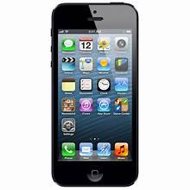Let’s Speak & Write

**The pros and cons of smart phones**

**INTRODUCE YOUR TOPIC OF DISCUSSION**

Introduce the fact / Make a brief comment about the fact and the way it affects our lives /

Say you‘ll examine both sides of the argument

**PROS** (use the words and expand them to full arguments)

emergency / easy fun / go online

**CONS**

invasion to privacy / hazard to our health / addiction / public nuisance / distraction

**CONCLUDE**

Tell your opinion / do advantages outweigh disadvantages? / close with a suggestion

* **Comment on the following strips.**

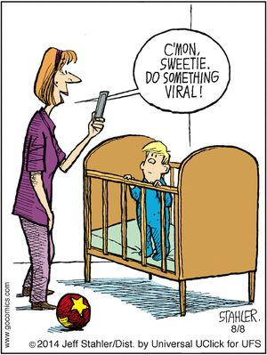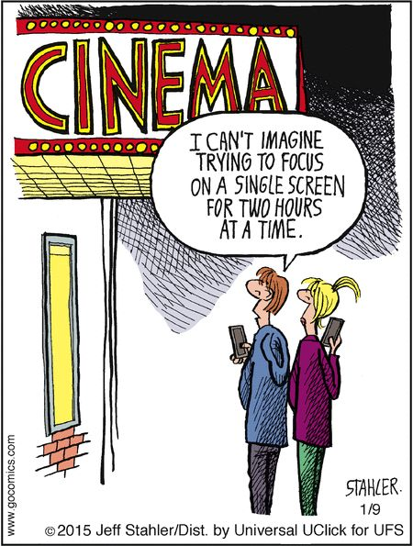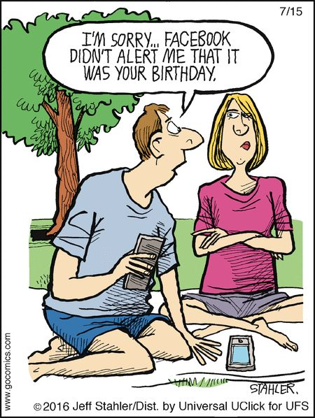

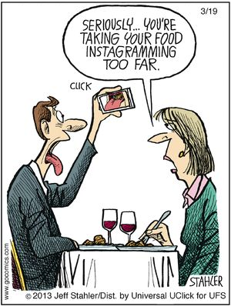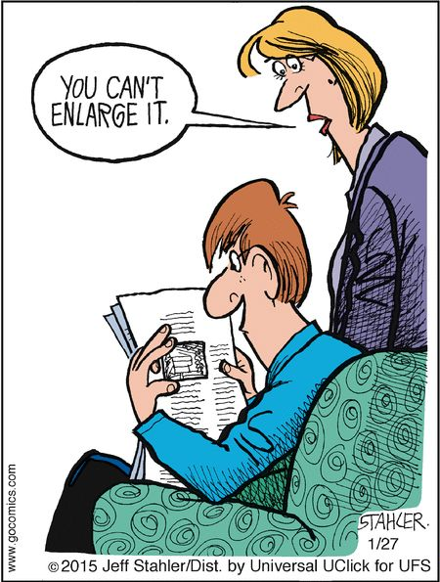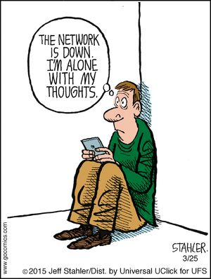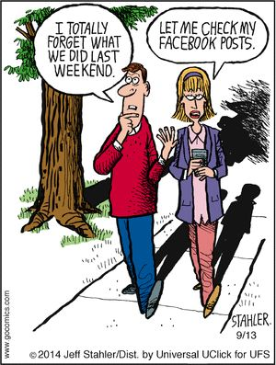

**21**

Let’s Read: SOCIAL MEDIA

A look at the ups and downs of being so digitally connected to people

*Social networking has changed the way we communicate, do business, get our daily news fix and so much more. But is it really all it's cracked up to be? There are pros and cons to everything in life—and that includes our social networking habits.* **The Pros of Social Networking**

**Connect to Other People All Over the World:** One of the most obvious pros of using social networks is the ability to instantly reach people from anywhere. They enable you to stay in touch with old friends and relatives or meet brand new people from cities or regions you've never even heard of before.

**Easy and Instant Communication:** Now that we're connected wherever we go, we don't have to rely on our landlines or snail mail to contact somebody. We can simply open up our laptops or pick up our smart phones and immediately start communicating with anyone on social media or one of the [many social messaging apps](https://www.lifewire.com/popular-and-free-instant-messaging-apps-3485937) available.

**Real-Time News and Information Discovery:** Gone are the days of waiting around for the six o'clock news to come on TV or for the morning newspaper. If you want to know what's going on in the world, all you need to do is jump on social media. An added bonus is that you can customize your news and information discovery experiences by choosing to follow exactly what you want.

**Great Opportunities for Business Owners:** Business owners can connect with customers, sell their products and expand their reach using social media. There are actually lots of entrepreneurs and businesses out there that thrive almost entirely on social networks and wouldn't even be able to operate without it.

**Plain Fun and Enjoyment:** You have to admit that social networking is just plain fun sometimes. A lot of people turn to it when they catch a break at work or just want to relax at home. Since people are naturally social creatures, it's often quite satisfying to see comments and likes show up on our own posts, it’s a new way of interaction.

  **The Cons of Social Networking**

**Threat to Privacy:** So much is shared online these days that the invasion of our privacy is becoming an increasingly big concern. Whether it's a question of social sites owning your content after it's posted or getting in trouble after posting something, sharing too much with the public can open up all sorts of problems that sometimes can't be undone.

**Peer Pressure and Cyber Bullying:** For people struggling to fit in with their peers — especially teens and young adults — the pressure to do certain things or act a certain way can be even worse on social media than it is at school or any other offline setting. In some extreme cases, the overwhelming pressure to fit in with everyone posting on social media or becoming the target of a cyber-bullying attack can lead to serious stress, anxiety and even depression.

**Social Isolation:** Since people are now connected all the time and you can pull up a friend's social profile with a click of your mouse or a tap of your smartphone, it's a lot easier to use online interaction instead of face-to-face interaction. Some people argue that social media actually promotes antisocial human behavior.

**Distraction:** How often do you see someone look at their phone? People get distracted by all the social apps and news and messages they receive, leading to all sorts of problems like distracted driving or the lack of gaining someone's full attention during a conversation.

**Sedentary Lifestyle and Sleep Disruption:** Lastly, since social networking is all done on some sort of computer or mobile device, it can sometimes promote sitting down in one spot for too long. Likewise, staring into the artificial light of a computer or phone screen at night can negatively affect a proper night's sleep.

Adjusted from [www.*Lifewire.com*](http://www.Lifewire.com)

1. **How can social media help you connect with people all over the world?**
2. **What did people use to do if they wanted to communicate at a distance? What about people today?**
3. **How did people in the past use to get news and information? What do they have to do today?**
4. **What kind of opportunities does social networking offer to people who do business?**
5. **How can social networks provide people with fun and enjoyment?**
6. **In what ways can social media be a threat to our privacy?**
7. **What results can online peer pressure and cyber-bullying have for teens and young adults?**
8. **Why are social networks blamed for causing anti-social behaviour?**  **22**
9. **Give some examples of how distraction from social sites and apps can be harmful.**
10. **How can social networking result in sedentary lifestyles and sleep disruption?**

* **Explain the highlighted words and phrases. Then use them complete the sentences.**

1. Tourism seems to ………………………..……………… in most islands.
2. Modern ………………………….………………….. choose to do online business.
3. Our new Internet connection will ………………………………………. us to have faster speeds.
4. The elderly are ……………..……………………… with modern online technologies.
5. The electricity cut caused a great deal of ………………..………………………. in the area.
6. A lot of people …………………….…………………. on the usefulness of social networks.
7. Teenage violence has become ………………….…………………………..
8. More and more kids are …………………..………………….. a smart phone nowadays.
9. We can ……………………….………………… connect with people from all over the world.
10. Sue felt an ……………….…………………… desire to eat ice cream.

* **Complete with the missing word.**

**Cyberbulling and “Haters”**

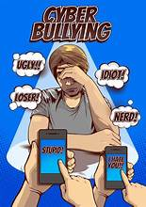Cyberbullying is bullying that (1) *……………………….* place over digital devices like cell phones, computers, and tablets. Cyberbullying (2) *…………………..* occur through SMS, texting, apps, social media or gaming (3) *………………………* people can view, or share content. It includes sending, posting or sharing harmful or mean content (4)*………………………* someone else with the aim (5) *………………..*causing embarrassment or humiliation. More often (6) *……………………* not, it crosses the line into unlawful or criminal behavior.

**What are "Haters?"**

"Haters" are people who use negative and critical comments and behaviour to bring another person (7) *………………………….* by making them look or feel bad. These hurtful comments and behaviours can be repeated over time. Haters are often anonymous but they can also be acquaintances, peers, or people (8) *………………….* were once considered friends. Often, haters pick (9) *…………………….* people they perceive as different from themselves. Being the target of cyberbulling s can trigger feelings of anger, hurt and confusion, and even lead to depression or even suicide.

Let’s Speak & Write

* **Use the clues and expand with information from the text or your own ideas to talk about the pros and cons of social networks. Remember to introduce the topic and conclude properly.**

**Pros:** 1. Connect to Other People All Over the World  **Cons:** 1. Threat to Privacy

2. Easy and Instant Communication 2. Peer Pressure and Cyber Bullying

3. Real-Time News and Information Discovery 3. Social Isolation

4. Great Opportunities for Business Owners 4. Distraction

5. Plain Fun and Enjoyment 5. Sedentary Lifestyle / Sleep Disruption

**Social Networking can bring only benefits to people and societies.**

Do you agree with the statement? Write an article between 120-180 words for your school magazine to express your opinion.

(*You may agree or disagree with the statement, but support your opinion with arguments and examples. Whether you agree or not, you should briefly refer to the other side of the coin and its benefits or drawbacks. Plan your paragraphs well with clear topic sentences. Don’t forget to give your article a catchy title)*

**23**

Let’s learn and practice: Phrasal Verbs

make

**1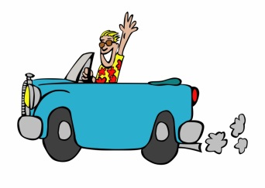 2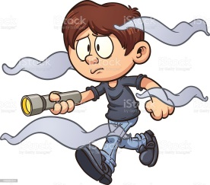 3 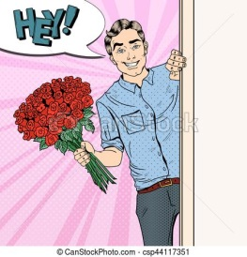 4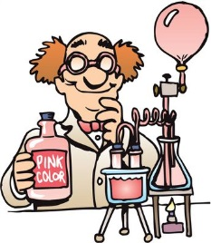 5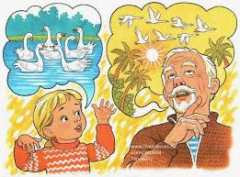 6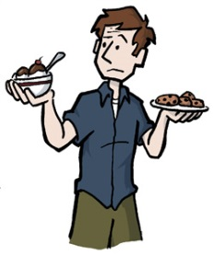**

**make for make out make up for make up make up make up your mind**

1. **Match the phrasal verbs with their meanings.**

**a**. to invent by putting together **b.** to decide **c**. to compensate for sth bad

**d**. to head for a destination **e**. to invent a story **f**. to see with difficulty

1. **Say and Write: Look at the pictures and answer the questions. Use the phrasal verb.**

1. Why is Clark happy?

2. What is Rick’s problem?

3. Why did Dave bring Sally some flowers?

4. What did the chemist manage to do?

5. How do Lina and her grandpa spend their evenings?

6. Why is Arthur thoughtful?

1. **Now, make your own sentences.**

fall

**1  2 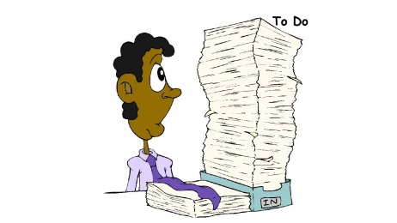 3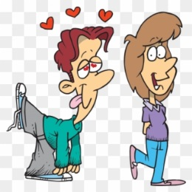 4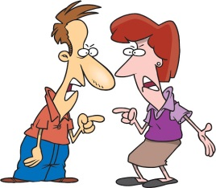**

**fall apart fall behind fall in fall out**

**Match the phrasal verbs with their meanings.**

a. to quarrel b. to break into pieces c. to fall in love d. to be left behind

1. **Say and Write: Look at the pictures and answer the questions. Use the phrasal verb.**

1. What happened to grandma’s vase?

2. What happened to Jo after she returned from holidays?

3. How did Larry feel when he saw Sally?

4. What happened to Rick and Kerry when he refused to lend her some money?

1. **Now make up your own sentences**

**24**

UNIT 3: MONEY & SHOPPING

Money doesn’t grow on trees

**1. Read the sentences and decide if the underlined phrases refer to “lots of money” or “little money”**

1. The wedding’s in one of the best hotels. Her father is a very **wealthy** man.

2. They must be pretty **well off**. They’ve just bought a six-bedroomed house.

3. I won’t be able to go on holidays this year. I’m a bit **short of money**.

4. My grandfather gets a very good pension, so he’s quite **comfortable**.

5. I can’t come out tonight, I’m **broke**.

6. I lent my brother some money last week. He’s a bit **hard up** at the moment!

7. When the children were young we **couldn’t afford** to go on holiday.

8. They live in a luxurious house so they must be **loaded**

9. We need to **tighten our belts** as prices are rising fast.

10. After losing his job, Jacob is struggling to **make ends meet**.

**Discuss the kind of lifestyles the wealthy and poor may have. Use the the expressions above and : glamorous / fortunate / have no worries about / live in luxury / often has to beg for / constant struggle / live on the dole**

**2. Complete with the correct word.**

**notes coins credit card currency cash money belt**

The less money you carry around you, the better. I usually have about 50€ in (1) …………………………. in my wallet and a couple of euros in (2) ……………………………… in my pocket. I pay (3) …………………………….. for things that cost under 20€ but anything over that I use my (4) …………………………………. . When I go on holiday, I carry all my (5) ………………….. in a (6) ……………………………….. round my waist just to be on the safe side!

**3. How much do you earn? Complete the definitions with the words.**

**pension fees benefit salary income interest pocket money wage**

1. A ……………………………………. is what you earn by day or by week.

2. A …………………………………. is what you get per month.

3. ………………………..…………… is paid to a school or University for studies

4. Your annual salary plus any other money you earn is your ………………….………………… .

5. ……………………………..…………….. is given by parents to children.

6. People who have retired receive a …………………………………………. .

7. If you have borrowed money from a bank, you give it back with an extra charge, called ………….……………………… .

8. A …………………………………. is money given to help unemployed or underprivileged people.

**4. Match the compound nouns with their definitions.**

**bargain hunter / car-boot sale / flea market / full refund / market stall / price tag / sales receipt / window shopping**

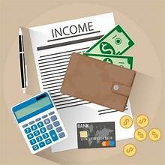

1. sth attached to a product which writes how much it costs. …………………………………………..

2. money you get back from a product because it’s faulty or you just don’t want it …………………………………

3. somebody who looks for the cheapest products. …………………………………..

4. when you just look at things without buying anything ……………………………………..

5. an outdoors bazaar where old or second hand things are sold. ……………………………….

6. a document that proves you have paid for things you bought. ………………………………………

7. a large table that is used for selling things ……………………………………

8. a market where people sell new or second-hand products from the back of their vehicle. …………………………………… **25**

**Shopping Mania**

It is said that shopping is **therapy / treatment**. It has the **power / strength** to help people get rid of any negative thoughts, even for a **small / short** time. Most people support that shopping gives them a sense of satisfaction, either when they shop **sensibly / irrationally** or even if they exceed their **bargain / budget**. Therefore, shopping has become a pleasant **purchase / pursuit** and shopping mania an **addiction / extinction**.

Apart from the conventional way of shopping, online shopping and telemarketing are **winning / gaining** ground. This means that they are both **on / in** the increase, because people in their effort to save time and avoid rushing and queuing into shops they prefer to shop at the **pleasure / comfort** of their own homes. Therefore, the manufacturer’s aim is to devise the most attractive advertising techniques on the Internet to **progress / promote** their products and draw the consumer’s attention. As a result, Internet advertising and online shopping has become a **thriving / rich** business for many companies today. They even use brainwashing to persuade consumers to buy and make them obsessed with shopping. However, there are **misleading / false** advertisements, too and consumers must know and demand their **goals / rights** when they are deceived or misinformed.

**Brand Name Mania**

Do you know what a large number of people and especially teenagers frantically buy today? Brand-name products of course! It’s a recent **trend / event** which encourages teens to buy designer clothes or accessories. Social media has made them become appearance-conscious and believe that appearance is what makes a good **impression / expression** on others. If they are dressed in fashion, they may feel self-confident and trendy and give them a sense of belonging to a group. Yet, such labels are overpriced and cost a good **deal / amount** of money.

In any case, when you go on shopping **spree / adventure**, try to spend your money wisely and handle it well.

**Choose the correct answer.**

**1. A satisfied shopper**

a. is one who get the best bargains.

b. shops in moderation.

c. values the action of purchasing more than the purchase itself.

**2. Online shopping is**

a. more popular than conventional shopping.

b. popular as it involves less effort than conventional shopping.

c. unlikely to overtake conventional shopping.

**3. Misleading advertisements**

a. is a flourishing business.

b. are only a few.

c. try to take in consumers.

**4. Brand-names**

a. make the wearer feel special.

b. are good value for money.

c. tend to be worn by wealthier teens.

**5. When going shopping, it’s always a good idea**

a. to spend money recklessly.

b. to spend money thoughtfully.

c. to pay by credit cards.

**What is the main purpose of advertisements?**

**What is a misleading advertisement? What should consumers do about it?**

**What is the problem with brands?**

**26**

Let’s Learn: Money & Shopping

**1. Shopping Phrasal Verbs: Choose the right option.**

1. Good morning! Is it OK if I **look round / look out for** your shop?

2. Can you lend me some money? I’ll **pay you back / pay you off** next week.

3. The clothes shop at the corner doesn’t have any customers. I think it will **shut over / shut down**.

4. I love the pattern on this dress. I’ll **try it out / try it on**.

5. A fashion victim always wants to **keep up with / keep down with** the latest fashions.

6. Meg was **put away / put off** by the price of the computer, so she didn’t buy it

7. This beautiful red jacket will make you **stand for / stand out** in the crowd.

**2. Fill in with the correct preposition and then complete the sentences 1-7**

a. …………. the sales b. ……………. offer c. …………… debt d. ……………… fashion

e. …………. an advert f. free ……… charge g. …………… cash h. ……………… credit card

1. Fay saw this cool watch …………………………………………..……………. on TV.

2. If you don’t stop spending so much money, you’ll soon be …………………………….……………………… .

3. I want to get a pair of new trainers …………………………..………………………… but they won’t start till January.

4. It’s not always safe to pay …………………………………………………….. when you shop online.

5. Sally is very stylish, she only wears clothes and footwear that are ……………………………………………………… .

6. I had lots of money with me, so I decided to pay ………………………..………………………….. .

7. All the sports equipment is …………………………………………………… this week. Tennis rackets are only 20 €!

8. We can send you your purchases without extra cost. Shipping is …………………..……………………………… .

**3. Complete with the right word.**

1. **uniform / costume**

Tony has a great …………………………………… for the fancy dress party. He’s hired a police ………………………………… .

**borrow / lend**

I’ll ……………………………………….. you my earphones as long as you let me ……………………………………. your blue jacket.

**bargain / purchase**

Her latest …………………………….. was a new handbag. She said it was a ……………………………… at 100€.

**convenient / comfortable**

Sue doesn’t feel ………………………………….….. in tight clothes at work. She finds loose shirts and trousers more ………………………………………….. .

**return / refund**

Any ………………………………. is accepted as long as you have the receipt with you. And of course, if any goods are faulty, you’ll get a ……………………………………… .

**fake / artificial**

No one could tell that the lake wasn’t natural but …………………………………………

The thief was wearing a ………………………..…………… beard in order not to be recognized.

**valuable / priceless / worthless**

Mum has a lot of …………………………………… jewellery.

There are numerous ………………………………….. paintings at the museum.

The ring is ………………………………….. but it has sentimental value to me.

**alive / living**

The market was ……………………………………….. with traders and customers.

He earns his …………………………………………….. by working as a market trader.

**27**

Let’s Read

**A**. **Read the blog entry about shopping and on the correct answer a, b, c or d.**

Personally, I love window shopping, as well as having a shop assistant to help me choose the outfit that **suits** me best or the pair of trousers that **matches** the colour of my T-shirt. Nevertheless, I’ve always been curious of online shopping, so last month I thought I’d **give it a go**. I took a look at different websites which some friends had recommended and, to be honest, I didn’t just buy one item or two. I went on a shopping spree and ended up spending a small fortune. When the packages arrived, I tried on all the clothes and they **fitted** me perfectly. But for some reason, I wasn’t as happy as I thought I would be, and had to figure out why. My conclusion is that shopping online is definitely more convenient as you do it at the comfort of your home, but the way I see it, nothing will ever replace the feeling of pleasure I get from traditional shopping.

**How does the author feel about shopping in stores?**

1. satisfied b. curious c. lucky d. disappointed

**B. Read the extract from a magazine about teenagers and fashion and on the correct answer a, b, c or d.**

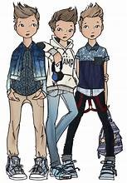Every generation expresses itself through style. However, more and more people accuse today’s adolescents of being fashion victims, stating that they spend too much time and money trying to be cool. What the older generations are forgetting, though, is that modern teens are always connected on the net, so they are always informed about the latest trends and they don’t need to wait for monthly fashion magazines to come out. The latest trends are available to them **at a click of a button**. And while teenagers may be keen on fashion and give in to **peer pressure** like any other generation before them, what people need to realize is that the new generation is actually spend less on this **industry** than never before.

**In general, the author is ………………………………. of teenagers.**

a.annoyed with b. strict towards c. supportive of d. worried about

**C. Read the extract from a web page about credit cards and decide on the correct answer a, b, c or d.**

Once someone turns 18 and opens a bank account, they can get their own credit card, so they need to know carefully the pros and cons of paying by credit card and the risk of **getting into debt** if they are not careful with monthly payments. It must also be clear that although plastic money may **come in handy** when there’s a bargain on offer, they must also make sure that the expense is well within their budget. No doubt, there are certain aspects that young credit card owners should pay attention to, but if handled thoughtfully, there will be nothing to worry about.

**What is the author’s opinion about credit cards?**

a. He believes there is nothing to worry about . c. He consider them easy to use.

b. He thinks they should be avoided. d. He points out they should be used carefully.

**Explain the words in bold and make sentences. Then, say in your own words what the writers’ opinion is on the three topics.**

**28**

Let’s Speak

**Where do you enjoy shopping? Think about the following places. Say what are the pros and cons of shopping in each one. Finally, choose the shopping place that suits you best and say why.**

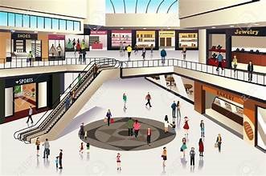 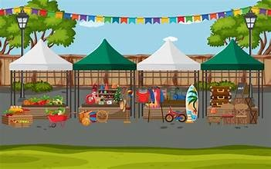

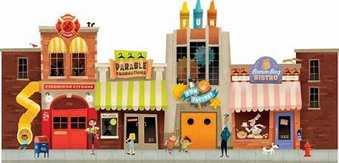 

Let’s write:The advantages & disadvantages of online shopping

**People around the world do a lot of online shopping nowadays. Decide which of the following are advantages and which are disadvantages. Then, use the clues to expand them**

* Find **bargains** (on offer / reduced prices)
* Products may **not live up to your expectations** (order from pictures / different from what you get / disappointed )
* **convenient** (shop from the comfort of your home / shop around the clock / avoid traffic and crowded places / no heavy bags to carry)
* Runs the **risk of credit card fraud** (credit card numbers may be hacked / only buy from reliable sites)
* It is **quick and easy** (saves time / visit a number of websites in no time / buy at the click of a button/ goods delivered straight to your door / return and refund policies)
* Runs **the risk of scamming** (deceived from fake sites / lose money / no refund)

**Use the statements above and write an article on the advantages and disadvantages of online shopping. (120-180 words)**

**29**

Let’s watch: The world’s largest shopping malls.

<https://www.youtube.com/watch?v=anV8utiTQrk>

**Watch the video. Which of these malls would you like to visit? Why?**

**Watch again. Complete the missing words.**

1.In the **SIAM PARAGON** you can watch a film at the state-of-the-art cinema ……………………………, see marine life in an Ocean aquarium, watch an opera performance at the concert hall, play bowling in the bowling alley or sing along at the ……………………………………karaoke centre.

2. In **BERJAYA TIMES SQUARE** in Malaysia you can go shopping in 1,000 retail shops, choose to eat at 65 food ………………………………………. or entertain yourself at a massive indoor theme park.

3. **ISTANBUL KEVAHR** has a spacious stage for hosting various events, a ………………………….. cinemas, a bowling alley, a miniature roller coaster and numerous other ……………………………………… options.

4. **MEGAMALL** in the Phillipines has an ice-skating ………………………………. and numerous cinemas .

5. **WEST EDMONTON MALL** in Canada is a miniature city, as under one ……………………………you can find a water park, a marine life ……………………………………….. and even a replica of Christopher Columbus’s Santa Maria.

6. In **DUBAI MALL** you can find over 1,200 shops, including the largest ………………………... shop in the world, an ice rink, a Sega game centre with a captivating 3D bowling game, a ……………………………………. 5 star hotel, as well as 22 cinema screens and an impressive selection of 120 restaurants and cafes.

7. The **SM MALL OF ASIA** in the Philippines is a place where shopping meets ………………………………………….

8. **CENTRAL WORLD** in Bankgong is not only about size, it’s a …………………………………… experience where you can find everything from high-end fashion labels to quirky local boutiques.

9. The **GOLDEN RESOURCES MALL** in Beijing, China hosts over ……………………………………….. stores that cater to every imaginable taste.

10. The **IRAN MALL** offers a unique tour of Persian culture and global influences all under one roof that really transforms the shopping experience to an ……………………………………………. of exploration and joy.

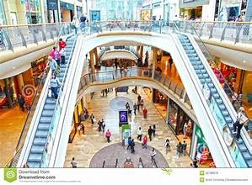 **30**

Let’s Practise: Double Conjuctions

**1) Answer the questions. Use double conjunctions.  
a) Use BOTH ……. AND …… .**1. You have met his father. Have you met his mother?  
***Yes, I have met both his father and his mother.***2. The driver was injured in the accident. Was the passenger injured in the accident?  
………………………………………………………………………………………………………………………………………………………….  
3. Wheat is grown in Kansas. Is corn grown in Kansas?  
…………………………………………………………………………………………………………………………………………………………  
4. He buys used cars. Does he sell used cars?  
………………………………………………………………………………………………………………………………………..……………….  
5. You had lunch with your friends. Did you have dinner with them?  
……………………………………………………………………………………………………………………………………………..………….  
6. The city suffers from air pollution. Does it suffer from water pollution?  
…………………………………………………………………………………………………………………………………………..…………….  
**b) Use NOT ONLY ……. BUT ALSO …… .**1. I know you are studying math. Are you studying chemistry too?  
***Yes, I’m studying not only math but also chemistry.***2. I know his cousin is living with him. Is his mother-in-low living with him too?  
………………………………………………………………………………………………………….………………………………………………  
3. I know the UK has good universities. Does the United States have good universities too?  
………………………………………………………………………………………………………………………………………………………….  
4. I know you lost your wallet. Did you lose your keys too?  
………………………………………………………………………………………………………….……………………………………………….  
5. I know she goes to school. Does she have a full-time job too?  
……………………………………………………………………………………………………..…………………………………………………….  
6. I know he bought a coat. Did he buy a new pair of shoes too?  
………………………………………………………………………………………………………………..………………………………………….  
**c) Use EITHER ……. OR …… .**1. John has your book, or Mary has your book. Is that right?  
***Yes, either John or Mary has my book.***2. You’re going to give your friend a book for her birthday, or you’re going to give her a pen. Is that right?  
…………………………………………………………………………………………………………………………………………………..………….  
3. Your sister will meet you at the airport, or your brother will meet you there. Right?  
…………………………………………………………………………………………………………………………………………………..………….  
4. They can go swimming, or they can play tennis. Is that right?  
………………………………………………………………………………………………………………………………………………..…………….  
5. You’re going to vote for Mr. Smith, or you’re going to vote for Mr. Jones. Right?  
……………………………………………………………………………………………………………………………………………………………….  
6. You’ll go to New Orleans for your vacation, or you’ll go to Miami. Right?  
………………………………………………………………………………………………………………………………………….…………………….  
**d) Use NEITHER ……. NOR ……**1. He doesn’t like coffee. Does he like tea?  
***No, he likes neither coffee nor tea.***2. Her husband doesn’t speak English. Do her children speak English?  
……………………………………………………………………………………………………………..…………………………………………………..  
3. The students aren’t fully awake today. Is the teacher fully awake today?  
…………………………………………………………………………………………………………………………………………………………..……..  
4. They don’t have fridge for their new apartment. Do they have a cooker? **31**  
………………………………………………………………………………………………………………………….……………………………………………..  
5. She doesn’t enjoy hunting. Does she enjoy fishing?  
………………………………………………………………………………………………………………………………………………………………………….  
6. Tom’s grades weren’t good. Were Jill’s grades good?  
…………………………………………………………………………………………………………………….…………………………………………………….

**2) Combine the following into sentences that contain parallel structure. Used appropriate paired conjunctions: BOTH…AND / NOT ONLY… BUT ALSO / EITHER… OR / NEITHER… NOR:**1. He does not have a pen. He does not have paper.  
***He has neither a pen nor paper.***2. Ron enjoys horseback riding. Bob enjoys horseback riding.  
……………………………………………………………………………………………………….………………………………………………………………  
3. You can have tea, or you can have coffee.  
……………………………………………………………………………………………..……………………………………………….………………………  
4. Arthur is not in class today. Ricardo is not in class today.  
……………………………………………………………………………………………………………………………………………………….………………  
5. Arthur is absent. Ricardo is absent.  
………………………………………………………………………………………………………………………………………………………………………  
6. We can fix dinner for them here, or we can take them to a restaurant.  
…………………………………………………………………………………………………………………………………………………………………………  
7. She wants to buy a BMW, or she wants to buy a Toyota.  
…………………………………………………………………………………………………………………………………………………………………………  
8. The leopard faces extinction. The tiger faces extinction.  
…………………………………………………………………………………………………………………….……………………………………………………  
9. The library does not have the book I need. The bookstore does not have the book I need.  
…………………………………………………………………………………………………………………………………………………………………………  
10. We could fly, or we could take the train.  
……………………………………………………………………………………………………………………………………………………………………………  
**3) Combine the following using BOTH…AND / NOT ONLY… BUT ALSO / EITHER… OR / NEITHER… NOR:**1. Paul must go to class. Jean must go to class.  
***Both Paul and Jean must go to class.***2. Paul speaks English. Jean speaks English.  
………………………………………………………………………………………………………………………………….………..………………………………  
3. Paul hasn’t left yet. Jean hasn’t left yet.  
…………………………………………………………………………………………………………………………………….………………………………………  
4. Shall I go to by air, or shall I go by sea?  
………………………………………………………………………………………………………………………..…………………………………………………..  
5. Paul didn’t stay long. Jean didn’t stay long.  
………………………………………………………………………………………………………………………..….………………………………………………..  
6. Paul has a two-car garage. Jean has a two-car garage.  
………………………………………………………………………………………………………………………….…………………………………………………..  
7. Shall I work tonight, or shall I go out?  
………………………………………………………………………………………………………………..……………………………………………………………..  
8. Paul’s house is very central. Jean’s house is very central.  
………………………………………………………………………………………………………………………………………………………………………………..  
9. Paul recognized the man. Jean recognized the man.  
………………………………………………………………………………………………………………………………………………………………………………..  
10. Shall I play volleyball or shall I play tennis?  
…………………………………………………………………………………………………………………………………………………………………………

**32**

Let’s practise: Word Building

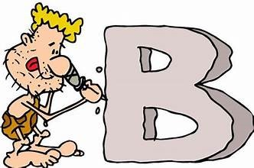

1. How long is the \_\_\_\_\_\_\_\_\_\_\_\_\_\_\_\_\_\_\_\_\_ from Rome to Paris ? (**FLY**)

2. I have a very good \_\_\_\_\_\_\_\_\_\_\_\_\_\_\_\_\_\_\_\_\_\_ with both my parents (**RELATION**)

3. Pulling my front tooth didn’t hurt. – It was completely \_\_\_\_\_\_\_\_\_\_\_\_\_\_\_\_\_\_\_\_\_\_\_ (**PAIN**).

4. I can tell from your \_\_\_\_\_\_\_\_\_\_\_\_\_\_\_\_\_\_\_\_\_\_\_ that you’re not really happy (**EXPRESS**)

5. We offer free \_\_\_\_\_\_\_\_\_\_\_\_\_\_\_\_\_\_\_\_\_\_\_\_\_ for purchases over € 100 (**DELIVER**).

6. James hasn’t had a lot of \_\_\_\_\_\_\_\_\_\_\_\_\_\_\_\_\_\_ lately, so I hope he’ll do well with his new company (**SUCCEED**)

7. It is \_\_\_\_\_\_\_\_\_\_\_\_\_\_\_\_\_\_\_\_\_\_ colder today that it was yesterday (**CERTAIN**).

8. What \_\_\_\_\_\_\_\_\_\_\_\_\_\_\_\_\_\_\_\_\_\_\_\_\_ is he ? Spanish or Portuguese ? (**NATION**)

9. You have the \_\_\_\_\_\_\_\_\_\_\_\_\_\_\_\_\_\_\_\_\_ . – You can either go by bus or walk (**CHOOSE**).

10. My best friend has a great \_\_\_\_\_\_\_\_\_\_\_\_\_\_\_\_\_\_\_\_\_\_\_ . (**PERSON**).

11. You need a lot of \_\_\_\_\_\_\_\_\_\_\_\_\_\_\_\_\_\_\_\_\_\_ to write a good story (**IMAGINE**)

12. The lesson was \_\_\_\_\_\_\_\_\_\_\_\_\_\_\_\_\_\_\_\_\_\_\_ . I almost fell asleep. (**BORE**)

13. Don’t be so \_\_\_\_\_\_\_\_\_\_\_\_\_\_\_\_\_\_\_\_\_\_\_\_ . This is the second vase you have broken this month (**CARE**).

14. It’s simply \_\_\_\_\_\_\_\_\_\_\_\_\_\_\_\_\_\_\_\_\_\_\_\_\_\_ . I have won the lottery . (**BELIEVE**)

15. I have to hold a \_\_\_\_\_\_\_\_\_\_\_\_\_\_\_\_\_\_ at my brother’s wedding (**SPEAK**)

16. There’s a lot of \_\_\_\_\_\_\_\_\_\_\_\_\_\_\_\_\_\_\_\_\_\_\_\_\_ about that on the internet (**INFORM**)

17. The children were very \_\_\_\_\_\_\_\_\_\_\_\_\_\_\_\_\_\_ when the teacher came in (**NOISE**).

18. The film was a bit \_\_\_\_\_\_\_\_\_\_\_\_\_\_\_\_\_\_\_\_\_\_\_ . I didn’t really understand what happened (**CONFUSE**)

19. He has to wear these gloves for \_\_\_\_\_\_\_\_\_\_\_\_\_\_\_\_\_\_\_\_\_ reasons (**SAFE**)

20. Sally was \_\_\_\_\_\_\_\_\_\_\_\_\_\_\_\_\_\_\_\_\_\_\_\_ for two years before she found a new job (**EMPLOY**)

21. In India, there are a lot of \_\_\_\_\_\_\_\_\_\_\_\_\_\_\_\_\_\_\_\_\_\_ in the streets (**BEG**).

22. When I was studying for exams I put on some \_\_\_\_\_\_\_\_\_\_\_\_\_\_\_\_\_\_\_\_ (**WEIGH**).

23. I had no \_\_\_\_\_\_\_\_\_\_\_\_\_\_\_\_\_\_\_\_\_\_\_\_\_ in finding the right street . (**DIFFICULT**)

24. He talked about \_\_\_\_\_\_\_\_\_\_\_\_\_\_\_\_\_\_ and peace in our world (**FREE**)

25. \_\_\_\_\_\_\_\_\_\_\_\_\_\_\_\_\_\_ , I was invited to watch the new film (**LUCKY**)

26. The \_\_\_\_\_\_\_\_\_\_\_\_\_\_\_\_\_\_\_\_\_ of our rainforests is a serious problem (**DESTROY**)

27. Animals in a zoo don’t live in their \_\_\_\_\_\_\_\_\_\_\_\_\_\_\_\_\_\_\_\_\_\_ environment (**NATURE**)

28. \_\_\_\_\_\_\_\_\_\_\_\_\_\_\_\_\_\_ does not have anything to do with how much money you have (**HAPPY**)

29. Thank you for being so \_\_\_\_\_\_\_\_\_\_\_\_\_\_\_\_\_\_\_\_\_\_ yesterday (**HELP**)

30. He has been a long- \_\_\_\_\_\_\_\_\_\_\_\_\_\_\_\_\_\_\_\_\_\_\_ runner for a few years now (**DISTANT**)

31. Don’t you think it’s too \_\_\_\_\_\_\_\_\_\_\_\_\_\_\_\_\_\_ for you to go sailing in such weather (**DANGER**)

32. This is my last \_\_\_\_\_\_\_\_\_\_\_\_\_\_\_\_\_\_\_\_\_\_ . – Don’t walk across the lawn ! (**WARN**)

33. He gave me some good \_\_\_\_\_\_\_\_\_\_\_\_\_\_\_\_\_\_ on where to go shopping (**ADVISE**)

34. If you want to complain about the product, please go to the \_\_\_\_\_\_\_\_\_\_\_\_\_\_\_\_\_\_ (**MANAGE**)

35. The new flat is not \_\_\_\_\_\_\_\_\_\_\_\_\_\_\_\_\_\_\_\_\_ . It’s too expensive (**AFFORD**)

36. John is six years old. He’s very \_\_\_\_\_\_\_\_\_\_\_\_\_\_\_\_\_\_ and full of life (**ACT**)

37. My mother spent her \_\_\_\_\_\_\_\_\_\_\_\_\_\_\_\_\_\_\_\_\_\_\_ in France (**CHILD**)

38. I have made a few \_\_\_\_\_\_\_\_\_\_\_\_\_\_\_\_\_\_\_\_\_\_ to your article (**CORRECT**)

39. Every child should get a good \_\_\_\_\_\_\_\_\_\_\_\_\_\_\_\_\_\_\_\_\_\_\_\_\_ (**EDUCATE**).

40. Listen carefully to the \_\_\_\_\_\_\_\_\_\_\_\_\_\_\_\_\_\_ before you go out ! (**INSTRUCT**)

**33**

UNIT 4: ENTERTAINMENT & THE ARTS

Let’s Learn: THE ARTS

1. **Put the words into the correct group.**

**concert novels pottery poetry / poems theatre painting drama / plays cinema sculpture biographies dance / ballet short stories opera drawing**

|  |  |  |
| --- | --- | --- |
| Fine Arts | Literature | Performing Arts |
|  |  |  |

1. **Match the words and use the collocations to make sentences.**
2. a work a. sculpture
3. archaeological b. exhibition of Greek antiquities
4. cultural c. of art
5. marble / bronze d. heirloom
6. temporary / permanent e. site
7. abstract f. statue
8. architectural g. masterpiece
9. family h. heritage
10. ancient ceramic i. of an original art object
11. a fake j. design
12. **Complete with the correct word from the box.**

**cultural sculptures exhibitions masterpieces galleries exhibits paintings art-lover**

**play comedy reviews theatergoer musical revival performance drama concert**

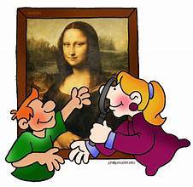Big cities offer a wide range of (1) ………………………………… activities. If you are a(n) (2) ………………………………………., you ‘ll enjoy going to temporary (3) ……………………… (*special, short-term shows*) or at times you may enjoy wandering around the halls of an art museum permanent (4) …………………………………. (*things shown or displayed*) to admire the (5) …………………………….. (*great works of art*) or less well-known (6) …………………………… (*pictures made with paint*) and (7) ………………………… (*statues, etc*) that are always on display. If you want to avoid the crowds, try visiting one of the smaller (8) ……………………………….. downtown.

If the performing are more your thing, you can always buy tickets to a (9) ……………………………… at a music hall or a (10) ………………………………. of the opera or ballet. If you’re an avid (11) ………………………………… (*a person who enjoys going to the theatre*), you’ll want to take in a (12) ……………………………….. at a theatre, but will it be? Perhaps, you’re in the mood for a Broadway (13) …………………… (*a show with singing and dancing*), a (14) ……………………………… (*a hilarious play*), a serious (15) ………………………………… or a (16) ……………………………….. (*new production*) of a favourite old classic. Whatever you decide, it’s always a good idea to check out the (17) …………………………………… (*critical articles*) in a relevant site or entertainment guide, to see what the critics have to say.

**34**

1. **Who is who in the arts - Match the people with what they do**

**audience playwright director scriptwriter conductor producer cast author composer broadcaster**

1. Someone who decides how a film, play or TV show will appear on screen or stage and guides the actors.
2. All the people who act in a film or play.
3. Someone who presents or participates in a TV show.
4. Someone who stands in front of an orchestra or choir and directs the performance.
5. A group of people who watch a performance.
6. Someone who writes the words for films or TV series.
7. Someone who writes short stories or novels.
8. Someone who writes plays.
9. Someone who controls the financials of a show
10. Someone who writes music.
11. **Fill in with the verbs in the correct form.**

**exhibit inspire portray / depict made of draw copy compose perform express paint**

1. He often ………………………….. his works of art at the local art gallery.
2. They admired the magnificent ancient temple ………………………………. white marble.
3. The painter was ………………………………….. by the beauty of the landscape in northern France.
4. The painting …………………………………… a beautiful young lady in a boat.
5. I went to the Opera House where the Vienna State Opera was ………………………………………
6. Artists ………………………………… their feelings and emotions through their works.
7. Mozart ……………………………………… some of the greatest symphonies in music.
8. The artist ………………………………… an impressive pencil portrait in a few minutes.
9. Most of the water colours which were exhibited were ………………………… by French artists.
10. He was arrested for forgery because he ……………………………… great art works and sold them as original ones.
11. **Choose the right word.**
12. The Mona Lisa is regarded as one of Leonardo da Vinci’s greatest **exhibits / masterpieces**.
13. The actor **performed / applauded** the role of Hamlet with deep emotions.
14. The whole cast gave a(n) **accurate / stunning** performance.
15. Have you seen the Picasso **revival / exhibition** at the Museum of Modern Art?
16. The **cast / audience** jumped to their feet and gave the audience a standing ovation.
17. The interviewer asked the author when his next book would be **purchased / published**.
18. She disliked the film because it had **accurate / excessive** violence.
19. The **conductor / producer** tapped his baton and the musicians lifted their instruments.
20. The film is a(n) **accurate / popular** depiction of the real historical events.
21. The novelist is a shy person who doesn’t enjoy being in the **spotlight / picture.**
22. **Up to you!**

**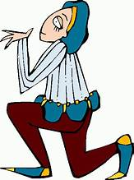Have you ever taken part in a theatrical performance or film making? What was it like? What did you do and how did you feel in the end? Use the phrases.**

* hard work – rehearse long hours
* spend lots of hours learning your role from the script.
* act as natural as you can to help the play seem more lifelike.
* help with the set / sound effects
* amazing performance
* proud / excited
* gain great satisfaction and confidence
* is worth the effort.

MUSEUMS

* **Match the types of museums a-f with the sentences 1-6.**

a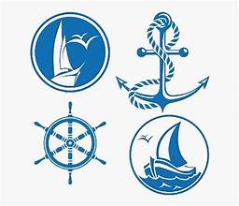b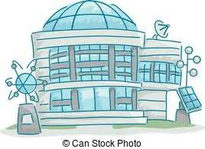c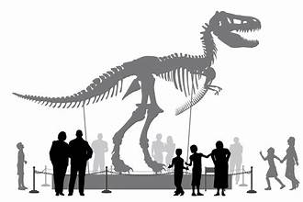d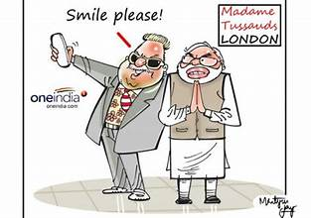e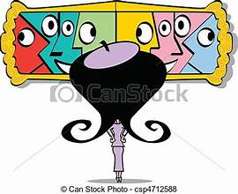f

**Maritime Science Natural History Wax Works Modern Art Archaeological**

1. We went to the …………………………………………. Museum to see the skeletons of pre-historic animals.
2. I visited the …………………………………… Museum to admire the ancient statues.
3. Visit the ……………………………. Museum if you like to learn about boats and ships of the past.
4. The new developments in technology will be presented on video wall screens in the …………………….. Museum.
5. At …………………………….. Museum one can see a wealth of lifesize, realistic models of famous or notorious people placed in different sets.
6. I saw a wide collection of abstract metal sculptures and mixed media paintings in the …………………. Museum.

**How about visiting a museum?**

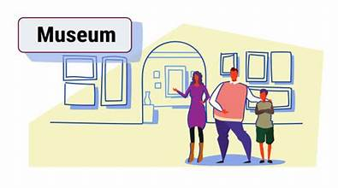Museums are places where human culture, history and civilization are **revived / introduced**. It is here where authentic priceless objects of artistic, cultural, historical or scientific interest, belonging to old or modern times, are **pointed / exposed** to the public. Archaeological finds, which have been unearthed and taken care of, are also exposed. They are preserved in well-lit glass **display / show** cases for people to see. Therefore, visiting a museum is travel back through time in a time-machine and relive the different stages of man’s course through the ages.

***Visitors to an up-to-date museums can see:***

* Large sections representing the various eras of centuries of a country’s history and civilization.
* Wide and fascinating **ranges / collections** of exhibits on **replay / display** after they had been carefully **restored / modernized**.
* Video wall screens with three-**dimensional / triangular** graphic representation of ancient settlements, buildings and monuments.

***Visitors are offered:***

* Free informative **advertisements / brochures** which facilitate their way around the museum.
* Clear, helpful and handy museum **guides / drawings** for guided tours.
* **Headphones / microphones** for recorded guided tours to many languages.

***Finally, visitors can pop into:***

* A gift shop and buy museum guided books and souvenirs such as miniatures or **replicas / artifacts** of the most important exhibits, postcards, posters or relevant videos.

1. **What is usually exhibited in a museum?**
2. **How are exhibits preserved and protected?**
3. **Why is visiting a museum like a time travel?**
4. **What can visitors of a modern museum see?**
5. **What provisions does a museum offer its visitors?**
6. **What can visitors buy at a museum gift shop?**
7. **Explain the highlighted phrases**
8. **What kind of museum would you like to visit? Why? 36**

**The Archaeological Museum of Mycenae**

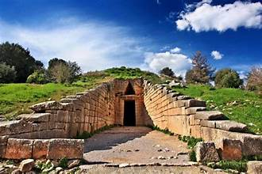 The Archaeological Museum of Mycenae is found at the entrance of the ancient settlement, just a few steps before the Lion Gate. The building of the museum is modern and covers a total surface of 2,000 sq.m. It is constructed in three levels and includes findings from excavations all over the ancient site of Mycenae. A large part of the building is used for storage and elaboration of the findings and only three rooms in two levels are exhibition rooms.

The exhibits come from Mycenae and the wider region and represent time periods from the Copper Period around 3,000 B.C. till the Hellenistic time in the 2nd century B.C. There are about 2,500 exhibits, mostly ceramic vases, jewelry, wall paintings (murals),tools and weapons. The jewelry pieces particularly are very impressive, made of gold and with complicated designs.

In one of the rooms, you can also see a copy of the Golden Mask of Agamemnon, a grave mask that was found in the Treasury of Atreus. The original mask, a funeral mask made of pure gold, is kept in the National Archaeological Museum in Athens. It is not exactly proved but archaeologist Schliemann, who first excavated Mycenae, believed it was the funeral mask of King Agamemnon.

The first room of the Archaeological Museum of Mycenae is dedicated to the life of the Mycenaeans with ceramic exhibits from the ancient town. The second room is dedicated to life after death and includes exhibits from graves, such as offerings to the dead. The third room is dedicated to the Mycenaen civilization in the concepts of religion, science, art, administration, and trade. At the entrance of the museum, there are wall posts narrating the history of Mycenae and of its excavation. Right opposite the entrance, there is also a model of the ancient site. ([www.greeka.com](http://www.greeka.com))

1. **Where is the museum located? Describe it.**
2. **How many exhibits are exposed? What do they include?**
3. **Why are the jewelry pieces impressive?**
4. **Which exhibit – although a copy- is famous?**
5. **What can you see in each of the three rooms?**

* **Match the exhibits of the museum to the pictures.**

**ceramic vases and vessels golden jewelry murals tools weapons**

**small statues the golden mask of king Agamemnon bead necklaces ceramic figures**

a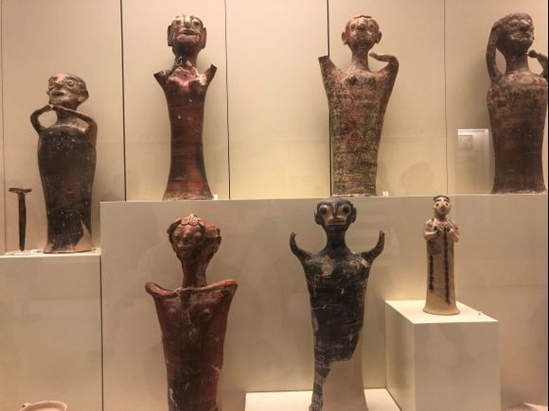b 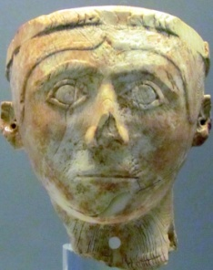 c 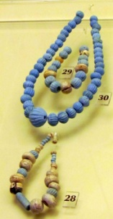d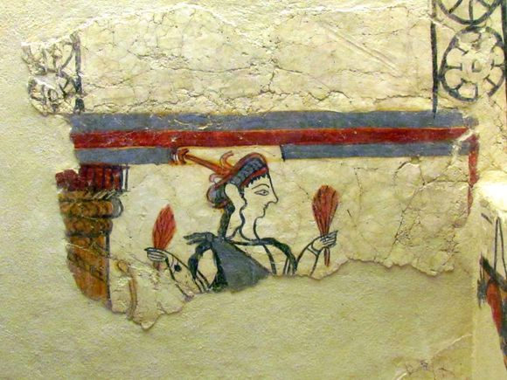e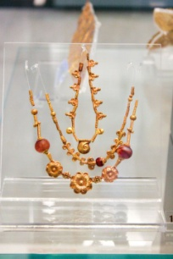

f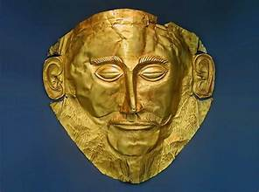g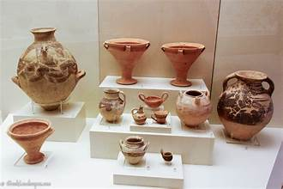h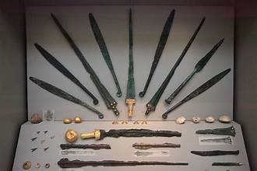i 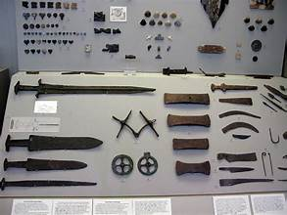

* **Use the adjectives to describe the above exhibits.**

**striking impressive elaborate priceless fascinating outstanding stunning marvelous**

* **Writing: Write an article of about 120-180 words with the title “A Visit to a Museum”**

Imagine you have visited the Mycenae Museum. Use the text and the pictures and write about it. Follow the plan:

**Par.1:** When did you go? Who did you go with? Describe the building and its location.

**Par. 2**: How many exhibits are there? What kind of exhibits are they? Did you manage to see them all?

Describe the exhibits that impressed you most

**Par.3**: Did you take a guided tour? Did you use brochures or headphones?

What did you buy at the Museum gift shop?

**Par. 4:** Did you enjoy the visit? (Why/not?)

Would you recommend other people to visit the Museum?

**37**

The World of Cinema

Film Genres

**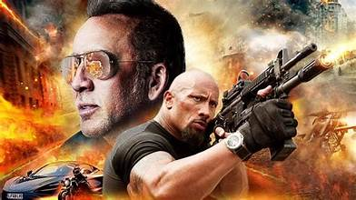Action Movies** are fast-paced films and include a lot of action with fight scenes, chase scenes, and destruction scenes. They can feature superheroes, martial arts, car crashes or extraordinary stunts. These films are more about the action and adventure rather than the plot itself. Action movies are thrilling to watch and leave audience members on the edge of their seats. Police, disaster and spy films are typical action-packed movies, that usually become blockbusters.

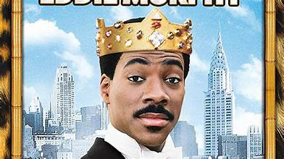

## Comedies are funny and entertaining. Comedies center around a hilarious story—usually putting the main characters in challenging, amusing, or humorous situations they’re not prepared to handle. Good [comedy](https://www.masterclass.com/articles/how-to-write-a-comedy-screenplay-a-guide-to-writing-a-comedic-screenplay-that-will-make-audiences-laugh) movies are less about making constant jokes and more about presenting real-life stories with next-door characters who learn an important lesson.

## C:\Users\pc\Desktop\th (2).jpg

****[**Drama**](https://www.masterclass.com/articles/how-to-write-a-dramatic-screenplay)**s** are fascinating stories with high stakes and many conflicts. They have an intriguing plot with lots of twists and turns. Dramas portray real-life stories or extreme situations that move the audience. They may have a happy or sad ending. They can be historical or costume dramas, romantic stories, teen adventures, medical dramas or outlaw stories.

## C:\Users\pc\Desktop\th (4).jpgFantasy Films feature magical and supernatural elements that do not exist in the real world. Although some stories take place in a real-world setting with fantastical elements, many create entirely imaginary universes with their own laws, logic, and populations of imaginary races and creatures. The Harry Potter film series, based on the novels by J.K. Rowling, follows a young boy at the Hogwarts School of Witchcraft and Wizardry and is a prime example of a fantasy film.

## Horror films include spine-chilling stories that aim to scaring the audiences to death. Horror movies often feature serial killers or monsters that play with the viewer’s fears or nightmares. Audiences who love the horror genre seek out these movies specifically for the adrenaline rush produced by ghosts, monsters, and jump scares.

## C:\Users\pc\Desktop\th (5).jpg

## Mystery Films or Thrillers are all about a puzzle and often feature a detective or person trying to solve it. [Mystery](https://www.masterclass.com/articles/what-is-the-mystery-genre) films are full of suspense, and the protagonist searches for clues or evidence throughout the movie, putting together events and interviewing suspects to solve the central question. The ones with an unpredictable ending can become box-office hits.

## C:\Users\pc\Desktop\th (6).jpg

**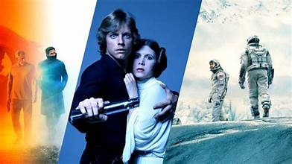Romantic films** are love stories. They center around two protagonists that fall in love but have to go through hardships like illness, infidelity, accidents, or other obstacles to their love. [Romantic comedies](https://www.masterclass.com/articles/how-to-write-a-romantic-comedy-screenplay-plus-15-classic-rom-coms-to-watch-for-screenwriting-inspiration), where lovers get into funny situations, are also very popular

## Science Fiction Films build realities filled with imagined elements that don’t exist in the real world. Sci-fi includes a wide range of themes that often explore time travel or space travel, are set in the future, and deal with the consequences of technological and scientific advances.

**38**

1. **Complete the chart with 3 characteristics about each film genre. Then, use your notes to talk about them.**

|  |  |  |  |
| --- | --- | --- | --- |
| **Action Movies** | **Comedies** | [**Drama**](https://www.masterclass.com/articles/how-to-write-a-dramatic-screenplay)**s** | **Fantasy Films** |
| 1. they are fast-paced and include a lot of action (fight scenes, chase scenes, and destruction scenes) 2. they are more about action and adventure rather than the plot itself. 3. they are thrilling to watch and usually become blockbusters. |  |  |  |
| **Horror films** | **Mystery Films or Thrillers** | **Romantic films** | **Science Fiction Films** |
|  |  |  |  |

1. **Which are your favourite and least favourite types of films?Why? Write 2 paragr. using the notes above.**
2. **Explain the highlighted words and phrases in. Then, use some of them to complete the sentences.**
3. The death of the protagonist in the end managed to …………………………………….. and have them crying.
4. The film ………………………………. Johny Depp as a notorious but hilarious pirate.
5. The horror film was full of ………………………………… scenes that kept viewers on the edge of their seats.
6. The new *Spiderman* film is ………………………………., full of chases, fights and amazing stunts.
7. Oliver Twist went through lots of ………………………………… before he found a caring family.
8. There will be ……………………………………. for your bad behaviour.
9. The protagonist leads a ………………………………. life, full of risks and adventure.
10. The plot was so ……………………………………. that I couldn’ t take my eyes off the screen.
11. The ………………………………….. noise kept me awake all night.
12. **Use the words to complete the sentences.**

**screen -soundtrack– subtitles-leading role–villain-adaptations-nominated–star-row–shot–trailers–credits-scene**

1. 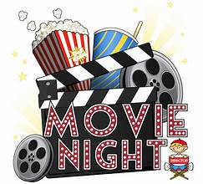The most impressive …………………………… in the film was when the protagonist jumped off the Eiffel Tower.
2. Let’s sit at the back. I don’t like being too close to the ………………………………..
3. I’d rather sit in the front ………………………….. because I forgot my glasses.
4. Tom Cruise ………………………….. in all *Mission Impossible* films.
5. I find it hard to read …………………………………………., so I prefer dubbed films.
6. I like seeing all the …………………………….. of the new films that are coming out.
7. I usually stay at the end to read the ……………………… because I like to know about the less important actors.
8. Harrison Ford has the ……………………………………………… in *Indiana Jones* films.
9. Have you heard the ………………………………… of *Pulp Fiction*? It features outstanding music and songs.
10. The film has been ……………………………….. for 4 Oscars, best film, direction and leading roles.
11. Most scenes were …………………………………….. in exotic locations.
12. *Twilight* films are screen ……………………………………. of the best selling novels.
13. *Joker* is a typical …………………………….. who gets caught in the end. **39**

Let’s Write: A Film Review

1. **The “Cinema World” magazine asks its readers to send reviews of a film they like. Write your review between 120-180 words and recommend the film to your peers.**

**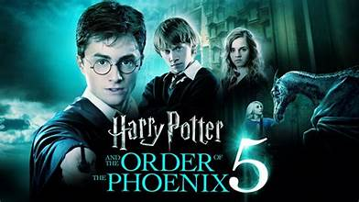**Harry Potter and the Order of the Phoenix

*Harry Potter and the order of the Phoenix* is a film adaptation of the fifth J.K. Rowling’s best-selling novel. It is set in Hogwarts boarding school and the Ministry of Magic. It is a fantasy film with magical and supernatural elements, excellently directed and produced, in which Daniel Radcliff stars as Harry Potter.

The film has an intriguing plot with lots of twists and turns. Harry and his friends, in their effort to find the wicked Voldermort, fight fiercely with the Death Eaters, the villain’s followers. Helped by some members with the Order of the Phoenix, they experience breathtaking adventures, in which their life gets at stakes. Harry manages to teach his friends how to fight in duets and cope with the risks.

It contains magic, great tension and outstanding special effects. The entire cast gives a visually stunning and superb performance throughout the film. Both the leading and secondary roles are brilliant. Its fascinating scenery and music evoke an atmosphere perfectly fitted to the scene and strengthen the supernatural elements. However, the film is sometimes too packed with action and therefore a bit tiring.

The film was the smash hit of the year and I highly recommend it to the whole family, as it can be a perfect night out at the cinema.

1. **Now complete the paragraph plan with information from the review.**

|  |  |
| --- | --- |
| **PARAGRAPHS** | **POINTS** |
| 1. **INTRODUCTION** 2. **What kind of film is it?** 3. **Where is it set?** 4. **Who is the director?** 5. **Who stars in it?** | *Film adaptation o J.K.Rowling’s novel* |
| 1. **MAIN PART**  * **What is the plot? (in a few words)** * **What about the cast/plot/scenery/soundtrack/special effects?** * **Are there any negative points?** |  |
|  |
| 1. **CONCLUSION**  * **Do you recommend the film? Why?** |  |

* **Decide which phrases you would include in the Introduction and which ones in the Conclusion**

1. It’s a gripping thriller and a smash hit at the Cannes Film Festival.
2. All in all, I found the film brilliant and the production spectacular.
3. Concluding, it is a box-office hit worth seeing whatever your age.
4. It is directed by Steven Spielberg and is set in Medieval England.
5. Brad Pitt and Emma Stone star in the leading roles.
6. The film is an adaptation of Charles Dicken’s classic novel.
7. It is a spine-chilling horror film that will keep you on the edge of your seat.
8. The film is a first class-comedy for family entertainment.
9. The film features car crashes, gun chases and bomb explosions. **40**

**VOCABULARY BANK**

**In order to write an interesting and vivid review, you need to use a range of vocabulary, especially adjectives, to give the reader the clearest possible picture about the film (or book or play) you are reviewing. Study the boxes below and put the titles over the correct group of expressions. Decide which ones are positive and which are negative.**

**PRODUCTION-DIRECTION ACTING SPECIAL EFFECTS PLOT SETTING**

……………………………. … …………………………………….. …………………………………………..

stunning / amazing gripping / intriguing /exciting/ high-quality / spectacular

picturesque touching / moving/ funny beautifully directed

realistic / unrealistic unpredictable / unexpected poorly / badly directed

romantic with twists and turns breathtaking scenes

exotic unconvincing / boring / dull keeps people at the edge of their seats

too dark confusing / indifferent

teaches a lesson about life

……………………………………………. ……………………………………………….

first-class / outstanding excessive / far-fetched

superb performance from all the cast hair-raising / spine-chilling stunts

poor / bad / disappointing state-of-the art computer graphics

unconvincing that can cause jump scares

* **Now, use the model review, your notes and the phrases from the Vocabulary Bank to write your review about a film you liked.**

**LISTENING**

**You will hear the reviews of three films. Choose the best answer.**

1. **“Blue Juice” is a(n) …**
2. sci-fi b. soap opera c. adventure
3. **“Blue Juice” combines …**
4. mystery and adventure. b. adventure and suspense. c. suspense and fun.
5. **“Blue Juice” has a(n) …**
6. fun ending. b. frustrating ending. c. unpredictable ending.
7. **The plot of “A Young Poisoner’s Handbook” is based on a(n) …**
8. deeply affecting old legend. b. full of suspense love stor.y c. gripping true story.
9. **The music of the “Young Poisoner’s Handbook”…**
10. brilliantly fits to the scene. b. doesn’t create an atmosphere. c. fails to fit the performance.
11. **Comparing the three films “ A Simple Twist of Fate” is …**
12. the most thrilling and tense film. b. the one which reaches a dramatic climax. c. the one whose leading actor’s performance is not convincing.
13. **“ A Simple Twist of Fate”**
14. may be enjoyed mostly by adults because it’s funny.
15. may not appeal to adults because it’s boring.
16. may be a first-class piece of family entertainment.

Let’s Learn: Idioms with Music

* **Match the idioms with their definitions.**

1. **Αll That Jazz a. buy or sell at** a very cheap price
2. **Blow Your Own Trumpet b.** play a piece of music without reading a music sheet
3. **Face the music c.** two people need to cooperate to overcome a problem
4. **For a song d.** do things the way you want without considering the others
5. **It Takes Two to Tango e.** sounds familiar
6. **March to the beat of your own drum f.** good to hear; welcome news
7. **Music to My Ears g.** similar things, similar qualities, etc
8. **Play it by ear h.** boast about your talents and achievements
9. **Ring a bell i.**  deal with the consequences of your actions**.**

* **Now, match the idioms to the pictures and try to explain what they mean.**

**1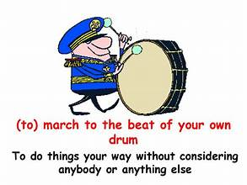2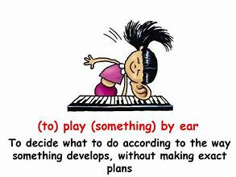3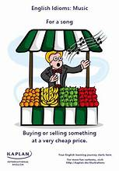4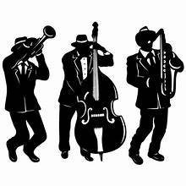5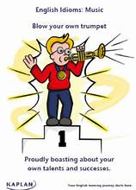**

**6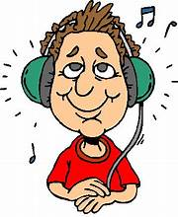 7 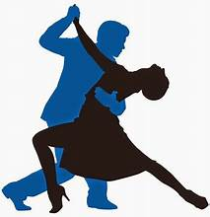 8 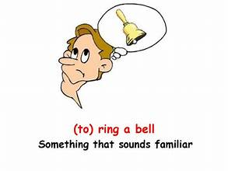 9. 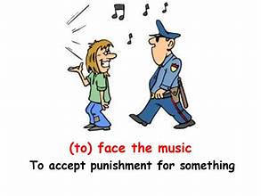**

* **Fill in with the right idiom.**

1. The teacher said I was lazy, that I needed to study more, and **……………………………………..**
2. I hate people who **…………………………………………..** and take so much pride on their achievements.
3. Rob and Keith were caught shoplifting in the local supermarket and now they’ll have to **…………………………**
4. We’d better go shopping for clothes at the flea market. We can buy good things **…………………………………….**.
5. Elena blames Jim for the breakup of their marriage, but **………………………………………**
6. I don’t think I can make Sue change her mind. She always **……………………………………………………..**.
7. Your news was **……………………………………………….** – I’m so happy you got the job.
8. Just because Tom can **…………………………………………………** doesn’t mean he’s a great song writer.
9. Your description**…………………………………………**, but I don’t think I’ve ever been there myself

**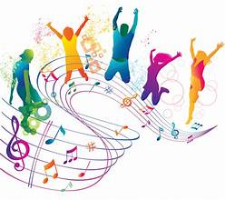 Music, a magical gift**

Music plays a **vital / insignificant** role in our lives. It is said that music **releases / inspires** us and makes us more **efficient / impressive** since it creates a pleasant atmosphere around us. It **deflects / reflects** our feelings and emotions and helps us keep up customs and traditions. Music **lifts / rises** our spirits, creates excitement or **reveals /** **soothes** our feelings and warms our hearts. Therefore, it greatly helps us **relieve / relax** stress after a busy day at work. I believe that music has a magic power and **brings / takes** different races and religions together. It’s a life-giving force and I couldn’t imagine life without it.

**42**

Let’s Practise: Clauses of Purpose & Contrast

**1. Combine the sentences using the words in brackets:**1. Jane gave up smoking because she wanted to save money. (**in order to**)  
………………………………………………………………………………………………………………………………………………………..

2. I came here so that I could see you. (**in order to**)  
……………………………………………………………………………………………………………………………………………….………  
3. She went shopping so she could buy herself a television. (**to**)  
…………………………………………………………………………………………………………………..……………………….………….  
4. I put the food in the fridge because I wanted it to get cold. (**in order to**)  
…………………………………………………………………………………………………………………………………………….………….  
5. Jane saved money. She wanted to buy a present for Harry. (**in order to**)  
…………………………………………………………………………………………………………..………………………..………………….  
6. Harry left early because he didn’t want to miss the bus. (**in order not to**)  
………………………………………………………………………………………………………………………………..………..…………….  
7. They will let the students use calculators in the exam. They don’t want them to spend a lot of time. (**so that**)  
……………………………………………………………………………………………………………………………………..……….……….  
8. The teacher tested the students. She wanted to see if they remembered the things they had learnt. (**in order to**)  
……………………………………………………………………………………………………………………………………….……..……….  
10. She didn’t leave her son home alone. She thought he might have an accident. (**in case**)  
………………………………………………………………………………………………………………………………………….…………….  
11. He tried to hide the broken vase. He didn’t want to be punished. (**so as not to**)  
………………………………………………………………………………………………………………………………………………………..  
12. She wants to sign a contact. She doesn’t want them to change their minds. (**in case**)  
………………………………………………………………………………………………………………………………………………………..  
13. Sue lowered the volume on the TV set. She didn’t want to disturb her roommate. (**so as not to**)  
………………………………………………………………………………………………………………………………………………………..  
14. I’ll be in my office until late this evening. You may need to get in touch with me. (**in case**)  
…………………………………………………………………………………………………………………………………………………………  
15. I’ll give you my phone number. You may need to speak to me. (**in case**)  
…………………………………………………………………………………………………………………………………………….……………  
  
**2. Complete the following sentences:**1. He decided to take a taxi so that ……………………………………………………….……………………….………………………..  
2. Mr. Brown booked his room at the hotel in case ……………………………………..……….………………………………….  
3. Betsy studies her lessons regularly so that ……………………………………………..…….………………………………………  
4. Mark phoned his friend in order to …………………………………………………….…………………………………………………  
5. You’d better call Susan and remind her the date of the party in case ……………………..…………..………………  
6. I need to buy some laundry detergent so that ……………………………………………………………………………..……….  
7. I need a pen so that ………………………………………………………………………………………………………………………………  
8. I’m taking a plane instead of a bus so that ………………………………..………………………..………………………………..  
9. Ralph borrowed some money from his friend in order to ………………….……………………………..……………………  
10. Martina is trying to improve her English so that ………………………………………………………………..…………………...  
11. Mary hurried to get the child out of the road to …………………………………………………………………..………………  
12. I put on my gloves in order to …………………………………………………………………………..………………………………….  
13. I think I’d better clean up my flat in case ………………………………………………………………………………………………..  
14. She locked the door before going to bed in case …………………………………………………………………………………...  
15. The teacher reminded the students the common test dates in case …………………………………………..…………  
 **43**

**3.Rephrase the sentences beginning with the words in brackets:**1. She has plenty of money, but she is very mean. **(although)**……………………………………………………………………………………………………………………….…………………………………  
2. They have a car, but they rarely use it. **(though)**…………………………………………………………………………………………………………………..……………………………………  
3. Dave was innocent, but he was sent to prison. **(although)**……………………………………………………………………………………………………………….……………………………………………  
4. Floyd has a number of relatives living nearby, but he never visits them. **(even though)**……………………………………………………………………………………………………………………………………………………..……  
5. She never takes any kind of exercise, but she is quite fit and healthy. **(however)**…………………………………………………………………………………………………………………………………………………….………

6. Betty is quite sociable. She rarely goes out. (**even though**)

…………………………………………………………………………………………………………………………………………………………….

7. Airplanes are fast. I’m afraid of flying, so I prefer travelling by car. (**however**)

…………………………………………………………………………………………………………………………………………………………….

**4. Rephrase the sentences using the words in brackets.**1. They went out for a walk, even though the weather was bad. **(despite)**…………………………………………………………………………………………………………………………………,……………….………  
2. She managed to write, even though her hand was injured. **(in spite of)**……………………………………………………………………………………………………………………………………………………………  
3. All the trains were on time, even though the snow was heavy. **(despite)**……………………………………………………………………………………………………………………………………………………………  
4. Our coach didn’t arrive late, even though the traffic was terrible. **(in spite of)**……………………………………………………………………………………………………………………………………………………………  
5. A lot of people buy those houses, even though the prices are high. **(despite)**………………………………………………………………………………………………………………………………………………………..…  
6. He stayed up late, even though he was very tired. **(despite)**……………………………………………………………………………………………………………………………………………..……………  
7. I didn’t buy the car, even though I had the money. **(despite)**……………………………………………………………………………………………………………………………………………………………  
8. He stayed outside in the cold weather, even though he felt ill. **(despite)**……………………………………………………………………………………………………………………………………………………………  
9. People continue to smoke, even though they know the dangers. **(in spite of)**……………………………………………………………………………………………………………………………………………………………..

**3. Sally and Peter are good friends, but they are very different. Compare Sally and Peter. Join each idea in A with the most suitable idea in B. Make sentences using WHILE / WHEREAS:  
 A B**1. She likes hard work. a) He prefers classical music.  
2. She likes jazz and pop music. b) He prefers staying at home.  
3. She likes going out a lot. c) He can be rather mean.  
4. She’s very practical. d) He’s quite lazy.  
5. She’s very generous. e) He’s quite idealistic.  
1. ………***She likes hard work, while / whereas he’s quite lazy*** ……………………………………………………………………

**44**

Let’s Practice: Word Building

1. A \_\_\_\_\_\_\_\_\_\_\_\_\_\_\_\_\_\_\_\_\_\_ of foreign languages, especially French and German, is required for the job. (**KNOW**)

2. Judo requires both skill and \_\_\_\_\_\_\_\_\_\_\_\_\_\_\_\_\_\_\_\_\_\_ (**STRONG**).

3. We decided to buy the house because the price was very \_\_\_\_\_\_\_\_\_\_\_\_\_\_\_\_\_\_\_\_\_\_ (**REASON**)

4. The \_\_\_\_\_\_\_\_\_\_\_\_\_\_\_\_\_\_\_\_\_\_ of the mountain is about 2000 metres (**HIGH**).

5. Tea or coffee? – If I had the \_\_\_\_\_\_\_\_\_\_\_\_\_\_\_\_\_\_\_\_\_\_ I’d take tea (**CHOOSE**).

6. She was very \_\_\_\_\_\_\_\_\_\_\_\_\_\_\_\_\_\_\_\_\_\_ and hoped to become a lawyer before she reached the age of 35. (**AMBITION**)

7. Thank you for everything you’ve done. You’ve been very \_\_\_\_\_\_\_\_\_\_\_\_\_\_\_\_\_\_\_\_\_\_ (**HELP**).

8. The painting looked real, but the \_\_\_\_\_\_\_\_\_\_\_\_\_\_\_\_\_\_\_\_\_\_ was obviously a forgery (**SIGN**).

9. Last year the company made a \_\_\_\_\_\_\_\_\_\_\_\_\_\_\_\_\_\_\_\_\_\_ of over $10 million (**LOSE**).

10. I could never live in Saudi Arabia because of the \_\_\_\_\_\_\_\_\_\_\_\_\_\_\_\_\_\_\_\_\_\_ (**HOT**).

11. She passed all of her exams with \_\_\_\_\_\_\_\_\_\_\_\_\_\_\_\_\_\_\_\_\_\_ (**EASY**).

12. I do not think it is a good idea to go to the beach today. It’s too \_\_\_\_\_\_\_\_\_\_\_\_\_\_\_\_\_\_\_\_\_\_ (**CLOUD**).

13. The police are looking into the \_\_\_\_\_\_\_\_\_\_\_\_\_\_\_\_\_\_\_\_\_\_ disappearance of the old man (**MYSTERY**)

14. Don’t touch that snake. It’s extremely \_\_\_\_\_\_\_\_\_\_\_\_\_\_\_\_\_\_\_\_\_\_ (**POISON**).

15.I think it’s a very \_\_\_\_\_\_\_\_\_\_\_\_\_\_\_\_\_\_\_\_\_\_ thing to wait before you buy the house. Prices might go down (**SENSE**)

16. Who prepared this fish? It’s awful and completely \_\_\_\_\_\_\_\_\_\_\_\_\_\_\_\_\_\_\_\_\_\_ (**TASTE**).

17.The judge demanded \_\_\_\_\_\_\_\_\_\_\_\_\_\_\_\_\_\_\_\_\_\_ of his innocence (**PROVE**).

18.Do you know the \_\_\_\_\_\_\_\_\_\_\_\_\_\_\_\_\_\_\_\_\_\_\_\_\_\_ of the Atlantic Ocean? (**DEEP**)

19. It is my \_\_\_\_\_\_\_\_\_\_\_\_\_\_\_\_\_\_\_\_\_\_ that there are other living beings in the universe (**BELIEVE**).

20. Everyone will tell you that \_\_\_\_\_\_\_\_\_\_\_\_\_\_\_\_\_\_\_\_\_\_ is the best way to keep prices down (**COMPETE**).

21. A phrasebook is a very \_\_\_\_\_\_\_\_\_\_\_\_\_\_\_\_\_\_\_\_\_\_ thing to have when you visit a foreign country (**USE**).

22. He definitely has the \_\_\_\_\_\_\_\_\_\_\_\_\_\_\_\_\_\_\_\_\_\_ to become a professional tennis player (**ABLE**)

23. This part of the country is made up of a landscape of great \_\_\_\_\_\_\_\_\_\_\_\_\_\_\_\_\_\_\_\_\_\_ (**BEAUTIFUL**)

24. I can’t finish this book. I’ll die of \_\_\_\_\_\_\_\_\_\_\_\_\_\_\_\_\_\_\_\_\_\_ (**BORED**).

25. The \_\_\_\_\_\_\_\_\_\_\_\_\_\_\_\_\_\_\_\_\_\_ of the plane was delayed because of fog around the airport (**DEPART**).

26.He was filled with \_\_\_\_\_\_\_\_\_\_\_\_\_\_\_\_\_\_\_\_\_\_ when he saw his neighbour’s new car (**ENVIOUS**).

27. You should care about your \_\_\_\_\_\_\_\_\_\_\_\_\_\_\_\_\_\_\_\_\_\_ when you go to the interview (**APPEAR**).

28. There is no \_\_\_\_\_\_\_\_\_\_\_\_\_\_\_\_\_\_\_\_\_\_ between his latest book and the earlier ones (**COMPARE**)

29. We had to get special \_\_\_\_\_\_\_\_\_\_\_\_\_\_\_\_\_\_\_\_\_\_ to leave early (**PERMIT**).

30. As the best man, he had to make a \_\_\_\_\_\_\_\_\_\_\_\_\_\_\_\_\_\_\_\_\_\_ at the wedding (**SPEAK**).

**WAYS OF LOOKING: Explain what the “looking” verbs mean with the help of the pictures. Then, write sentences about each picture using the verbs.**

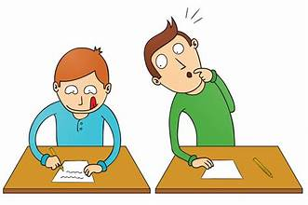 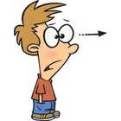  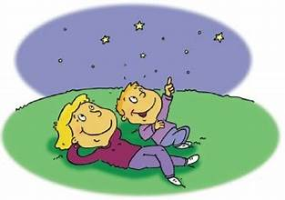 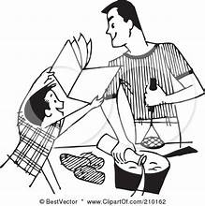 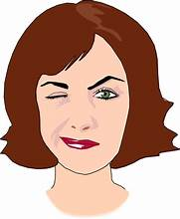

**1. glance 2. stare 3. examine 4. gaze 5. glimpse 6. blink**

1. ….. Greg glanced at Tom’s English test to write, because he was unprepared………………………………………………..

2…………………………………………………………………………………………………………………………………………………………………………….

3…………………………………………………………………………………………………………………………………………………………………………….

4…………………………………………………………………………………………………………………………………………………………………………….

5……………………………………………………………………………………………………………………………………………………………………………..

6……………………………………………………………………………………………………………………………………………………………………………..

**45**