ENGLISH
for
B΄ CLASS
LEVEL B1



Cosmas Markis (EFL Teacher)
3rd Junior High School of Preveza

CONTENTS
UNIT 1: ACCIDENTS & INJURIES ……….p.1-9
UNIT 2: ANIMALS IN THE WILD………….. p.10-18
UNIT 3: IN SICKNESS & IN HEALTH…… p.19-25
UNIT 4: TRAVEL & TRANSPORT………… p.26-32
Unit 5: PRESENT & PAST…………………. p.23-40

UNIT 1: ACCIDENTS & INJURIES
Let’s Learn:
- Match the expressions with the pictures.
- I’ve broken my arm. 4. I’ve burnt my hand 7. I got an electric shock
- I’ve sprained my wrist. 5. I have a nosebleed 8. I got stung by a jellyfish.
- I’ve cut my thumb. 6. I hit my head 9. I twisted my ankle
a 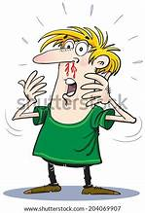 b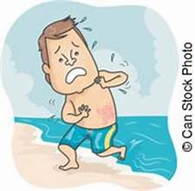 c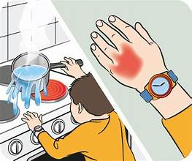d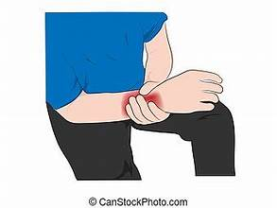 e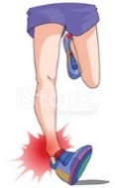f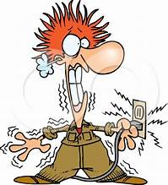g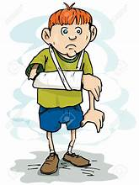h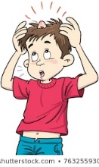i

- Match the phrases with the pictures.
- He’s unconscious 3. He’s bruised 5. He’s got a black eye
- It’s bleeding 4. He’s got a bump 6. He’s got a bad scar on the cheek.
a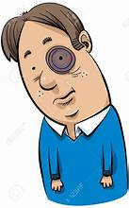 b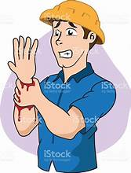 c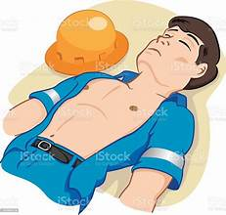d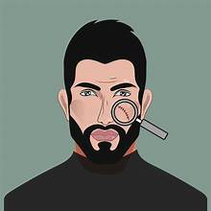 e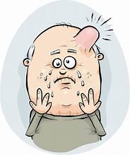f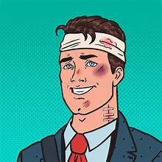

- Complete the following dialogues with the phrases.
burn myself cut myself scratched myself injured myself
- –“You’ve got blood on your face!” - “I know. I’ve just ……………………………….. in shaving.”
- –“What have you done to your hand?” - “I …………………………………..as I taking the food out of the oven.”
- – Have you ever been horse riding? - “Yes, once, but I fell off and ……………………………….. quite badly.”
- – What’s the matter?” - “I’ve just ………………………………….. on that rose bush.

- OUT OF HOSPITAL: Match the descriptions with the pictures.
1. His leg’s in plaster. 5. His ancle’s bandaged up.
2. His arm’s in a sling. 6.He had to have stiches.
3. He’s walking on crutches. 7. He’s in a wheelchair.
4. He needs a walking stick. 8. He can’t walk without a zimmer.
a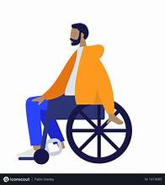 b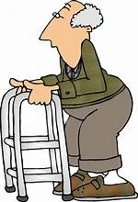 c 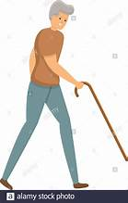 d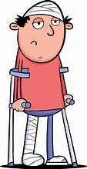e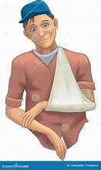f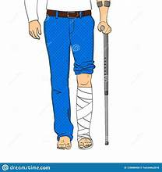g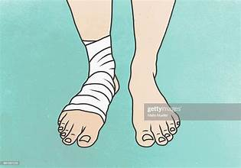 h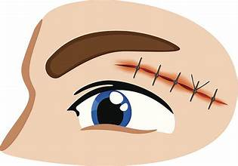
- Read the following paragraph and then write a similar one to describe an accident briefly.
Yesterday afternoon, I went to play basketball with my friends. I was very excited at the game. At a point, I made a high jump to score but I tripped over my feet and fell flat on the ground. I felt a terrible pain on my ankle. At first, I felt scared because I thought I broke my leg. I stood up but I could walk with difficulty. My dad took me to the doctor. Luckily, it was not a broken leg but a twisted ankle. The doctor covered it with bandage and gave me some painkillers. Now, I have to rest in bed for two or three days.
1
Let’s Practise:
NARRATIVE TENSES (Past Simple / Past Continuous)
- What were you doing at the following times? Complete using the Past Continuous.
- (at 8 o’clock yesterday evening) ………………………………………………………………………………………………………………………………..………………………
- (at 11:00 yesterday morning) …………………………………………………………………………………………………………………………..…………………………..
- (at 5:00 this morning) ……………………………………………………………………………………………………………………….……………..……….……..
- (this time last week) …………………………………………………………………………………………………………………………….………………………..
- (half an hour ago) ………………………………………………………………………………………………………………………….……………………………

- Use your own ideas to complete the sentences. Use the Past Continuous.
- Tom burnt his hand while he …………………………………………………………………………………………………………..
- The doorbell rang while I …………………………………………………………………………………………………………………
- We saw an accident …………………………………………………………………………………………………………………………
- Mary fell asleep while she …………………………………………………………………………………………………………………
- The television was on but nobody ……………………………………………………………………………………………………

- Put the verbs into the correct tense (Past Simple or Continuous)
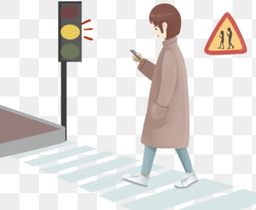
I ……………………………………….. (see) Jill in town yesterday but she …………………………… (not / see) me. She …………………………………………….. (look) at her mobile.
I …………………………………………. (call) her but she …………………………………………….
(not / hear) me because of the traffic noise.

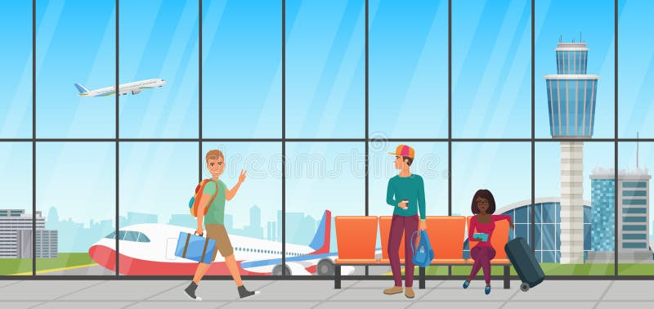
I ……………………………………………… (meet) Tom and Anne at the airport a few weeks ago. They …………………………………………… (go) to Berlin and I ……………………………………. (go) to Madrid. We …………………………………………….. (have) a chat while we ……………………………………… (wait) for our flights.

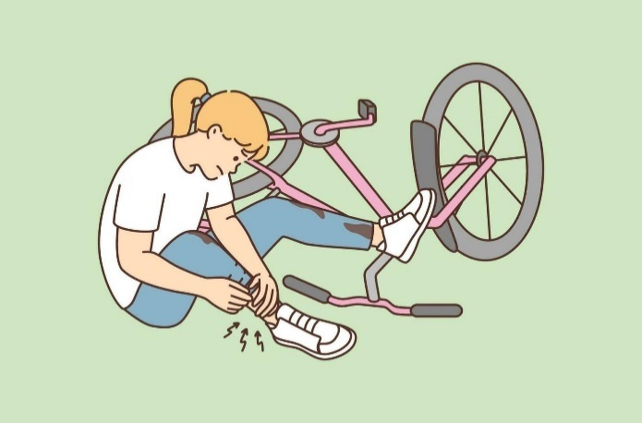
Sally ……………………………………..... (cycle) home yesterday. She ………………….
(be) in a hurry and ……………………………………………….. (not / notice) a deep hole in front of her. Before she ………………………………………… (know) it she ……………………………………… (fall off) her bike. Luckily, she ………………………………………………….. (not / be) seriously injured. She only ……………………………………………. (hurt) her ankle.
2

- How did it happen?
1. How did Bruce hurt himself? (play football)
………………. He hurt himself while he was playing football. ………………………………………………….
2. How did Martin burn himself? (iron his clothes)
……………………………………………………………………..………………………………………………………………………
3. How did Helen cut her thumb? (slice onions)
…………………………………………………………………………………………..…………………………………………………
4. How did Jennifer twist her ankle? (skate)
…………………………………………………………………………..…………………………………………………………………
5. How did Marvin break his arm? (ride his bike)
………………………………………………………………………………………………………………………………………………
6. How did you lose your wallet? (ride my scooter)
………………………………………………………………………………………………………………………………………………
7. How did Jeff get an electric shock? (fix the light)
…………………………………………………………………………………………….…………………………………………………
8. How did Bob get a black eye? (fight with his brother)
…………………………………………………………………………………….…………………………………………………………
9. How did your children burn themselves? (make breakfast)
………………………………………………………………………………………………………………………………………………
10. How did Martha fall? (dance)
………………………………………………………………………………………………………………………………………………

- What’s the matter? Make dialogues as in the example:
Who? | What was he / she doing? | What happened?
Tina | ice-skate | fall on the ice | break foot
Jack | play football | kick the goalpost | break leg
Bob | cycle | fall off the bike | injure hand
Ann | skate | fall over | break arm
Alice | dance | trip over the carpet | sprain ankle

Example: You : Hi, Tina! What’s the matter with your foot?
Tina : I broke it.
You : How did it happen?
Tina : I fell on the ice while I was ice-skating
Write sentences based on the dialogues.
eg. Tina broke her leg because she fell on the ice while she was ice-skating
2.Jack …………………………………………………………………………………………………………………………………………………….
3. Bob ……………………………………………………………………………………………………………………………………………………
4. Ann ……………………………………………………………………………………………………………………………………………………
5. Alice …………………………………………………………………………………………………………………………………………………..
3

Let’s Speak & Write: A FIRE IN MY NEIGHBOURHOOD
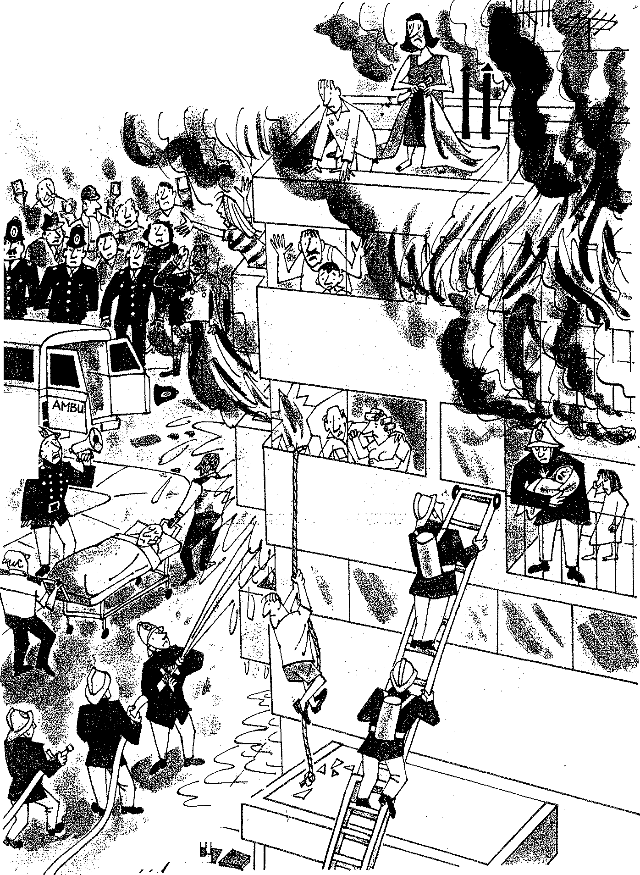

4
A fire in my neighbourhood
A. Find the people in the picture
1.people in the crowd 2. a row of policemen 3.two stretcher-bearers 4.the people in the building 5.firemen / firefighters 6.a baby 7.the baby’s older sister 8.a young man 9.the young man’s parents 10.Dad with his little son 11.mum 12. a couple

B. Imagine and say how the people in the picture seem
terrified upset relieved worried frightened distressed afraid nervous

C. Use the clues to say what the people were doing at the time of the fire.
- take pictures or videos / mobiles
- try / hold / crowd / away / the burning building
- carry / injured man / nearby ambulance / get / hospital
- shout / people / building / keep calm
- try / put out / fire / throwing water / a hose
- climb up / ladder / second floor / help / people / building
- hold / baby his arms
- cry / feel / upset but relieved.
- climbing down / rope / save himself / flames
- watch / son / feel / distressed / wait for help
- be / trapped / flat
- look / window / hope / firefighters / help them out
- scream for help.
- tie / sheets / climb down / the burning building

D.Use the clues above and write a story with the title: “A Fire in my neighbourhood”. Use also the questions below to help you write the introduction and the conclusion.
INTRODUCTION
When? - yesterday afternoon
Where? -at home
What were you doing? - watch TV / do homework / play video games / chat online
What happened? - heard police sirens wailing outside
What did you do? -run out to the balcony / see what / going on.
What did you see? -when / got out / see black smoke everywhere / ambulance / rush / the end of the street / lots of people / run and shout.
What did you realize? - a building / on fire
What did you do next? - get out / house / go there / too / fire break out / block of flats / air /choking.
How was everybody feeling? - upset / terrified

CONCLUSION
What happened in the end?
Three hours later / firefighters manage / put out / fire / luckily / no one lose / lives / only / injured / taken / hospital.
How do you feel about the incident?
sorry / people / left homeless / at least / no casualties / everyone / safe and sound.
5

Let’s Read & Write: An accident
- Emily has invited her friend Gina to her party next Saturday but she cannot go because she had an accident. Read Gina’s answer and complete her mail with the correct word.

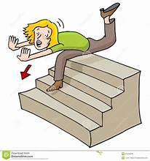
pain top plaster set operation accident stumbled broken crutches ambulance
Dear Emily,
I was so glad to hear that you’re having a party next Saturday and normally I would look forward to coming – your parties are always top!
Unfortunately, I can’t make it because of a (1) ……………………………… leg. You know, I had an (2) ……………………………. at my own home four days ago. It was Thursday evening and I was listening to music in my room. Suddenly, I heard my mum calling me loudly – she must have called me several times but with my earphones on I couldn’t listen to her. I ran downstairs in a hurry when I (3) ………………………………. , slipped and that was all! I found myself at the end of the stairs with a terrible (4) …………………………….. in the leg. Mum called an (5) ……………………………….. , which took me to hospital. The doctor examined me, X-rayed my leg and found out it was broken. He managed to (6) …………………………… the bone and put my leg in (7) ……………………………………… . Luckily, I didn’t need an (8) ……………………………………………… I still can’t believe how this happened to me!
I’m now walking on (9) ……………………………… and still in hospital so I ‘m unable to come even if I want it so much. What a pity! Anyway, time flies and I’ll soon be on (9) …………………………………. of the world again. I wish I could come to your party. Maybe, next time. Love
Gina
- Use the clues to describe what happened to Emily.
Thursday evening / listen to music / / mum calling / earphones on / couldn’t listen / run downstairs in a hurry / stumble / / slipped / find herself / end of the stairs / terrible pain / leg / Mum call an ambulance /
/ take her to hospital.
- Use the clues to describe what happened at the hospital
doctor examine / X-ray / leg / find out / broken / set the bone / put leg in plaster / luckily / not need an operation / now / walk on crutches / still in hospital.
- How does she feel about the accident?

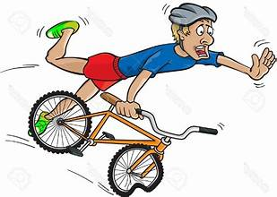
- Choose the correct noun / phrase to complete the collocations. Then, make example sentences.
- fall off a. on wet floor
- lose / regain b. on the stairs
- stumble c. consciousness
- slip d. a concussion
- suffer / have e. a bike

- Useful phrases to turn down an invitation
Read the phrases and decide which ones you would use in the beginning of a mail and which in the ending.

- I’m sincerely sorry for not coming to ….
- Perhaps we can meet some other time.
- Thanks for inviting me to … but I can’t make it.
- I’m really sorry I have to miss it.
- Please forgive me for not being able to come and thanks for your invitation once again.
- I’m sorry to upset you but … 6
- Bill has invited his friend Tanya to an international chess competition he’s taking part in but she cannot go because she had an accident. Look at the pictures that show how the accident happened and match them with the phrases a-g. Explain the words in bold.

- I heard a screeching noise as she slammed on the brakes.
- She lost control of the car because the road was wet and slippery.
- We were driving along a country lane when a red car pulled out of a side road.
- Mum swerved to the other side of the road to avoid hitting it.
- I banged my head on the windscreen and everything went black. I had passed out.
- She swerved over again to avoid collision and got into the way of an oncoming vehicle.
- The car skidded (on the road) and crashed onto a tree.
1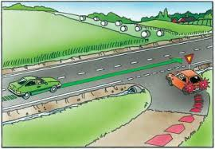 2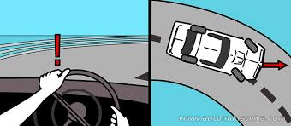 3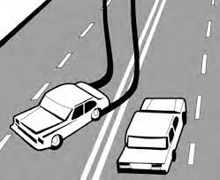4 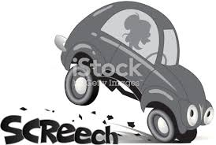
5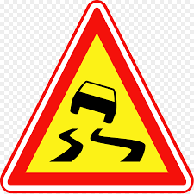 6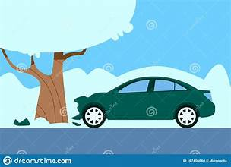7 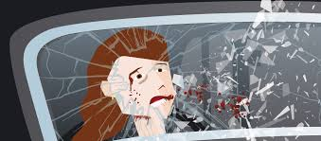 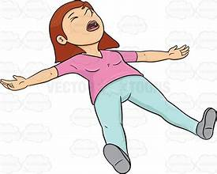
- Now, complete the letter with the accident description.
Hi Bill,
I’m so glad about the competition and I feel proud that you’re taking part. However, it’s impossible for me to come as last weekend I had a car accident and I’m still in bed!
It happened last weekend as mum and I were coming back from the Mall . ……………………………………………………………… ………………………………………………………………………………………………………………………………………………………………………………………………………………………………………………………………………………………………………………………………………………………………………………………………………………………………………………………………………………………………………………………………………………………………………………………………………………………………………………………………………………………………………………………………………………………………………………………………………………………………………………………………………………………………………………………………………………………………………………………………………………………………………………………………………………………………………………………………
……………………………………………………………………………………………………………………………………………………………………………………
When I came round, I heard the wailing sirens of an ambulance, which took me to hospital. The doctors examined me and decided I had a minor concussion. They prescribed me some medicine and advised me to stay in bed. Mum’s got over it with some bruises on her arms but she’s very worried about me
As you can understand, I’m still in a state of shock. I’m really sorry I can’t attend your chess competition but I’m sure you’re going to be the winner. You’ve proved many times that you can beat even the most competent opponents and win. So, don’t worry at all. Just keep a cool head!
All the best
Tanya
7

- Your friend Mark has sent you a short mail inviting you to spend a weekend at his home by the sea. Sent him an e-mail between 100-150 words saying that you cannot go because you had an accident and describe it in detail.
Dear Steve,
How about coming to my home by the sea next weekend? We could enjoy the sea together, do water sports and even go scuba diving.
I think it would be wonderful. What do you say?
Mark

Let’s Listen
You will hear five people describing some accidents they had. For questions 1-5 choose which of the situations A-H each speaker is describing. There are three extra letters you won’t need to use.
- Who was satisfied with his deed?
- Who lost consciousness? Speaker 1 ………
- Who stayed as still as a statue? Speaker 2 ………
- Who had stitches? Speaker 3 ………
- Who won a scholarship? Speaker 4 ………
- Who was shocked by what he was told? Speaker 5 ……….
- Who was sick with measles?
- Who took part in a car race?

- Now listen again and explain the highlighted words. Write them under the correct picture.
It all happened on the spur of the moment.
I heard an ear-splitting sound.
I saw stars and passed out.
I decided to drive back home down a winding road.
Suddenly, I saw a bulky object rushing towards my car.
My cheeks were as heavy as lead and I had a splitting headache.
I was shattered when the doctor diagnosed that I had the mumps
Another car which was speeding along crashed into the blue one and overturned.
As a result, I ended up in hospital and had my hand sewn up.
1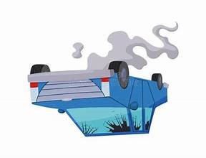2 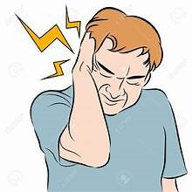3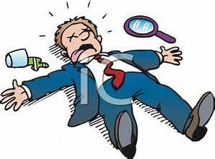4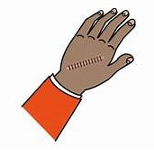5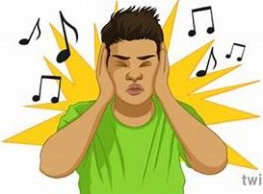

6 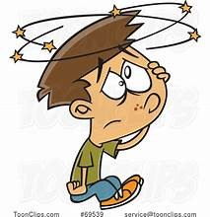7 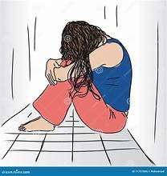8 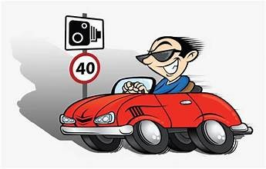9 10 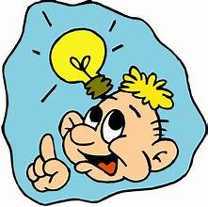

8
Let’s Learn and Practise: Phrasal Verbs
break
1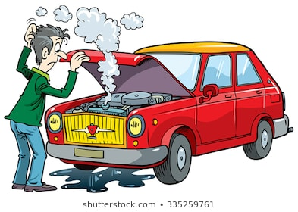 2 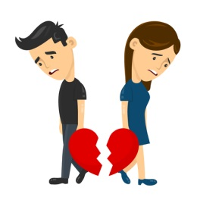 3 4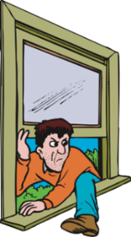 5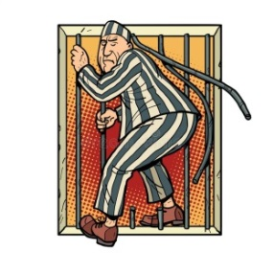 6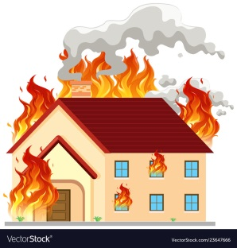
break down break up break up break into break out break out

- Match the phrasal verbs with their meanings.
a. to escape b. (of machines) to stop working c. to stop for holidays
d. to separate e. (for fires, wars, diseases) to begin g. to enter illegally

- Say and Write: Look at the pictures and answer the questions. Use the phrasal verb.
- Dad was late last night. What happened to him?
- What happened to Sam and Elly after five years of marriage?
- Why are the students happy?
- What happened to the neighbouring house yesterday?
- Did Jack the Horrible do a lot of time in prison?
- What happened to the large house at the end of the street last week?

- Now, make your own sentences

look
1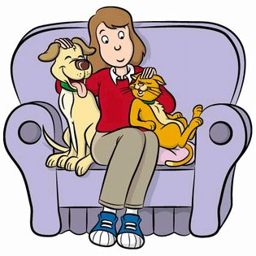2 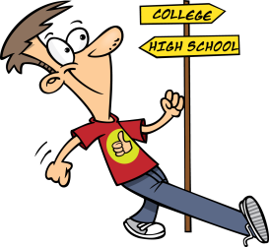 3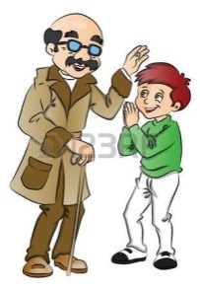4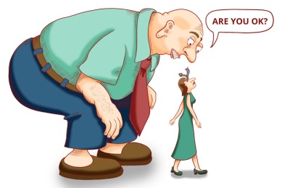 5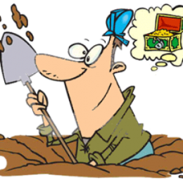 6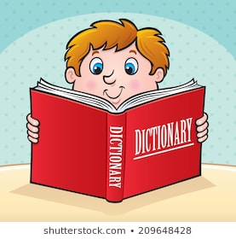7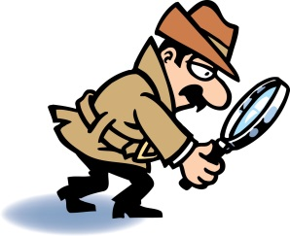
look after look forward to look up to look down on look for look up look into

- Match the phrasal verbs with their meanings.
a. to consider sb as inferior b. to search in a list c. to take care of d. to investigate
e. to respect g. to search h. to expect sth with pleasure

- Say and Write: Look at the pictures and answer the questions. Use the phrasal verb.
1. What does Sally love to do?
2. Phil is finishing school this year. How does he feel?
3. How does Gerry feel about his uncle?
4. How does Bruce feel about his cousin Lina?
5. Why is Charlie digging?
6. What should you do if you meet unknown words ?
7. What is the detective doing?

- Now, make your own sentences.

9
UNIT 2: DISASTERS
Let’s Learn
Write the correct word under the picture
Natural Disasters
earthquake tsunami blizzard avalanche storm volcanic eruption tornado flood
1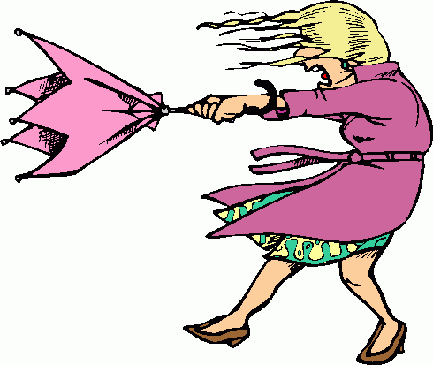 2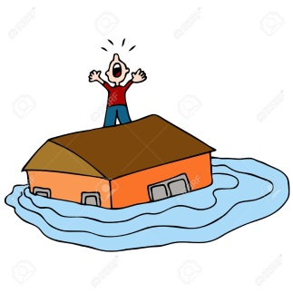 3 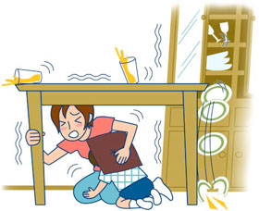 4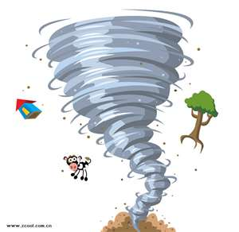

5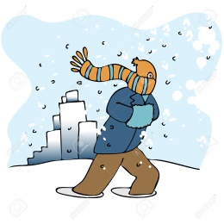 6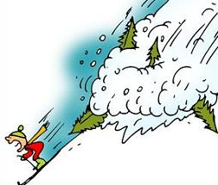 7 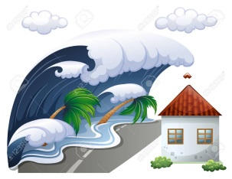 8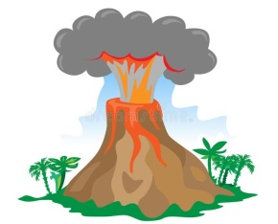

Manmade Disasters
war fire famine nuclear explosion
1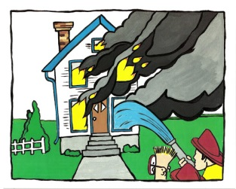 2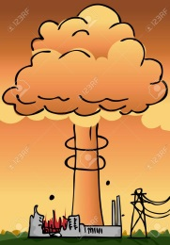 3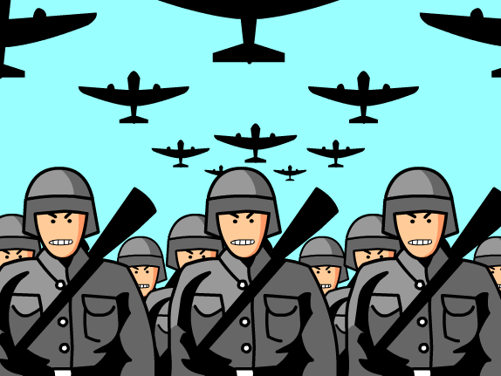 4 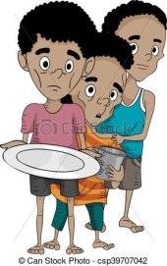

Which disaster are the sentences about?

- It had been snowing for two days! We could hardly get out of the house!
- The big wave swept away the whole village. There were many casualties.
- Hot lava and gases erupted out of the volcano.
- The soldiers marched in the town and bombed everything.
- Suddenly, the earth started to shake. Several buildings collapsed and buried people under the debris.
- After downpours of torrential rain, the drains blocked and the river burst its banks.
- Huge snow waves rolled down the slope. Two skiers are missing.
- The house was covered in flames. The fire brigade managed to put it out after four hours.
- There will be gale-force winds and rain showers. Citizens are advised to stay home.
- Most countries in the third world suffer from lack of food.
- The hurricane uprooted trees and destroyed houses on its way.
- The plantation exploded with a loud bang.
10
Let’s Practice: The Past Perfect
- Use the clues and complete with the Past Perfect.

- You went to Daniels’s house but she wasn’t there. (go out)
………………………………………………………………………………………………………………………………………………………
- You visited your home town after many years. But it wasn’t the same as before. (it / change / a lot)
……………………………………………………………………………………………………………………………………………………….
- I invited Sue to the party but she couldn’t come. (she / arrange / do something else)
………………………………………………………………………………………………………………………………………………………..
- You went to the cinema last night but you arrived late. (film / already / begin)
..............................................................................................................................................................
- I was pleased to see Dave again after such a long time. (not see / for years)
…………………………………………………………………………………………………………………………………………………………
- I offered Sue something to eat but she wasn’t hungry. (just / have / breakfast)
…………………………………………………………………………………………………………………………………………………………
- Last summer we went to Denmark. It was our first time there. (not be / before)
………………………………………………………………………………………………………………………………………………………….

- The following sentences tell a story in the order it happened. Use them to tell the story in a more interesting way. Begin with the underlined sentence.

1. Somebody broke into the office last night.
2. We arrived at work in the morning.
3. We called the police.
…………………………………………………………………………………………………………………................
…………………………………………………………………………………………………….……………….………….
……………………………………………………………………………………………………………….….…………….
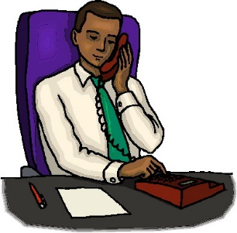
1. Fay went out.
2. Her boss tried to find her on the phone.
3.There was no answer.
…………………………………………………………………………………………………………..……………..…………....
………………………………………………………………………………………………………….……..……….…………….
……………………………………………………………………………………………………….……………………………….
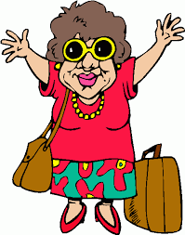
1. Milly came back from holiday last Monday.
2. I met her the same day.
3. She looked great.
………………………………………………………………………………………………….………………..……………….……..
……………………………………………………………………………………………….……………….……..…………………..
……………………………………………………………………………………………….……………..….………………………..


1. Laura texted Celia many times.
2. She never replied to her messages.
3. Yesterday, she had a phone call from her.
4. She was surprised.
…………………………………………………………………………………………………………………………………………….
…………………………………………………………………………………………………………………………………………………………………………………………………………………………………………………………………………………………………………………………………………………………………………………………………………………………..…
11
- Complete with SIMPLE PAST or PAST PERFECT:
1. They ……………………………. (go) home after they ………………………….. (finish) their work.
2. She ………………………………….. (just / go) out when I called her.
3. My brother ………………………………. (eat) all the pie before we got back.
4. He wondered why I …………………………………………. (not / visit) him before.
5. Lyn said that she ……………………………………………. (already / see) the Pyramids.
6. The fire ……………………………….. (spread) to the next building before the firemen ……………………………………….. (arrive).
7. They drank some coffee, after they ………………………………………. (finish) dinner.
8. Bryan told me he ……………………………………………….. (catch) a young lion.
9. His mother …………………………………………. (be worry) a lot about him before she ……………………………………… (hear) that he was safe
10. He ……………………………………………….. (already / learn) English before he …………………………………………. (leave) for England.
11. Mary ………………………………………….. (go) swimming after she …………………………… (come) home.
12. I ……………………………………… (go) to the theatre with my friends yesterday. I ……………………………… (not / be) to the theatre for a year.
13. After they ……………………………… (finish) their breakfast, they …………………… (leave) for school.
14. Linda ……………………………………. (play) tennis after she ………………………… (do) her homework.
15. My father ……………………………. (water) the flowers after he ………………………. (clean) the car.

- Combine the following sentences by using AFTER / BEFORE:
1. I heard a rumbling noise. The earthquake began.
…………………………………………………………………………………………………………………………………………………….….
2. Frank heard a loud thunder. Then he saw a bolt of lighting..
…………………………………………………………………………………………………………………………………………………….….
3. I washed the dishes. I watched TV.
……………………………………………………………………………………………………………………………………………..…………
4. Sue washed her hands. She had lunch.
…………………………………………………………………………………………………………………………………………..……………
5.The earthquake stopped. We got out of the house.
…………………………………………………………………………………………………………………………………………………………
6. There were gale force winds. The storm began.
…………………………………………………………………………………………………………………………………………………………
7. The thieves ran away. They broke the window.
………………………………………………………………………………………………………………………………………………………..
8. I fastened my seat belt. The plane took off.
…………………………………………………………………………………………………………………………………………….…………..
E. Complete the following sentences:
1. After I had watched that horror film, I ………………………………………………………………………..………………
2. She finished her homework after ………………………………………………………………………….…………………….
3. When I came home, my sister ………………. already ………………………………………………………………………
4. Before he went out, ……………………………………………………………………………………..………………………………
5. They had telephoned me before …………………………………………………………………………………………………..
12

Let’s Read & Write: A storm at sea
Put the words and phrases under the right picture. Then use them to complete the text.
lightning scared to death sea became rough set out on a sailing holiday shouting the storm flames on the deck dark clouds coast guard rescued
a gust of wind mast rocking from side to side thunder
a 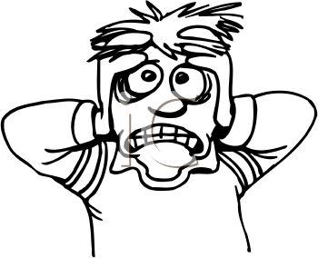 b 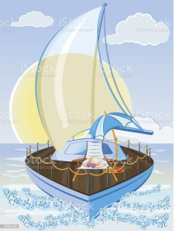 c 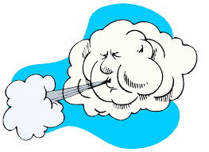 de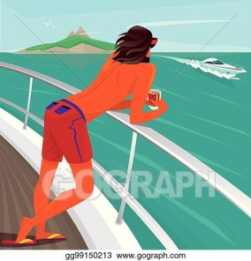
……………………………….. ………………….. ………………………………….. ………………………….. …………………………….
f  g  h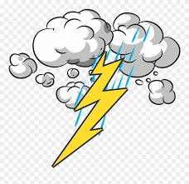 i 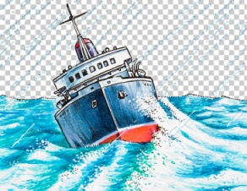 j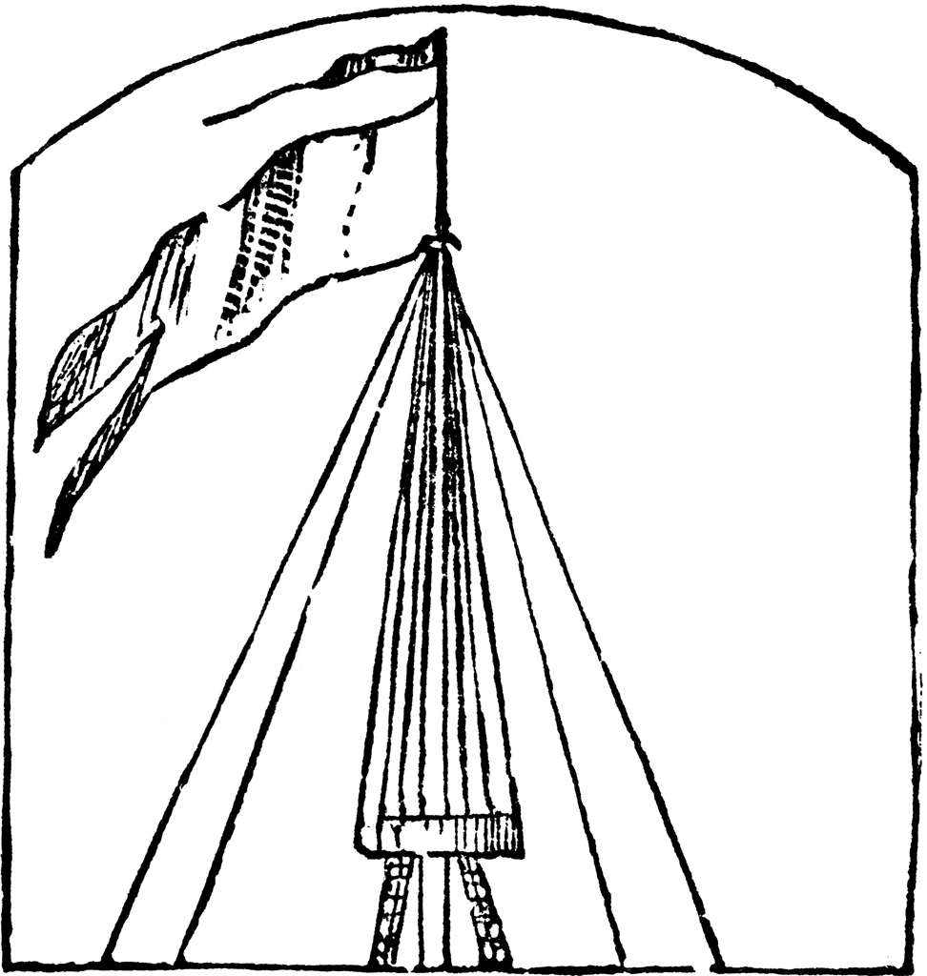
………………………………….. …………………………………. ……………………….. ……………………………….. ………………..
k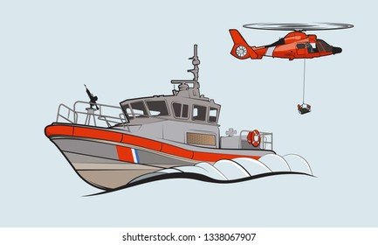 l 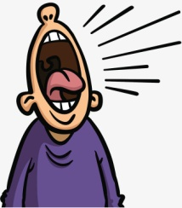 m n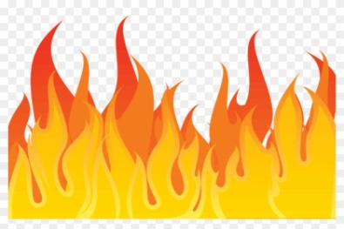 o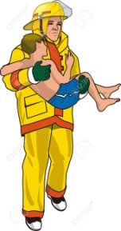
…………………………………….. ……………………….. ………………………………… ………………………………. …………………
It was a hot summer day last June. Leslie and his friends, Bill, Sara and Jim decided to (1)……………………………
in the Ionian Sea. So, they boarded on a yacht and they headed for Corfu Island.
They had been sailing for about two hours and Bill was standing (2)………………………… when suddenly there was a (3)……………………….... and it got dark. He looked up in the sky. He saw (4)……………………… were gathering and a strong wind started to blow. They were in for a storm!
Before they knew it (5) ……………… broke and they were right in the middle of it! The (6) ………………………….. and the boat was (7) ……………………………… as huge waves crashed around it. They tried to keep calm and Jim quickly radioed for help. Up in the sky, (8) …………………… flashed and (9) ………………………. rumbled. Just then, a bolt of lightning struck the boat and the (10) ……………………… burst into (11) ……………………………. They were all feeling (12) …………………………, they were screaming and (13) ……………………… for help. No doubt, they were drowning.
Suddenly, over the roar of the storm, they heard the siren of a ship. It was the (14) …………………………………
They came closer and (15) ………………………………. them just in time. From aboard the ship, they saw their yacht. It was sinking into the dark sea. They were still shaking but happy to be alive. It was a lucky escape.

Look back and complete the phrases.
- Standing …………………………… 7. The boat …………………………. 13. Just in ………………………….
- A gust of …………………………… 8. A lightning ………………………. 14. Sink into ………………………
- It got ………………………………… 9. Thunder …………………………….. 15. Happy …………………………..
- Dark clouds ……………………….. 10. Burst into ………………………… 16. A lucky …………………………
- A storm …………………………. 11. Feel scared ……………………….
- The sea ………………………….. 12. Shout for …………………………... 13
Now, imagine you were one of the company that had the adventure at sea. Use the phrases and the text to tell and write about the story. The pictures and the guidelines will help you.

What was the background (Who,Where,When)

How the adventure began
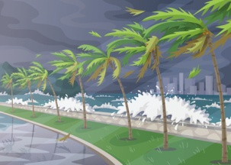

What was the peak point of the adventure
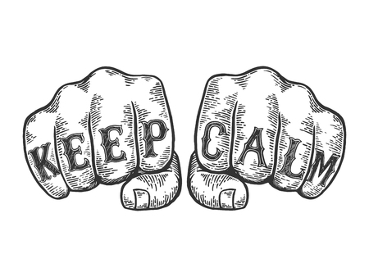

How it ended
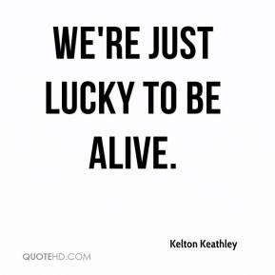

Remember to create mystery and suspense with the phrases:

Suddenly Before they knew it quickly Just then
They were all feeling No doubt just in time It was a lucky escape

14
Let’s Read: The Flood

My name is Keith Jones and I live in Queensland, Australia. This is my story of how I survived a terrible flood, three years ago. Queensland is a rainy area and people are used to heavy rains but nothing could have prepared us for what we would experience. The weathermen on TV and the internet had been given warnings about the powerful thunderstorm that was coming towards us, advising the residents to stay home and not move out at all. They proved to be right as it wasn’t an ordinary flood. In fact, it was so powerful that it took everyone by surprise.
At about 11:00 am, the sky turned black and it started raining. Soon, the rain became so heavy that it sounded like bombing. Me and my family, dad, mum and my little brother had been locked at home putting sand bags and towels outside the door to keep water from coming into the house. We were looking out of the windows but we could hardly see what was going on outside. Three hours later the torrential rain kept falling without giving any signs of stopping.
Feeling terrified, we saw the road in front of our house had turned into a little river, sweeping away cars and little trees. Dad was trying to catch up with the news on his mobile when there was a power cut.
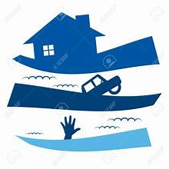
“Look! The water’s coming in through the door,” mum screamed in terror. “Hurry up, let’s go upstairs.”
We rushed on the first floor of the house only to see that the nearby river had burst its banks and the water was quickly turning our neighbourhood into a lake!
“Run, let’s get on the roof,” dad shouted and took my little brother in his arms. Mum grabbed some blankets and we climbed on top of the house.
From up there, we saw our whole area had been covered by water which was getting higher and higher. All the residents were on their house roofs praying and crying for help. There was no electricity, no phones, we were alone and desperate. It was worse than a nightmare.
The flood had almost reached the roof and the whole house was now underwater. We were hopeless.
Suddenly, we heard the sound of helicopters. We looked up and saw them coming to rescue us. A helicopter hovered right above us and the rescue team threw us a ladder to climb up. As soon as we all climbed on it, they gave us warm clothes and hot tea and got as to a safe place.
The rain stopped early in the evening but our neighbourhood was now flooded under the water. It was a terrible experience but, at least, we are relieved to be alive. 22 people lost their lives in the flood and 58 were injured and carried to hospitals.

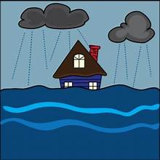
- What is characteristic of the area Keith Jones lives in?
- What had the weathermen been doing?
- How had Keith’s family been prepared for the flood?
- What did they see outside the window?
- What did they see from the first floor?
- What did they decide to do?
- How did they feel on the roof?
- How were they saved?
- What was the outcome of the flood?
- How does Keith feel?

- Explain the highlighted words and expressions and use some of them to complete the sentences.
- The river ………………………………………….. and flooded the whole village.
- After hours of ………………………………………….. the whole town was flooded.
- The rain started unexpectedly and ……………………………………………………………. .
- The ……………………………………………… managed to save all the people in the area.
- After losing their homes in the flood, the people felt ………………………………………… .
- Susan managed to ……………………………………. her handbag before she run out of the flooded building.
- The thunderstorm caused a ……………………………………. and there was no electricity for days.
- We saw the flood …………………………………. vehicles and rubbish bins.

- Look back at the questions. Use them to make a short summary of Keith’s story.
15
Let’s Watch: How do earthquakes happen?
https://www.youtube.com/watch?v=Rmkds_ox_6k
Watch the video and complete the sentences with the missing words.
world terrible back and forth shook moving caused split predict ground fall cover damage
1. When an earthquake happens, the whole ground beneath your feet is ............................................
2. Sometimes, things on shelves and ceilings .......................................
3. Strong earthquakes are ....................................... and destructive.
4. Some ancient Greeks believed that earthquakes were ............................................. by God Poseidon.
5. In the earthquake of San Francisco, in 1906, the ground ............................................. for 45 seconds non-stop!
6. Buildings fell apart and there was a huge amount of ..................................................
7. There were cases of fences that had been .................................... and moved. They were all connected in a line.
8. There are fault lines all over the .......................................
9. When two sections of land push away each other the ................................................... starts to shake violently.
10. It’s dangerous when buildings and houses start swaying ............................................
11. It’s important to duck and ........................................ during an earthquake to protect yourself from falling objects.
12. Scientist still cannot fully ............................................. an earthquake.

Let’s Tell a Story: An Earthquake
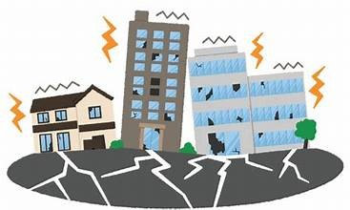
Who/When/Where?
my family and I/late at night last Wednesday / at home
What were you doing?
watch TV / mum cook /dad work on his laptop/ everything quiet
What happened?
hear a low rumbling noise/ look at ceiling / light started swaying back and forth
before I knew it / another rumbling noise / room start shaking / fall flat on the floor
duck and roll under the table / wait for the earthquake to stop
vases fall off selves / smash into pieces / books fall off bookcase / pictures fall off wall
whole house jump up and down / terrible noise
How did you feel?
scared to death /scream in horror /mum as white as a sheet / dad try not to panic
What did you do after it stopped?
run outside house / door stuck /dad burst through door / hurry outside
Was anyone injured?
neighbours gathered in open space / no one hurt
How did it end?
stay out all night / afraid of aftershocks /lucky to be safe and sound

Use the clues to tell and write a story with the title: An earthquake
16
Let’s Remember: ACCIDENTS & DISASTERS
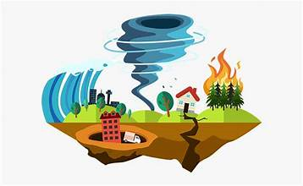
- The big wave swept away / out the whole village. There were many dead / casualties.
- At least, after the flood everyone was safe / alive and sound.
- Hot lava and gases exploded / erupted out of the volcano.
- Suddenly, the earth started to shake. Several buildings destroyed / collapsed and buried people under the ruins / debris.
- The building was on / in fire.
- After the torrential rain, the river burst / outcame its banks.
- The house was covered in flames. The fire brigade managed to put it out / off after four hours.
- Two stretcher-bearers / carers were carrying an injured man
- There will be gale-force air / winds and rainfalls. Citizens are advised to stay home.
- Most countries in the third world suffer from luck / lack of food.
- The bomb erupted / exploded with a loud bang.
- Suddenly, I heard police sirens wailing / screaming outside.
- Rafael Nadal was unable to finish the match due to a shoulder wound / injury.
- My grandad was seriously injured / wounded in World War II.
- I think, we ‘d better call an ambulance. Grandma is on / in pain.
- We live in a rainy area and people are used to heavy / strong rains.
- A lightning flashed on the sky and then there was a loud bang / thunder!
- I lost control of the scooter and fell full / flat on the ground.
- It was a terrible experience but, at least, we are received / relieved to be alive.
- Luckily, no one was hurt. It was a close / lucky escape!

- Say what’s the problem.
1 2 3 4 5
6 7 8 9 10 12
17

Let’s Learn and Practice: Phrasal Verbs

come
1 2 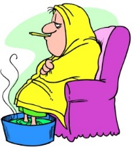 3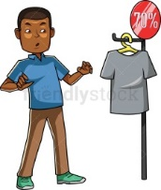 4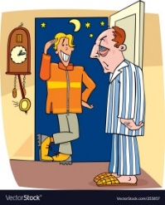 5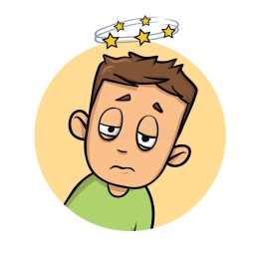 6 7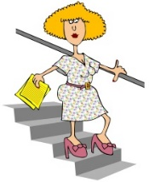
come up with come down with come across come over come round come up come down
1. Match the phrasal verbs with their meanings.
a. to visit b. to find (a solution, an idea, an answer) c. to find by chance d. to become ill
e. to rise g. to regain consciousness h. to move to a lower level

2. Say and Write: Look at the pictures and answer the questions. Use the phrasal verb.
1. How did Mary manage to solve the problem?
2. Where is Bert? I haven’t seen him for two days!
3. How did Harry buy such an expensive T-shirt?
4. Why is Richard tired today?
5. Did Ron faint for a long time?
6. Were your school grades better at the second term?
7. What happens to prices during sales?

3. Now, make your own sentences.

get
1 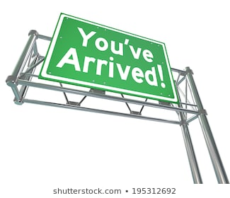 2 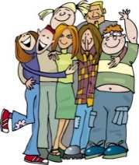 3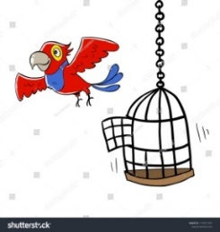 4 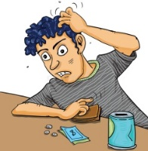 5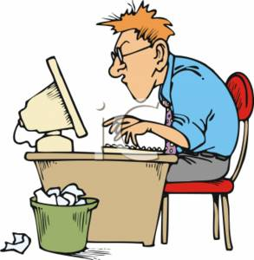 6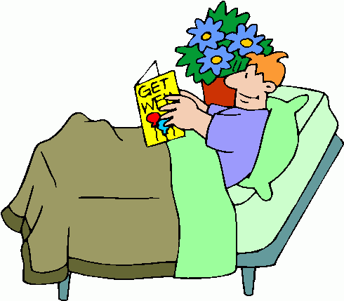
get to get on / along with get away from get by get down to get over
4. Match the phrasal verbs with their meanings.
a. to start working b. to escape c. to arrive d. to have enough for your needs
f. to be on friendly terms h. to overcome an illness or difficulty

5. Say and Write: Look at the pictures and answer the questions. Use the phrasal verb.
- What time did you arrive in Athens?
- Do the classmates have a good relationship?
- What happened to your parrot?
- Does David have enough money?
- What did Kevin do when he learnt he had to deliver the project tomorrow?
- I’ve heard Roy is in hospital. How is he?

6. Now, make your own sentences.

18

UNIT 3: IN SICKNESS AND IN HEALTH
Let’s Learn: Feeling ill
- Match the phrases with the pictures.
have a cough have/be down with the flu my arm hurts feel dizzy have a stomachache have a cold have a sore throat have a temperature have a headache my kneck aches have a pain in my knee have a backache have a rash have a toothache
1 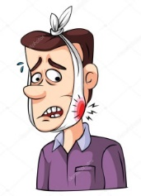 2 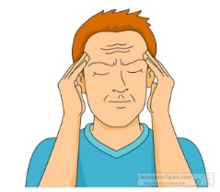 3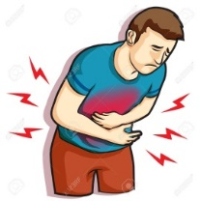 4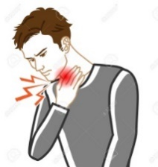 5 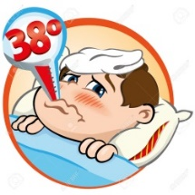 6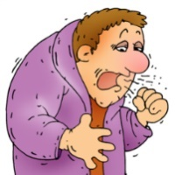 7 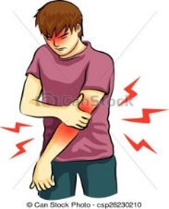
8. 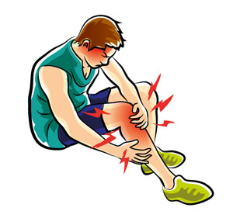 9 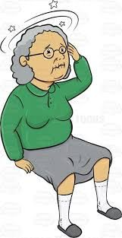 10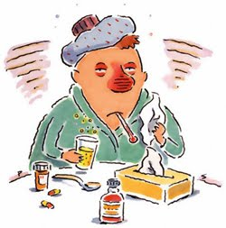11. 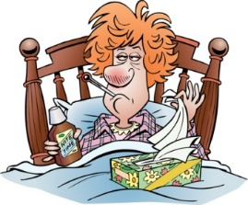 12. 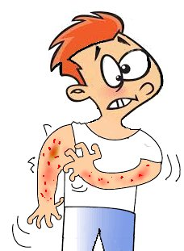 13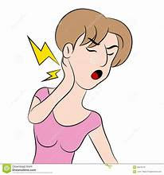14 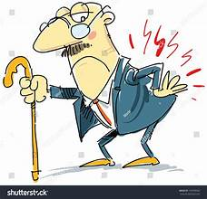
2. What should you do if you …? Match the symptoms in ex. 1 with the advice. Make sentences as in the example.
eat lots of fruit and vegetables stay in bed visit a dentist take some cough tablets
see a doctor stay indoors put on some cream relax and not move relax for a while
take medicine take an aspirin/a painkiller drink some tea put on a bandage
- What should you do if you have a headache?
- If you have a headache, you should take an aspirin / a painkiller

- Complete the sentences with the words:
cough symptom appointment virus rash medicine infection prescription
- Could I come late in tomorrow? My wife and I have an ……………………………………… at the doctor.
- That’s a nasty ……………………………… you’ve got. You’ve really got to stop smoking.
- The main ………………………………. of measles is little red spots all over your body.
- I sometimes get a …………………………… on my face after I’ve been shaved.
- I’m taking antibiotics for this ear ……………………………………….. .
- Covid 19 was a really deadly ……………………………………….. .
- Very often, rest is the best ……………………………………………
- Did you take that …………………………………. at the chemist’s?
4. Complete the dialogues 1-5 with the phrases: I always get seasick / I feel dizzy / I’ve caught a cold / You’ll make yourself ill / I’ve got an upset stomach
- –What’s the matter? - I think I ate my dinner too quickly. ………………………………………………………………………….
- - We should take the boat. It’s much cheaper than flying. – Oh, no please. ………………………………………………
- – I think, …………………………………………………………… - Well, drink some tea and get an early night.
- – You look exhausted. You ‘ve been working too hard. …………………………………………………………………………………..
- Are you all right? You’ve gone as white as a sheet!
- No, I need to sit down, ………………………………………………. 19
In Hospital
- Match the following words and phrases with the pictures 1-13. Then use them to complete the text.
in a lot of pain as pale as a ghost in plaster blood sample a twisted ankle stethoscope
stitches a broken wrist ear infection prescription bandaged treated

1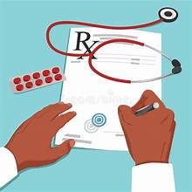 2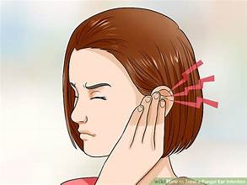 3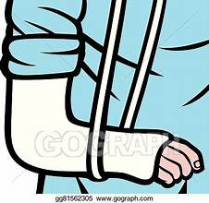 4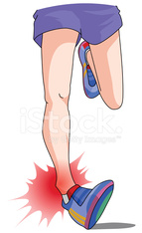 5 6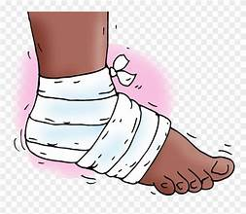 7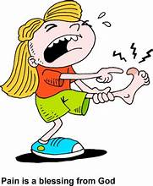 8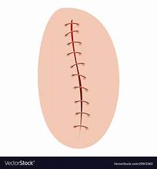 9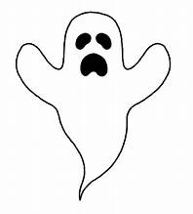 10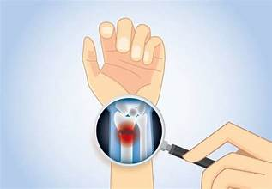 12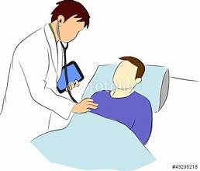 13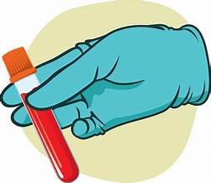
A doctor’s day
Have you ever thought about becoming a doctor? Well, if you have, all I can say is go for it. Although it’s a hard and demanding job, it’s worth it because it’s rewarding.
To begin with, no two days are ever the same. This is because each patient comes in with different symptoms. Not only that, but each patient has their own unique personality, too. For example, this morning I (a) ……………………………. two young men both with painful injuries, one with (b) ……………………………………….. and the other with
(c) ………………………………………. The first told me that he had a fear of hospitals and was
(d) …………………………………….. while I examined and (e) ………………………………………. his ankle. The other one, however, managed to remain cheerful and told us funny jokes while I put his injured wrist (f) …………………………………….. This afternoon, a woman brought her young son in to see me. The boy seemed to be (g) ……………………………………..
I listened to his chest with my (h) ……………………………………………… and took his temperature.I also took (i) ………………………………………... it was when I looked at his ears that I noticed that he was suffering from a bad
(j) ……………………………………………, so I wrote out a (k) ……………………………………………. for antibiotics. I could see a look of relief on the woman’s face as she left. It can be really worrying for a mother to see her child suffer and don’t know what’s wrong. My last patient of the day had fallen over and hurt his arm. Fortunately, it wasn’t serious and didn’t need to have (l) ……………………………………………….
So, do you still want to become a doctor? Remember that despite the tiredness I feel I also get a great deal of job satisfaction when I go home in the evenings and think about all the people I have helped that day.

- Is the doctor satisfied with his profession?
- What were the cases of the two patients that he examined in the morning? How did he treat them?
- What was the case of the child he treated?
- What was the last case of the day?
- What do you understand by the term job satisfaction?
- Have you ever been to the doctor’s? What were the symptoms? How did he treat you?

20

Let’s Practise: Make or Do?
Fill in with make or do, and write a caption for each picture. Then, complete the sentences that follow.
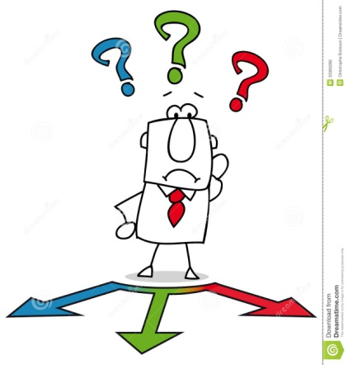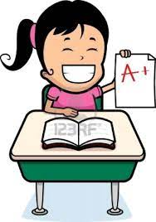
……………… a decision …………. your best …………….. an effort ……………. an impression
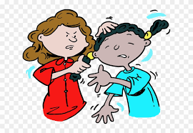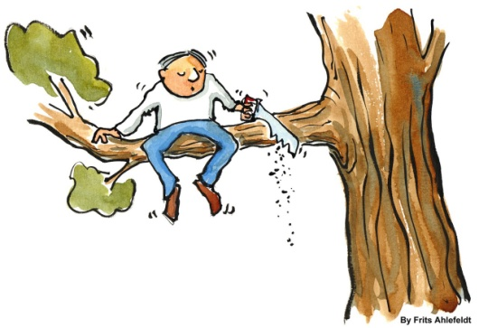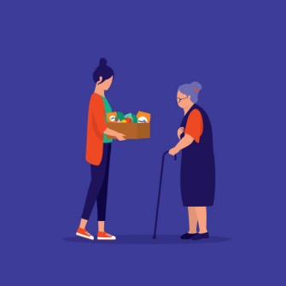
……………… harm ………………… a mistake ……………… a favour ……………. money
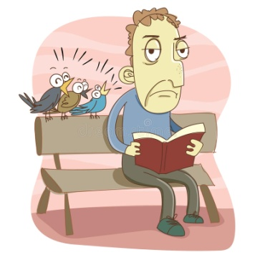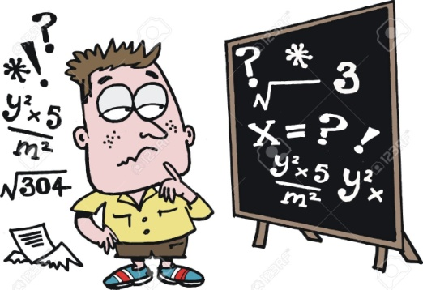
………………. noise ………………. progress …………. the housework …………….. sense

- I ‘ve …………………………………………………… in the maths test, so I don’t expect a high grade.
- Always ………………………………………………….. at a competition!
- His handwriting was so bad that I couldn’t …………………………………………….. of what he wanted to say!
- Dan must …………………………………………………. if he will leave the job or not.
- The road workers ………………………………………………… so I couldn’t concentrate on my homework.
- Smoking and drinking alcohol …………………………………………….. .
- Will you …………………………………………? Will you buy me some milk on your way home?
- The young actress ……………………………………… in the Oscar Awards ceremony.
- Mum doesn’t have much time to ……………………………………………….., so we all lend a hand.
- Students with low grades must ……………………………………….. to do better at the second semester.
- My grandfather moved to the USA and ……………………………………….. .
- After studying more, Harry ……………………………………………… with his schoolwork.

21

Let’s Practise: Articles - Prepositions
A) Put in a/an, the or –
1. There was ………….. waiter standing at ………… entrance of ………… restaurant. ………….. waiter was kind.
2. “Is that your wife?” “No, my wife’s ………. woman in ………. red dress.”
3. I work with ………. man and two women. ………. man is quite nice, but ………. women are not very friendly.
4. Can you show me ………. that book, please? ………… red one with ……….. picture on the cover.
5. ……….. water turns into ……….. ice at 0 degree C.
6. I like ………… steak, but I don’t like ……….. eggs.
7. She lives in ………… nice flat on ………. fifth floor of ……….. old house.
8. I bought ……. hat and ……… bracelet. …… hat is in my bag but I don’t know where ………… bracelet is.
9. We don’t go to ….….. cinema very much these days. In fact, in ………. town where we live there isn’t ……… cinema. 10. Did ………. police find ………. person who stole your bicycle?
11. We went out for ………… meal last night. ………… restaurant we went to was excellent.
12. After the accident, Harry went to ………… hospital. The doctor advised him to stay in ………… bed.
13. The thief was sent to ………… prison. His wife often visits him in ……….. prison.
14. ………… youngest boy has just started going to ……….. school; ………. eldest boy is at ………… university.
15 . Dad went to ………… school to talk to ………… headmistress about my progress.
16. My mother goes to …………church in …………. morning, and in ………… afternoon goes to visit ………… friends.
17. There was ………. knock on ………. door. I opened it and saw ………… man in ………. overcoat and ……… hat.
18. I have ……….. little money left; let’s have dinner in ……….. restaurant.
19 ………. important products which we get from ………… India are ……….. tea, ……… cotton, and ………… rice.
20. I go to work by ………… underground ………… every day while my sister takes …………. bus.
21. ………… sun is shining but part of ………… sky is still covered with ………… clouds.
22. Sometimes we must take ………… medicine.…………. . medicine which ………….. doctor prescribed helped me a lot.
23. He likes to study ………….. French. She wants to go to France.
24. He works in ………… building on ………… corner of ………. Wellington street.
25. ………… Tokyo is one of the ………… largest cities in ……….. world.
26. …………. Mississippi is …………. largest river in …………. USA.
27. ………… Lake Ontario is in ………….. Canada.
28. …………. Mount Everest is ……………….. highest mountain in ………….. world.
29. ……….. Alps is ……… highest mountain range in Europe.
30. Corfu is ……… beautiful island. It belongs to …………. Seven Islands.
31. ………….. Asia is …………… largest continent in ………….. world.

B) Complete with the correct preposition
- Please try and listen …………………. my instructions.
- Don’t laugh ………………….. me! I’m not a funny clown!
- Lou apologized …………………… her mistake.
- Sue paid …………………….. my ticket.
- Do you believe ………………….. ghosts?
- Does this bag belong ………………… you?
- Albert was accused ……………….. stealing.
- Wendy succeeded ……………………… passing the exam.
- Are you interested ……………………… computers?
- I’m not very keen ……………………. swimming.
- I feel sorry …………………… Sam because he hasn’t got any friends.
- Don’t be jealous ……………………. your friends. It’s very bad!
- Helen is married ………………….. Jack.
- Harry is really good ………………… maths.
- You can really rely …………………… me.
22
Let’s Learn: A sound mind in a sound body

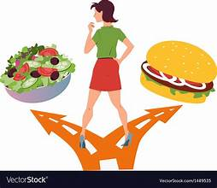
Breakfast: Never skip / slip breakfast because it gives us valuable nutrients / items which our body needs to develop properly. Breakfast should mainly consist / form of cereals and diary / dairy products, orange juice, eggs, marmalade, bread and butter. They all provide / produce our body with vitamins, fibres, minerals and other basic substances which give us energy and protect us from viruses and other diseases. They build up /over our immune system.

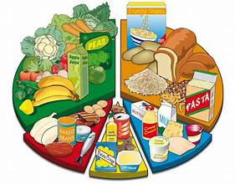
Diet: Always watch your diet because we are what we eat. Try to adapt / adopt a balanced diet avoiding junk food, salty, sugary and fatty snacks. These snacks are very fat / fattening, and increase the risk of suffering from obesity or heart diseases later in life. So, eat low-fat products, vegetables and fruit which have nutritional cost / value so us not to gain / take weight. Adopt healthy eating customs / habits. Finally remember that home cooking / ready- made meals can help you remain fit and healthy. Have / Bear in mind that many foods and drinks, such as tinned food, processed food and fizzy drinks have lots of harmful chemicals, preservatives, and additives / preserves. So, if you want to please / satisfy your hunger between the main meals of the day, eat some fruit or drink some natural juice. Always go for the best food choices.

Get Exercise: Get out of bed and exercise if you want to be in good shape / formation and be healthy. Today, advertisements in magazines and work-out videos online both stress / stretch the importance of regular exercise and nutritious diets. Exercise, in particular, clears our minds and helps us fight sedentary / sitting modern lifestyles.

- Why is breakfast an important meal? What should we do?
- What does an ideal breakfast consist of?
- Why are sugary, salty or fatty snacks life-threatening?
- What is the problem with processed food and fizzy drinks?
- What kind of snack can you grab if you feel hungry?
- Why is exercise as important as a balanced diet?
- What is a “sedentary lifestyle?

- Use the following verbs in the correct form to complete the sentences.
avoid go on keep take up stay give up cut down on
- Playing basketball once a week ……………………………………… me fit.
- Lots of fresh fruit and vegetables will help you to …………………………….. healthy.
- My doctor keeps telling me I should ……………………………… smoking.
- You eat too much sugar, you should ………………………………. it.
- If you can, try to ………………………………. stressful situations.
- I’ve put on some kilos! I must ……………………………….. a diet.
- You must …………………………… eating big meals at night.
- I think, I should ……………………………… a sport or hobby.
23
Let’s Read: Are Teenagers Becoming Couch Potatoes?
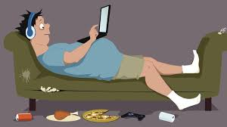
Nowadays, many teenagers live a sedentary lifestyle that can be quite dangerous. Thankfully, though, there are ways to minimize the risks.
Firstly, one of the dangers is that teenagers put on weight because they don’t have any physical activity. Moreover, sitting in front of a screen for too long brings about health problems, such as backaches or eye-strains. Also, lots of teenagers tend to eat junk food, which can seriously affect their health. Junk food contains a lot of preservatives and additives which are harmful for the heart, blood pressure and teeth. Still worse, teenagers end up isolated in front of a screen with few or no friends, and become the perfect couch potatoes. As a result psychological problems, such as depression and anxiety are on the rise.
However, there is still hope. First, parents should set a good example by spending time with their children, working out, biking, taking walks and avoiding eating junk food or spending long time in front of the screen themselves. They can also make their children take up interests and hobbies. Schools could also play an important role by encouraging subjects such as physical education, art and music and engage students in outdoor activities and projects. Finally, free facilities where teenagers can do sports should be provided by local authorities. In this way, teenagers will exercise and communicate more with their peers, and become more sociable.
In conclusion, leading a sedentary lifestyle can only bring negative results. Therefore, certain steps can be taken to help teenagers overcome this problem.

- Explain the words and expressions in bold.
- Keep notes under the correct heading and then use them to talk about the dangers a sedentary lifestyle for teenagers and how they can be avoided.
Dangers of a sedentary lifestyle How they can be avoided

Let’s Write: What should I do?
- Your best friend has the problems you see in the pictures. Say and write what the problems are.
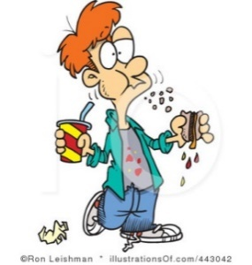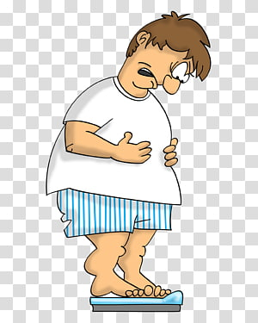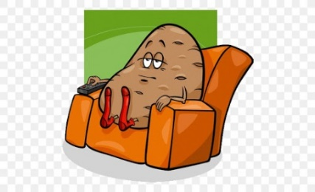
……………………………… ……………………………… ……………………………………… …………………………………………..
- Give him / her advice on how to overcome problems. Use the pictures and the phrases in the box.
Giving Advice
You should / shouldn’t … You could … You must / musn’t … You d’ better …
If I were you, I’d … Why don’t you …? A good idea would be to …..
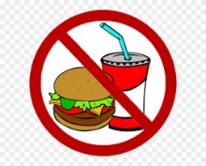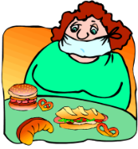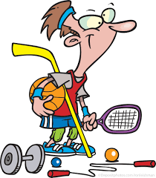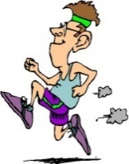
Now, write an e-mail to your friend to give advice.
24
Let’s Learn & Practise: Phrasal Verbs
run
1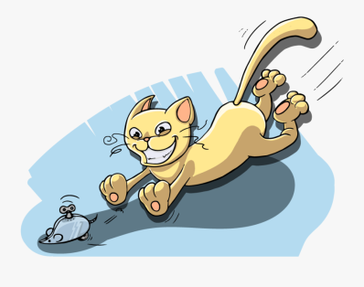 2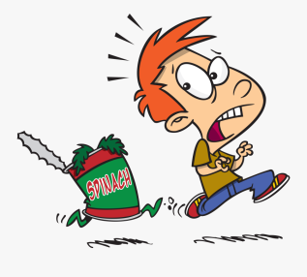 3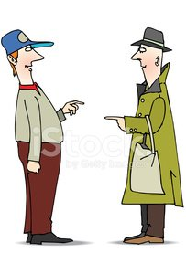 4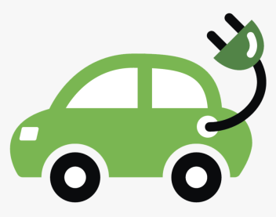 5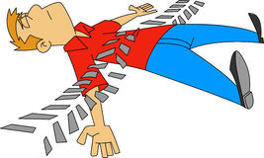 6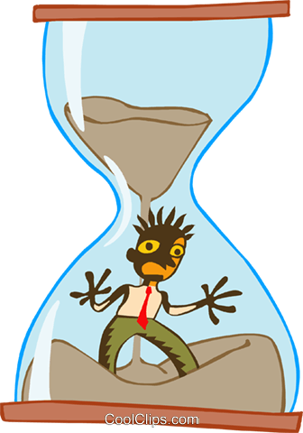 7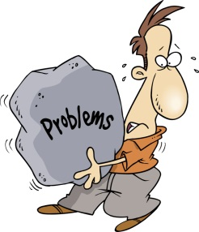
run after run away run into run on run over run out of run up against
1. Match the phrasal verbs with their meanings.
a. to knock down with a vehicle b. to escape a duty, chore etc c. to get power from
d. to chase e. to face f. to have very little left h. to meet by chance
2. Say and Write: Look at the pictures and answer the questions. Use the phrasal verb.
1. Does the cat play with the mechanical mouse?
2. Does Roy eat spinach?
3. How did Phil meet his old friend Jack?
4. How do electric cars move?
5. I’ve heard that Sid is in hospital. What happened?
6. Do you think you can hand in your project soon?
7. I’ve noticed that Dave is sad. What’s going on?
3. Now, make your own sentences.
take
1 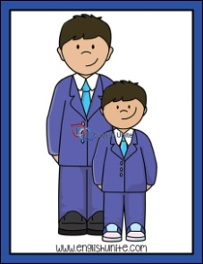 2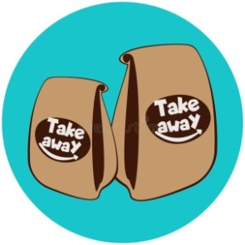 3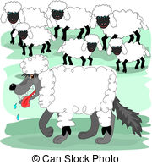 4 5 6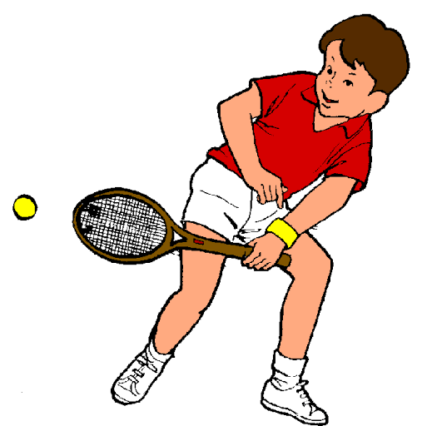7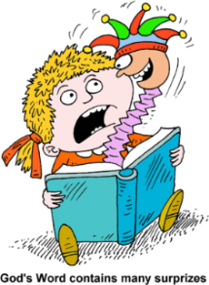
take after take away take in take off take to take up be taken aback

4. Match the phrasal verbs with their meanings.
a. to like b. to look or act like a relative c. to begin hobby or sport
d. to leave the ground e. to deceive f. to be surprised g. buy food to eat elsewhere

5. Say and Write: Look at the pictures and answer the questions. Use the phrasal verb.
1. Does Barry look like his mother?
2. Do we have to eat the burgers at the restaurant?
3. Why did the wolf dress up as a sheep?
4. Is the plane still on the runway?
5. Does Phillip have any hobbies?
6. Is Dave still playing basketball?
7. What happened when the kid opened the box?

6. Now, make your own sentences.

25

UNIT 4: THE WORLD OF SPORTS
Let’s Learn
TEAM SPORTS

goal build up self-esteem cooperation concentrated rules spirit score
In team sports (1) ………………………… among teammates is the key to success. All players in a pitch or court have to get on well and be united towards a common goal- to beat the rival team and (2) achieve the best………………………….. Of course, they should obey the (3) …………………………….. of the game. Players either attack to score a (4) …………………………….. or play a defensive role to prevent the opposing team from scoring.
These sports encourage team (5) ………………………… and each player has a specific role to play in a team. Therefore, professional players need to do intensive training, be dedicated to what they do and (6) ……………………………….... when playing. No doubt, these sports boost confidence and (7)…………………………………... They also help them get self-discipline and - most important – they (8)…………………………. team spirit and develop social skills.

- What do you need to do in a team sport?
- What are the benefits of team sports?

INDIVIDUAL & ONE-TO-ONE SPORTS
judges intensive discipline against compete participants

In individual sports, athletes (1) …………………………………… alone, trying to score points or racing (2) …………………………………. the clock. Gymnastics and athletics are individual sports during which (3) …………………………………. perform and (4) ………………………… decide the scores. Like team sports, individual ones need dedication, (5) ……………………………. training, stamina and self-discipline in order to succeed.
On the other hand, in one-to-one sports like boxing, wrestling, martial arts or tennis, athletes compete against one another at a time. Especially Asian martial arts, like karate, tae-kwon-do or judo represent the traditional methods of fighting and defending yourself and their principles are (6) …………………………, confidence and respect to the opponent.

- What are the characteristics of individual sports?
- What are the principles of martial arts?

EXTREME SPORTS
challenge achievement cope overcome daredevils alive
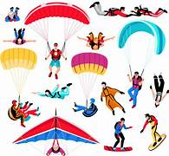
Apart from the common sports, there are extreme sports which (1) …………………………… are crazy about. Extreme sports fans believe that the (2) ………………………………… of facing danger head-on makes them feel alive. Sports like bungee jumping, sky diving or hang gliding get the adrenaline high and make people feel (3) ……………………..! Fans also say that such sports help them (4) ………………………………………… their fears and react quickly in unexpected situations. It gives them a sense of (5) ……………………………… and makes them feel strong and confident to (6) ………………………………with any difficulties they may run into.

- Why do some people choose to do extreme sports? How would you call them?

Use the ideas and the expressions of the three passages to talk and write about the requirements and the benefits of each kind of sports. Use linkers: First, Second, Finally, What is more, Also, Moreover, On the other hand, However 26
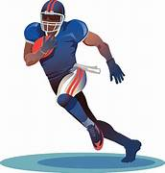
Let’s Read: “FOOTBALL” & FOOTBALL!
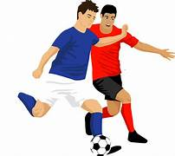
The English and the Americans may share a common language, but there are many cultural differences between them. Take sport, for instance – it’s rather surprising that the word “football” means a completely different thing in each country. In the USA, it refers to American football, which requires great strength and stamina to play. In fact, it’s such a rough game that the players have to wear safety helmets and gloves to protect themselves when their opponents tackle them. What the British know as football is actually “soccer” in America and as there is less physical contact between the players. British footballers only have to wear a simple football kit and football boots. Both football games have referees, linesmen and captains, but that is where the similarities end. In British football, the players use their feet to pass the ball to their teammates until one of them finds the chance to kick the ball past the goalkeeper and into the net. In American football, though, the players use their hands to pass the ball to each other, which makes you wonder why they call it football, doesn’t it?
Decide if the statements are True or False and correct the false ones.
- The British and the Americans speak the same language.
- The word “football” means different things in both languages.
- You must be strong and well-trained to play American football.
- American footballers need a football kit and football boots.
- The Americans use the term “soccer” for British football.
- There are referees, linesmen and captains only in British football.
- American footballers have to use their feet to pass the ball.
- The purpose of each team in British football is to kick the ball into the opponent’s net.
Use the words in bold to fill in the sentences.
- The …………………………………….. between the two films are obvious. The one has copied the other.
- All motorcycle riders must wear ……………………………………………..
- We really get on very well with all my ………………………………………………
- Can you please ………………………………….. me the salt?
- There is a lot of ………………………………………….. between basketball players so accidents happen often.
- A marathon runner needs a great deal of ………………………………………..
- Taking exams and doing well …………………………………….. a lot of studying.
- Football ……………………………………. blow the whistle to end the game.
Choose the right option.
- Where exactly is the football pitch / court located?
- The athlete ran around the track / arena so quickly that she broke her own record.
- Figure skating is a sport in which individuals or pairs perform on an ice ring / rink.
- I challenge you to a bowling contest, so let’s meet at the bowling line / alley.
- Wimbledon is a prestigious tennis tournament / contest that is held every summer.
- The majority of the viewers / spectators at the match were supporters of the local team.
- The umpire / referee blew the whistle to end the football game.
- A good coach always stands up for / stands out of his players.
- Do you believe our team will win / beat the opponents?
- How many teams are contesting / are competing in the championship this year?
- The final score was 3-3, so it was a(n) draw / equal.
- Sportspeople receive huge financial awards / rewards these days.
- Although the team was out of / without practice, they managed to win.

27

Let’s Practise: Conditionals

A) Choose the correct item and underline it:
1. If I move / I’ll move to Boston, I live / I’ll live on Main Street.
2. If you call / you’ll call your mother, she’ll be very happy.
3. If the mechanic fixes our car on time, we drive / we’ll drive to Athens.
4. If it rains / it’ll rain today, we won’t go to the park.
5. If I’m not in a hurry tonight, I text / I’ll text her.
6. If she isn’t / won’t be sick, she’ll go to school.
B) Find correct items and complete the following sentences:
1. If we ….. go …….. to London, …… we’ll ………. visit our cousin.
2. If they ………………. their homework tonight, their teacher ……………………. happy.
3. If the weather ………………… good, George ………………… swimming this weekend.
4. If you don’t eat your dinner tonight, ……………………………………………... hungry.
5. If .they …………………………..tired, they’ll go to sleep early tonight.
6. If you ………………... too many cookies after dinner tonight, ………………get a stomachache.
C) Complete the sentences with your own ideas
1. If the weather is bad tomorrow, ……………………………………………………..…………………….……………………..
2. If I don’t sleep well tonight, ………………………………………………………………………………………….………………
4. If you don’t fix the broken window, ……………………………………………..………………………………………………
5. If I go to London, ………………………………………………………………………... ……………………………………………….
6. If ……………………………………………………………………………………..………..,they’ll go to a restaurant tonight.
7. If …………………………………………………………………………….……………………………., his mother will be happy.
8. If I become rich, …………………………………………………………………………………………………………………………….
9. If I study hard, ………………………………………………………………………………………..………………………………………
12. If it’s sunny at the weekend, ……………………………………………………………...
D) What would you do in each situation?
* call an ambulance * complain to the manager * run away* try to catch it * ring the police* walk to the nearest garage to get some
1. You find a fly in your soup. If I found a fly in my soup, I would complain to the manager.
2. You see a burglar breaking into your house.………………………………………………..…………………………………………………..
3. You see a mouse in your kitchen.………………………………………………………………..…………………………………………………..
4. Your car runs out of petrol.……………………………………………………………………….……………………………………………………..
5. You see an accident.………………………………………………………………………………………………………………………………………..
6. You see a ghost in your room.……………………………………………………………….………………………………………………………….

E) Use the correct tense:
1. The teacher will be very angry if you …………………………… (not do) your homework.
2. If he ……………………………….. (tell) me, I could help him.
3. If you don’t water the flowers, they ………………………………………… (die).
4. If you didn’t water the flowers, they …………………………………………(die).
5. I ……………………………………….. (come) if I had time.
6. If you don’t hurry, you ……………………………………….. (miss) the bus.
7. If I …………………………… (be) you, I wouldn’t buy that car.
8. He will play tennis if the weather …………………………………. (be) good.
9. I would be very happy if she …………………………………. (be) my sister.
10. She could win the race if she …………………………………. (try).
11. If he ……………………….. (go) to bed early, he will get up early.
12. I wouldn’t say it if I ……………………….. (be) you.
28

F) Match 1-10 with a-j
1. Everyone on board the plane would have died a) If I had not been to a doctor.
2. If the officials hadn’t stopped the poor man, b) if you had taken him to the fun-fair.
3. If the climbers had found an easy way, c) if the plane had crashed.
4. I would be in a hospital now d) she could have bought some expensive clothes.
5. We would have got wet e) so many people wouldn’t have been killed.
6. If he had had enough time last summer, f) he could have built his small house in two days.
7. I might have come to your help g) if we hadn’t taken our umbrellas.
8. If the driver had not slept, h) they could have reached the top easily.
9. The young boy would have been very happy i) he would have gone on a holiday.
10. If her father had been rich, j) if I had had time last Sunday

G}Fill in the correct form of the verb. Use the type given at the end of the sentence.
1. If he __________________ (eat) everything, he ______________________ (be) ill (3)
2. The police ______________________ (arrest) him if they ____________________(catch) him (1)
3. What ______________________ (happen) if my parachute __________________(not open)? (1)
4. I ______________________ (be) angry if he _____________________(make) more mistakes. (2)
5. If he ______________________ (be) late, we ______________________ (go) without him (3).
6. If I ________________(lend) you 10 pounds, ___________________ (you, give) it back to me? (1)
7. If you _________________ (not like) this T-shirt, I __________________ (bring) you another one. (1)
8. If I ______________________ (know) that, I ______________________________ (visit) you. (3)
9. I ______________________ (not drink) that wine if I ______________________ (be) you. (2)
10. If we __________________ (have) more rain, our crops ____________________ (grow) faster (3)
11. If you ______________________ (paint) the walls white, the room ______________________ (be)
much brighter (1).
12. I ____________________________ (can repair) the roof myself if I ______________________
(have) a ladder. (3)
13. You ______________________ (not have) so many accidents if you ______________________
(drive) more slowly (2).
14. What ______________________ (you, do) if you ______________________(hear) the alarm? (2)
15. If you ______________________ (go) to Paris, where ______________________ (you stay)? (1)
16. I __________________________ (bring) you something to drink if you ______________________
me (tell) (3).
17. If anyone ______________________ (attack) me, my dog ______________________ (jump) at
him (3).
18. If everybody ______________________ (give) me 3 pounds, we ______________________
(have) enough. (1)
19. This __________________________ ( not happen)if you ______________________ (be)more
careful (3)
20. We ______________________ (invite) him if he ______________________ (be)at home(2)
21. I ______________________ (put)some money into the bank if I ______________________
(have)some left (2)
22. I ______________________ (offer) them coffee and cake as soon as they
_________________________ (come) over (1)
23. If you ______________________ (give)me the letter, I __________________________ (post) it for
you (3)

29
Sports and Equipment
- Write the correct word under the picture.
boxing gloves goggles (table tennis ) bat net roller skates goalpost surfboard knee pads weights tennis racket safety helmet hoop
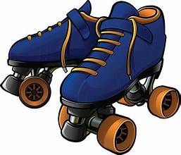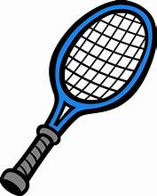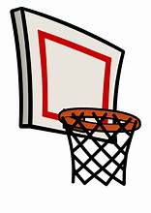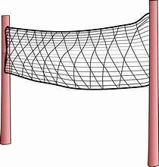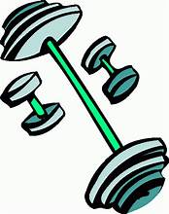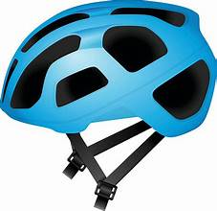
1………………………………. 2……………………… 3………………………. 4…………………………. 5………………………. 6……………………
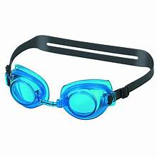 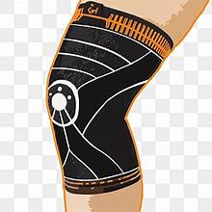  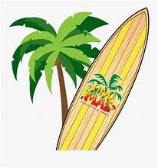 .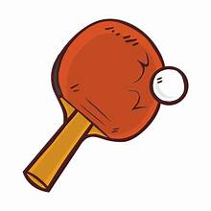 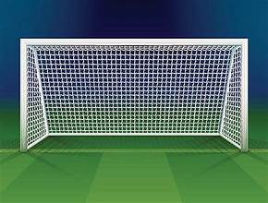
7……………………………… 8………………………… 9…………………….. 10………………….. 11……………………… 12…………………………
- Now make sentences as in the example.
- If you want to go rollerblading, you ‘ll certainly need rollerblades.
- ……………………………………………………………………………………………………………………………………..
- ……………………………………………………………………………………………………………………………………..
- ……………………………………………………………………………………………………………………………………..
- ……………………………………………………………………………………………………………………………………..
- ……………………………………………………………………………………………………………………………………..
- ……………………………………………………………………………………………………………………………………..
- ……………………………………………………………………………………………………………………………………...
- ………………………………………………………………………………………………………………………………………
- ………………………………………………………………………………………………………………………………………
- ………………………………………………………………………………………………………………………………………
- ………………………………………………………………………………………………………………………………………
- Make sentences as in the example.
  - Bryan forgot his goggles, so he got sore eyes after the pool.
If Bryan hadn’t forgotten his goggles, he wouldn’t have got sore eyes after the pool.
  - Sue forgot her racket, so she didn’t play tennis.
  - The net was torn, so they didn’t play volleyball.
  - The hoop was broken, so the basketball game was cancelled.
  - Sam wasn’t wearing a helmet, so he hit his head when he fell off the bike.
  - Jake didn’t have his knee pads on, so he hurt his knees.
  - Luke’s bat was broken, so he missed the table tennis match.
  - The football field was flooded, so the match was put off.
  - I didn’t find my rollerblades, so I couldn’t go rollerblading.
30
Let’s remember: SPORTS VOCABULARY
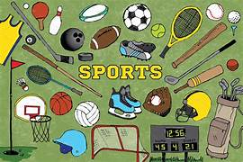
Choose the right option.
- The person who trains players is called a captain / coach.
- Football is played in a court / pitch.
- In the USA football is called rugby / soccer.
- Sports personalities are play / role models for youngsters.
- Weight lifting requires vivid / intensive training.
- Basketball is played in a course / court.
- People who support a team are called fans / spectators.
- The football match ended in a(n) equal / draw.
- You can overcome / overtake your fear of heights by taking up / taking on bungee jumping.
- A coach’s job is challenging / uninteresting and rewarding.
Correct the underlined words.
- Football spectators often throw coins, bottles and other things onto the track, creating total disorder.
- Many people like to compete on contests of all kinds.
- I easily won my opponents and earned the cup.
- Kick-boxing has become many women’s favourite sport because it’s great in self-defense.
- I like going for swimming in the summer.

Let’s Watch: The Olympics
https://www.youtube.com/watch?v=uSf7-LsmU3Y
Watch the video and tell the class one thing you remember about the Olympics. Then watch again and complete the sentences.
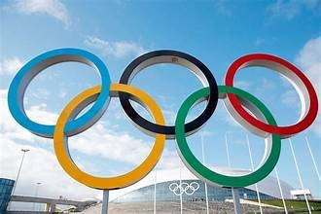
1. The Olympic Games is a celebration of peace and …………………………………….
2. The first Olympics took …………………….. in Greece nearly 3,000 years ago in 776 BC
3. During the games, there was an Olympic Truce, when .......... and battles were not allowed.
4. In the ancient Olympics, only men were allowed to …………………………… .
5. The winners were awarded a wreath or crown of ………………………. branches, which was a great honour.
6. The final games of the ancient Olympics were ………………… in 393 AD, ending a tradition of over a thousand years.
7. The first games organized by the International Olympics Committee took place in Athens, Greece in ……………………
8. The Paralympics began to be held for athletes with ………………………………….
9. While the Ancient Olympics were held at the same place each time, the modern Olympics are held in different ………………………….. around the world.
10. In modern Olympics the winners ……………………………………….. medals.
11. Third place wins ……………………………, second place wins silver and first place gets a gold medal.
12.Another important ………………………………….. of the Olympics is the Olympic rings.
13. Each of the rings represents one of the five inhabited ………………………………….. of the world.
14. After the rings, one of the most important symbols of the Olympics is the Olympic …………………………………….. .
15. Before each Olympics, the torch is lit in a special ……………………………… at ancient Olympia, Greece.
16. The torch then makes a special journey to the city that will ……………………………. The Olympics.
17. When the flame is put out, it means the ………………………………….. end of the games.
18. The goal of the Olympics is to build a better world through international cooperation, ………………………………….. and love for the games.
19. The most important thing in the Olympics is not to win but to take …………………………………. .

Now take notes and talk about five differences between the ancient and the modern Olympics.
31
Let’s Learn & Practice: Phrasal Verbs
put
1 2 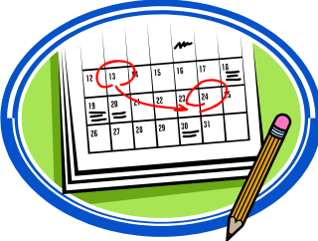 3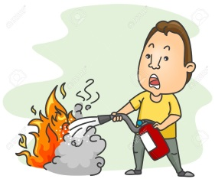 4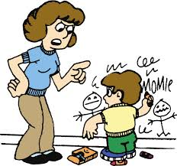 5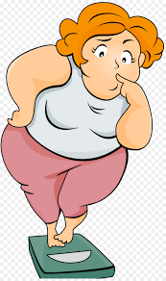 6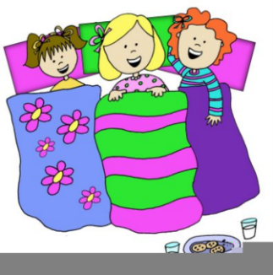
put aside put off put out put up with put on put up
1. Match the phrasal verbs with their meanings.
a. to offer hospitality b. to extinguish a fire c. to tolerate bad behaviour
d. to save money e. to gain weight f. to postpone

2. Say and Write: Look at the pictures and answer the questions. Use the phrasal verb.
1. How are you planning to go on holidays?
2. What happened to the football match because of the rain?
3. Did the fire at Brian’s house spread?
4. Does mum tolerate with Larry’s misbehavior?
5. Why is Mandy worried?
7. What did Jenny do last Saturday?
3. Now, make your own sentences.
turn
1 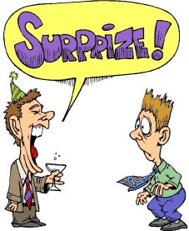 2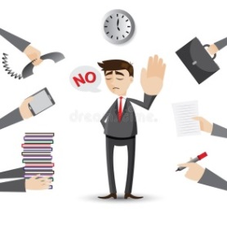 3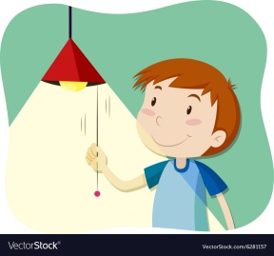 4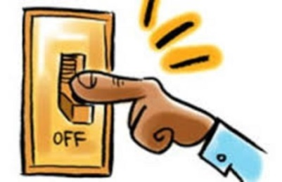5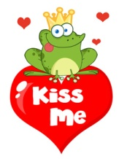6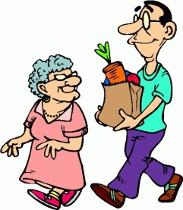 7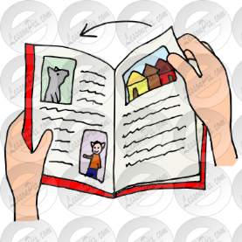
turn up turn down turn on turn off turn into turn to turn over

4. Match the phrasal verbs with their meanings.
a. to ask someone for help or advice b. to convert into c. to appear unexpectedly
d. to reject an offer e. to switch off f. to turn to a new page g. to switch on

5. Say and Write: Look at the pictures and answer the questions. Use the phrasal verb.
1. Why was nick surprised when he saw Andrew at his birthday party?
2. Did the manager accept the proposals?
3. What did the boy do when it started getting dark?
4. What should you do when you leave a room?
5. What happened to the frog when the princess kissed him?
6. What did the old lady do because she couldn’t carry her shopping?
7. What should all students do while reading in class?

- Now, make your own sentences.

32
UNIT 5: PRESENT & PAST
Let’s Practise: The Present Perfect Tense

Have you ever …? - Present Perfect for Experiences -
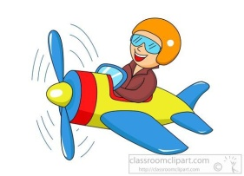 1 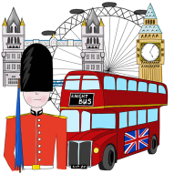 2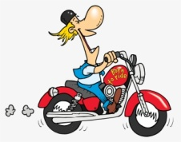 3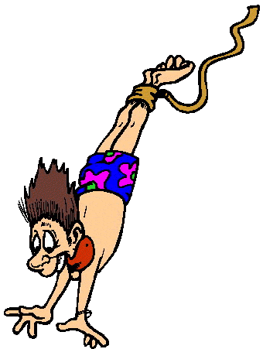 4 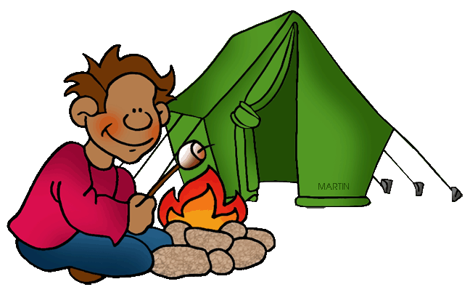5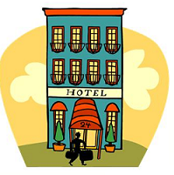6 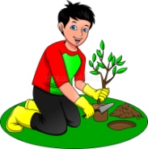
fly be ride do go stay plant
7 8 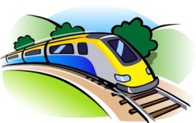9 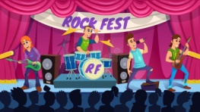101112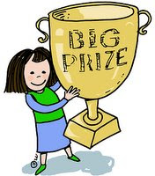13 
visit travel be at a live concert meet a celebrity cook win be
-Have you ever flown an airplane?
-Yes. I have! It was exciting! OR -No, I haven’t. I have never flown an airplane.
-Would you like to try?
-Yes, I think it must be exciting! OR No, I think it must be dangerous.

- Make similar conversations for all the situations. Use the words: exciting, fantastic, breathtaking, thrilling, interesting, fun, delicious, dangerous, boring, awful, disgusting, frightening, horrible

- Write sentences as in the example:
I have never flown an airplane and I wouldn’t like to fly one. It must be dangerous.
I have never been to China but I would like to go. It must be fantastic.
I have met a celebrity. It was exciting!
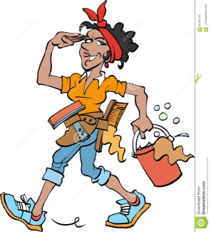
Household chores with just / already / yet

Mrs Brooks is a cleaning lady. Today, she’s cleaning the Browns’ house. Look at the pictures and say: what she has already done, what she has just done and what she hasn’t done yet.
1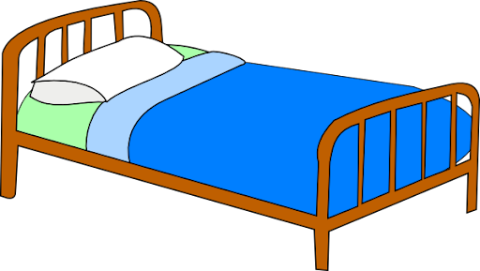2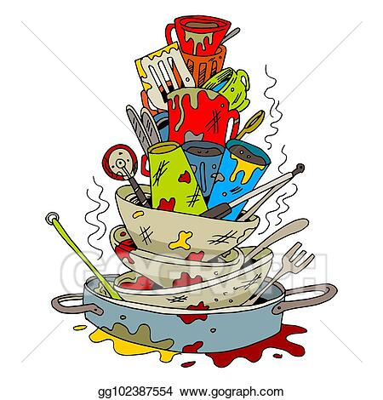3 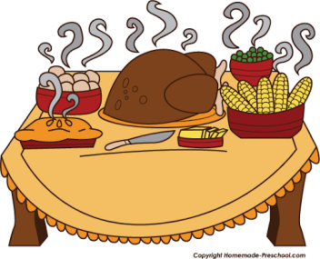 4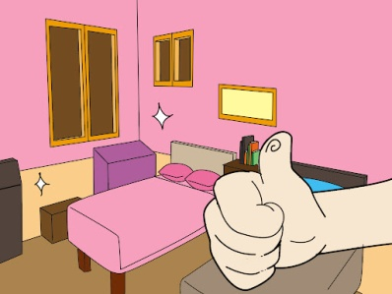5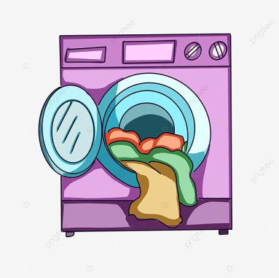 6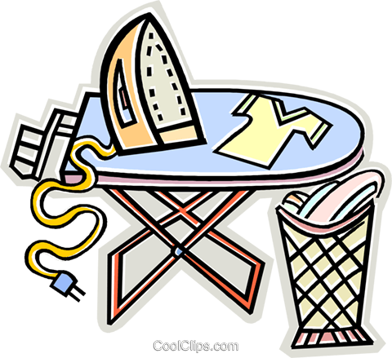
make do cook tidy do iron

7 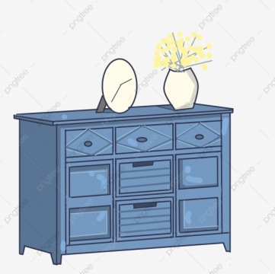 8 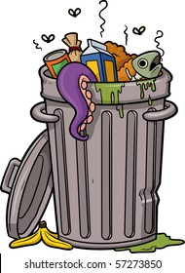 9 10 11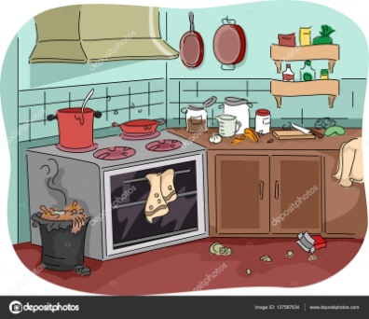 12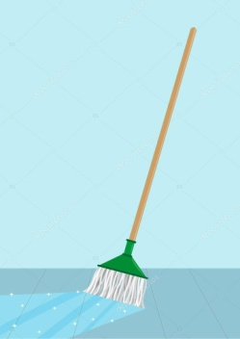
dust take out clean set clean mop
33

Present Perfect with for / since
Look at the pictures and use the clues to make sentences as in the example, using since or for.
1. Sue went to London last Monday. She is in London now. She has been in London since last Monday.
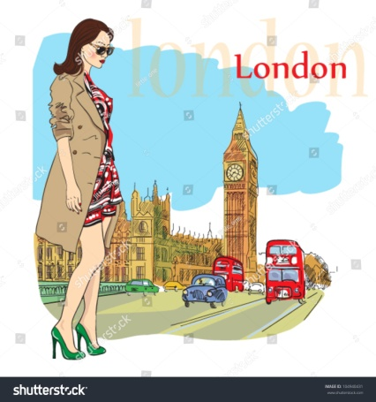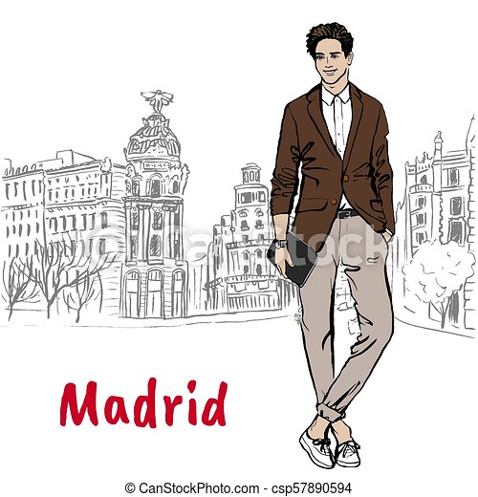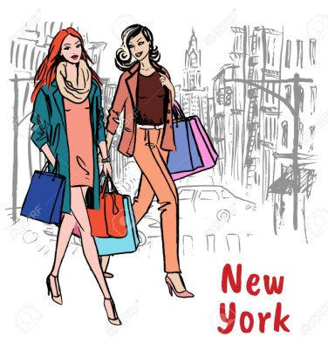
1. Sue / go / be / last Monday 2. Bill / go / be / 3 days ago 3.Helen and Fay / go / be / last week
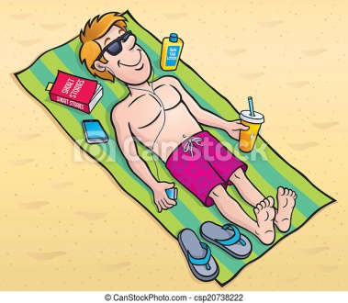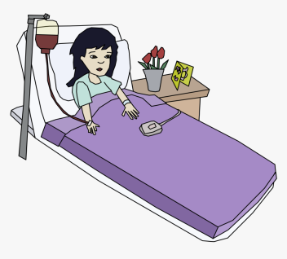
4. Mum / go / be / 2 hours ago 5.Ted / go / be / at 2:00pm 6.Clara / go / be / last week
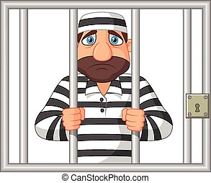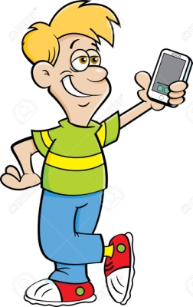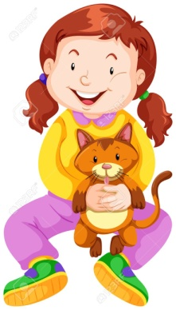
7.Sammy / go / be /in 2019 8.Nick / buy /have / yesterday 9. Lina / find / have / two days ago

I haven’t seen you for a long time!
(Present Perfect & Simple Past)
Make sentences for each picture as in the example:
1.Lisa went on holidays last summer? (When did she go? Last summer.)
Lisa hasn’t gone on holidays since last summer

1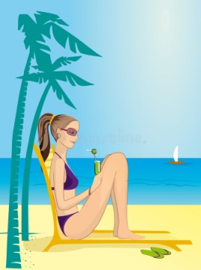 2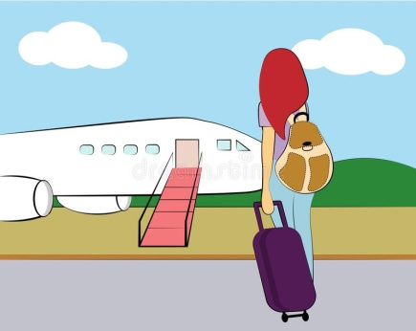 3 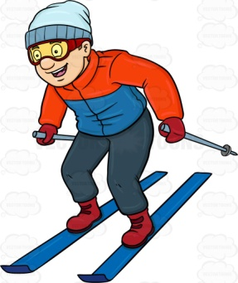 4  5 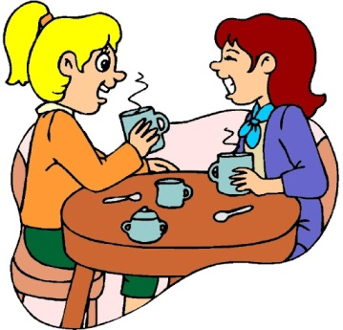
Lisa / go / last summer Fay / fly / in 2022 Bill / go/ last winter Tina / be / last year Flo and Jill / meet / last month
6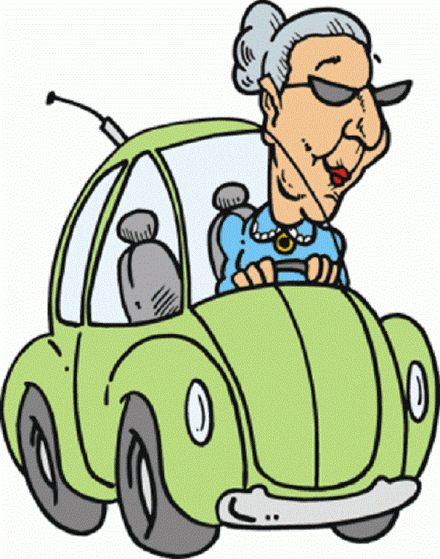 7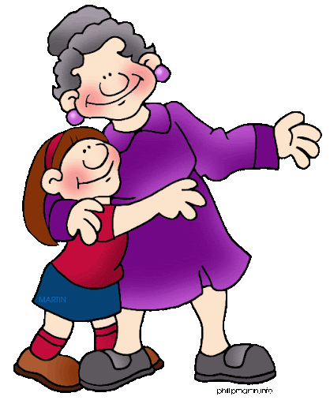 8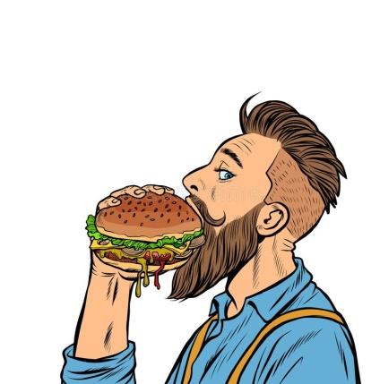 9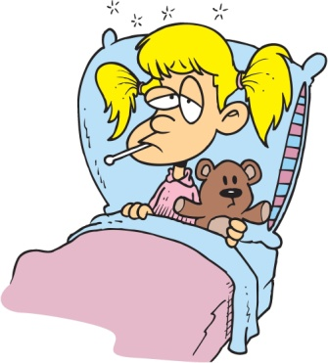 10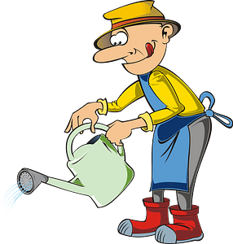
Lilly / drive / long ago Sue / see / a month ago Don / eat / 4 days ago Jo / be ill / 2 years ago Ben / water / 2 days ago
34
Present Perfect and Simple Past
When did you…. & How long have you…?
Look at the example and make similar conversations for the pictures based on the clues.
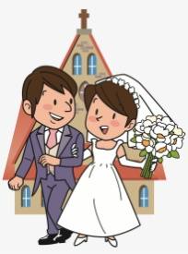
Jack and Jill / get / be / 5 years ago
Jack and Jill are married.
When did they get married?
They got married 5 years ago.
How long have they been married?
They have been married for 5 years.

1. 2. 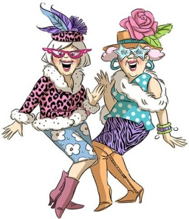 3. 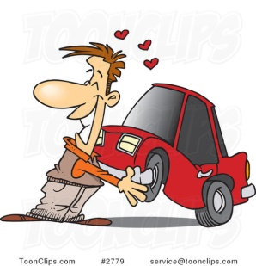 4. 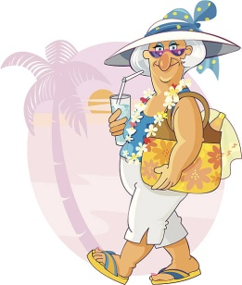
Seth has a beard. Gilda and Frida are friends. Rick has a new car. Maggie is on holiday
grow /have / last year become / know / a long time ago buy / have / a month ago go / be / last Sunday
5. 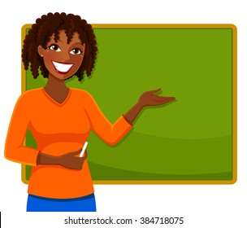 6. 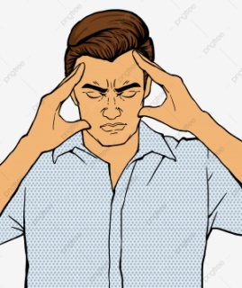 7. 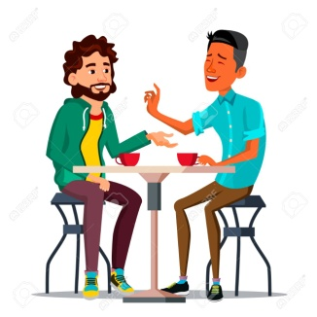 8. 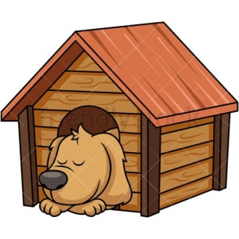
Anne is a teacher. Dean has a headache That’s my best friend Jim Rex has a new kennel
become/ be /7 years ago start having /have /an hour ago meet / be / at school have / last Monday
Present Perfect or Simple Past?
1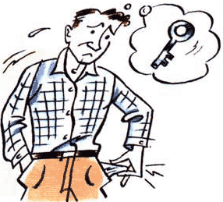2  3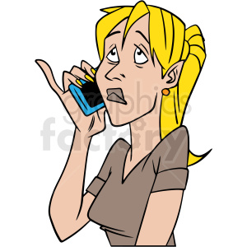45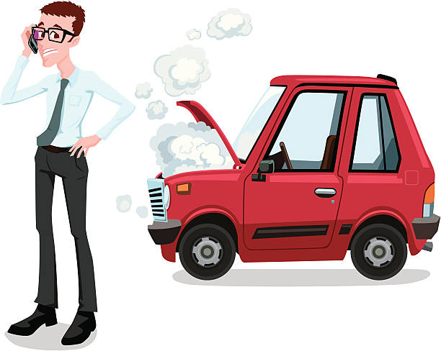6
7 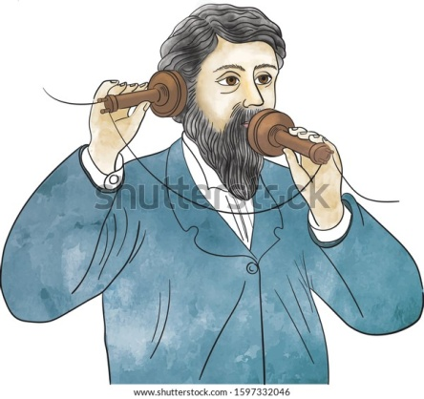 8 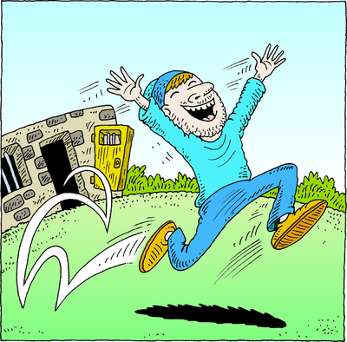 9 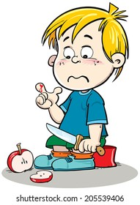 10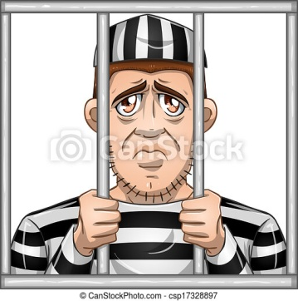 11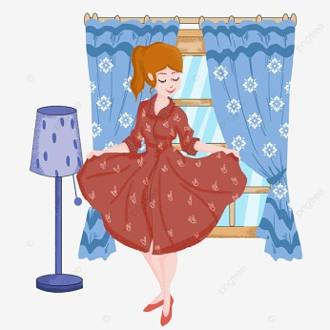 12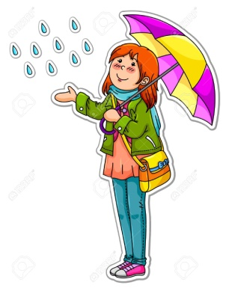
1.Tom can’t get into his house. He …………………………. (lose) his key.
2.The office is empty now. Everybody…………………………………. (go) home.
3. I wanted to call you last night but I ……………………….. (forget)
4.-Are you OK? -Yes, I ……………………………. (have) a headache, but I feel fine now!
5. -Yes please, can you help me? My car …………………………………… (break down)
6. Wow! We ..…………………………………. (win) the lottery.
7. Alexander Graham Bell ……………………. (invent) the telephone.
8. Rudy ……………………………. (be) in prison.
9. Oh no! I ……………………………… (cut) my finger. It’s bleeding!
10. Jake ……………………………………. (be) in prison for a year now.
11. I …………………………………… (buy) a new dress. Do you like it?
12. The weather ……………………………… (be) nice but now it’s raining. 35
Present Perfect Continuous (What have they been doing?)

Make sentences for the pictures as in the example. Use the clues.
Don is playing tennis. He has been playing tennis for an hour.
1. 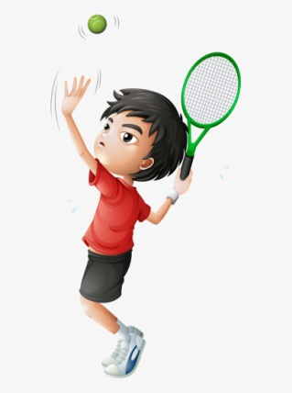 2. 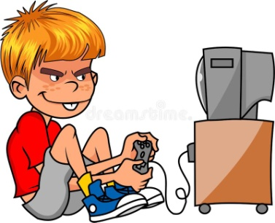 3. 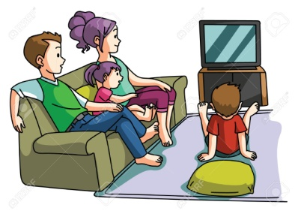 4. 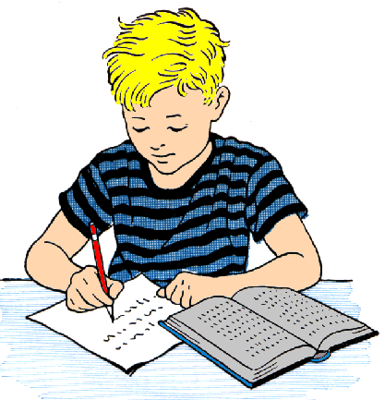
Don / an hour Morty / play / two hours The Simpsons / watch / all evening Dennis / study /all afternoon
5.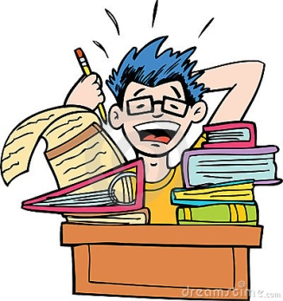 6. 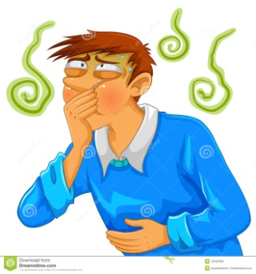 7. 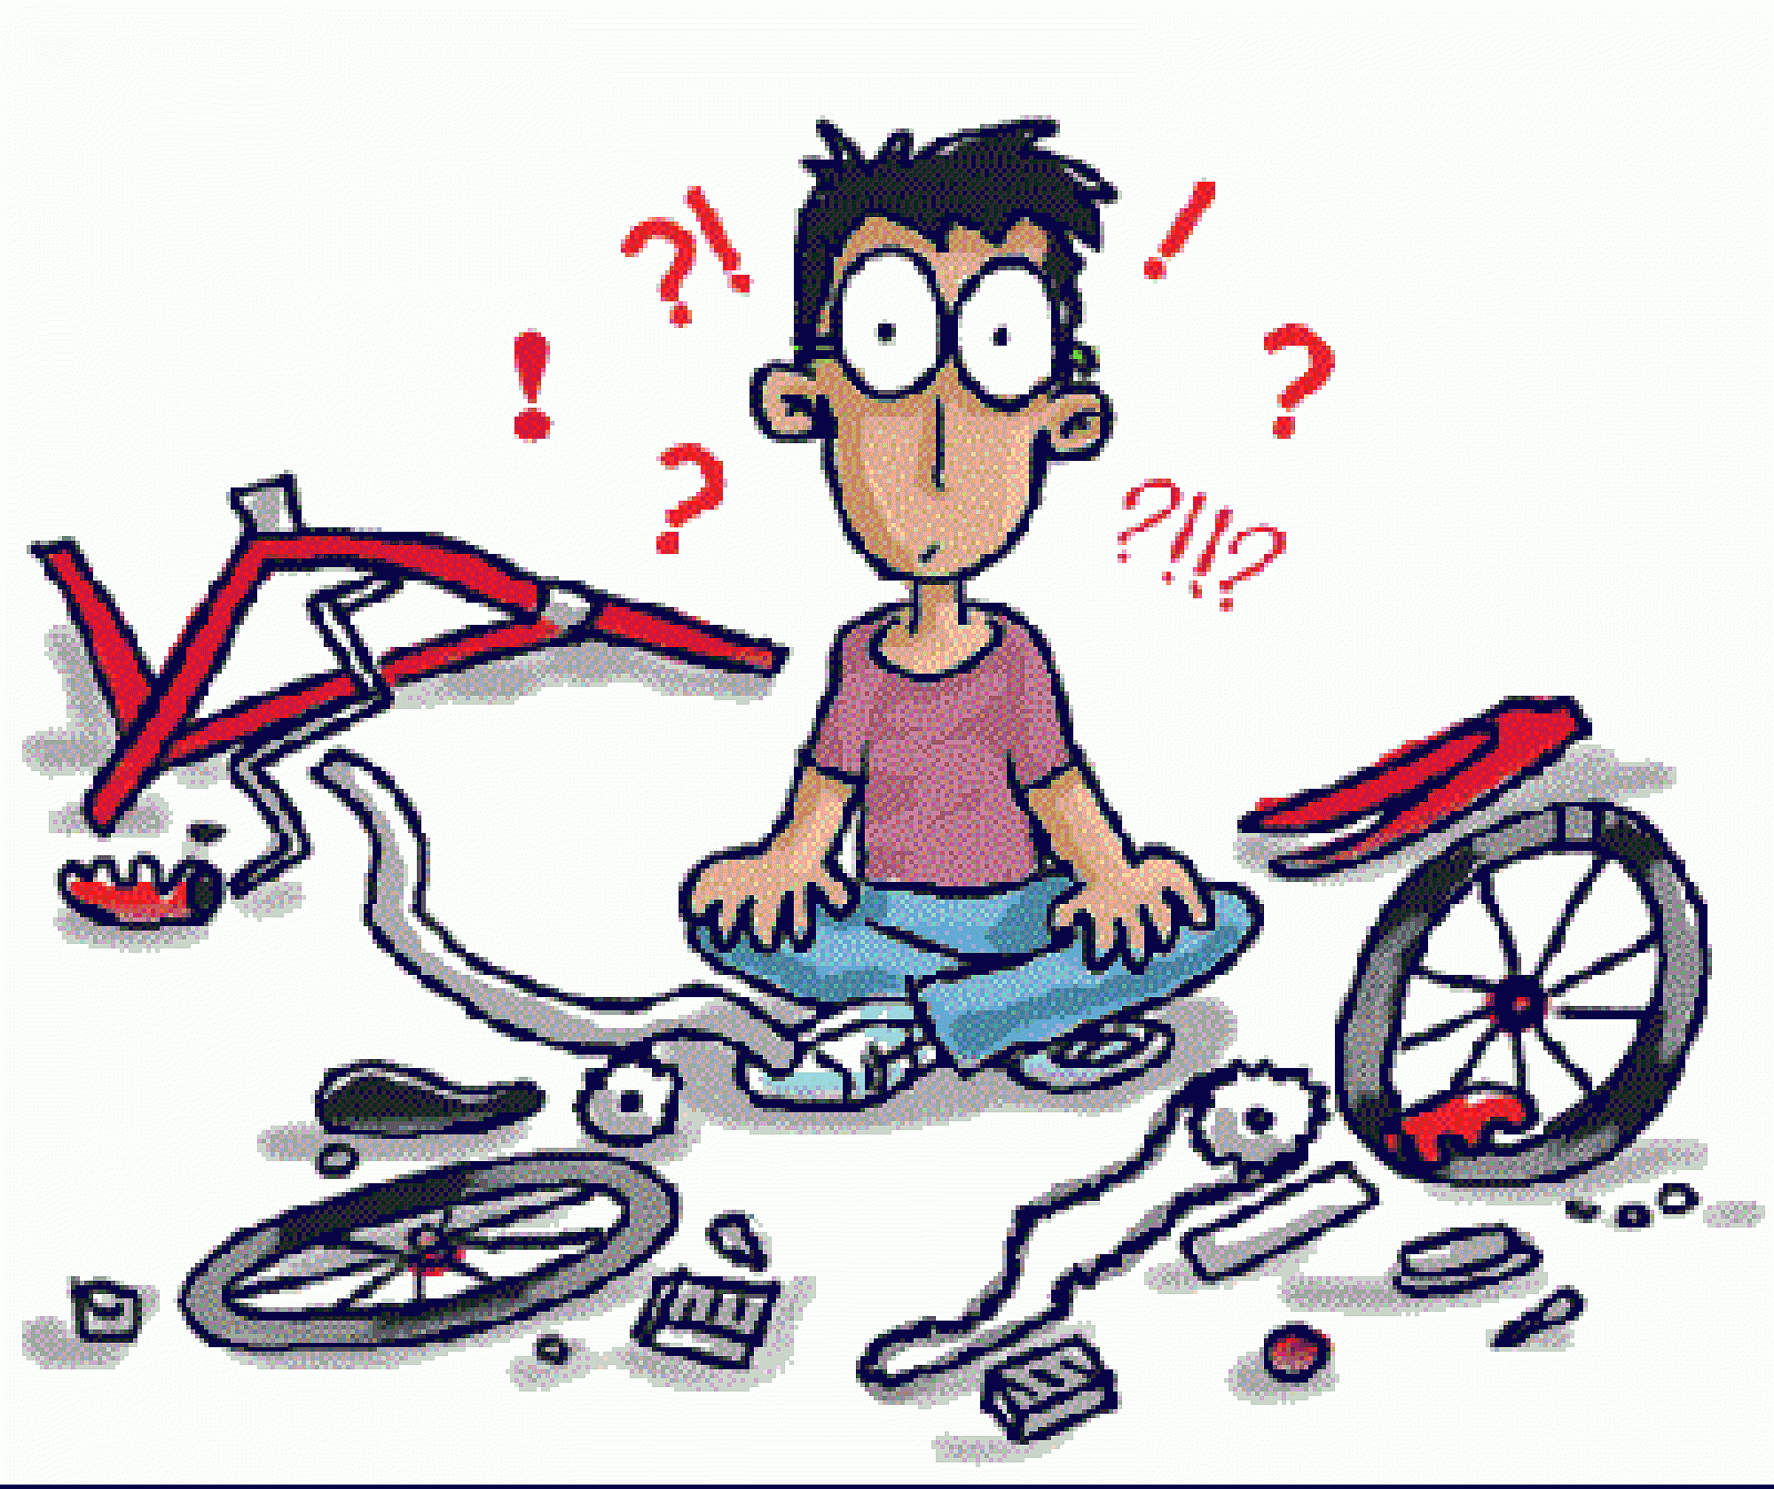 8.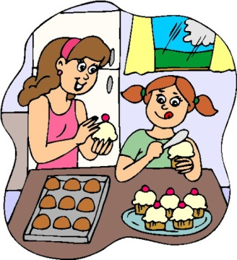
Albert / do / three hours Sam / feel sick / morning Bob / try / four hours Sue and Mum/make/two
9.  10. 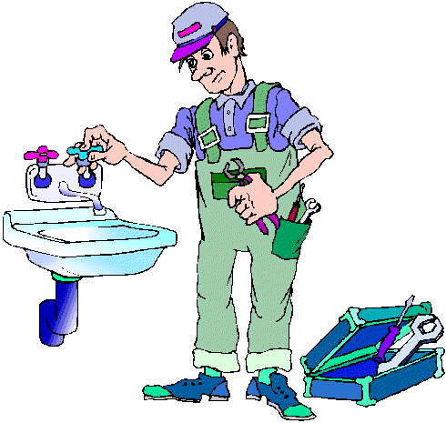 11.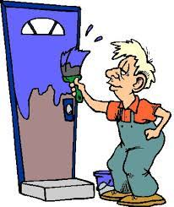 12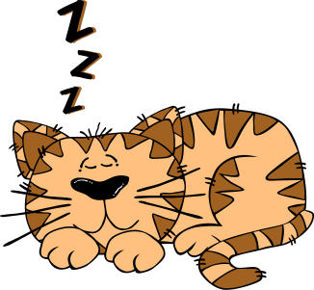
Mr Scott / read Ben / work / nine years Joe / paint / all afternoon the cat / sleep / hours

Present Perfect Continuous for Visible Results
Why are they tired? What have they been doing?
1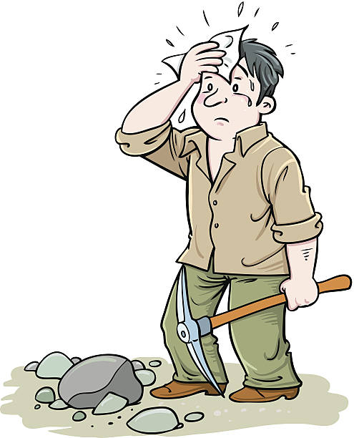2 3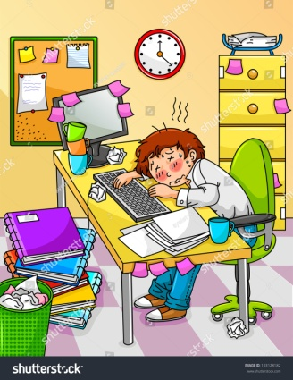 4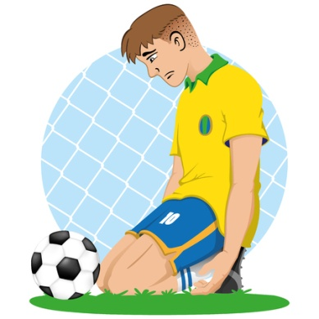5 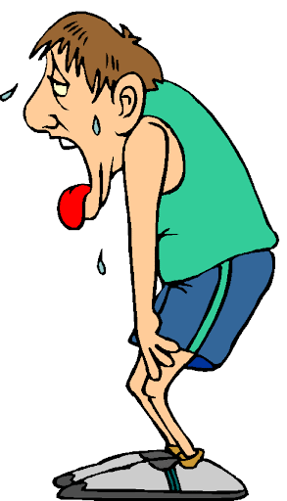6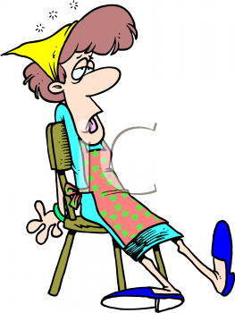 7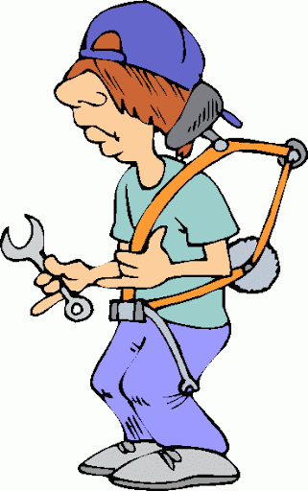
8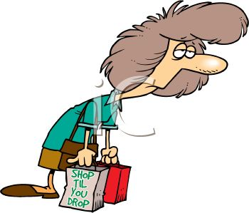9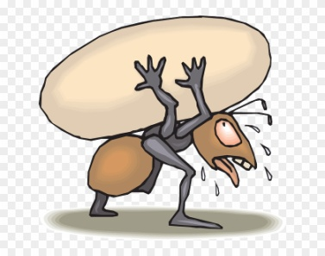10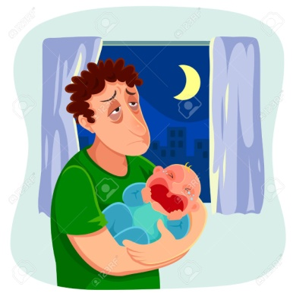11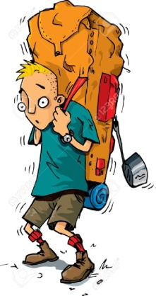12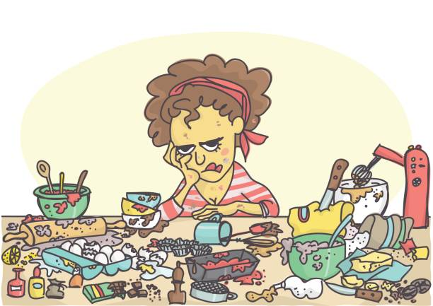
- ………………………………………………………………. 7 ……………………………………………………………………….
- ……………………………………………………………… 8 ………………………………………………………………………..
- ………………………………………………………………. 9 …………………………………………………………………………
- ……………………………………………………………… 10 ……………………………………………………………………….
- ………………………………………………………………. 11 ……………………………………………………………………….
- ………………………………………………………………. 12 ……………………………………………………………………….

36

Present Perfect Continuous for repeated actions
Make similar conversations for each picture using the clues.
- Suzan is a great tennis player.
When did she start playing tennis? She started playing tennis when she was 8.
How long has she been playing? She has been playing tennis since she was 8.

1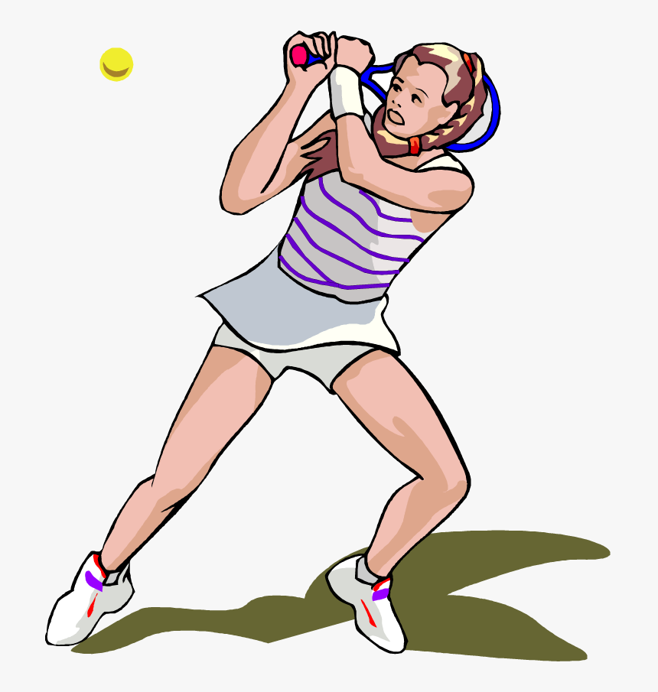 2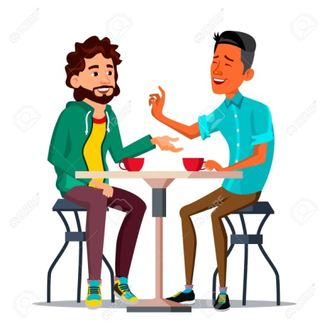 3 4
Suzan/a great tennis player Dan and Phil meet at a café Roy / speak German. Tracey /a teacher.
Start / when she was 8 start meeting / 2 years ago started learning /5 years ago start working / 2018.
5  6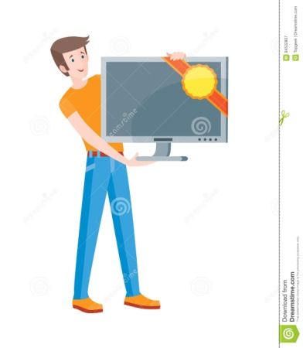 7 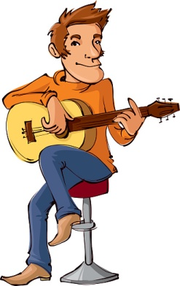 8
Patty live / Berlin. Harry sells computers Phil play / guitar Greg / a magician
moved / 2020 start selling / last year start/when he was a child. start / magic tricks / 8 years ago

Present Perfect Simple (how many?)& Continuous (how long?)
Make sentences as in the example for each picture using the clues:
She has been writing letters. She has written five letters so far.

1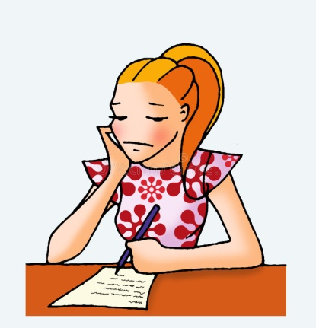 2 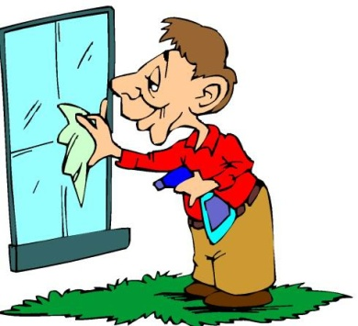 3. 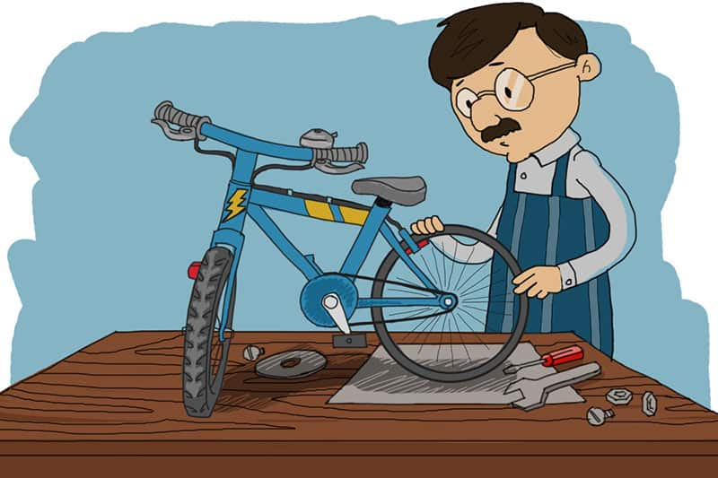4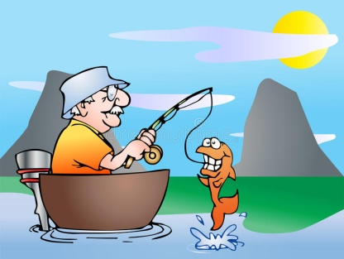5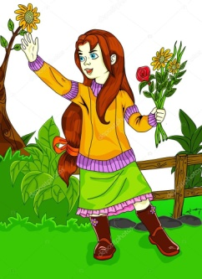
write / 5 clean / 4 fix / 2 fish / only 1 pick / 3

6 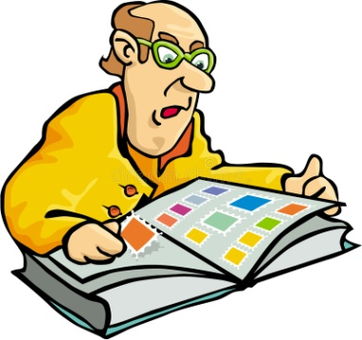78 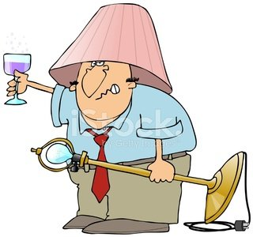9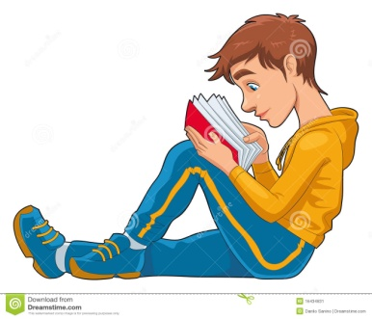10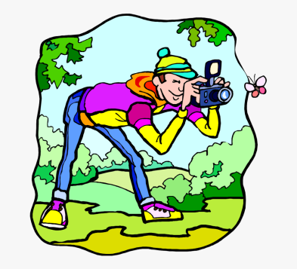11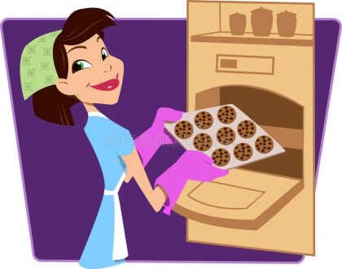
collect / 465 eat / 7 drink / a bottle read / 34 pages take / 24 make / 9

37

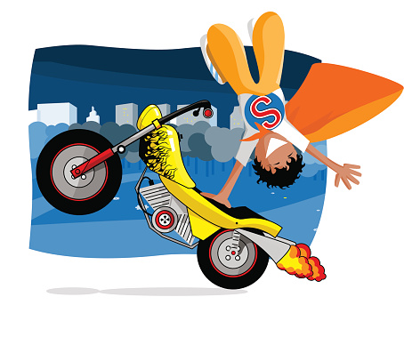
Let’s Read: Risky Jobs
How long have you been a stuntman?
I ‘ve been a stuntman for seven years!
What do you do in your job?
I perform stunts. For example, I jump off high buildings or running cars, I drive cars and motorbikes at very high speed or I go through fires!
When did you do your first stunt?
Seven years ago.I rode a motorbike down a mountain slope.
What is the most dangerous stunt you’ve ever done?
I jumped off a helicopter that was on fire!
Do you like your job?
I love it. Although it’s risky, I think it’s exciting!
RON WOOD-STUNTMAN
Ron Wood is a stuntman. He has been a stuntman for seven years. In his job, he performs stunts. For example, he jumps off high buildings or running cars, he drives cars and motorbikes at very high speed or goes through fires!
He did his first stunt seven years ago when he rode a motorbike down a mountain slope. The most dangerous stunt he’s ever done was when he jumped off a helicopter that was on fire! Ron loves his. Although it’s risky, he thinks it’s exciting!

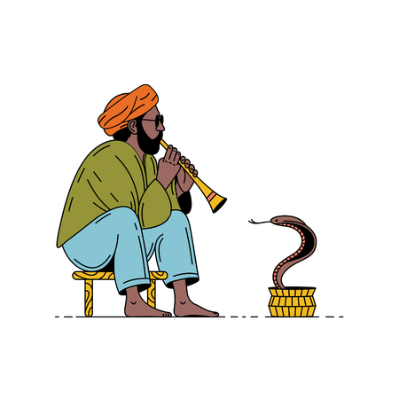
___________________________________________________
I ‘ve been a snake charmer since I was a kid!
___________________________________________________
I ‘m a street performer in India. I play the flute and make snakes come out of a pot and “dance”.
___________________________________________________
When I was eight years old. I made a cobra dance to the music of my flute!
___________________________________________________
The most dangerous performance was when I made a python dance! Pythons are huge snakes that can break your bones!
___________________________________________________
I love it. Although it’s dangerous, I think it’s mysterious!
RAVI SANDAR-SNAKE CHARMER
……………………………………………………………………………………………………………………………………………………………………………………………………………………………………………………………………………………………………………………………………………………………………………………………………………………………………………………………………………………………………………………………………………………………………………………………………………………………………………………………………………………………………………………………………………………………………………………………………………………………………………………………………………………………………………………………………………………………………………………………………………………………………………………………………………………………………………………………………………………………………………………………………………………………………………………………………………………………………………………
…………………………………………………………………………………………………………………………………………………………………………… 38
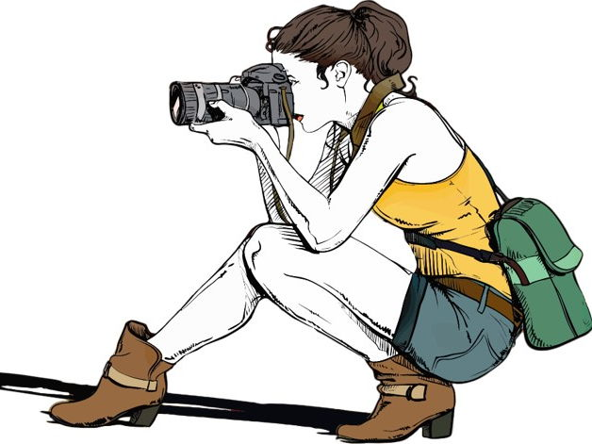
________________________________________________
I ‘ve been a war photographer since 2017!
________________________________________________
I take pictures in war zones. Then, I upload the pictures and people can see that a war is a terrible thing.
________________________________________________
I took my first photo five years ago. It was a child who lost his parents in war!
________________________________________________
The most dangerous picture was a bombing. I was nearly killed!
________________________________________________
I love it. Although it’s dangerous, I think it’s adventurous!

MAY WEST-WAR PHOTOGRAPHER
…………………………………………………………………………………………………………………………………………………………………………………………………………………………………………………………………………………………………………………………………………………………………………………………………………………………………………………………………………………………………………………………………………………………………………………………………………………………………………………………………………………………………………………………………………………………………………………………………………………………………………………………………………………………………………………………………………
……………………………………………………………………………………………………………………………………………………………………………………


_________________________________________________
I ‘ve been a willdlife photographer for 12 years!
__________________________________________________
I take pictures of wild animals. Then, I sell the pictures and people can see that wildlife is amazing.
__________________________________________________
I took my first wildlife photo a long time ago. It was in the Amazon!
__________________________________________________
The most dangerous picture was a lion in Africa. It was scared and nearly attacked me!
__________________________________________________
I love it. Although it’s risky I think it’s fantastic!

ED SHERMAN-WILDLIFE PHOTOGRAPHER
…………………………………………………………………………………………………………………………………………………………………………………………………………………………………………………………………………………………………………………………………………………………………………………………………………………………………………………………………………………………………………………………………………………………………………………………………………………………………………………………………………………………………………………………………………………………………………………………………………………………………………………………………………………………………………………………………………
……………………………………………………………………………………………………………………………………………………………………………………
39
Let’s Learn: Proverbs

What is a proverb?
A proverb is folk wisdom or advice in short sentences. Most proverbs are local and reflect wisdom, beliefs, and traditions of the place, but some are global. The majority of them have been around for centuries – and even millenniums.

Look at the pictures A-J and try to imagine if they bring you in mind any Greek proverbs. Then match them with the English proverbs 1-10.
A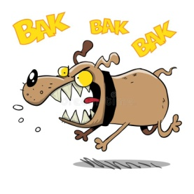 B C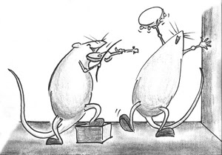 D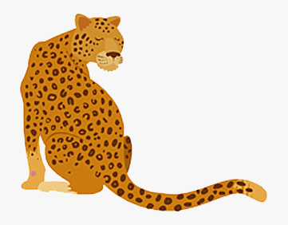 E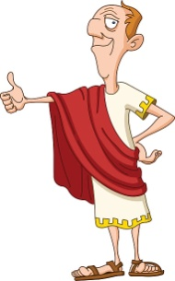F G 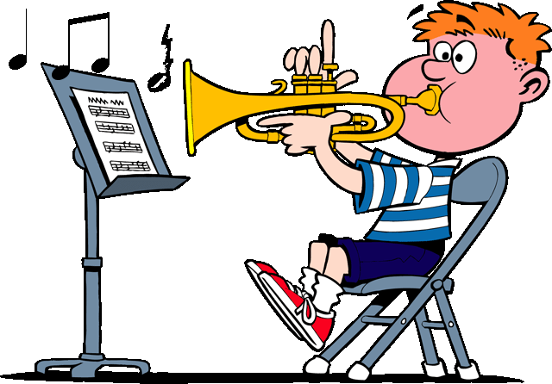H  I 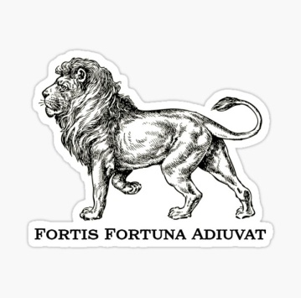 J 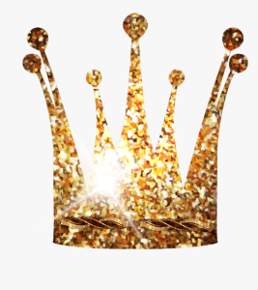

A leopard doesn’t change its spots.

All is well that ends well.

All that glitters is not gold.

An apple a day keeps the doctor away.

Barking dogs seldom bite.

Fortune favors the brave.

Money doesn’t grow on trees.

Practice makes perfect.

When in Rome, do as the Romans do.

While the cat is away, the mice will play.

Now try to match the proverbs with their meanings a-j.
- If you carry out your plans boldly, luck is more likely to be with you.
- When the outcome is good, problems on the way don’t matter.
- When you visit a foreign land, follow the customs of local people.
- People can’t change their character, especially when they‘re bad.
- People often break the rules when no one watches over them.
- Eating an apple a day will keep you healthy.
- When you do something over and over, you become better at it.
- Things that look good outside, may not be valuable.
- Spend money carefully because you can’t grow it like apples.
- People who appear threatening rarely do harm.

Try to say the proverbs by only looking at the pictures. Then, in pairs find more proverbs in English and tell them in class. Ask your classmates to tell their meaning.

40

