**ENGLISH**

**for**

**A΄ CLASS**

LEVEL A2

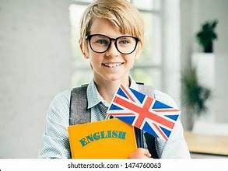

**Cosmas Markis (EFL Teacher)**

**3rd Junior High School of Preveza**

CONTENTS

UNIT 1: CELEBRATIONS & FESTIVALS……….p.1-8

UNIT 2: ANIMALS IN THE WILD………………… p.9-15

UNIT 3: FOOD & COOKING………………………….. p.16-21

UNIT 4: TRAVEL & TRANSPORT …………………p.22-28

Unit 5: MYTHS & STORIES ………………………….p.29-35

**UNIT 1: CELEBRATIONS AND FESTIVALS AROUND THE WORLD**

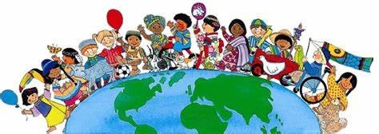

**1. Do the following quiz to find out how much you know about celebrations and festivals around the world.**

1. On **Thanksgiving Day**, people in the USA eat
2. turkey and pumpkin pie b. beef and corn c. chicken and pancakes
3. In **Halloween**, people dress up in
4. old costumes b. scary costumes c. historical costumes
5. The most famous **carnival** in the world takes place in
6. Paris b. Rio de Janeiro c. Los Angeles
7. On **Chinese New Year**, decorations are
8. Red and blue b. blue and silver c. red and gold
9. **Valentine’s Day** is celebrated in
10. January b. February c. March
11. In **La Tomatina Festival** in Spain, people throw on the crowd from balconies
12. water b. tomatoes c. rubbish
13. At **Loy Krathong festival**, people in Thailand let off
14. fireworks b. lanterns c. kites
15. On **Christmas Eve**, children sing
16. happy songs b. hymns c. carols
17. Radaman is the greatest celebration for
18. Muslims b. Buddhists c. Jews
19. On **Easter Day** Greeks eat
20. lamb-on-the-spit b. roast chicken c. pork-on-the-spit

**2. Make questions for the 10 quiz sentences. Be careful of the question forms.**

**(QUESTION WORD) + AUXILLIARY VERB + WHO + VERB + REST SENTENCE**

**Who/What/Which/ do / does / is / are**

**When/Where/How**

Eg. Do the Chinese celebrate New Year ‘s Day?

When do the Chinese celebrate New Year’s Day?

How do the Chinese celebrate New Year’s Day?

1. What do people in the USA eat on Thanksgiving Day?
2. ……………………………………………………………………………………………………………………………………………………….
3. ……………………………………………………………………………………………………………………………………………………….
4. ……………………………………………………………………………………………………………………………………………………….
5. ………………………………………………………………………………………………………………………………………………………..
6. ………………………………………………………………………………………………………………………………………………………..
7. …………………………………………………………………………………………………………………………………………………………
8. ………………………………………………………………………………………………………………………………………………………..
9. …………………………………………………………………………………………………………………………………………………………
10. ……………………………………………………………………………………………………………………………………………………….. **1**

**Let’s Learn:**

**All around the world people love to celebrate. Celebrations and festivals are connected with tradition, religion or history. Some celebrations include food, music and dancing, and others decorations, lights and fireworks. In lots of celebrations people dress up in special costumes and make parades. In all cases, celebrations and festivals are a wonderful chance for people to get together and have fun.**

1. **Match the words with the pictures.**

**lantern fireworks candle parade float pole hot-air balloon trick-or-treat calendar**

1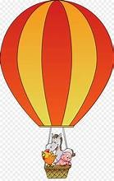2 3 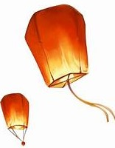5 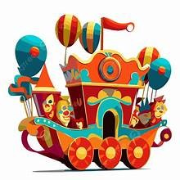6 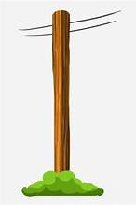7 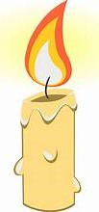8 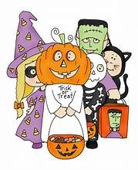9 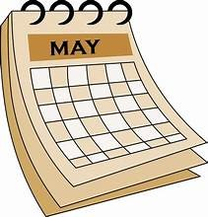10 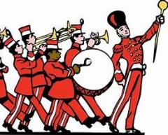

1. **Let’s read about some of the most popular celebrations around the world and do the tasks that follow.**

Halloween

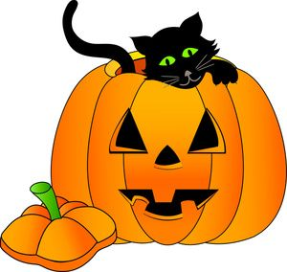Halloween is a traditional celebration that began in Europe hundreds of years ago.  At that time, some people believed that ghosts of the dead visited the living.  Nowadays, it is a special day in several countries around the world, but it is most popular in Canada and the United States.  It’s always on the same date every year: October 31.

  In the evening of October 31, children wear scary costumes.  They dress up as ghosts, animals, monsters or vampires.  They can be very funny or they can be quite scary.  The costumes often include a face mask or some face painting.  For example, at Halloween you can see a dinosaur or an elephant, a witch with a tall black hat, or maybe a ghost. Children go from house to house and ask for sweets by saying, “Trick or treat?” They also play traditional games like “Bobbing for apples”. Older kids and adults dress up and go to Halloween parties. Jack - o’ lanterns are very common during this time.  They are pumpkins with lights inside and faces cut into them. A lot of people like to put **them** in their windows.  Most people, both young and old, have a lot of fun at Halloween.  “Happy Halloween” everyone!

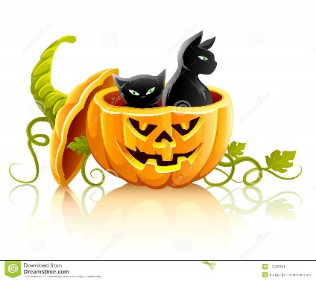**Circle T (True) or F (False).**

1. Halloween is a relatively new celebration. T F

2. It is on the last day of October. T F

3. Only children wear costumes. T F

4. Children go around houses asking for lanterns. T F

5 . Faces are carved into pumpkins. T F

6. Not all costumes are scary. T F

7 . People of all ages enjoy Halloween. T F

Chinese New Year

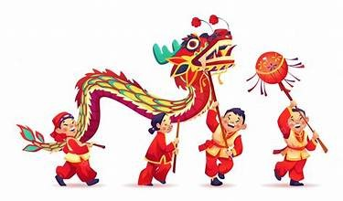The date of the Chinese New Year depends on the moon, but it’s usually in January or February and it’s a big celebration. Everyone gets outside to watch the spectacular parades and the awesome fireworks that light up the sky. There are red decorations in every house and red dragons dancing in the streets.

The Chinese New Year is a time to make everything fresh and new. People clean up their houses, wear new clothes and get a haircut to clean away bad luck. They also hang up red and gold decorations. They make handmade calendars and wish each other good luck and happiness.

**Complete the sentences.**

1. Chinese New year is ................................................. 4. People want to clean away ...................................
2. You can see ............................................................ 5. They make ...........................................................
3. Every house has .................................................. 6. They wish each other ............................................  **2**

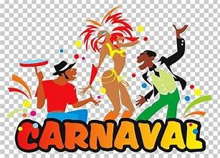Carnival in Brazil

The world-famous Carnival in Rio de Janeiro, Brazil is a stunning celebration. It usually takes place at the end of February and lasts for four days. All the streets come alive with parties, singing and dancing. The carnival attracts thousands of people from all over the world and gives them the chance to learn about the rich culture of Brazil.

The Samba school parade is the most popular event. About 3,000 performers with dazzling costumes dance in the parade. There are also hundreds of colourful floats. They all dance and have fun to the sound of samba music. In the end, the best Samba School wins the competition for the title of the Carnival Champion.

**Complete with the correct word.**

1. The Carnival in Rio de Janeiro, Brazil is a ........................................... celebration .
2. Carnival in Rio ........................................ for four days.
3. Tourists have the .......................................to learn about the rich culture of Brazil.
4. About 3,000 performers with ...................................... costumes dance in the parade.
5. The best Samba School ...................................... the competition.

La Tomatina

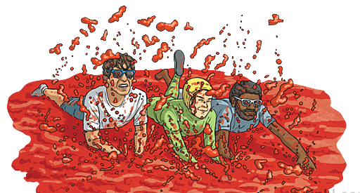La Tomatina is a fun festival that takes place in August, in the town of Bunol, in Spain. People throw tomatoes at one another and have a great time!

The festival begins at nine o’ clock in the morning in the town square. A lot of fun things happen before the tomato fight starts. People eat a delicious breakfast of fresh bread and cakes. Then they put up a big pole and cover it with soap. They put a piece of meat on the top and try to climb the pole to get it. It is very funny because the pole is slippery and everyone laughs. Other people stand on their balconies and throw water on the crowd.

At 11 o’clock, the first big lorry full of tomatoes arrives. Soon, the battle begins and everyone turns red!

**What happens at La Tomatina Festival? Put tick(V) or cross (X).**

1. They throw tomatoes. 5. They cover a pole with soap.
2. They eat a good breakfast. 6. They hang up decorations.
3. They dress up in costumes. 7. They sing traditional songs.
4. They have a parade. 8. They throw water.

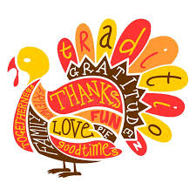

Thanksgiving Day

Thanksgiving Day is a national holiday in the USA. It is on the fourth Thursday in November.

Thanksgiving is a time when families get together and give thanks for all the good things in their lives. People eat a traditional dinner, roast turkey and pumpkin pie for dessert. In New Year there is a big parade. It’s called Macy’s Thanksgiving Day parade. At the parade you can see floats, marching bands and clowns. All over the USA is an important celebration.

**Put the words in the correct order to make sentences**.

1. is / Thanksgiving Day / a / holiday / national
2. November / takes / in / It / place
3. celebration / It / important / an / family / is
4. in / There / a / New York / parade / big / is
5. pumpkin / turkey / for / eat / pie / and / roast / dessert / People
6. and / floats / see / at / You / can / parade / the / clowns

**3**

Loy Crathong

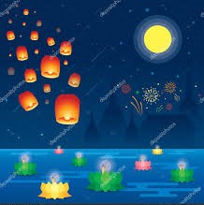Loy Krathong is one of the most popular festivals in Thailand and it is about 700 years old. It takes place on the night of the full moon in November.

“Loy” means “float” and a “krathong” is a special decoration, like a basket, for this time of year. A traditional “krathong” is made from a piece of banana tree trunk with banana leaves and flowers.

On the night of Loy Krathong, families gather around rivers. First, they light their candles, then they hold their krathongs over the water. They make wishes and send their krathong down the river. It carries away their troubles and helps their wishes come true!

At Loy Krathong festival people also light paper lanterns and send them up into the sky. They are spectacular and look like little hot-air balloons!

**Complete the notes and use them to talk about Loy Krathong**

How old? …………………………………………………………………….……………………………………………………………………………….

When? ………………………………………………………………………………….……………………………………………………………………..

Where? ………………………………………………………………………….…….……………………………………………………………………….

Special decoration made of …………………………………………………………………………………………………………………………..

What they do ………………………………………………………………………………………………………………………………………………..

Other activity? ……………………………………………………………………………………………………………………………………………….

**Complete with the correct word and then use the phrases to make sentences.**

**let off light marching win traditional special wish delicious spectacular make national colourful**

1. ………………………………… celebration 7. ………………………………………holiday
2. …………………………………….. parades 8. ……………………………….. bands
3. ………………………. fireworks 9……………………………….. decoration
4. …………………………………….. floats 10. ………………………………….. wishes
5. …….……………………. a competition 11. …………………………… a candle
6. …………………………… breakfast 12. ………………………………… come true

**LET’S WATCH: DIA DE LOS MUERTOS (THE DAY OF THE DEAD)**

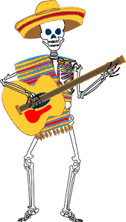**Watch the following video about the popular Mexican festival “The Day of the Dead”. Then watch again and complete the missing words**

<https://www.youtube.com/watch?v=OMzSsTrs4Gs>

1. The Day of the dead is a festival to honour people who are no longer ………………………………….
2. It is celebrated in South ……………………………………
3. The first day is ……………………………………………………
4. On the second and third day the …………………………………… of the dead adults and children visit earth.
5. The history of the celebration dates back ……………………………………………………….
6. Surprisingly, the day of the dead is not a ……………………………………………… time.
7. The Day of the Dead is a fiesta of flowers, food, …..……………., …….…….………, prayers and …….…………..
8. People dress up as …………………………………………….
9. They light ………………………………………. during the afternoon.
10. During the day the eat a special …………………………………..



**4**

**Let’s Practise: PRESENT SIMPLE & CONTINUOUS**

1. **Complete the following sentences with Present Simple:** 
   1. My sister ________________________ (not/ play) tennis every day.
   2. I __________________________ (study) English at school from Monday to Friday.
   3. Chimpanzees ___________________________ (not/ speak) any language.
   4. She always __________________________ (wear) jeans and T shirts.
   5. ___________ they ____________________ (travel) by bus?
   6. ___________ your mum _________________________ (cook) dinner at night?
   7. Jim and Joe _________________________ (not/ go) to the theatre on Sundays.
   8. Sam never __________________________ (brush) his hair in the morning.

1. **Complete the following sentences with Present Continuous:** 
   1. What ___________ you _______________________ (eat)?
   2. Kat ________________________ (open) the window because she’s hot.
   3. My dog __________________________ (not/ sleep) now.
   4. The girls_________________________ (listen to) music now.
   5. My brothers __________________________ (not/ watch) TV now.
   6. ___________ she ____________________ (comb) her hair?
   7. ___________ Mary ____________________ (copy) from the board?
   8. We __________________________ (practice) the Present tenses in English.
2. **Complete the following sentences with Present Simple or Present Continuous:**
   1. I _____________________________ (not/ study) French now.
   2. We always ________________________ (play) cards during break time.
   3. Where __________ your granny ____________________ (live)?
   4. Peter ____________________-___ (not/ take) the children to school in the morning.
   5. What ________ your brother __________________ (do) every morning?
   6. You __________________________ (talk) a lot!
   7. What _________ John __________________ (write) now?
   8. What’s that noise? Peter __________________________ (play) the drums.
   9. We _____________________________ (usually/ travel) to England in summer.
   10. This kind of animal ______________________________ (eat) meat.
   11. Look! She _____________________________ (speak) to a stranger.
   12. I’m looking at that girl. She __________________________ (wear) a beautiful skirt.
   13. I _____________________________ (never/ drink) wine at night.
   14. What languages _________ you __________________________ (speak)?

**5**

**PREPOSITIONS OF TIME**

**at on in**

**6:30 Monday April the morning**

**noon / midnight Thursday morning winter the afternoon**

**the moment / present Christmas day 2021 the evening**

**Christmas / Easter October 23rd the 1980s 10 minutes**

**the weekend my birthday the 20th century**

**1.GAME: One student says a time expression and the other repeats it with the correct preposition.**

**eg. STUDENT 1: November STUDENT 2: In November**

**2. Complete with at, in, on**.

1. ...... night 7. ...... Tuesday 13. ......the end of th school year

2. ...... Christmas Day 8. ...... 8th June 14. ...... the morning

3. ...... 17.30 9. ...... weekends 15. ...... half past two

4. ...... May 10....... Tuesday afternoon 16. ........ twenty minutes

5. ...... summer 11. ...... 1996 17. .......... this afternoon

6. ...... the evening 12. ...... the 15th century 18. ............ the moment

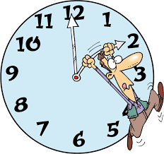**3. Write at, in, on or –**

1. We often go on holiday ......... summer.

2. I saw Brenda .......... last week.

3. Do you want to go to the cinema .......... the weekend?

4. James isn´t here .......... the moment.

5. Are you coming ........... Tuesday morning?

6. See you ............. next Friday!

7. I´m almost ready. We can go out ........... 10 minutes.

8. The film starts ........... 7.30.

9. The factory opened ............ 2002.

10. We live ……..... the 21st century.

11. Her birthday is ............ 22nd May.

12. Sally met her boyfriend ............ last summer.

13. We have lunch ............. midday.

14. They´re coming ……...... the afternoon.

15. His friends got married ............ New Year´s Eve.

**4. If the preposition is wrong, write the correct one in the blank. If it´s correct, write ok.**

1. My birthday is **in** 23rd May. ......

2. The train leaves **in** 10 minutes. ......

3. It doesn´t rain much **on** winter. ......

4. The film starts **at** 10 o´clock. ......

5. The plane arrives **at** Tuesday. ......

6. We have lessons **on** Monday morning. ......

7. **In** Christmas Day the shops close. ......

8. I play tennis **in** the weekend. ......

9. We usually go swimming **at** the summer. ..........

10. Leonardo da Vinci lived **in** the 15th century. ........

11. Dad was born **at** 1982. ........

12. I have a lot of homework **at** present. ..........

13. We ll meet **at** the evening. ............

14. Sam goes to bed **in** about midnight. ............

15. There were no mobiles back **on** the 1980s. ...........

**7**

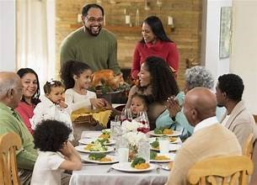Let’s Write:

**Read the mail that Keith sent to Pierre, his French friend.**

Dear Pierre,

How are you? I’m writing to tell you that it’s Thanksgiving today here in the USA and I‘m really excited because it’s my favourite celebration.

Thanksgiving is the biggest family celebration in the USA. We celebrate it at the end of November. It began when the first settlers wanted to give thanks for the corn harvests of the year, but today it is a time when we give thanks for everything we have. On this day, people who live far away usually travel long distances to be with their families and friends and enjoy a traditional meal of turkey and cranberry sauce. And of course, the delicious pumpkin pie for dessert. So, now I’m in my best clothes waiting for my aunt, uncle and cousins to arrive and have dinner together.

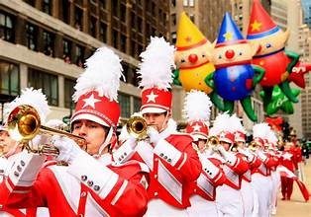There is also a large parade in New York on this day and millions of people go to see it every year. There are marching bands, colourful costumes and dazzling floats. People dance, sing and throw confetti. We are all going to see it after dinner. We never miss it.

Anyway, my cousins are arriving soon, so I have to go. I’m sure we’ll have a wonderful time this year, too. I’ll write back soon and tell you all about it.

Bye for now,

Keith

**A. Fill in with the missing information**

1. Keith is excited because Thanksgiving is his ………………………………………………………….........................

2. Nowadays, people ………………………………………………………… for everything they have.

3. Lots of people travel ………………………………………………………………… to be with their families and friends.

4. Families enjoy a ……………………………………………………….. of turkey and cranberry sauce.

5. There is a ……………………………………………….………………. in New York.

6. People dance, sing and ………………………………………………………. .

**B. Read Keith’s mail again and fill in the chart with notes.**

|  |  |
| --- | --- |
| **OPENING PARAGRAPH**  **Greetings/ Reason for writing** |  |
| **1st Paragraph**  **What is the celebration**  **When it takes place**  **What people do** |  |
| **2nd Paragraph**  **What else people do**  **What is happening today** |  |
| **CLOSING PARAGRAPH**  **Greetings** |  |

**C. Write a mail to a friend from another country to describe a popular celebration or festival in Greece. Follow the plan to help you. (80-120 words)**

**8**

**UNIT 2: ANIMALS IN THE WILD**

Let’s Learn!

1. **Write the names of the following animals**

1 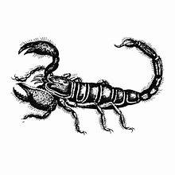 2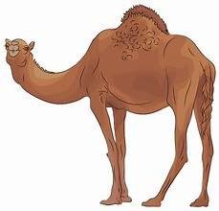 3 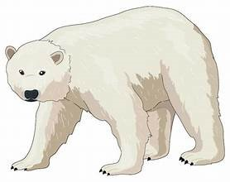 4 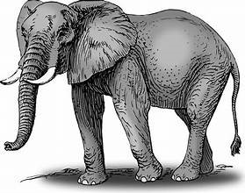 5 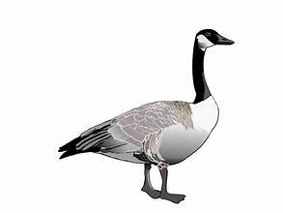6 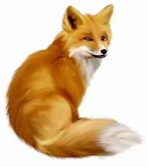

7 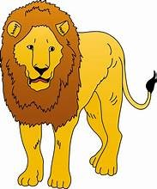 8 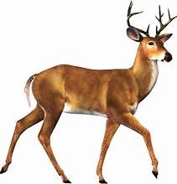 9 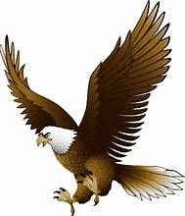 10 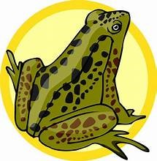 11 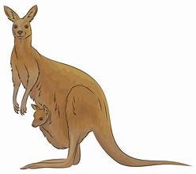 12 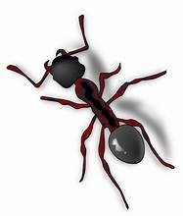 13 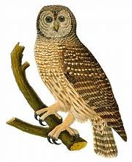

14 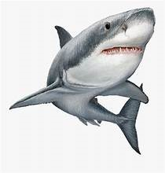15 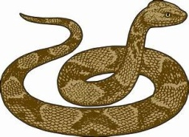16 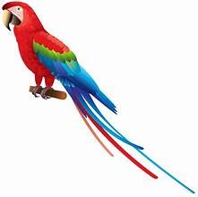17 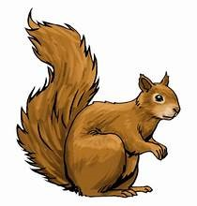18 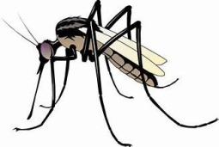19 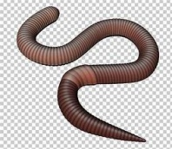20 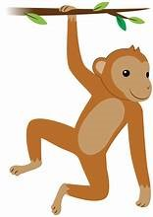

21 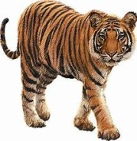 22 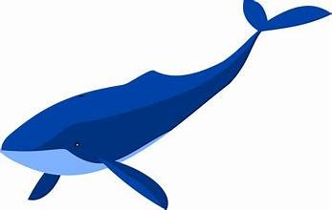23 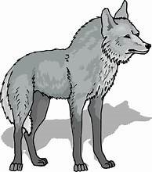 24 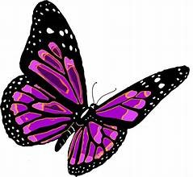 26 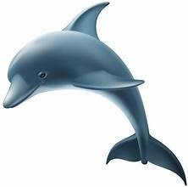 27 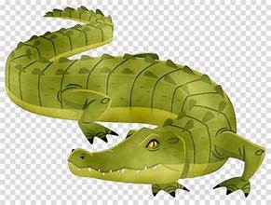

**What kind of animal is it?**

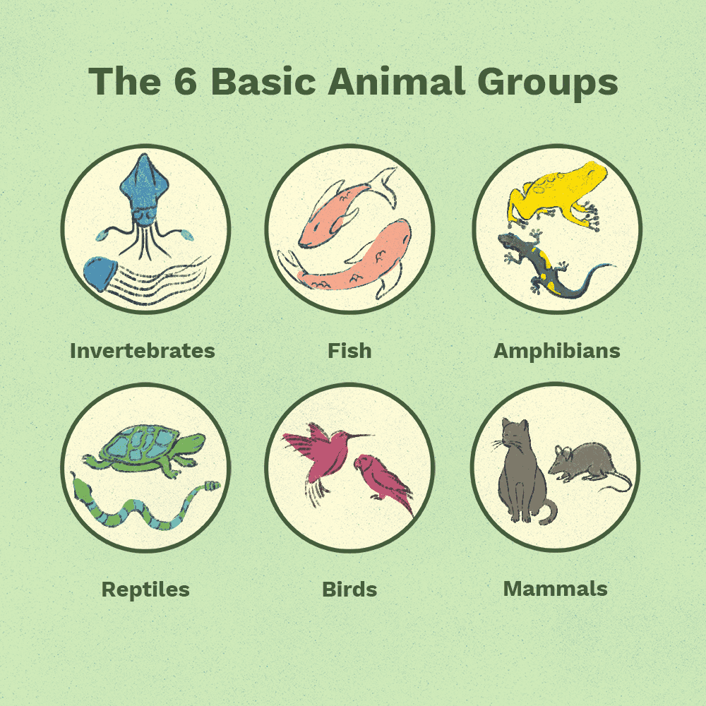**Animals are…**

**Mammals** (have cubs and feed them on milk)

**Reptiles** (slither or crawl and lay eggs)

**Amphibians** (live both underwater and on the earth)

**Birds** (most of them can fly-some can sing)

**Fish** (live underwater)

**Invertebrates** (**insects, worms, sea creatures** - no spine)

**Find from Task A animals that belong to each group.**

eg. Scorpions are reptiles.

**9**

**What do they eat?**

**only plants** (*herbivores*) **only meat** (*carnivores)* **both plants and meat** (*omnivores*)

**they are predators (they prey on other animals)**

**Find from Task A animals that belong to each group**

eg. Lions are carnivores. They eat meat. They are predators , so they prey on other animals.

**Where do they live? (habitat)**

**in the wild**(**in forests, in mountains, in jungles, in savannahs, in deserts, in the poles, underwater**)

**Find from Task A animals that live in different places.**

eg. Camels live in deserts.

**What do they look like?**

**Animals have got…**

a tail paws a sting thick skin

sharp teeth claws scales feelers

long/pointed ears wings a fin horns

short/long neck feathers stripes a hump

whiskers a beak spots a trunk

a mane strong jaws fur a pointed snout

**Find from Task A animals that have the above characteristics.**

Eg. The wolf has a brown fur, a long tail, a pointed snout and sharp teeth.

**What can they do?**

run fast slither/crawl on earth attack

jump high swim well fly

climb onto trees see in the dark hibernate

communicate travel long distances smell well

make packs prey on other animals hear well

**Find from Task A animals that can do the things above.**

Eg. Tigers can run fat, attack and prey on other animals.

**REMEMBER**

Animals which are **at risk of extinction** are called **endangered species**.

**Can you circle the animals that are endangered ?**

blue whale cat pidgeon chimpanzee penguin sea lion sheep

cobra panda fox sea lion panda ant dolphin

**10**

Let’s Read!

WILD ANIMALS TALK

**Read what the wild animals say and match them with the correct picture. Then complete the missing words.**

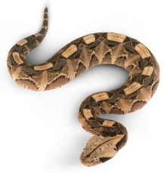 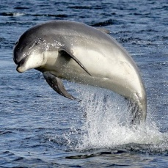 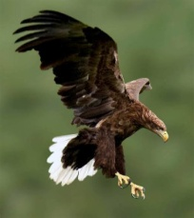 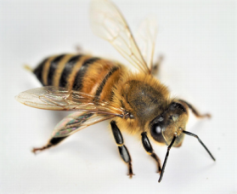 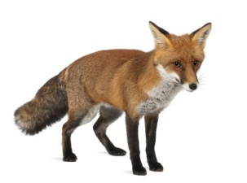 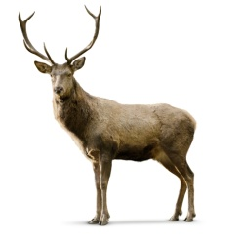

**viper dolphin eagle bee fox deer**

**slither horns fur communicate fins cubs sting claws lay snout**

**A**. I am a mammal. I have **(1)** ……………………………………..and feed them on milk. I am a carnivore animal and prey on other animals. I live in the mountains and forests but sometimes I hide around people’s houses. They say that I’m very clever! I have a brown **(2)** ………………………………….. and a long furry tail. I have a pointed **(3)**…………………………………. , pointed earsand sharp teeth.

**B**. I am a bird. I live in the mountains and I’m very strong and proud. I **(4)** …………………………………..…. eggs every spring. I am a carnivore bird and I hunt other small animals like squirrels, mice, hares or even little sheep. I have brown, black and white feathers, a strong beak and very sharp **(5) …….……………………………** to catch my prey. I also have great vision, I can see very well from high above. When I see my prey, I attack fast and catch it.

**C**. I am a snake. I am carnivore and eat other animals. I live in the forests and mountains but I sometimes

**(6)** ……………………………………… in old houses and gardens. People don’t like me because I’m dangerous and my bite is poisonous. I am not very long and I can also climb on trees and walls. Be careful!

**D**. I am an insect. I have a yellow and black body, six legs, five eyes and a trunk to drink flower juice. I also have a **(7)** …………………………………….. to protect myself. I live in forests together with others. I am a very useful insect because I can make honey and wax.

**E**. I am a mammal. I live in forests and mountains. I am a herbivore animal, I eat grass and plants. I have a grey or brown fur, cute black eyes and a pointed snout. I also have big **(8)** …………………………………………... People and other carnivore animals hunt me so I have four strong legs and I can run very fast.

**F.** I am a mammal but I live in the sea. I have a long grey body, a pointed snout and two long **(9)** …………………………….. Of course, I can swim very well and jump above the water. Also, I can **(10)** ……………………………………. because we have a special language with sounds!

**Read again and decide:**

1. This animal can run fast. …………………………. 6. This animal has cute eyes ……………………………..
2. This animal can talk with sounds ………………………. 7. This animal has sharp claws …………………………….
3. This animal can see very well …………………………….. 8. This animal has a trunk …………………………………..
4. This animal is dangerous ……………………………………. 9. This animal makes food ………………………………….
5. This animal has pointed ears ……………………………… 10. This animal has horns. …………………………………..

**Now, look at the texts again, choose an animal and talk about it.**

*Eg. It is a mammal. It has babies and feeds them on milk…*

**11**

Let’s Practise: COMPARISONS

|  |  |  |
| --- | --- | --- |
| **Positive=θετικός** | **Comparative=Συγκριτικός** | **Superlative=Yπερθετικός** |
| **clean** | **cleaner (than)** | **the cleanest of/in** |
| **large** | **larger (than)** | **the largest of/in** |
| **happy** | **happier (than)** | **the happiest of/in** |
| **big** | **bigger (than)** | **the biggest of/in** |
| **comfortable** | **more comfortable (than)** | **the most comfortable of/in** |
| **good** | **better (than)** | **The best of/in** |
| **bad** | **worse (than)** | **the worst of/in** |
| **much/many** | **more (than)** | **the most of/in** |
| **little** | **less (than)** | **the least (of/in)** |
| **far** | **farther/further (than)** | **the farthest/furthest** |

**ALSO: The tiger is as big as a lion.**

**The squirrel is not as big as the cat.**

**Comparisons with Animals**

1. **Put the verbs in brackets into the comparative or superlative.**
2. Dolphins are ……………………….……… (**friendly**) than sharks.
3. The red kangaroo is the ………………..………….. (**big**) kangaroo in the world.
4. A horse’s tail is …………………….……….. (**long**) than a rabbit’s.
5. Bears are …………………………………… (**heavy**) animals in the world.
6. Hares are …………………….……………….. (**small**) than foxes.
7. **Make comparisons with the clues.**
8. **short** – rhino / giraffe …………………………………………………………………………………………………………………………….
9. **heavy** – elephant / rabbit ………………………………………………………………………………………………………………………
10. **tall** – giraffe / sheep …………………………………………………………………………………………………………………..………….
11. **dangerous** - tiger / cat ……………………………………………………………………………………………………………………………
12. **long** – dolphin / trout …………………………………………………………………………………………………………………………….
13. **powerful** – bear / fox………………………………………………………………………………………………………………………………
14. **Put the words in the correct order.**
15. than/tigers/iguanas/heavier/are

………………………………………………………………………………………………………………………………….…………………………….

1. largest/the/in/the/apes/gorillas/are/world

…………………………………………………………………………………………………………………….………………………………………….

1. than/swan/a/more/parrot/colourful/is/a

……………………………………………………………………………………………………………………..………………………………………….

1. the/have/necks/giraffes/got/longest/the/in/kingdom/animal

…………………………………………………………………………………………………………….…………………………………………………….

1. than/rabbit/a/dangerous/bear/more/is/a

…………………………………………………………………………………………………………………………………….…………………… **12**

1. goat/an/a/elephant/than/has/ears/larger/got

…………………………………………………………………………………………………………………………………………………………………

1. **Compare the animals. Use: short, tall ,heavy, thin, fast, slow**

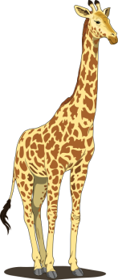 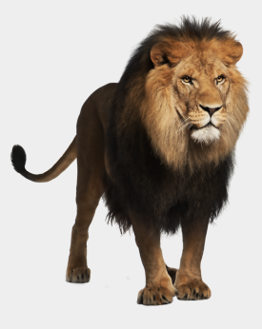 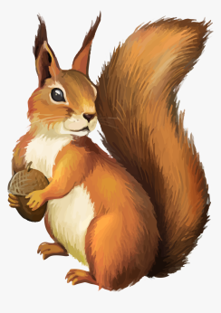

**Giraffes Lions Squirrels**

**height**: about 5.5 m **height**: about 1 m **height**: about 15-17 cm

**weight**: 500-1200 kgs **weight**: 125-190 kgs **weight**: 0.35-0.95 kgs

**can run up to**: 48 kms/h **can run up to**: 80 kms/h **can run up to**: 15 kms/h

………………………………………………………………………………………………………………………………………………………………………………………………………………………………………………………………………………………………………………………………………………………………………………………………………………………………………………………………………………………………………………………………………………………………………………………………………………………………………………………………………………………………………………………………………………………………………………………………………………………………………………………………………………………………………………………………………………………………………………………………………………………………………………………………………………………………………………………………………………………………………………………………………………………………………………………………………………………………………………………………………………………………………………………………………………………………………………………………………………………………

1. *Make comparisons in the superlative form with the animals in the pictures. Use:* ***large, colourful, strong, dangerous, intelligent, small***

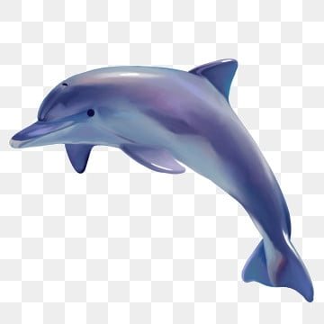 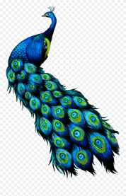  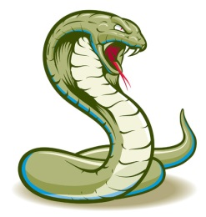 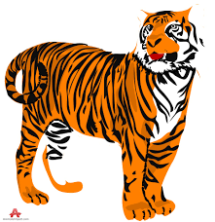 

**dolphin peacock panda cobra tiger frog**

…………………………………………………………………………………………………………………………………………………………………………………………………………………………………………………………………………………………………………………………………………………………………………………………………………………………………………………………………………………………………………………………………………………………………………………………………………………………………………………………………………………………………………………………………………………………………………………………………………………………………………………………………………………………………………………………………………

……………………………………………………………………………………………………………………………………………………………………………………

……………………………………………………………………………………………………………………………………………………………………………………

**13**

Let’s Watch!

EXTINCT & ENDANGERED ANIMALS.

**Watch the video:** <https://www.youtube.com/watch?v=E5cVr3HdLa4>

1. **Complete the missing information**
2. Dinosaurs are extinct because they disappeared .......................................... years ago.
3. Giant pandas are endangered because there are not a lot of them ................................ on earth.
4. Extinct means that certain kinds or species of animals .................................. live anywhere in the world.
5. Sometimes a huge event causes something called a ........................................... extinction.
6. An example of mass extinction is when an asteroid collided with the earth and made dinosaurs ......................
7. Extinction mainly happens naturally or with ................................... interaction.
8. Natural extinction happens when animals do not .............................. to natural changes in their environment.
9. Natural extinction can happen due to climate change, new ....................................... or lack of food sources.
10. The woolly mammoth became extinct ..................................... years ago because of climate change.
11. Other reasons for animal extinction are overhunting, habitat destruction, ............................ and deforestation.
12. The dodo became extinct due to overhunting, and because other animals moved into its ................................
13. Today, there are many animals in danger of .......................................... extinct.
14. Endangered animals have super ....................................... populations.
15. Most extinct animals were endangered before they ..................................................
16. Today, some endangered animals can only be found in a .................... or animal preserve and not in the wild.
17. The most endangered animals in the world are black rhinos, orang-utans, Bengal tigers, ...................................., sea lions, giant pandas, mountain gorillas, chimpanzees and many others.
18. There are more than .............................. species that are endangered or at the risk of becoming extinct.
19. Some ways to help save endangered animals are recycling, saving energy or ...................................a garden.
20. If we all work together we can .............................................. a difference.
21. **Answer the questions by looking back at Task A.**
22. 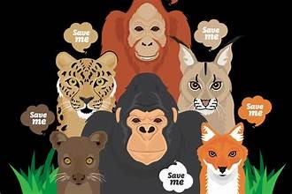What is the difference between extinct and endangered animals?
23. What are the two reasons animals become extinct?
24. How can natural extinction happen?
25. How can human interaction cause animal extinction?
26. Where can you find endangered animals today?
27. Name three animals that are endangered.
28. What are some ways to help save endangered animals?
29. How can we make a difference?
30. **Name the animals in the pictures. What do they all have in common?**

1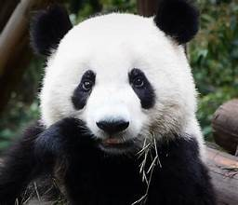2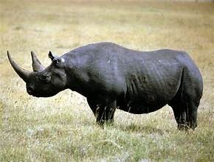3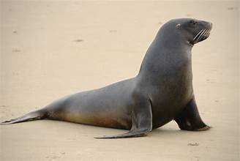4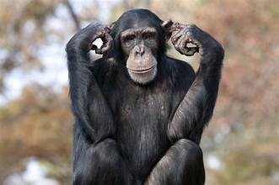5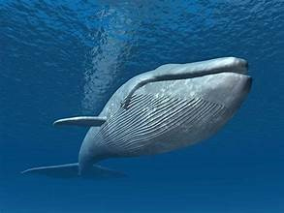

………………………………………………………………………………………………………………………………………………………………………………………………………

1. **Use the questions in Task B to write a paragraph about “Animals that are in danger of becoming extinct”**

**14**

**Let’s Write:** Describe a wild animal

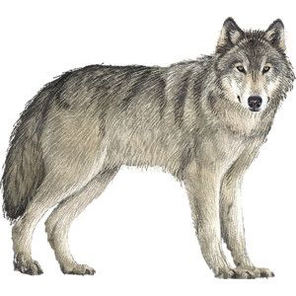**Wolves**

Wolves are mammals. They give birth to babies, called wolf-cubs and feed them on milk.

Wolves live in the wild. They live in the mountains and forests. Wolves usually live in packs and protect each other.

Wolves are carnivore animals. They eat meat, so they hunt other smaller animals.

They are around 60-90 cm. tall and weigh at about 20-30 kilos.

Timber wolves, the most common type of wolf in Europe, have a large body with a long, bushy tail. They have a fur from grey to black. They have beautiful eyes and large pointed ears. They, also, have a long pointed snout with strong jaws and sharp teeth. They have strong legs with sharp claws.

Wolves can run really fast and jump high. They can also see and smell very well. Most wolves can swim in rivers and lakes. If they feel threatened, they can be dangerous.

Wolves live at about 8-16 years.

Polar Bears

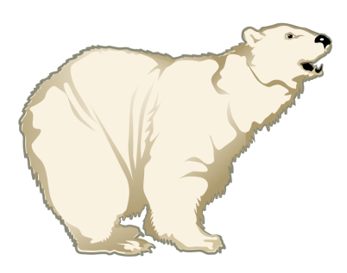 Polar bears are wild animals. They are mammals because they give birth to babies and feed them on milk.

They live in the North Pole. They are an endangered species because people destroy their natural habitat and they can’t find anything to eat. Also, they have no place to hide.

They are predators because they are carnivore animals. They prey on other animals, such as seals and big fish.

Polar bears are huge and they have got white fur, sharp claws and sharp teeth. They weigh up to 500 kilos.

A special trait of theirs is that they hibernate, which means that they sleep during the winter. In the spring, they wake up really hungry and hunt for food. They can run very fast and they hide carefully in the snow to prey on seals. They can smell their prey from many kilometres away, which makes them excellent hunters.

**Complete with a word from the texts.**

1. 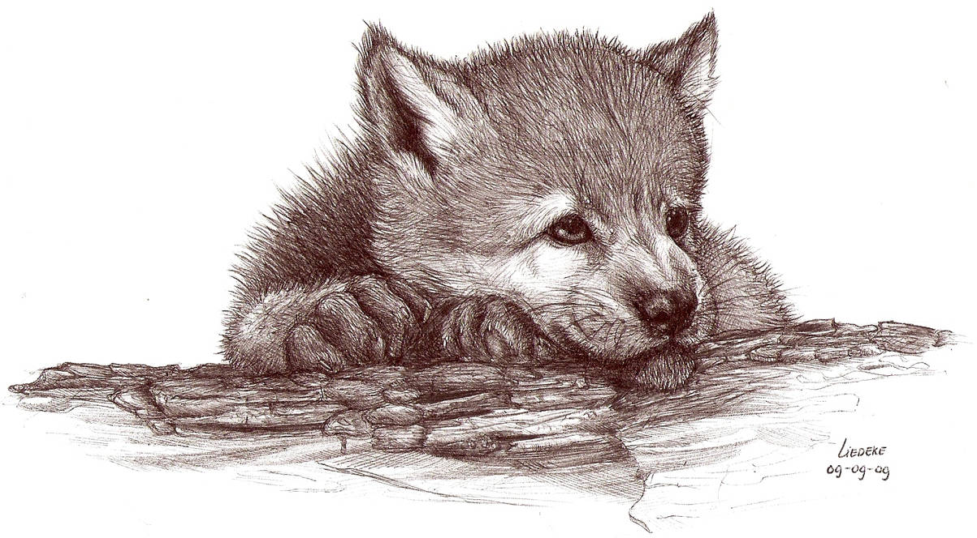Baby wolves are called ...................................................
2. Wolves live .....................................................................
3. Wolves have a long, .......................................................
4. Their ears are .................................................................
5. They have sharp .............................................................
6. Mammals feed their babies ...........................................
7. Polar bears are endangered ...........................................
8. They prey ........................................................................
9. In winter bears ................................................................
10. They are excellent ...........................................................

**Describe an animal**

**To describe an animal follow the questions:**

* **What kind of animal is it?**
* **Where does it live?**
* **What does it eat?**
* **Is it big or small? /How tall is it? / How much does it weigh?**
* **What does it look like?**
* **What can it do?**
* **How long does it live?**
* **Is there anything special about it?**

1. Ask each other these questions and give answers from the texts.
2. Use the questions and to describe a wild animal.

**15**

**UNIT 3: FOOD & COOKING**

Let’s Learn: How much do you know about food?

**1. Which food is not a dairy product?**

a. cheese b. rice c. milk

**2. Which is a summer fruit?**

a. orange b. fig c. apple

**3. What can you make with eggs?**

a. an omelette b. soup c. a pie

**4. What is a starter?**

a. the last dish b. the main dish c. the first dish

**5. Which is a leafy vegetable?**

a. carrot b. lettuce c. cucumber

**6. Which is the healthiest meat to eat?**

a. beef b. pork c. chicken

**7. Which fruit is used to make wine?**

a. grapes b. oranges c. strawberries

**8. Which food belongs to pulses?**

a. spaghetti b. cereal c. beans

**9. Which food belongs to grains?**

a. corn b. yoghurt c. honey

**10. What is a dessert?**

a. the last dish b. the main dish c. the first dish

**Correct Answers:**

8-10: You’re a food expert! 6-9: You ‘re OK but you must learn a little more! 1-5: Learn what you eat!

**2. Write what you see**

1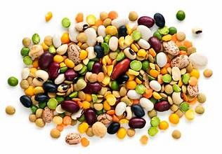 2 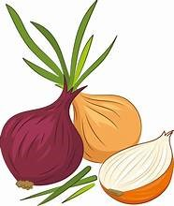3 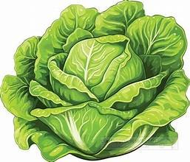4 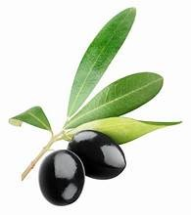5 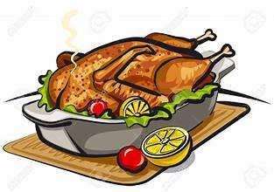6 

7 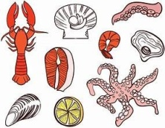8 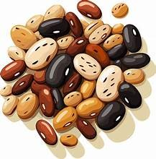9 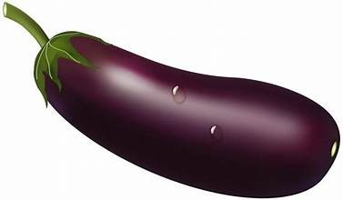10 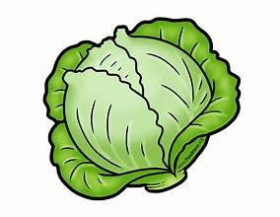11 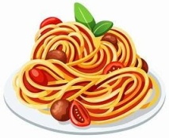12 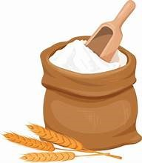

1……………………………………………… 5…………………………………………… 9………………………………………………

2………………………………………………. 6…………………………………………… 10………………………………………………

3………………………………………………. 7…………………………………………… 11……………………………………………

4………………………………………………. 8…………………………………………… 12……………………………………………

Let’s Watch: Do the quiz in the following video.

<https://www.youtube.com/watch?v=CT26X6o208g>

**After the video make a similar “What am I” question and play the game in class.**

**16**

Let’s Read: Food in Britain

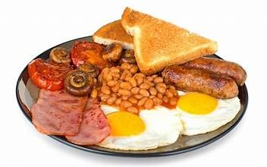Hi, I’m Jill. I’m 12 and I live in Liverpool with my parents and my younger brother, Jonathan. Do you know what British families eat? Read on to find out.

**Friday morning**

Breakfast time at home. We usually eat something simple like milk and cereal or toast and jam and run to catch the bus to school. We all love the traditional English breakfast - bacon ,fried eggs, tomatoes, mushrooms , beans ,toasted bread and sausages. And of course tea, orange juice or coffee. It’s very **nutritious** but on weekdays everyone is **in a hurry,** so Dad makes it for us on Saturday mornings and we all enjoy it.

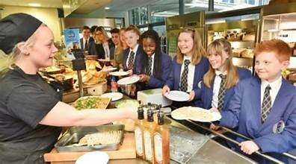

**School lunchtime**

Do the children in your country eat lunch at school? In Britain we do. Some children bring a **packed lunch** from home while others prefer a cooked meal in the **school canteen**.

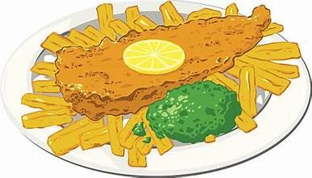

**Friday evening**

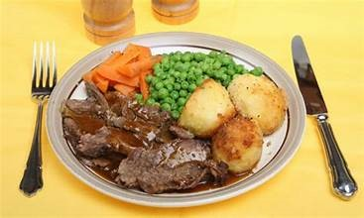At around 6 o’clock in the evening, most families in Britain sit around the table and enjoy dinner. Dinner is for us **the main meal** of the day. On weekdays, **home-cooked food** is usually on the menu but on Fridays we **order a takeaway**. There is such **a huge variety of different cuisines to choose from** that it’s always hard for us to decide what to order. Indian, Chinese and Mexican food are the most popular but not as popular as the British favourite fish and chips. This is large fried pieces of cod fish in vinegar sauce and chips. Yummy!

**Sunday lunchtime**

Sunday means **roast beef, lamb** or **chicken** for the British. Today, it’s lamb and I’m helping mum make the **dessert**. Sunday lunch is a time when we all have the time to enjoy eating home-cooked food together.

**A. Answer the questions from the text.**

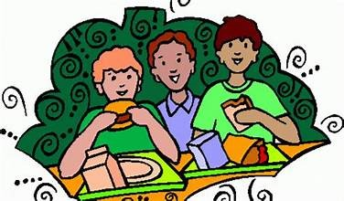1. What do they have for breakfast on weekdays?

2. Why can’t they have a traditional English breakfast on weekdays?

3. What does a traditional English breakfast include?

4. Do all children eat in school canteens?

5. What is the main meal of the day for the British?

6. What do they eat on Friday evening?

7. Why is it hard to decide what takeaway to order?

8. What is the most popular choice?

9. What do they eat for lunch on Sunday?

**B. Answer the questions about food habits in Greece.**

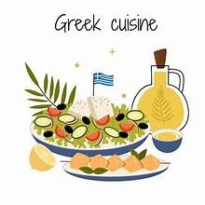1. What do you usually have for breakfast?

2. Why is breakfast an important meal? Why shouldn’t we skip it?

3. Do you take a packed lunch at school or do you buy a snack? What do you usually eat?

4. Which is the main meal of the day in Greece?

5. What is your favourite home-cooked meal?

6. How often do you order a takeaway?

7. Which is your favourite takeaway?

8. What do you usually have for Sunday lunch?

9. What is your favourite dessert?

10. Do you like any foreign cuisine?

**C. Write a paragraph with the title “Food in Greece”. Use the questions in Task B to help you.**

**17**

Let’s practise: Countable & Uncountable Nouns

**A. Mark C for Countables and U for Uncountables**.

1.milk _____ 2.cucumber _____ 3.potato _____ 4.cherry _____ 5.olives _____ 6.yoghurt _____ 7.carrot _____ 8.peach ____ 9.money ____ 10.water ____ 11.egg ____ 12.flour ____ 13.time ____ 14.oil ____ 15.sugar ____ 16.onion _____ 17.banana _____ 18.bread _____ 19.cheese _____ 20.lemonade _____ 21.hamburger _____ 22.orange _____ 23.coffee _____ 24.salt _____ 25.rice _____ 26.beer _____ 27.chicken _____ 28.tea _____ 29.book _____ 30.love _____ 31.meat _____ 32.fork _____ 33.knife _____ 34.butter ____ 35.spoon ______

**B. Fill in the blanks with a / an / some / any**

1. There is _________ honey in the jar. 9. There are ________ strawberries in the bowl.

2. There aren't ________ apples in the basket. 10. Do you want to eat __________ orange?

3. There is _________ egg on my plate. 11. There is __________ tomato in the basket.

4. There isn't _________ water in the glass. 12. There is __________ jam in the big jar.

5. There is __________ chicken and salad. 13. We don't need ___________ bread today.

6. Let's buy __________ cheese from here. 14. I need ___________ lemon for the salad.

7. There is __________ pizza in the box. 15. There are __________ carrots in the fridge.

8. There isn't _________ milk in the bottle. 16. Susan has got _________ apple. It's juicy.

**C. Fill in some or any as in the example**

1. Are there …….. any ………… rabbits in the garden? 8. Are there ……………………… fish in the water.

2. Are there …………………… children in the class? 9. Are there …………………….. oranges in the basket?

3. There aren’t ………………….. chairs in the room. 10. There isn’t ……………………. milk in the fridge.

4. Are there ……………………… birds in the tree? 11. I have …………… tea, but I don’t have ……………… sugar.

5. There isn’t ……………………. money in the bag. 12. Is there ………………… meat at home?

6. There is ………………………. coffee in the cup. 13. There were ………………… apples here a minute ago.

7. There are …………………….. policemen in the police station. 14. There aren’t ……………….. glasses on the table.

**D. Write how much or how many**

1. ____________ cans of coke do you want? 11. ____________ kilos of meat does she want to buy?

2. ____________ orange juice is there in your glass? 12. ____________ sugar would you like for your tea?

3. ____________ time have we got to go to school? 13. _____________ bananas are there in that basket?

4. ____________ olive oil do you need for your cake? 14. ____________ jam is there in that big jar?

5. ____________ money do you earn? 15. ___________ lemonade will you make for the party?

6. ____________ people are there in your class? 16. ___________ cars does that rich man have?

7. ____________ pencils would you like to buy? 17. ____________ hours does Steven sleep every night?

8. ____________ computers are there in your house? 18. ____________ bars of chocolate would you like?

9. ____________ hamburgers do you eat a week? 19. ____________ children are playing in the garden now?

10. ___________ bread do you eat at breakfast? 20. ____________ sleep does an adult need a day?

21. ____________ salt do you put in your soup? 22. ____________ t-shirts does she have in her wardrobe?

**E. Fill in how much, how many, a few, a little, some or any**

1. A: ……………………………. bananas would you like, sir? 6. A: ……………………. sugar would you like in your coffee?

B: Just …………………………. , please. B: Just ………………………, please.

2. A: Can I have …………………………… milk? 7. A: Could I have ……………………. tea, please?

B: Sorry, we haven’t got ……………………….. milk. B: Would you like ………………………. biscuits, too?

**18**

3. A: ………………………… bread would you like? 8. A: Is there ………………………. wine in the fridge?

B: Just ……………………….. , please. B: No, we need to buy …………………….

4. A: ……………………… carrots do we have? 9. A: ………………………. flour does Mom need?

B: We have only …………………………. . . B: Just ……………………..

5. A: ……………………….. oranges do we need? 10. A: Have you got ……………………… potatoes?

B: We don’t need ……………………….. oranges. B: Yes. …………………………. would you like?

**F. Fill in some, any, much or many:**

**1**. A: I’d like ……………………. eggs, please. **2**. A: I’d like …………………… olive oil.

B: Of course. How ……………………. would you like? B: How ……………………… do you need?

A: Six, please. Are there ……………………… tomatoes? A: Half a bottle. Is there ……………………. flour?

B: Certainly. How …………………… do you need? B: Certainly. How ………………………. do you need?

A: A kilo, please. A: Half a kilo, please.

**TURNING UNCOUNTABLES INTO COUNTABLES.**

**F. Write what you see in the pictures.**

1 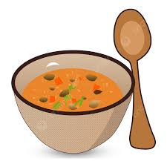 2 3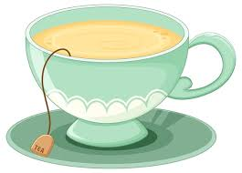 4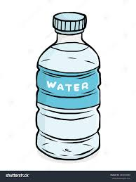 5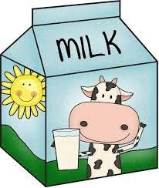 6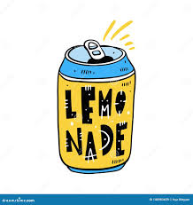

7 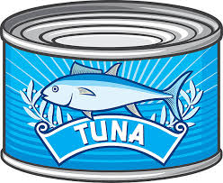 8 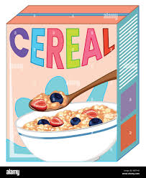 9  10 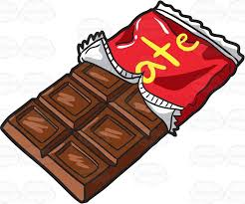11

12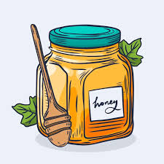13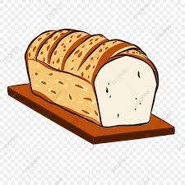14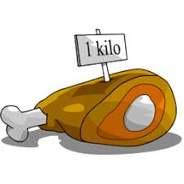 15  16 

1. ….*a bowl of soup*……………………….. 9. …………………………….……………………..
2. ………………………………………….………. 10. …………………………………………………..
3. ………………………………………………….. 11. …………………………………………………..
4. ………………………………………………….. 12. ……………………………………………………
5. ………………………………………………….. 13 …………………………………………………….
6. ………………………………………………….. 14. ……………………………………………………
7. ………………………………………………….. 15 …………………………………………………….
8. ………………………………………………….. 16 …………………………………..…………………

**19**

Let’s Learn: Cooking is fun

**Everyone knows that home-made food is tasty and nutritious. But do you know that making it can be fun?**

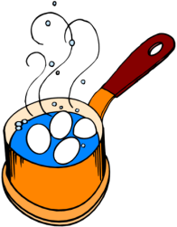 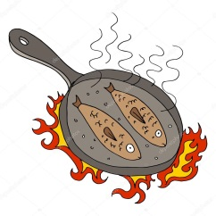 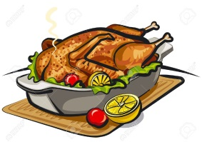 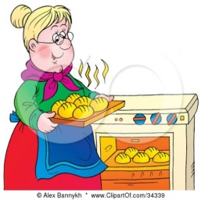 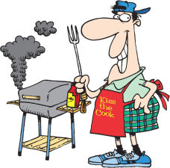

**boil fry roast bake grill**

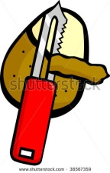 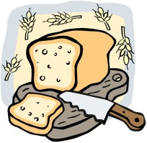 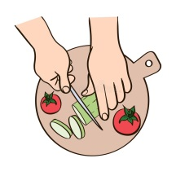 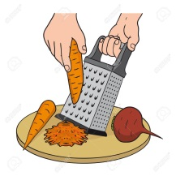 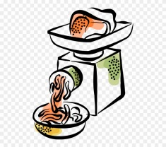 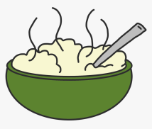

**peel slice chop grate mince mash**

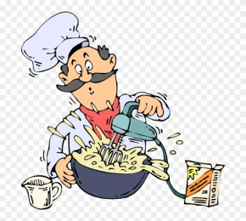 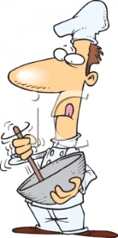 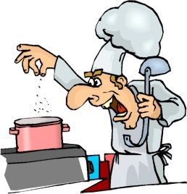 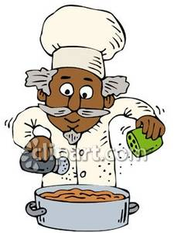 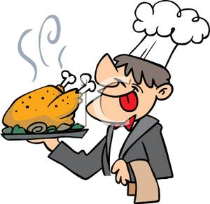

**mix stir add sprinkle serve**

**Say and Write:**

1. Write 5 things you can boil: …………………………………………………………………………………………………………………
2. Write 5 things you can fry: …………………………………………………………………………………………………………………..
3. Write 5 things you can roast: ………………………………………………………………………………………………………………
4. Write 3 things you can bake: ………………………………………………………………………………………………………………
5. Write 4 things you can grill: ………………………………………………………………………………………………………………...
6. Write 3 things you can peel: ………………………………………………………………………………………………………………..
7. Write 3 things you can slice: ………………………………………………………………………………………………………………
8. Write 5 things you can chop: ………………………………………………………………………………………………………………
9. Write 3 things you can grate: ………………………………………………………………………………………………………………
10. Write 2 things you can mince: ………………………………………………………………………………………………………………
11. Write 2 things you can mash: ………………………………………………………………………………………………………………
12. Write 4 things you can sprinkle food with: ………………………………………………………………………………………….

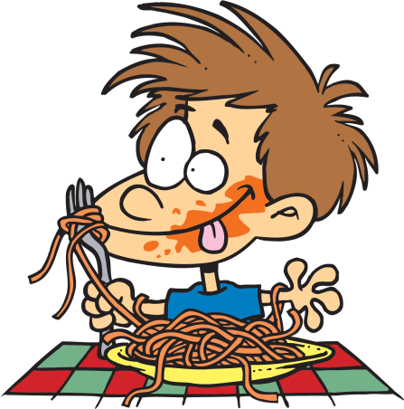

1. Write 5 green vegetables …………………………………………………………………………………………………………………….
2. Write 6 summer fruit ………………………………………………………………………………………………………………………….
3. Write 4 dairy products ………………………………………………………………………………………………………………………..
4. Write 3 kinds of meat ………………………………………………………………………………………………………………………….
5. Write 2 kinds of fish ……………………………………………………………………………………………………………………………

**20**

Let’s write: A recipe

**Scrambled eggs with fresh tomatoes-*a traditional Greek dish***

**INCREDIENTS**

4 large eggs, 3 ripe tomatoes, a piece of feta cheese, four spoonfuls of olive oil, a pinch of salt and pepper.

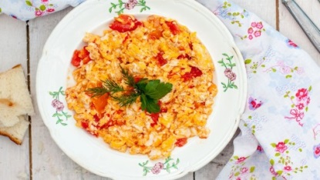 **RECIPE**

First *peel* the tomatoes. Then *chop* them.

Put the oil in a pan to *fry*.

*Beat* the eggs well.

Put the chopped tomatoes in a pan and fry for 5 minutes.

*Add* the eggs and the salt and *stir* them.

*Slice* the cheese and add it. *Mix* well.

Fry until it is well done.

*Sprinkle* with pepper and *serve* hot. Eat it with a slice of freshly-baked bread.

**Look at the following traditional Greek dishes. Choose one and write the recipe in English.**

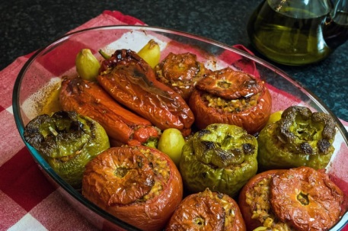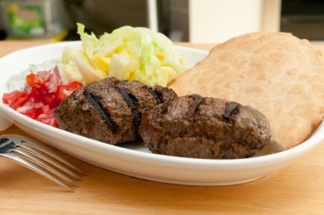***Greek meatballs*** are made with minced meat, mixed with onion, mint, vinegar, salt and pepper. The little balls are fried in hot oil. You will find *Keftethes* on the table on most festive occasions in Greece.

**Stuffed tomatoes and peppers**. These tasty vegetables are stuffed with rice and herbs, but can also include minced meat. There are many different recipes and people love to eat it with freshly-baked bread and feta cheese.

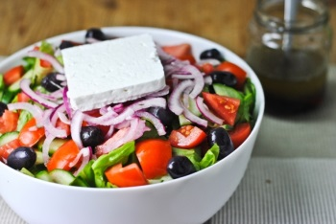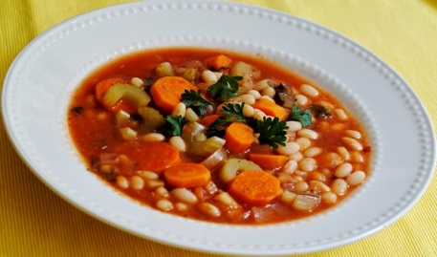**Legume soup**. This soup is made with all kinds of legumes like beans, lentils or chickpeas. They boil together with, carrots, celery, onions, tomato sauce and oil. It is very healthy. Greek households cook it at least once a week.

**Greek Salad**. This popular salad is made of fresh tomatoes, slices of cucumber and onion, peppers, olives and feta cheese. It also has olive oil, origan and a little salt. It is tasty, nutririous and people eat it at home meals or in taverns.

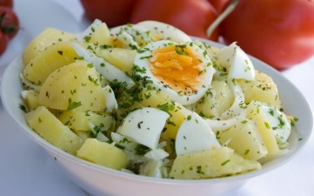

**Potato salad** is made of boiled potatoes, boiled eggs, slices of onion and parsley. It is coated with olive oil, yoghurt and mustard.

**21**

**UNIT 4: TRAVEL & TRANSPORT**

Let’s Read: Means of Transport

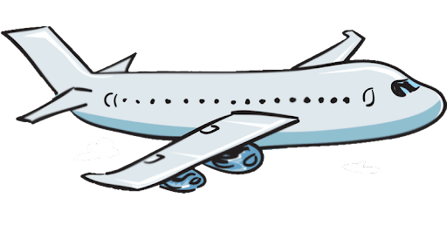 **Airplane**

Airplanes are fast and safe. They are exciting, especially when they **take off**. It’s fantastic to travel by air because you fly above the clouds and **enjoy the amazing view**. Don’t forget to **book your flight in advance** because air tickets are quite expensive.

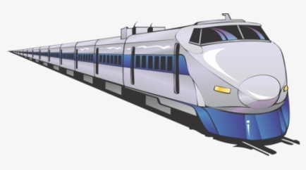 **Train**

It’s nice to travel **by rail** because trains are very comfortable. You can see lots of different places because you travel through cities, towns and countryside. You can see rivers, mountains and plains. You can enjoy this beautiful view outside the window and talk with other **passengers**.

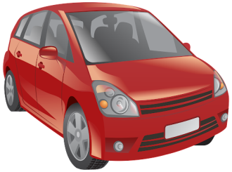

**Car**

Cars are very comfortable. When you travel in your own car, you can **plan your journey**. You can **set off**, stop or **arrive at your destination** anytime you like. Car trips are not so expensive but they are quite tiring for the driver.

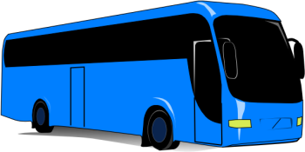 **Bus**

It’s easy and cheap to travel by bus. Buses usually travel to all destinations. The problem is that they are tiring and the **journey** is quite slow and boring.

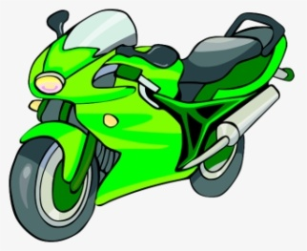

**Motorbike**

It’s exciting to travel by motorbike. Motorbikes are fast but they are very dangerous when accidents happen. Riders should always wear a **helmet**.

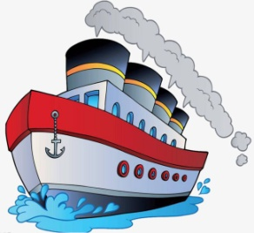  **Ship**

Ships are enjoyable and fun, especially when the weather is nice. When the weather is bad they can make you **feel seasick** and they can be really dangerous.

**1. Talk and write about the means of transport.**

I like travelling by ……………………. because ……………………………………………..……………………………………

I don’t like travelling by …………………….. because…………………………………………………………………………

I’d like to travel by ……………………………………………………………………………………………………………………….

.

**2. Use the adjectives to compare the means of transport as in the example**: ***fast – slow – safe – dangerous - exciting – boring – expensive – cheap – comfortable – tiring - enjoyable***

eg. A motorbike is faster than a car but the airplane is the fastest of all.

**22**

**Let’s Learn: Going on holidays**

**1. When you are on holidays, where do you like staying at?**

a. a five-star hotel b. a campsite c. a cosy hotel

**2. What do you enjoy visiting?**

a. monuments b. art galleries c. churches

**3. Museums? Well, I think they’re. …**

a. fantastic b. boring c. interesting

**4. What do love doing on holidays?**

a. taking sightseeing tours b. going shopping c. taking boat tours

**5. Where do you enjoy going shopping?**

a. in flea markets b. in local shops c. in shopping malls

**6. Which famous landmark would you like to visit?**

a. Big Ben b. the Eiffel Tower c. the Statue of Liberty

**7. What do you prefer buying?**

a. souvenirs b. local handicrafts c. local products

**8. What type of holiday do you like?**

a. city breaks b. camping c. cruise

**9. What do you prefer seeing?**

a. buildings b. statues c. parks

**10. What do you like eating?**

a. local cuisine b. fast food c. unusual food

**1.Write the words for the pictures**

1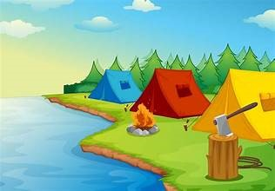 2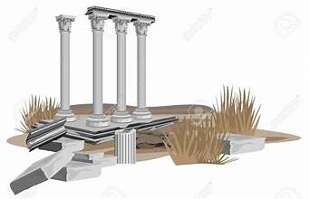 3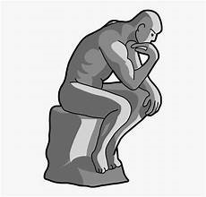 4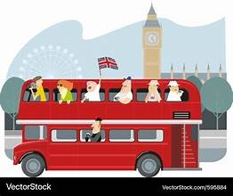

………………………………………….. …………………………………………. …………………………….. ……………………………………………

5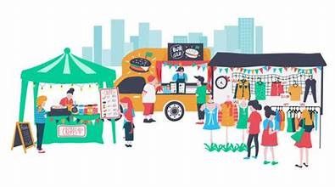 6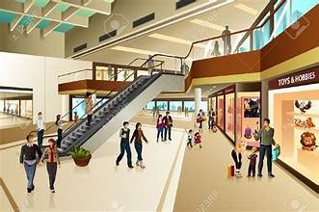 7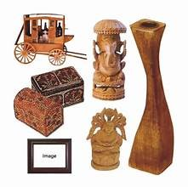 8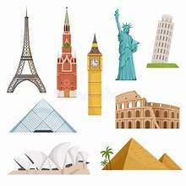

……………………………….. …………………………… …………………… …………………….

**2.Study and Complete**

**It was… I felt…**

**exciting excited** 1.The trip was ………………………….. . We felt …………………………… (**excite**)

**fascinating fascinated** 2. The visit to the museumwas rather …………………….and we were all **amazing amazed** ……………………….. (**bore**)

**thrilling thrilled** 3. The rollercoaster ride was ……………………… . I was ……………………… (**thrill**)

**surprising surprised** 4. The tourists were ……………………….. after the visit in the Acropolis Museum. **boring bore** The exhibits were ……………………………. (**amaze**)

**disappointing disappointed** 5**.**  The city tour was rather ……………………….. . There wasn’t much to see so I  **scary scared** felt …………………………….. . (**disappoint**)

**3.Use the words is Tasks 1 and 2 to write a paragraph about things you like to do on holidays.**

*eg. When I am on holidays I like staying at a five-star hotel because it’s fascinating. I enjoy visiting monuments but I think museums are boring…*

**23**

Let’s Practise: Past Simple

A) Write questions and answers. Use the past tense of BE:1. A: We had a nice holiday.  
B: (you / with your whole family?) …….. Were you with your whole family?……………………………………………  
A: (no / my daughter / in Montreal) …….. *No, my daughter was in Montreal*…………………………………………...  
2. A: I bought these new shoes yesterday.  
B: (they / on sale ?) ………………………………………………………………………………………..….…………..  
A: (yes / they / only $25) ………………………………………………………………………………………………………...  
3. A: (you / at home / last night ?) ……………………………………………………………………………..…………………………..  
B: (no / I / at the library) …………………………………………………………………..……………………………………..  
4. A: (the guests / late for the party ?) …………………………………………………………………..…………………………………….  
B: (no / they / all on time) …………………………………………………………… …………………………………………….

**B) Fill in with the Past Simple.**

1. The children __ *played__* (play) hide and seek an hour ago.
2. I ____________ (relax) on the beach with my friend last Saturday.
3. The Coopers _____________ (paint) their house yesterday.
4. Alice ___________ (help) her mum with the shopping bags.
5. Martin ___________ (ask) the teacher a question.
6. It ____________ (snow) a lot on Christmas day.
7. The train ___________ (arrive) at the station at 3:45 pm.
8. My brother ____________ (want) us to watch cartoons, but I _________ (prefer) a comedy.
9. The lifeguard _____________ (save) the drowning lady.
10. The team ______________ (plan) to win by following the coach’s instructions.
11. Jill ____________ (tidy) her room the day before yesterday.
12. Tom ____________ (watch) an interesting movie last night.
13. Celia ____________ (study) history when she was twenty years old.

n)Paula _______________ (tidy) her room last week.

1. Our neighbour _________________ (shout) for help yesterday.
2. Andy ______________ (like) his new jacket.
3. Sam _______________ (finish) his homework an hour ago.
4. The girls _______________ (reach) the airport at 2:00.

**C) Fill in the blanks with a verb from the box in the SIMPLE PAST:**

**break swim have make sit write spend buy drink lose wash**  
1. She ………………….. a cake an hour ago.  
2. She ………………….. a hat last week.  
3. The boy ………………….. a letter yesterday.  
4. They ……………………. in the sea for an hour.  
5. They ………………….. a lot of Coke last night.  
6. She ………………… her arm last week.  
7. He ……………………. all his money last week.  
8. She …………………… a bath two minutes ago.  
9. He ……………………. his wallet last night.  
10. She ………………….. on the old chair a minute ago.  
11. She ………………….. the clothes yesterday.

**D) Write what Jean DID or DIDN’T do yesterday:**go shopping ( - ) ………… ***Jean didn’t go shopping yesterday.*** …………….  
clean the house ( + ) ………………………………………………………………………..……… **24**  
feed the cat ( + ) .…………………………………………………………….…………………  
telephone Mary ( - ) …………………………………………………………………………………  
watch a film on TV ( - ) **…………………………………………………………………………………** visit her grandparents ( + ) …………………………………………………….………………………  
take them a cake ( + ) …………………………………………..…………………………..……

**E)What’s the question?**

**how what where how long what time who how many how much when why**

1. …………….***.Who did you visit*** …………………………………….? I visited **my cousin**.  
2. ……………………………………………………………………….……….? We talked **about my job**.  
3. ………………………………………………………………….…………….? S he went **to the beach**.  
4. …………………………………………………………….………………….? Sally met **her friend**.  
5. ……………………………………………………………………………..….? They spoke **Italian**.  
6. ………………………………………………………………………………….? They swam **in the ocean**.  
7. ……………………………………………………………………………..….? J ohn had dinner **at 8:00**.  
8. ……………………………………………………………………………..….? Mum baked **an apple pie**.  
9. ………………………………………………………………………..……….? She cried **because her dog ran away**.  
10. ……………………………………………………………………………….? I stayed in London **for a week**.  
11. ……………………………………………………………………..……….? Paul came home **by train**.  
12. …………………………………………………………………..………….? Tom ate **three hamburgers**.  
13. ……………………………………………………………………………...? He left the restaurant **at 9:00**.  
14. …………………………………………………………………………..….? She wrote a letter **to her mother**.  
15. …………………………………………………………………………..….? They studied **all morning**.  
16. ……………………………………………………………………………….? We took **a lot of photographs**.  
17. ……………………………………………………………………………….? We sent a postcard **to our teacher**.  
18. ………………………………………………………………..…………….? Dad paid **40€** for the tickets.  
19. ………………………………………………………………………….….? I lost **my wallet** when I went sightseeing.  
20. …………………………………………………………….……………….? The children covered their eyes **because they were scared**.

**E)** Complete the sentences with the verb in the correct tense. Use SIMPLE PRESENT, PRESENT CONTINUOUS, or SIMPLE PAST.1. I ……………………………….…..(**go / not**) to the cinema last night. I ……………………..…………. (**stay**) home.  
2. Fred ……………………..…….……. (**come** **/ not)** to class every day.  
3. Sue …………………….………….…… (**read**) a book right now. She …………………………………….. (**watch / not**) TV.  
4. I ……………………………….……… (**finish / not**) my homework last night. I ……………………………….………. (**go**) to bed early.  
5. Jane ……………………………………... (**stand / not**) up right now. She ………………………………………….…. (**sit**) down.  
6. It ……………………………..……. (**rain / not**) right now. The rain ………………………………………… (**stop**) a few minutes ago.  
7. The weather …………………………….………… (**be / not**) cold today, but it ………………………………… (**be**) cold yesterday.  
8. Mary and I …………………….…………. (**go / not**) shopping yesterday. We …………………..……. (**go**) shopping last Monday.  
9. I ………………………………………….. (**go**) to a movie last night, but I ……………………………………………… (**enjoy/ not**) it.  
10. I …………………………….……………. (**write**) a letter to my friend yesterday, but I ……………………………………. (**write / not**) a letter to her last week.  
11. Keith …………………..…………………………. (**come / not**) home for dinner last night. He ………….……………………… (stay) at his office.  
12. The children …………………………….…….. (**go**) to bed a half an hour ago. They ………………………………………. (**sleep**) now.  
13. We …………………………………….……… (**be**) late for the movie last night. The movie ……………………………….…. (**start**) at 7:00, but we ………………………………………..….. (**arrive / not**) until 7:15.  
14. She usually …………………………….………. (**take**) the bus to school but today we ……………………………………. (**go**) on foot.

**25**

Let’s Read: A weekend in London

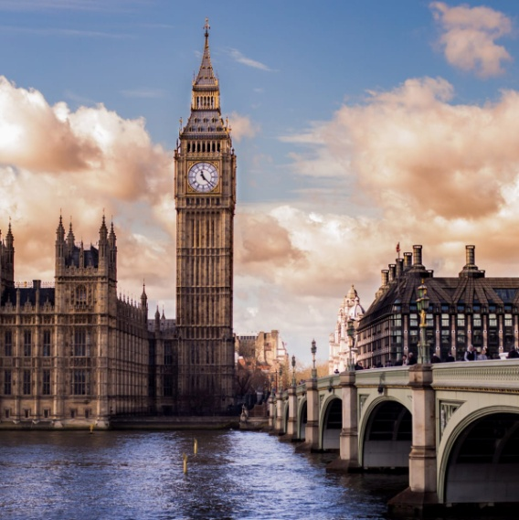Hi Jane,

Hope you are well. I’m writing to tell you about a weekend trip I took to London.

My parents and I **…………………………….. ( plan )** every detail because we **………………………….** **( want )** a perfect holiday. We …………………………………… (**book**) and …………………………….………………. **( buy )** our ticket two weeks ago and we **…………………………….** **( search )** for a hotel on the net.

Everything **…………………..** **( be )** ready and our holiday **………………………………** **( begin )** with a fantastic fight. It …………………………………… (**be**) amazing to admire the view from above.

We …..**……………………………….( arrive )** at London Heathrow Airport early in the morning and **……………………..…..** **( take )** the bus from the airport to the hotel. It **……….................** **( be )** acosy hotel at the heart of the city. We **…………………. ( be )** all tired after the trip, so we **…………………………………………** **( decide )** to take a nap.

In the afternoon, we …………………………………………**( take )** the sightseeing bus and **…………………………………….**

**( enjoy )** a fantastic tour around London.. The bus tour **……………………………** **( last )** for about two hours and we **………………………………….. ( be )** hungry. So, as soon as we **…………………….………………...** **( get off )** the bus we **………………………………….( go )** to a Chinese restaurant. We .……………………………………… **( have )** a great dinner there. After dinner, we **………………………………..( go )** back to the hotel on foot to admire the beautiful monuments.. It **……………………………….** **( be )** a tiring day but we **…………………………………………** **( not - want )** to stay at the hotel. We ……**…………………………………………….** **( relax )** for an hour and **………………………………………..** **( go )** to the theatre. We ……………………………. (**watch**) a musical called “Annie”.

Next day, we **………………………………………..** **( get )** up early and **…………………………………………** **( have )** breakfast in a café near the bridge. Then, we **………………………………** **( do )** a lot of shopping. Also, we **…………………………….** **( visit )** the Science Museum and **……………………………………….** **( take )** some photos.

At night we had to go back to the airport and …………………………………………………. **( fly )** back home. It **……………………………………………** **( be )** a wonderful holiday.

Love

Karen

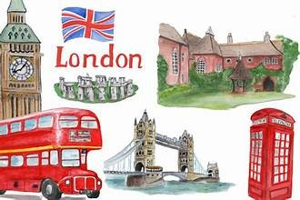

1. Where did Karen and her family go?
2. When did they take their tickets?
3. What did they do before the trip?
4. Where did they arrive first?
5. What did they do when they arrived at the hotel?
6. Where did they have a dinner?
7. Did they stay at the hotel after dinner?
8. What was the hotel like?
9. Where did they have their breakfast?
10. What did they do at the second day of the trip?

**26**

Let’s write: A trip to Athens

**Now write a similar e-mail to a friend describing a weekend trip to Athens. First write captions for the pictures and then use your ideas to answer the questions and write the mail.**

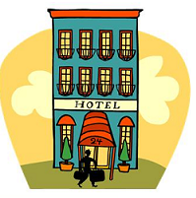 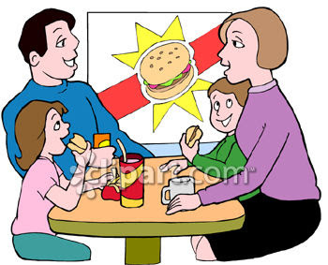 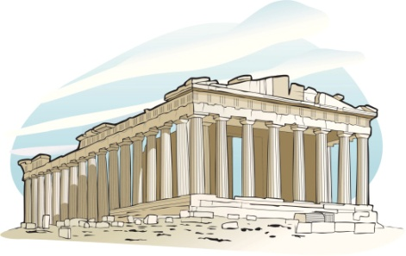

……………………………………………………. ……………………………………………………. …………………………………………………………….

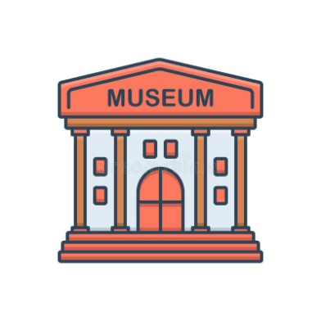 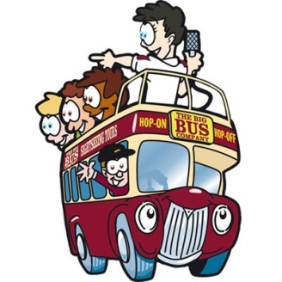 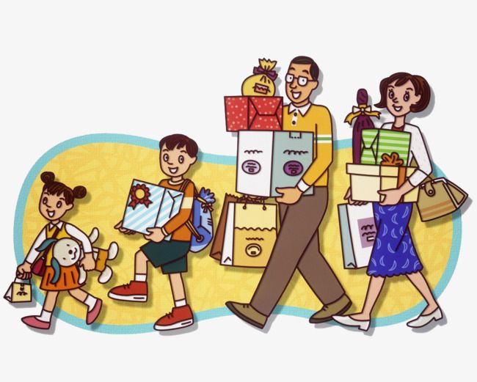

……………………………………………….. ………………………………………………… ………………………………………………………..

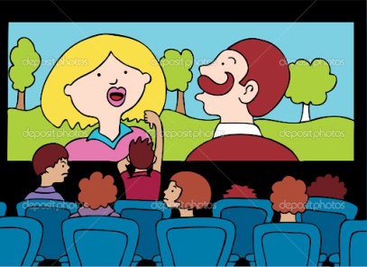 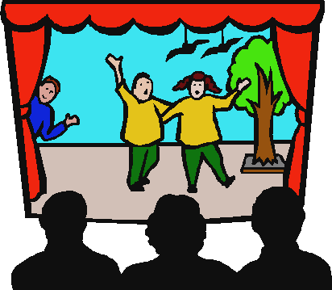 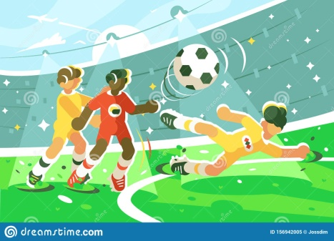

…………………………………………………… …………………………………………………….. ………………………………………………….

1. When did you go?
2. Who did you go with?
3. How did you go?
4. How was the journey?
5. Where did you stay?
6. How was the place?
7. What was the first thing you did?
8. What did you do at night?
9. What did you do next morning?
10. Did you visit a museum?
11. Did you go shopping?
12. Where did you have lunch?
13. When did you leave?
14. How was the trip? **27**

Let’s Read & Write: A camping holiday

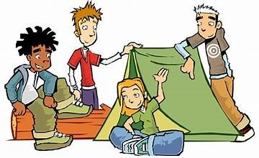 Last summer my friends and I ………….............…… (decide) to go camping. I ……..............………… (pack) my **rucksack** on Thursday night. I ……...................…… (put) a pair of **hiking boots**, a **cap** and a **raincoat**. I ……..............………… (not/ forget) my sleeping bag and my **binoculars** because I like bird watching.

We ……...........................………… (meet) at the station on Friday. At 15:30 me and my three friends …….....………… (get) on the train to the mountain. We …………....................… (arrive) at 18: 15 and …….............………… (go) to the local shop to get some food. Pete is a good cook, so he ………..............……… (prepare) our meals. He ……….................…… (bring) a **portable stove**, but he ……………… (not/ bring) a **lighter**, so we …………..............… (have) to ask the campers next to us.

When we …………...…… (get) there, we immediately ……........…… (put) the **tent** up. At night, we ….......………… (make) a campfire and ………............……… (sit) around. We ………............……… (tell) stories and jokes and …........………… (sing). Everything …….........……… (be) dark, but the stars and the moon ……….......………… (shine). However, in the tent we ………………..........… (not/ can /see) anything, so we …………… (use) Tom’s **torch** to get into our sleeping bags.

In the morning, we ……….........… (get) up early and ………...........… (have) a big breakfast. Then we ……........……… (go) hiking. We …………… (see) some nice birds, but we …………… (need) some **insect repellent** because there …………… (be) lots of mosquitoes near the river. Fortunately, we ………… (bring) our water bottles and …………..… (fill) them there, so we ………........… (drink) fresh water when we ……….........…… (stop) for a snack.

Not everything ……………..… (go) well. I have to tell that we …………… (lose) our way twice since our mobiles battery was law and we couldn’t use the **compass**. We also ………… (find) some mushrooms, but we …………… (not/ pick) them up because we …………… (not/have) a **penknife**. Anyway, we ………… (spend) a couple of days in a clean, peaceful place.

**A. Answer the questions.**

1. What did the writer put in his rucksack? 6. What did they do at night?

2. How did they go to the mountains? 7. Why did they use Tom’s torch?

3. What did they do first when they arrived? 8. What did they do after breakfast?

4. Could they cook? Why? 9. What kind of insects were there near the river?

5. What did they do when they arrived at the campsite? 10. Did they have any mishaps?

**B.Write the words in bold under the correct picture.**

1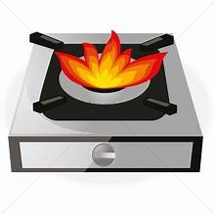2 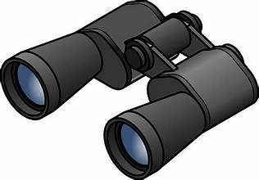3 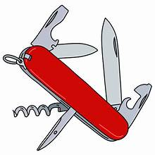4 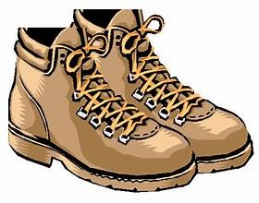5 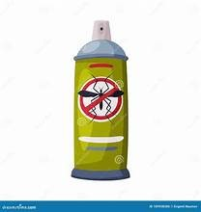6 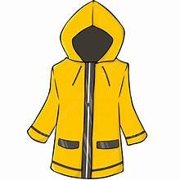

……………………………… ………………………….…….. ……..………………….. ………….…………………. ………………….… ………….………..

7 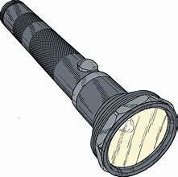8 9 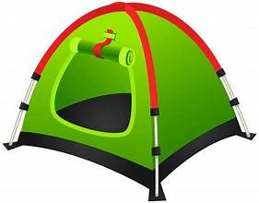10 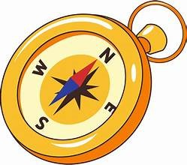11 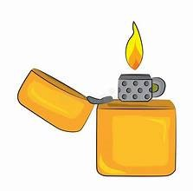12 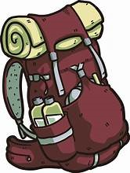

…………….............. ………………………… ………………….. ……………………. ……………..……. ………………….……..

**C. Use the words in the pictures to make a leaflet “ What you need to take on a camping holiday”**

**eg. You need a portable stove in order to cook / in case you want to cook / if you want to cook**

**28**

**UNIT 5: MYTHS & STORIES**

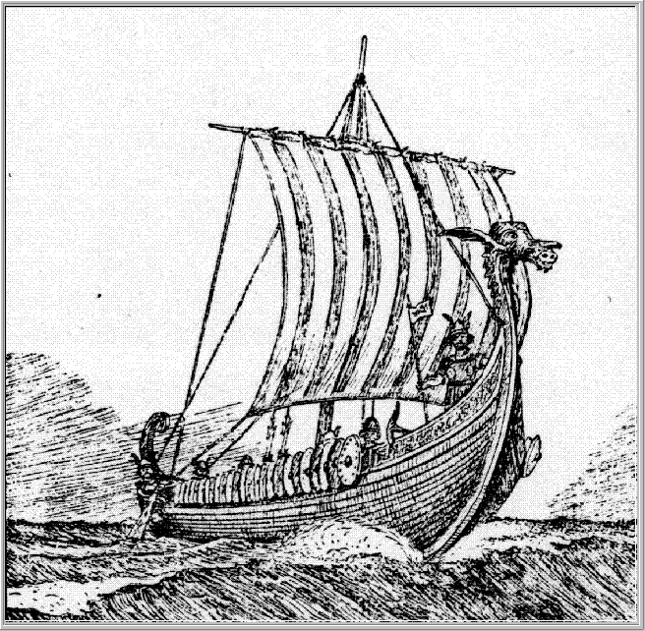Let’s read: Odysseus in the Cyclops’s cave

Odysseus and his companions ………………… (be) at sea for almost a year after the Trojan war.

One day, they ……………………. (arrive) at an island. They …………………………. (be) hungry and thirsty. They …………………… (get) off the ship and ……………………….. (go) to the island to find some food and water. On the island they …………………………….. (discover) a cave. In it, there ………………….. (be) **giant** things, like **huge** barrels of wine, large **tree trunks** and a lot of meat! They …………………………….. (start) eating and drinking when suddenly they ………………………… (hear) **heavy footsteps**. They ……………………………… (feel) terrified and …………………………(hide) behind a big rock.

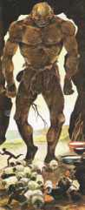 After a while, they …………………………. (see) a very scary monster. An ugly giant with only one eye on the forehead. The giant ……………………… (look) unfriendly. He ………………………….. (get into) the cave together with **a flock of big sheep**. Suddenly, the giant ………………………………… (start) smelling the air.

-I can smell human flesh, he …………………………… (say).

The **beast** ……………….. (start) searching all the cave. He …………… (be) very scary. Odysseus and his companions ……………… (try) to hide in a dark corner of the cave but the beast ………………… (find) them.

-Ah, here you are, he ……………………….. (say). What a nice meal!

He …………………………. (**grab**) one of them with his big, hairy hand and …………………………. (eat) him **on the** **spot**. Odysseus’s **blood** …………………………………. (**run**) **cold**! His companions ……………………………. (scream) and …………………………….. (run) to save their lives. But the giant ……………………………… (be) fast and strong and ………………………….. (can) see them with his only eye. He …………………………….(catch)two of them and ………………………….. (eat) them, too. His mouth ………………….. (be) full of blood. Odysseus and his companions were **shaking with fear**. After that, the giant …………………… (feel) very tired and ………………… (fall) asleep.

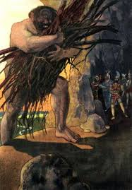 The next day he …………………………… (wake up), ………………………………… (take) his flock of sheep and ………………………… (go) out. He ………………………… (close) the cave hole with a huge rock. Odysseus and his companions ………………………. (realize) they …………………...(be) in danger and ………………………………(have) to make a plan to escape.

In the evening, they …………………………….. (hear) the heavy footsteps again. The giant …………………… (return) to the cave. He ……………………. (be) hungry and thirsty.

-I’m going to eat some people for dinner, he …………………………….. (**groan**)

Odysseus ……………………………… (stand) in front of him.

-Giant, he …………………………….. (say), it is a bad thing to eat us. We’re strangers, we’re far away from our home and the gods will be angry with you. Look, we ……………………….. (bring) you some great wine as a present. We’re friends.

The giant …………………………… (look) at him with his only eye and ……………………….. (laugh).

-Stranger, he …………………………….. (**reply**), you’re clever and brave. I’m going to eat you last! What’s your name?

Odysseus ………………………. (think) well before he ……………………….. (answer).

-My name’s Nobody! Odysseus ……………………….. (tell) him.

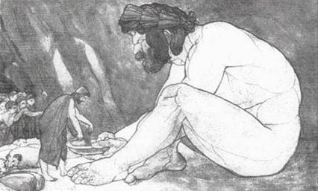 Then, the Cyclops …………………….. (**grab**) two of his companions and …………………… (eat) them. Afterwards, he …………………………. (drink) all the wine. He ………………………….. (get) drunk and …………………………….. (fall) asleep.

When the Greeks ……………………………. (make) sure the Cyclops was **sound asleep**, they ……………………… (hurry) because Odysseus …………………….. (have) a plan. They ………………………….. (take) a tree trunk and ………………………… (make) it sharp with their swords. Then they ……………………………… (put) the sharp end in the fire and ……………………….. (burn) it to make it hot. They

**29**

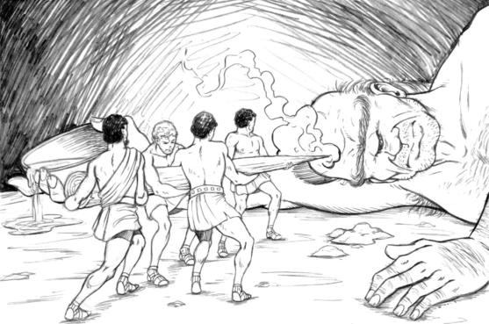

…………………………… (hold) it together and …………………………. (move) near the sleeping giant. The trunk ……………………… (be) like a hot **burning spear**. They ……………………………… (count) to three and ………………………….. (**stub**) the trunk into the Cyclops’s only eye.

The giant …………………………….. (**scream**) **with pain**. He ………………………… (run) up and down the cave and ………………………………… (shout) angrily.

-Help, help, he ………………………… (scream). I’m blind. He ………………………… (hurt) me!

The other Cyclopses ………………………….. (hear) his screams and ……………………………. (get) out of his cave.

-Why are you screaming? Who …………………………. (blind) you? they ……………………………. (ask)

-Nobody …………………………… (blind) me, he ……………………………………. (answer).

-Ah, they ……………………… (say), nobody …………………………. (hurt) you!Why are you screaming then? Are you drunk?

The other Cyclopses ……………………………… (laugh) and returned to their caves to sleep.

The beast ………………. (be) furious. He ………………. (try) to find the Greeks all night but he ………………………….. (cannot) because he …………………………… (be) **as blind as a bat**.

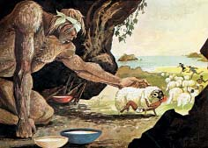 The next morning Odysseus …………………………….. (have) another idea to escape. He ……………….. (tie) himself and his companions under some huge sheep. The blind Cyclops ………………………….. (open) the door hole and …………………………. (let) the sheep out. He ………………………….. (feel) them all, one after the other to check if the Greeks were hidden among them. Of course, he …………………….. (not / find) them because they ………………….. (be) under the animals. So, Odysseus and his companions …………………………… (leave) the cave **safe and sound**.

When the giant …………………………. (realize) that they …………………………….. (not / be) there, he …………………………….. (try) to find his way to the shore. When he …………………… (arrive), he ………………………….. (hear) them leave the island.

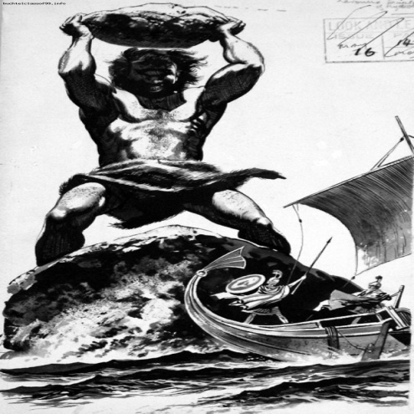 -Hey Cyclops, ……………………………. (shout) Odysseus. Remember, next time you must **be kind to strangers**! And when they ask you who …………………………… (blind) you, don’t say nobody, say that it was Odysseus, the king of Ithaka.

The Cyclops ………………………………. (get) mad! He ………………… (take)**enormous** rocks and……………………………….. (throw) them on the ship.He ……………………………. (want) to break it and kill them all. But the Greeks ………………………….. (manage) to escape. The only thing they ………………………….. (not / know) was that the beast ………………………… (be) God Poseidon’s son. Poseidon …………………………… (get) so angry with Odysseus that he …………………………………. (decide) to **take revenge**.

**A. Explain the words in bold.**

**B. Correct the underlined words to make true sentences.**

1. Odysseus and his companions were at sea for almost five years when they arrived at an island.

2. In the cave there were small things, like tiny barrels of wine, large tree branches and some meat!

3.The giant was friendly. He had only one eye on his chin.

4. Odysseus told the Cyclops that they’re re friends and the gods will be good with him.

5.When the Cyclops asked his name, Odysseus said it’s Somebody.  
6. The Greeks took a tree branch, made it sharp with their swords and stabbed it into the Cyclops’s ear

7.The Cyclops couldn’t hear them because he was as deaf as a stone.

8.Odysseus and his companions hid under the tiny dogs and escaped.

9.The Cyclops started throwing small stones at them.

10.God Poseidon wanted to help because the Cyclops was his enemy.

**30**

Let’s read: Aesop’s Fables

**Read some wise fables told by Aesop. Before you read, explain the words in the box and then use them to fill in the blanks.**

**Τhe Town Mouse & the Country Mouse**

**attack comforts hurried polite leftovers security**

**dreams delicious breathe served reached meal**

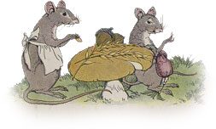A Town Mouse once visited a relative who lived in the country. For lunch the Country Mouse **(1)…………………..** grains, roots, and corn, with a little cold water for drink. The Town Mouse ate very little, and it was clear that she didn’t like the simple food but she wanted to be **(2)…………………**.

After the **(3)…………………..**, the friends had a long talk. The Town Mouse talked about life in the city while the Country Mouse listened. Then, they went to bed and slept until morning. In her **(4)………………………….**, the Country Mouse saw that she was a Town Mouse with all the luxuries and **(5)…………………………..** of the city. So the next day, when the Town Mouse invited the Country Mouse to go with her to the city, she gladly said yes.

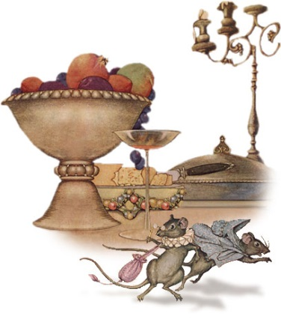When they**(6)………………………** the rich house where the Town Mouse lived, they went straight to the dining room and found on the table the**(7)………………………..** of a very fine dinner. There were pieces of meat and yummy slices of cheese, pastries, fruit and nuts. It was the most **(8)……………………….** foods that a Mouse can imagine. But the moment that the Country Mouse was about to bite a piece of cheese, she heard a wild miow. It was the large cat of the house who was ready to **(9)…………………….** them. The Mice felt terrified and hurried to a hiding place. There, they stood still for a long time, they didn’t even **(10)………………..**. When, at last, the cat left, they ran to the dining table. They were very hungry. But again, when they were ready to eat, the door opened suddenly and the servants came in to clear the table. The House Dog followed them. Once again, the mice ran to the hiding place. The Country Mouse picked up her bag and umbrella.

"You have luxuries that I don’t have," she said as she **(11)…………………………** away, "but I prefer my plain food and simple life in the country with the peace and **(12) ………………………** that go with it." *Adapted from “Library of Congress”*

**Now, use the questions retell the story.**

1. What did the town mouse eat in the country?
2. Did she like the food?
3. What stories did she tell the country mouse after dinner?
4. What did the country mouse see in her dreams?
5. What did the town mouse do the next morning?
6. Where did they go as soon as they arrived at the rich house?
7. What did they see there?
8. What happened when they were about to eat?
9. What did they do?
10. What happened the second time they tried to eat?
11. What did the country mouse decide to do in the end? Why?

**31**

**The Fox & the Grapes**

**hung sour ripe in vain failed juice** **missed**

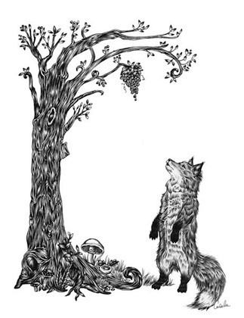One day a Fox saw a beautiful bunch of **(1)……………………..** grapes. They were hanging from a vine and they seemed full of **(2) ……………………….**. The Fox's mouth watered as she stared at them. The bunch **(3) ………………………………..** from a high branch, and the Fox had to jump for it. The first time she jumped she **(4)** ……………………….…. it. So he walked back a little and took a running leap at it. But once more, she **(5) …………………………….** to catch the grapes. Again and again she tried, but **(6) …………………………….** In the end, she sat down and looked at the grapes.

"What a fool I am," she said. "I am making myself tired to get a bunch of **(6) …………………………..** grapes. They are not tasty at all.” And she walked away.

1. What did the fox see? 4. What happened on her second attempt?
2. How did she feel? 5. What did she think in the end?
3. What happened on her first attempt? 6. Why do you think the fox though so?

**The Lion & the Mouse**

**hunting bite generous** **net afraid voice paws begged tiny**

A Lion was asleep in the forest. He had his giant head on his (**1)………………………**. Suddenly, a little Mouse appeared. The mouse was **(2) ……………………..** of the lion so he hurried away but he ran across the Lion's nose. The Lion woke up and put his huge paw angrily on the**(3) …………………………….** animal to kill it.

"Don’t kill me!" **(4) …………………………** the poor Mouse. "Please let me go and some day I will surely repay you."

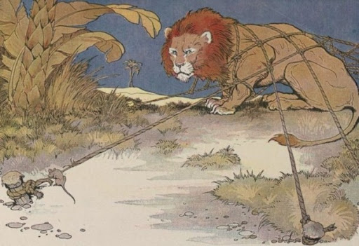The Lion found it very funny that a Mouse could ever help him. But he was **(5) ………………………………..** and let the Mouse go.

Some days later, the lion went **(6)……………………………** in the forest. While it was running after a small animal, it fell in a hunter's **(7) ………………………………..**. He tried to free himself but it was impossible. All the animals in the forest heard his angry roar. The Mouse knew his (**8) …………………………….** and ran to him quickly. The Lion was terrified in the net. The mouse started to **(9) ………………………………** the net and soon the Lion was free.

"You laughed when I said I would repay you," said the Mouse. "Now you see that even a Mouse can help a Lion."

1. What happened to the lion while he was sleeping?
2. What did he mouse ask the lion to do?
3. How did the lion react?
4. What happened a few days later?
5. What did the lion do?
6. How did the mouse react?

**Each of the Aesops fable teaches us a life lesson, this is called morale. Match the morales with the fables**.

* Kindness is never wasted.
* Poverty with peace and security is better than wealth with fear and uncertainty
* There are many people who pretend to hate and belittle whatever is beyond their reach.

**PROJECT: In pairs, choose a fable by Aesop and write it in English. Then present it in class.**

**32**

Let’s Watch: Plot Twist

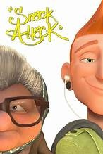**A plot twist in a story, is a point when the story changes direction. Something unexpected is happening or revealed that twists the story to a new path and gives it a different ending. Plot twists make stories more interesting and exciting.**

**Watch the following video and find what the plot twist is.**

**SNACK ATTACK**: <https://www.youtube.com/watch?v=38y_1EWIE9I&list=PLlbkyhAZrBl-XJQudaCfoMsGy_Jjau6HE>

Although we think that the young man is rude because he picks on the old lady’s cookies, we realize that …………………………………………………………………………………………………………………………….…

………………………………………………………………………………………………………………………………………………….

**Watch again and put the sentences in the right order.**

a. The young man takes a cookie and stuffs it into his mouth.

b. The old lady grabs her cookies and hides them behind the paper.

c. The old lady is surprised but the young man is listening to music with his earphones on and is not looking at her.

d. She reaches the packet to catch another cookie and touches a young man’s hand.

e. She drops a coin to buy the last box but the machine gets stuck and the packet doesn’t come out.

f. The young man reaches the cookies, takes one and munches it.

g. An old lady is at a train station. She ‘s hungry and decides to buy a packet of cookies from a vending machine.

h. She gets very angry and kicks the machine madly. She bursts onto it and the packet slips down.

i. She leaves the cookies next to her and takes a newspaper to read.

j. She takes the packet, sits on a bench, and picks a cookie. She devours it happily.

**1…….. 2……… 3…….. 4…….. 5…… 6…… 7……. 8…….. 9…….. 10……**

k. The train conductor asks the woman’s ticket and she opens her bag.

l. She is looking outside the window and sees the young man leaving.

m. The old lady gets mad and crunches the half cookie into pieces. She thinks that the young man is very rude.

n. Now, she realizes her mistakes and thinks that the young man was very kind and not very rude.

o. They start fighting over the last cookie. The young boy grabs the cookie and breaks it in two.

p. To her surprise, she finds her box of cookies in her bag and realizes that the cookies she took were the young man’s and

q. He cleans the old lady’s skirt from the remains but she gets furious and tells him off.

r. The old lady gets on the train and sees from the window the young man rhythmically pointing his finger at her. not hers.

s. While she is shouting angrily, the young man is listening to loud music and smiling at her.

t. While he is giving the half cookie to the old lady, her train is arriving.

**11……. 12…… 13…… 14….... 15…… 16……. 17…… 18….. 19……. 20………**

**Use the sentences to tell and write the story in the Simple Past.**

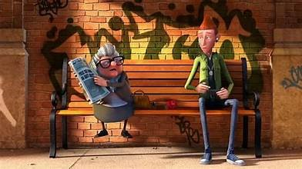

**33**

Let’s practise: Tenses, comparisons & prepositions

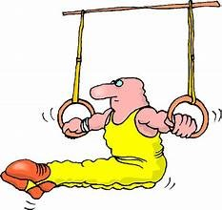**1. Write the questions. Use WHEN, WHERE, WHO or WHAT:**1. A: We went to California on our vacation.  
B: Really? …. ***Where did you stay***…………………… (you / stay)?

A: In a hotel in Santa Monica.  
2. A: The children visited the usual tourist attractions.  
B: Oh, yeah? …………………………………………….. (they / see)?  
A: Oh, they went to Disneyland, the San Diego zoo, and a movie studio.  
3. A: My wife played a lot of tennis.  
B: ……………………………………………………….. (she / play) with?  
A: She played with our oldest son.  
4. A: I really enjoyed the trip. We even stayed a few extra days.  
B: ……………………………………………………….. (you / plan) to come home?  
A: Well, we planned to come home on Monday, but we didn’t get back until Friday.

**2.Complete the sentences. Use SIMPLE PRESENT, PRESENT CONTINUOUS, or SIMPLE PAST.**1. I ……………………….. (get) up at eight o’clock yesterday morning.  
2. Mark …………………………….. (talk) to John on the phone last night.  
3. Mark …………………………….. (talk) to John on the phone right now.  
4. Mark …………………………….. (talk) to John on the phone every day.  
5. Jim and I ……………………. (eat) lunch at the cafeteria two hours ago.  
6. We ……………………………. (eat) lunch at the cafeteria every day.  
7. I …………………………. (go) to bed early last night.  
8. My roommate ………………………….. (study) Spanish last year.  
9. Sue ………………………….. (write) a letter to her parents yesterday.  
10. Sue ………………………….. (write) a letter to her parents every week.  
11. Sue is in her room right now. She …………………………. (sit) at her desk. She …………………………………. (write) a letter to her boyfriend.  
12. Marianne ……………………… (do) her homework last night.  
13. Yesterday I ………………………. (see) Dick at the library.  
14. I ……………………… (have) a dream last night.I ……………………….. (dream)  
about my friends. I …………………………. (sleep) for eight hours.  
15. Alice ……………………… (smoke) a cigarette after class yesterday.  
16. My wife ………………………….. (come) home around five every day.  
17. Yesterday she …………………………… (come) home at 5:15.  
18. Our teacher ………………………………… (stand) in the middle of the room right now.  
19. Your teacher …………………………….. (stand) in the front of the room yesterday.  
20. John usually ………………………. (sit) in the back of the room, but yesterday he ………………………… (sit) in the front row. Today he ………………. (be) absent.He ………………….. (be) absent two days ago too.

**3.Complete the sentences. Use SIMPLE PRESENT, PRESENT CONTINUOUS, or SIMPLE PAST.**

1. I ………………………………..(go / not) to a movie last night. I …………………. (stay) home.  
2. Fred ……………………………. (come / not) to class every day.  
3. Sue ……………………………… (read) a book right now. She ………………………….. (watch / not) TV.  
4. I ………………………………… (finish / not) my homework last night. I ……………….(go) to bed early.  
5. Jane ………………………………. (stand / not) up right now. She ………………………. (sit) down.  
6. It ………………………………. (rain / not) right now. The rain ……………………(stop) a few minutes ago.  
7. The weather ………………… (be / not) cold today, but it ……………… (be) cold yesterday.  
8. Mary and I …………………………. (go / not) shopping yesterday. We ……………. (go) shopping last Monday. **34**   
9. I ……………….. (go) to a movie last night, but I ………………………… (enjot / not) it.  
10. I ……………………. (write) a letter to my girlfriend yesterday, but I …………………… ……………….. (write / not) a letter to her last week.  
11. My husband ……………………………. (come / not) home for dinner last night. He ……………………………… (stay) at his office.  
12. The children …………………….. (go) to bed a half an hour ago. They …………………. (sleep) now.  
13. We ………………… (be) late for the movie last night. The movie ………………………. (start) at 7:00, but we ……………………………………….. (arrive / not) until 7:15.  
14. He …………………………………….. (dance) with Mary now. 15. She usually …………………………. (take) the bus to school.  
16. Her husband never ………………………………. (remember) her birthday.  
17. We …………………………………….. (watch) a film on television at the moment.

**4. Fill in the blanks as in the example:**I went on holiday last year but it was a disaster! My hotel room was .. ***smaller than*** … (**small**) the one in the photograph in the brochure. I think it was …………………………….……… (**small**) room in the hotel. The weather was terrible too. It was ……………………………….…… (**cold**) in England. The beach near the hotel was very dirty – it was …………………………………… (**dirty**) all the beaches on the island. The food was …………………………………………. (**expensive**) I expected and I didn’t have enough money. One day I went shopping in a big department store and I broke a vase. It was …………………………………………………… ( **expensive**) vase in the whole shop. But …………….……………………………. (**bad**) thing all was that I lost my passport and I couldn’t go back home. It was …………………………………………….. (**horrible**) holiday all my life.

**5. Put in the correct prepositions AT / ON / IN:**1. Columbus discovered America …………… 1492.  
2. You can see the stars …………… night, if the sky is clear.  
3. Tom isn’t here …………. the moment. He’ll be back …………. five minutes.  
4. The course begins ……….. 7 January and ends ………… 10 March.  
5. Tom’s grandmother died ……….. 2017 ……….. the age of 79.  
6. The price of electricity is going up …………. October.  
7. Ann works hard during the week, so she likes to relax …………. weekends.  
8. I can’t be at home ………… the morning. Can you phone me ………. the afternoon instead?  
9. Jack’s brother is an engineer but he’s out of work ……….. the moment.  
10. …………. Sunday afternoons I usually go for a walk in the country.  
11. Tom doesn’t see his parents very often these days- usually only ……….. Christmas ,and sometimes …………. the summer for a few days.  
12. The telephone and the doorbell rang …………. the same time.  
13. I walk up a lot of stairs everyday. My flat is …………. the third floor and there is no lift.  
14. We went to the theatre last night. We had seats ………… the front row.  
15. It can be dangerous when children play football ………….. the street.  
16. I can’t find Tom ………… in this photograph.  
17. Do you take sugar ………….. your coffee?  
18. You can find the sports results ………….. back page of the newspaper.  
19. Sue and Dave got married …………… Manchester four years ago.  
20. Mr. Boyle’s office is …………. the first floor. When you come out of the lift, it’s the third floor ………….. your left

21. In most countries people drive …………. the right.  
22. Last year we had a lovely skiing holiday …………… the Swiss Alps.  
23. She spends all day sitting …………. the window and watching what is happening outside.

**35**