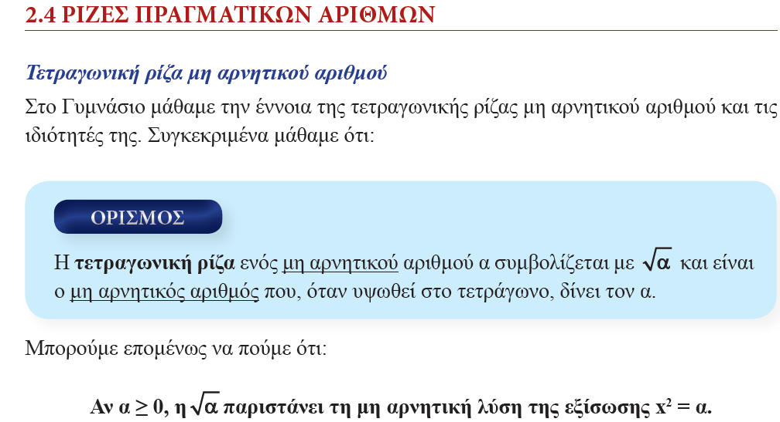

< ⬄ 2< < 3

2 διότι 22=4

διότι 32=9 < < < ⬄ 8 < < 9

=12 =16

$\sqrt{289}$ =17 $\sqrt{324}$ =18 $\sqrt{361}=19$ $\sqrt{400}=20$ $\sqrt{900}$ =30

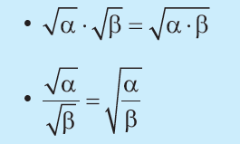

ΔΕΝ ΙΣΧΥΕΙ : $\sqrt{α+β}=\sqrt{α}+\sqrt{β}$

$5=\sqrt{25}$ = $\sqrt{16+9}$ = $\sqrt{16}+\sqrt{9}$ = 4 +3 =7 ΛΑΘΟΣ

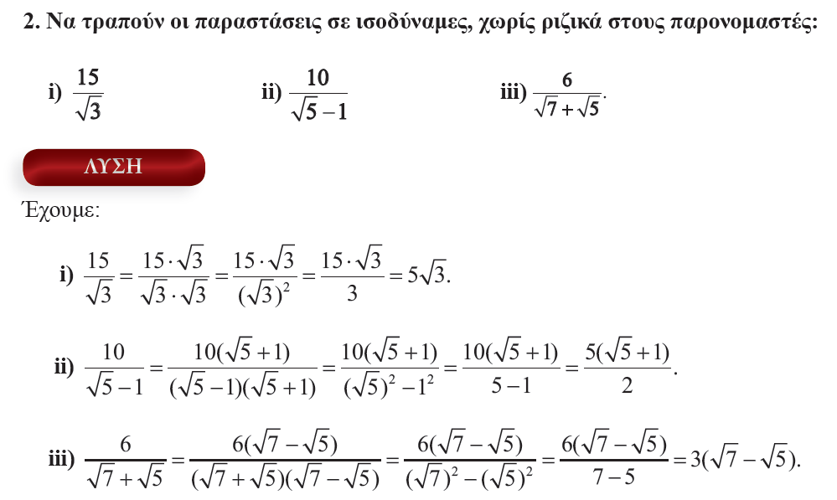

Θυμόμαστε την ταυτότητα : (α-β)(α+β) = α2 – β2

5

5| = 5 =

* ΠΡΟΣΟΧΗ

Άρα

)2 = χ διότι χ

= |χ| διότι χ2 ⬄

Π. χ . = = |3-χ |=

Χ-3=0 ⬄ χ=3 χ | 3 $∞$

Χ-3 | - 0 +

Αν χ<3 τοτε χ-3<0 άρα = |3-χ |= -3+χ

Αν χ $≥$ 3 τοτε χ-3 $≥$ 0 άρα = |3-χ |= 3-χ

Π.χ.(  2=χ-3 διότι χ-3

**ΑΣΚΗΣΗ 2 Β ΟΜΆΔΑΣ ΣΕΛ75**

Α) = 32+122= 9 +1228 =

(3-2)2 = 32-122= 9 -1228 = 37-12

Β) - = 2 -

= |- |= - (2

=  - 2 = 6

(2)2 =28 άρα 3<23-2

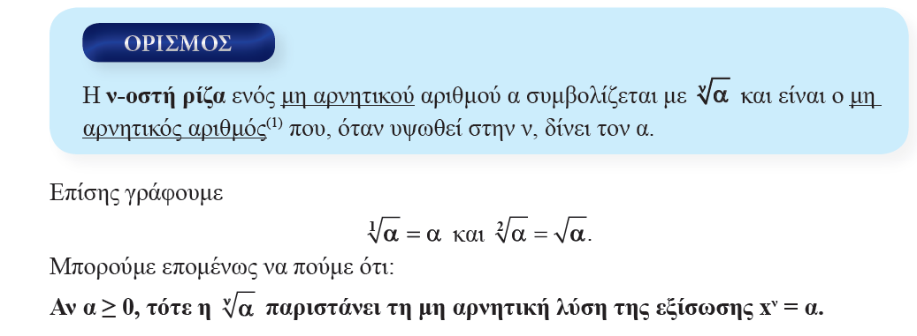

* = α, όταν α3= χ ( α,χ

= 2 , διότι 23 = 8

= 3 , διότι 33 = 27

= 5, διότι 53 = 125

= 1,……

* = α, όταν α4= χ ( α,χ

1, διότι 14 = 1

= 3, διότι 34= 81

* = α, όταν αν= χ ( α,χ $≥0)$ ν $∈Ν$

*

Προσοχή : $\sqrt[2]{5}$ = $\sqrt{5}$, $\sqrt[1]{5}$ = 5

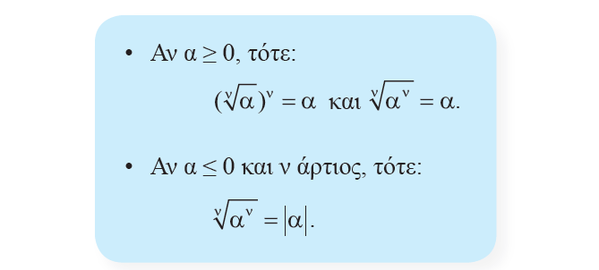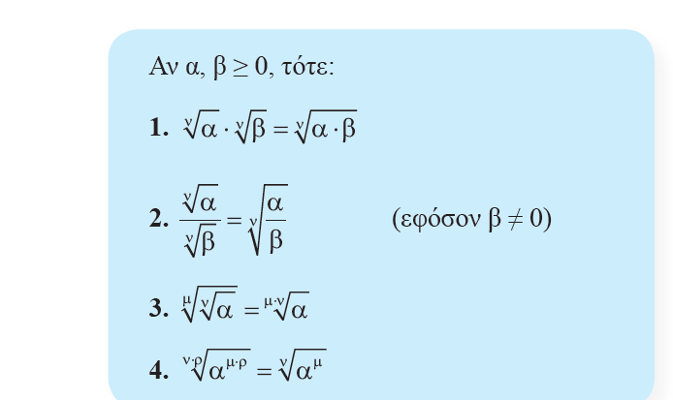

Μετατροπή άρρητου παρονομαστή σε ρητό:

$\frac{2}{\sqrt[3]{2}}$ = $\frac{2\sqrt[3]{2^{2}}}{\sqrt[3]{2}\sqrt[3]{2^{2}}}$ = $\frac{2\sqrt[3]{2^{2}}}{\sqrt[3]{2∙2^{2}}}$ = $\frac{2\sqrt[3]{2^{2}}}{\sqrt[3]{2^{3}}}$ = $\frac{2\sqrt[3]{2^{2}}}{2}$ = $\sqrt[3]{4}$

$\frac{-3}{\sqrt[5]{χ^{3}}}$ = $\frac{-3\sqrt[5]{χ^{2}}}{\sqrt[5]{χ^{3}}\sqrt[5]{χ^{2}}}$ = $\frac{-3\sqrt[5]{χ^{2}}}{\sqrt[5]{χ^{3}χ^{2}}}$ = $\frac{-3\sqrt[5]{χ^{2}}}{\sqrt[5]{χ^{5}}}$ = $\frac{-3\sqrt[5]{χ^{2}}}{χ}$ όπου χ>0

=

=

=

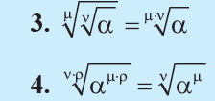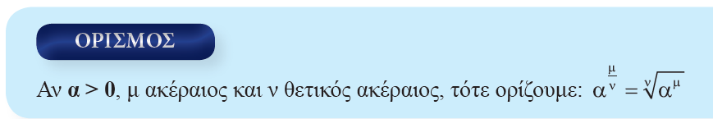

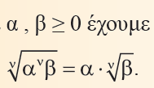

* = = x

ή

= = χ

* = = = = = Χ2 =χ2

= = = =χχ= χ2

* = = = =
* = = =

= = = = 57 = 57

* =