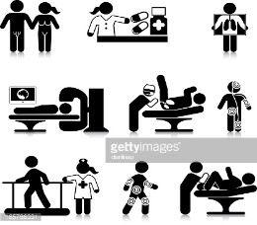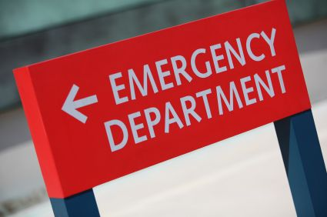

Unit 2-HOSPITAL DEPARTMENTS (PAGES 6 & 7)
Conversation (use complete sentences for the answers)
What services do patients get in different hospital departments?
The hospital is beginning construction to repair damages. T
Which hospital departments needs nurses the most?
The radiology department is on the same floor as the cardiology department.
What department that deals with the care of children?
Patients have to go through the pathology department to get to orthopedics.

Which place do you go where pharmacists distribute pharmaceutical drugs?
Which doctors that use a medical field and operate on patients? What kind of hands do they need?
Which are the employees that study and diagnose disease? What must they wear?
What do you call it when a patient’s life is in danger?
Do doctors in the pathology department respond to emergency situations?
If Ralph’s heart is beating abnormally, which department should he go to?
Should Francesca go to the surgery to pick up her prescription? Where should she go?
The pregnant woman should go to which department?
Wendy has a broken leg, where should she go?
Which doctors work in the pathology lab?
Where should I go to get an x-ray taken?

Do doctors perform surgery in the pharmacy? If not, Where?

Cardiology
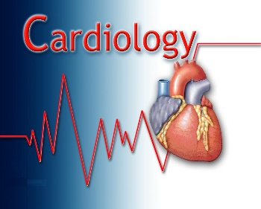

Radiology


Pathology


Obstetrics
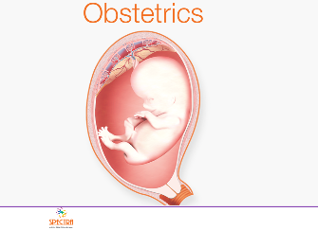

Pediatrics
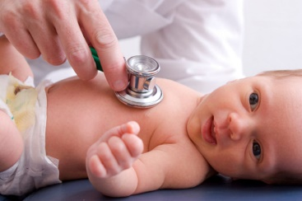

https://www.tes.com/lessons/VBSXFHiX7JutKA/week-three-hospital-departments-3-11-17-2018
Orthopedics


Dermatology


Surgery


Emergency


Pharmacy


