Mechanical Engineering
Unit 1
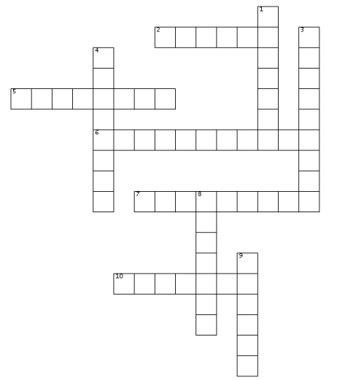

ACROSS
2. a person who joins metals
5. a large aeroplane that carries passengers
6. a large vehicle or aeroplane for carrying large objects
7. things needed or used for a particular purpose
10. make something work

DOWN
1. cargo
3. make, create, build something
4. keep something in a good condition by checking it regularly
8. set up equipment for use
9. plan and draw a machine so as to make it

