Β’ ΕΠΑΛ – Unit 3 CB p.47-56
Answer Key
Γεια σου! Πολύ ενδιαφέρον το κείμενο για τον "Άρχοντα των Δαχτυλιδιών". Είναι μια κλασική ιστορία που βοηθάει πολύ στην εκμάθηση των αγγλικών, ειδικά στον Ενεστώτα (Present Simple).
Ακολουθούν οι απαντήσεις στις ασκήσεις σου, βασισμένες αποκλειστικά στο κείμενο που μου έστειλες:

1. Good and Bad Characters
GOOD CHARACTERS:
- Bilbo Baggins (Hobbit)
- Frodo (Hobbit)
- Gandalf (Wizard)
- Sam (Gardener/Servant)
- Pippin & Merry (Friends)
- Aragorn (King of Men)
- Elrond (Lord of Rivendell)
- The Elves
BAD CHARACTERS:
- Sauron (Evil wizard)
- Black Riders (Sinister riders)
- Saruman (Helper of Sauron)
- Orcs
- Fiery demon

2. List of Places
- Middle-Earth
- The Shire (Bucolic village land)
- New Zealand (The filming location)
- Rivendell (Elvish home)
- Mordon (Sauron's domain)
- The Crack of Doom

3. What are the magic powers of the ring?
According to the text, the ring is magical and can balance the power. It also allows the wearer to disappear (as Bilbo did). However, it has a negative side: it influences all who use it to behave unreasonably and affects the minds of those around it.
4. Why does Sauron want the ring?
Sauron wants the ring because it would allow him to get back full power and gain strength.
5. Where does Frodo want to take the ring?
Frodo wants to take the ring to Mordon (specifically the Crack of Doom) to destroy it.

6. Vocabulary (Synonyms from the text)
- goes: disappears / runs away
- live for ever: eternal
- reshaped: copied (in the context of the ring)
- evil: sinister / wicked
- hurt: wounded
- affects sb: influences
- people who offer themselves...: volunteers
- kingdom: domain
- throwing: casting
- losing his life to save the others: sacrificing his own life

GRAMMAR: Write a description of a film
Ακολουθεί ένα παράδειγμα περιγραφής για την ταινία "Spider-Man", γραμμένο σε απλό Ενεστώτα (Present Simple), όπως ζητάει η άσκηση:
Film Title: Spider-Man
Peter Parker is a shy student who lives with his aunt and uncle. One day, a radioactive spider bites him during a school trip. Soon, Peter discovers that he has amazing powers. He is very strong and he climbs walls easily. He decides to fight crime in New York City. He wears a red and blue suit and fights against the Green Goblin, an evil villain. In the end, Peter understands that "with great power comes great responsibility."

Ελπίζω να σε βοήθησα με τις ασκήσεις σου! Καλή μελέτη!

Συνεχίζουμε με τις επόμενες ασκήσεις! Εδώ έχουμε κυρίως Γραμματική (Συγκριτικός και Υπερθετικός βαθμός) και Λεξιλόγιο.

2. Form comparatives/superlatives from the following adverbs
Adverb | Comparative | Superlative
slowly | more slowly | the most slowly
easily | more easily | the most easily
hard | harder | the hardest
fast | faster | the fastest
early | earlier | the earliest
late | later | the latest
soon | sooner | the soonest
near | nearer | the nearest
well | better | the best
badly | worse | the worst

3. Put adjectives and adverbs in the correct list
- -er, -est: easy, cheap, short, fast, pretty, old, hot.
- more... than, the most: interesting, modern, famous, difficult.
- Irregular: good, well, bad, badly.

4. Complete the gaps (Comparative/Superlative)
- Mary speaks Italian better than her sister.
- Which is the highest mountain in your country?
- He is the fastest runner in the world.
- "I will sleep more peacefully if he doesn’t take the car," said his mother.
- A 4x4 is more expensive than a family car.
- She is the worst cook in her class. Nobody wants to try her dishes.

Work and play with words
1) Prepositions
- The waiter has already served dinner to us.
- People should be educated about how to use energy more efficiently.
- A lot of tests have been carried out on the patient.
- She’s aiming at a scholarship to continue her studies.
- We need somebody to market our products to companies in Europe.
2) Types of beer
- Lager, Ale, Stout, Pilsner, Alcohol-free beer, Draught beer.
3) Methods of cooking
- cook in the oven without oil $\rightarrow$ bake
- cook in boiling water $\rightarrow$ boil
- cook in hot oil $\rightarrow$ fry
- cook over or under strong heat $\rightarrow$ grill
- cook in the oven with oil $\rightarrow$ roast
5) Word building (Adjectives in -ous)
- nerve $\rightarrow$ nervous
- ambition $\rightarrow$ ambitious
- fame $\rightarrow$ famous
- religion $\rightarrow$ religious
- poison $\rightarrow$ poisonous
6) Make sentences (Examples)
- I always feel nervous before exams.
- That snake is very poisonous, don't go near it.
- She is very ambitious and managed to become the manager.
- Mt. Olympus is a famous mountain in Greece.
- He is a religious person and goes to church every Sunday.

7) Food Pyramid
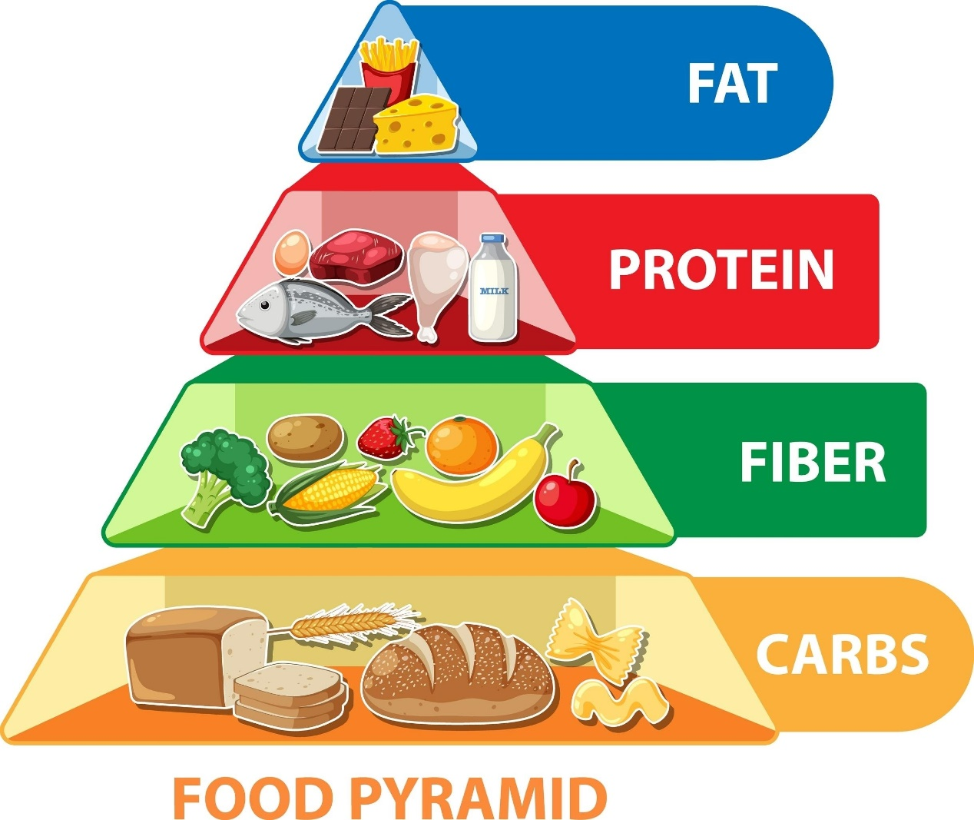
Shutterstock
Εξερεύνηση
- Meat/Poultry: steak, chicken, lamb, turkey.
- Fish/Seafood: salmon, shrimps, octopus, sardines.
- Dairy Products: cheese, yogurt, milk, butter.
- Fruit: apples, bananas, oranges, strawberries.
- Vegetables: lettuce, tomatoes, broccoli, carrots.
- Cereals/Grains: bread, pasta, rice, corn.

