|  |  |  |
| --- | --- | --- |
| Name: | Class no: | Date: |

**Prepositions of Place & Vocabulary**

**First label the items in the picture and then complete the sentences with either: (in, on, above, under, next to, near, behind, in front, between)**

|  |
| --- |
| **armchair cushions rug table lamp chair vase book** |

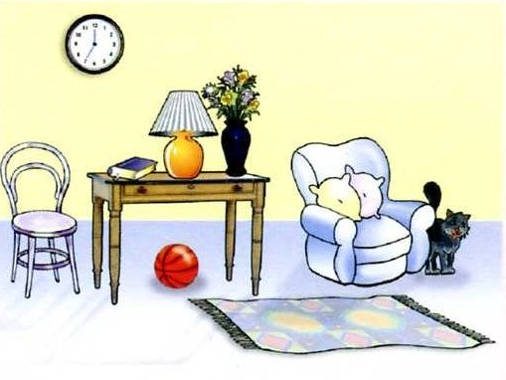

1. The black cat is _____________________ the armchair.
2. The table is ____________________ the armchair and chair.
3. The red ball is __________________ the table.
4. The clock is __________________ the wall.
5. The orange table lamp is __________________ the table.
6. The chair is __________________ the table.
7. The vase of flowers is __________________ the table lamp.
8. The ball is _________________ the floor.
9. The little black book is _________________ the table.

**10.**The table lamp is _________________ the book and the table lamp.

**11.**The cushions are _______________ the armchair.

**12.** The clock is _______________ the chair and table.