PAST SIMPLE AND PAST CONTINUOUS

PAST SIMPLE  • a completed action at a definite time in the past  Martina joined a sculpture class last summer.  • one completed action after another  I took a deep breath and let go.  •a past habit or regular past event  Every Saturday she went shopping in town. | PAST CONTINUOUS  •an action in progress in the past  Several Japanese tourists were admiring the cow now.  •two actions in progress at the same time in the past  Some were laughing, others were taking photos.

PAST CONTINUOUS AND PAST SIMPLE

•past continuous for an action in progress in the past when another action (past simple) interrupted it
They were rushing to meet Martina’s mum at the café when they noticed something.

•past continuous to ‘set the scene’ in a story; past simple for the actions and events
While they were drinking their coffee, she showed them a leaflet about CowParade.

- Complete the conversation with the past simple of the verbs in brackets.

Jane: What 1) _____________________ (you/do) yesterday?
Nick: Well, 2) _____________________(go) to an exhibition of Ancient
Egyptian mummies at the museum.
Jane: How spooky! 3) ___________________ (you/enjoy) it?
Nick: Yes. I 4) _________________ (think) it was amazing!
Jane: 5) ________________ (they/have) anything else there apart from
mummies?

Nick: Actually, they 6) ______________ (have) statues and masks. But I
was disappointed because I 7) __________________ (not see) the
mask of King Tutankhamun. They 8) ________________ (leave)
that in Egypt.

- Match the beginning (1-6) with the endings (a-f). Then complete the sentences with While or When and the correct form of the verbs in brackets.

- I (see) lots of tourists a) I (climb) the mountain.
- We (swim) in the see b) I accidentally (knock) it down.
- I (break) my leg c) I (walk) past the museum today.
- My brother (talk) d) I (see) a huge octopus!
- I (admire) a sculpture e) the famous artist (paint).
- People (take) photos f) everyone else (listen) to the guide.

1._______________________________________________________________
2. _______________________________________________________________
3. _______________________________________________________________
4. _______________________________________________________________
5. _______________________________________________________________
6. _______________________________________________________________

- Complete the text with the correct form of these verbs.

Become eat lie paint represent set up
Stand take off take over take up work

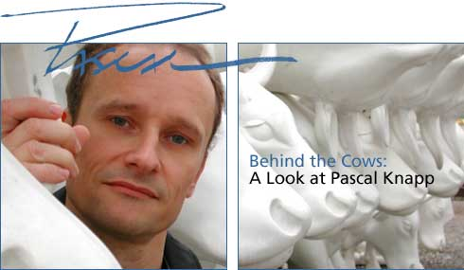
In 1996, Pascal Knapp 1) _____________ as a sculptor when his father asked him to make a cow sculpture for an exhibition in Zurich, Switzerland. Pascal immediately 2) ______________ the challenge. First, he 3) ____________ a cow that 4) ________________ on all four legs with its head up. It was so popular that Pascal’s father soon asked him to make two more cows. The second cow 5) _______________ down and the third cow 6) _______________ grass.
In 1999, Peter Hanig 7) ______________ the very first CowParade in Chicago. Local artists 8) _________________ the cows in a way that 9) ______________ local culture. They placed them throughout the city centre in public places such as train station and parks. Sometimes they 10) ___________________ whole streets and squares.
Soon after the Chicago event, CowParade 11) _______________ in other countries and Pascal’s cow 12) _____________ an international success.

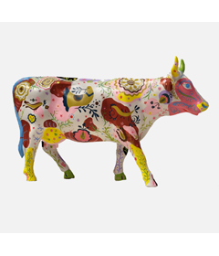
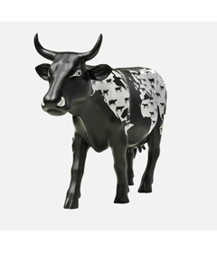
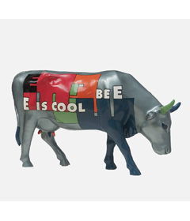
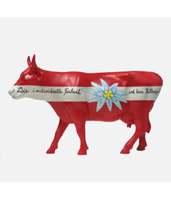

Time to talk

Are there any statues or sculptures in your local area? Do you like them? Why/Why not?

Key:

- 1. Did you do 2. Went 3. Did you enjoy 4. Thought
4. Did they have 5. Did they have 6. Had 7. Didn’t see
8. Left

- 1c 2d 3a 4f 5b 6e

- 1. Was working 2.took up (accept) 3. Made 4. Was standing
5. was lying 6. Was eating 7. Set up 8.painted 9. Represented
10. took over 11. Took off (become successful) 12. became

