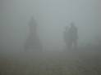
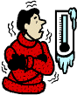
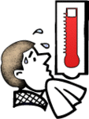

b
WEATHER

it's boiling hot
it's cloudy

it's cold

it's foggy

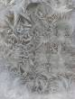
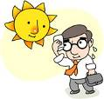
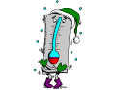

it's hailing

it 's hot

it's freezing

it's frosty



hurricane
lightning

drought

it's rainy

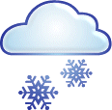



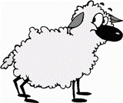



WORDS IN SINGULAR:

leaf strawberry
cherry sheep
person shelf
watch paintbrush
fox mouse
match puppy
knife tomato
loaf glass
potato sandwich
fish
it's sleeting

it's sunny
it's snowy
it's stormy

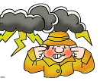



it's windy

it's wet

tornado

thunder

