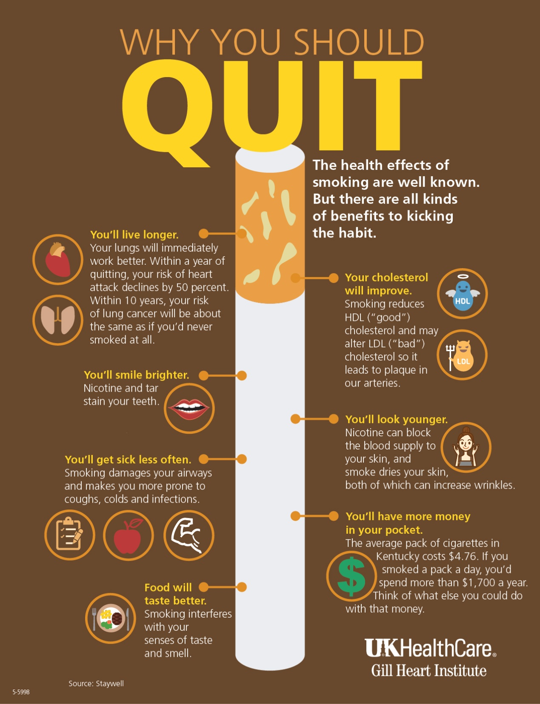

1. What are some other effects of smoking apart from harming your health?

2. What is the aim of this text?

3. How would you compare this text to the previous one?

4. Which of the two texts would be more appealing to young people? Why?