*Source of text: (https://visual.ly/community/Infographics/health/hazards-smoking-cigarettes)*

1. Who do you think the above text is aimed at?

2. What is the purpose of the text?

3. Are the following statements *True*, *False* or *Not Mentioned*?

* The above text presents scientific data.
* Smoking harms nearly every organ of the body.
* Second hand smoking is also very harmful.
* 90% of tobacco users are estimated to die of lung cancer.
* Men are more affected than women.
* Nicotine is the most harmful of all the chemicals contained in tobacco.
* The organ which is affected by tobacco most of all is your lungs.
* Tobacco alone is responsible for far more deaths than all the other causes leading to death.

4.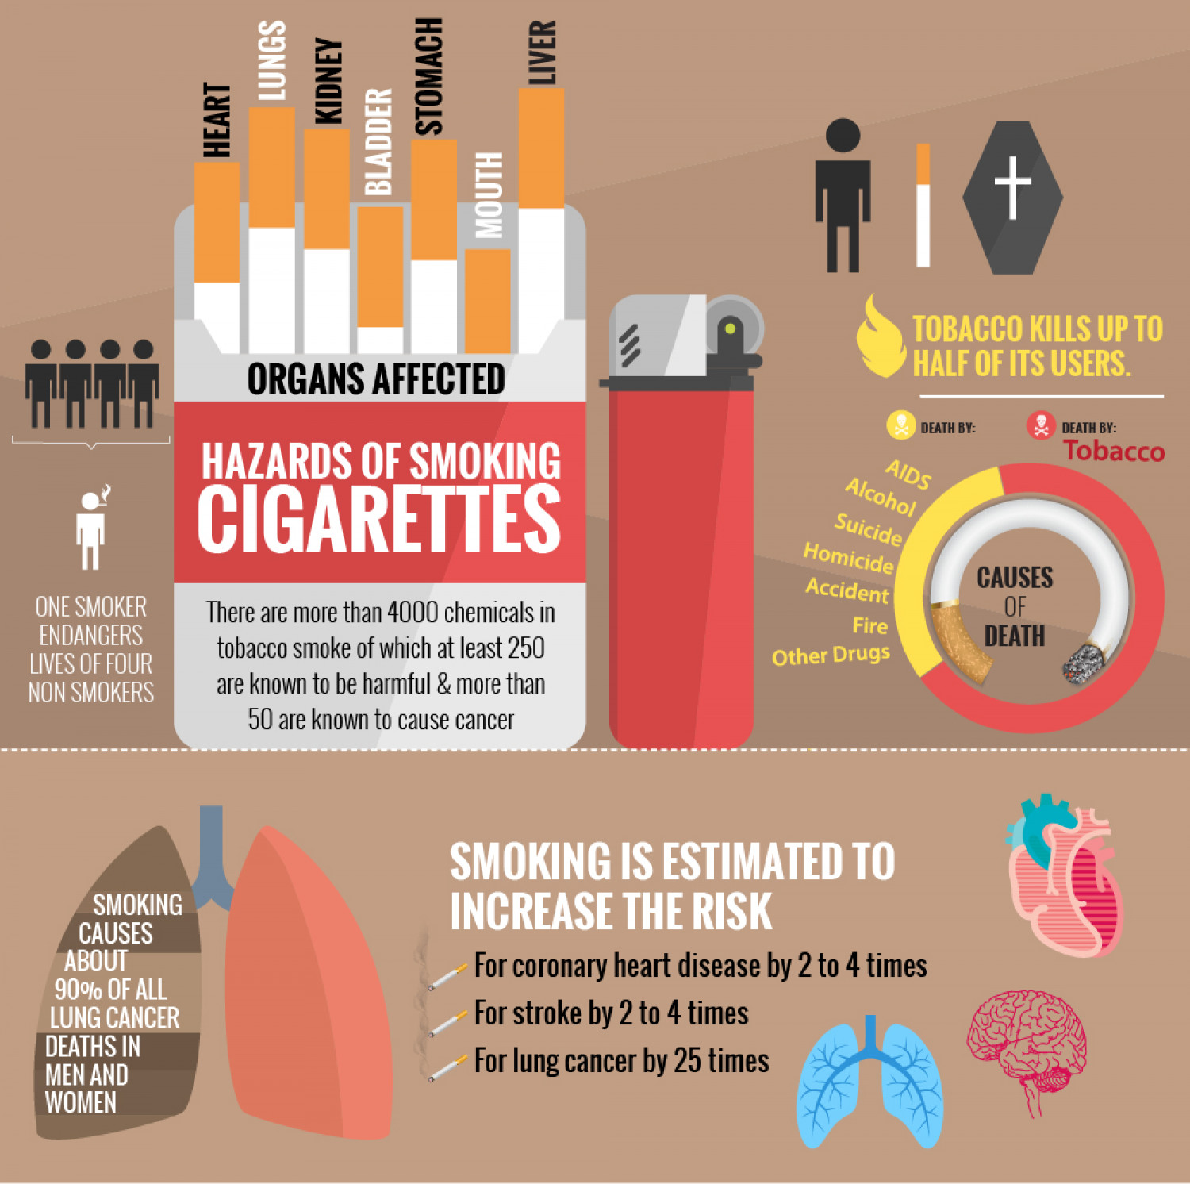 Which piece of information is the most shocking in your opinion?