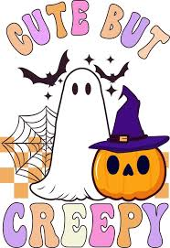
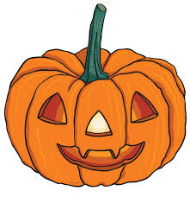

Reorder the paragraphs to find out how it all began.
They believed that this night was special because the line between the living and the dead became very thin. That meant ghosts and spirits could come back to the world of the living!
As years passed, Halloween changed. It became more about fun than fear. People started going door to door asking for treats, wearing funny or spooky costumes, and carving jack-o’-lanterns out of pumpkins. Today, Halloween is a mixture of old traditions and new fun, and it’s one of the most exciting nights of the year!
It all started over 2,000 years ago with a group of people called the Celts. They lived in places like Ireland, Scotland, and England. The Celts celebrated a festival called Samhain on the night of October 31st. It marked the end of the harvest season and the beginning of the New Year.
To keep safe, the Celts would light big fires to scare the spirits away. They also wore masks and scary costumes hoping to fool the ghosts so they wouldn’t bother them.
Halloween is a fun holiday that we celebrate every year on October 31st. We dress up in costumes, go trick-or-treating, carve pumpkins, and sometimes tell spooky stories. But do you know where Halloween came from?
Later, when Christianity spread, the church wanted people to celebrate a holy day instead. So they created All Saints’ Day on November 1st, a day to remember saints and good people who had passed away. The night before became known as All Hallows’ Eve -“Hallow” is an old English word for Saint. Over time All Hallows’ Eve (=All Saints’ Eve) turned into the word we use today: Halloween!
