THE MOST EXCELLENT

AND LAMENTABLE TRAGEDY OF

ROMEO & JULIET

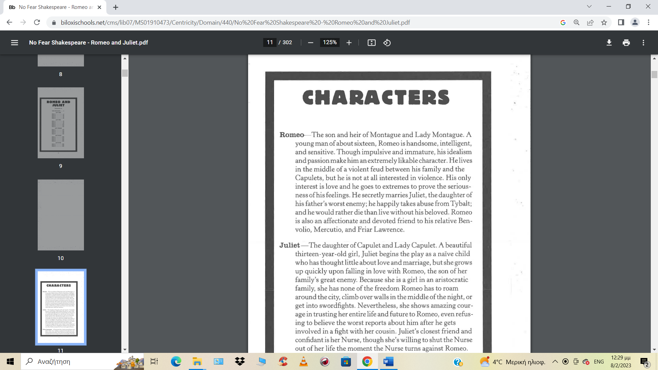

PROLOGUE

ORIGINAL TEXT MODERN TEXT
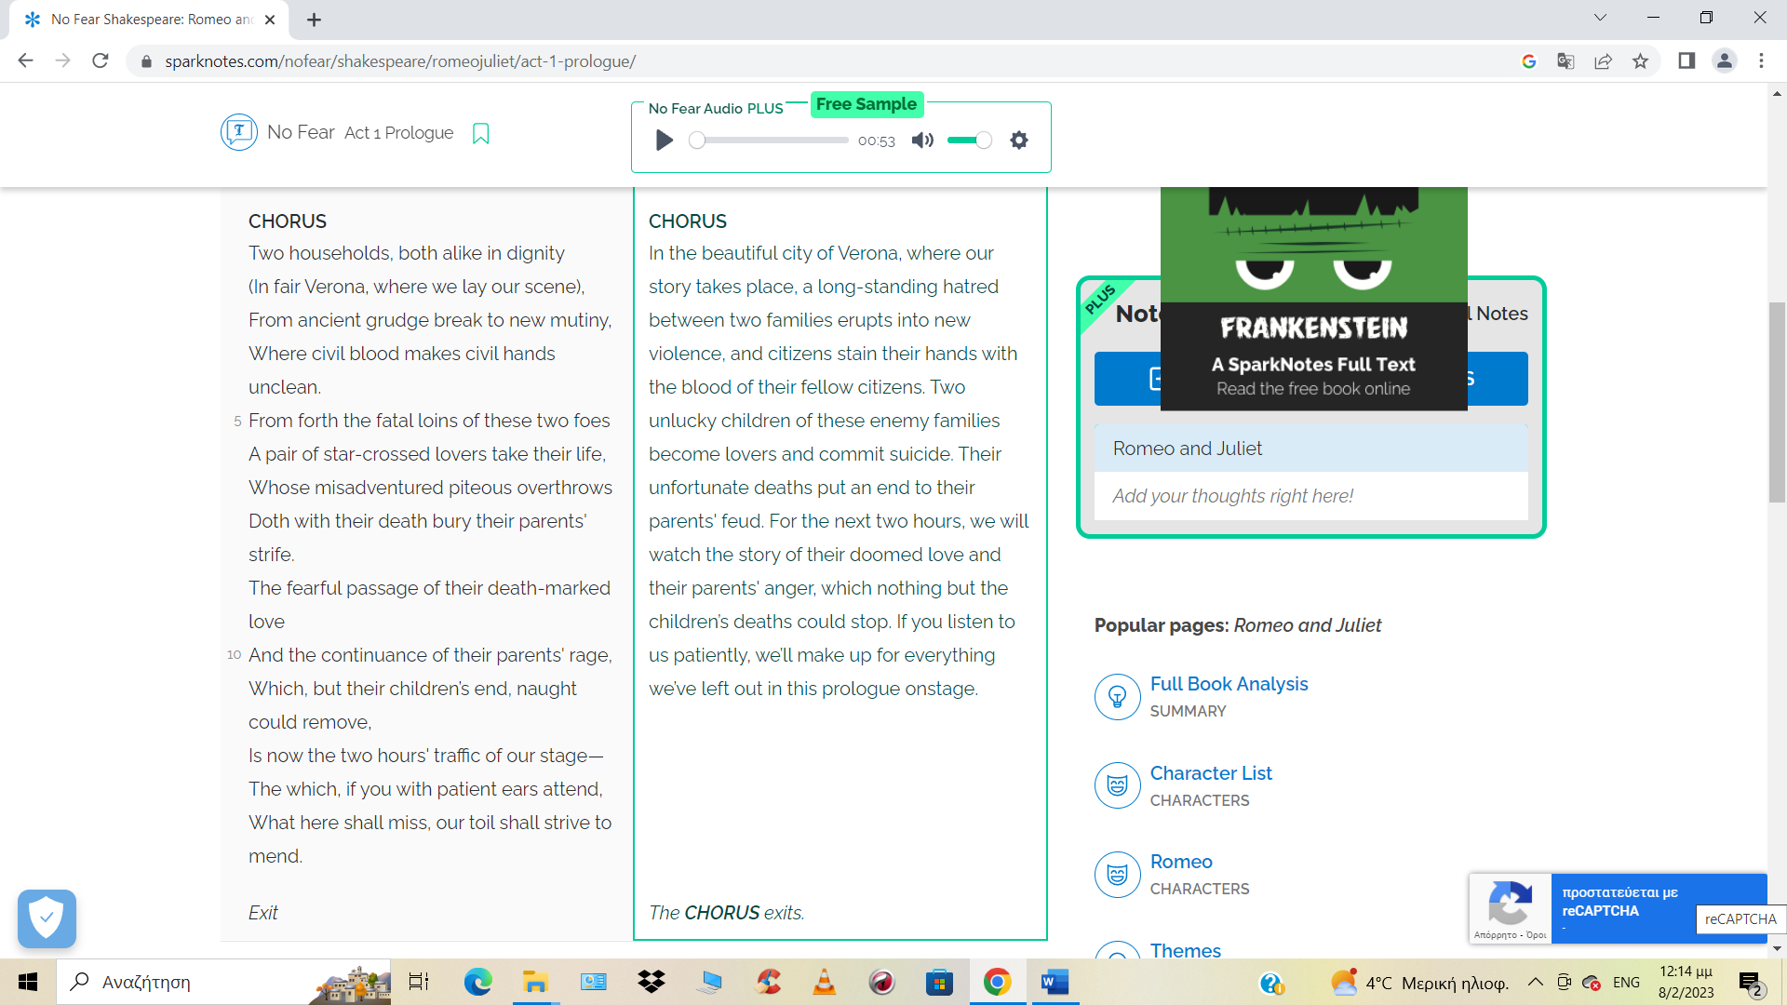

Act 1 Scene 5
(At the Capulet’s house there is a masked ball, which is also going to be the engagement party for Juliet, who is unwilling to meet her groom-to-be. Romeo arrives uninvited aiming to see there another young lady, he thinks he is in love with, until… )
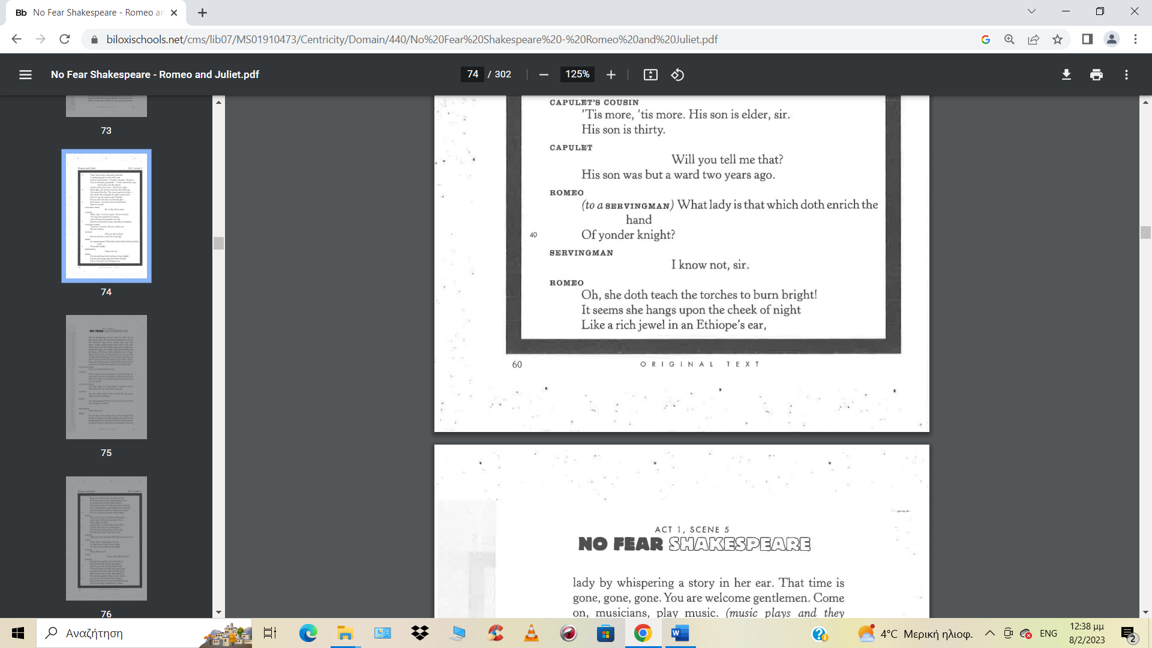
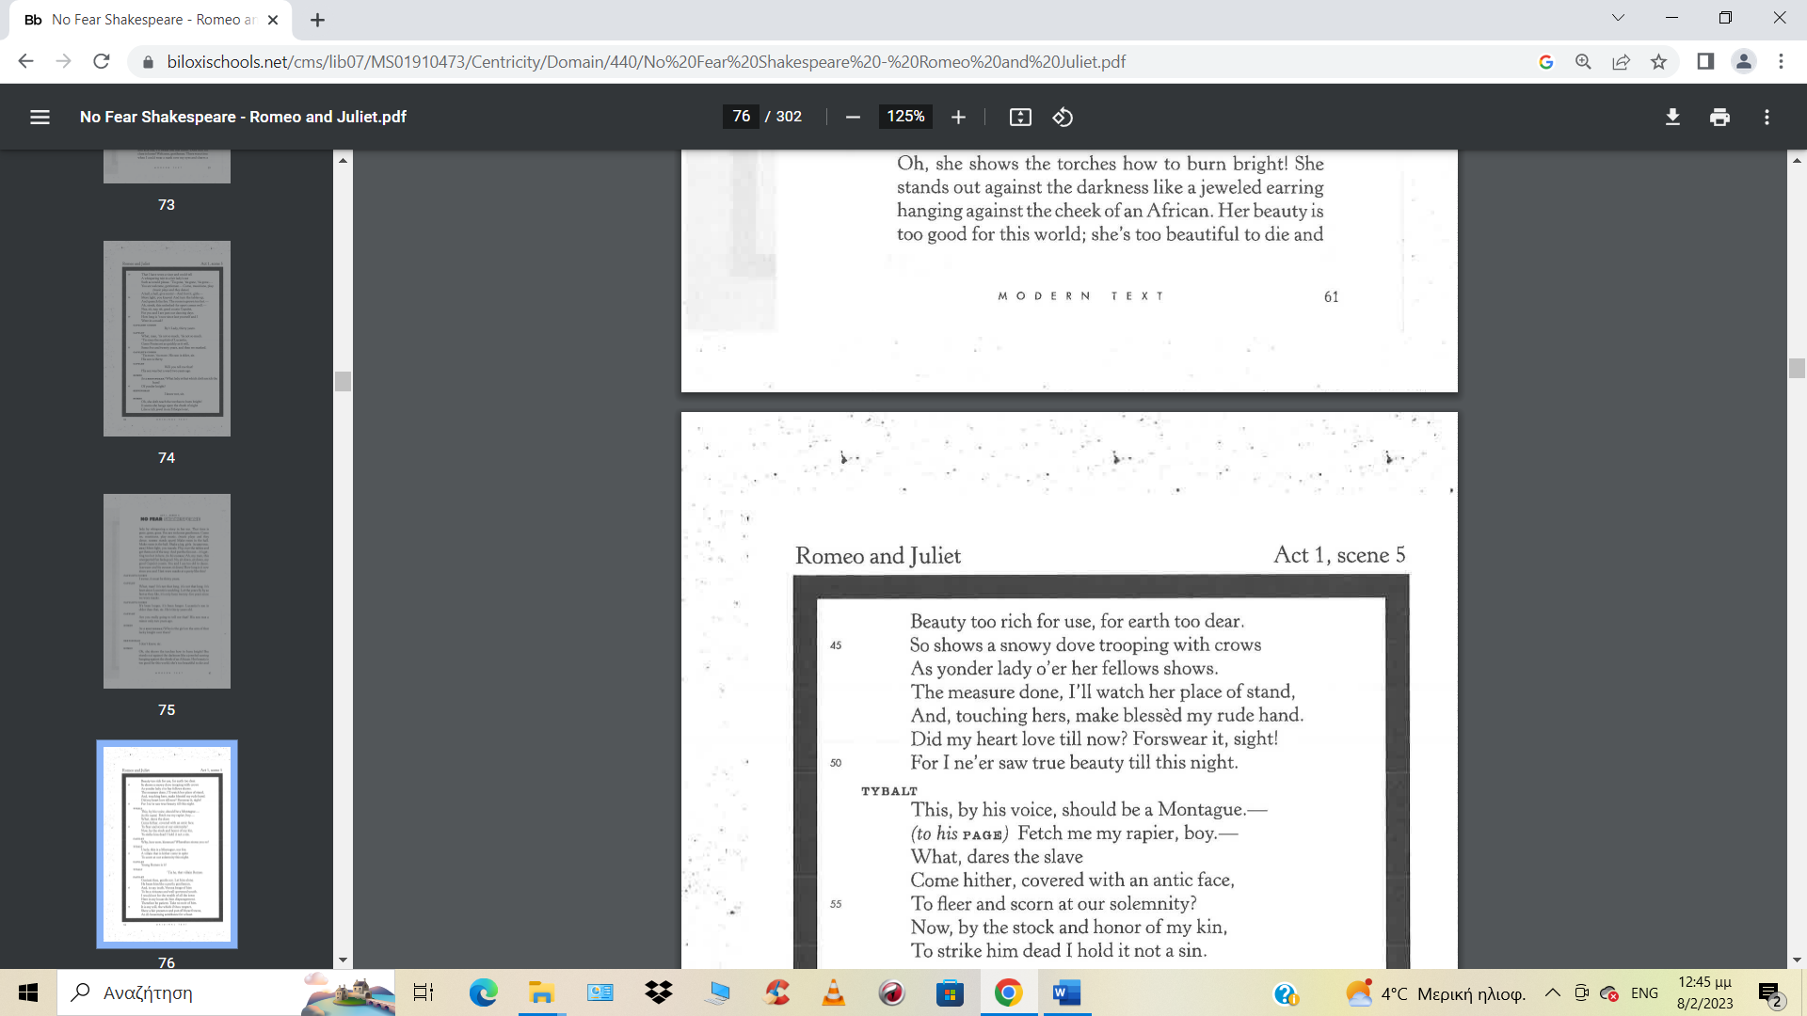
MODERN TEXT
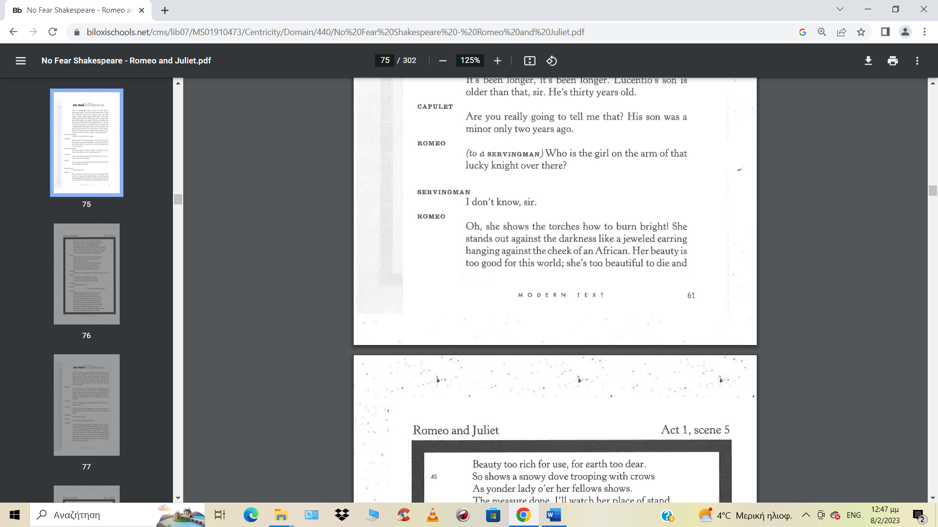
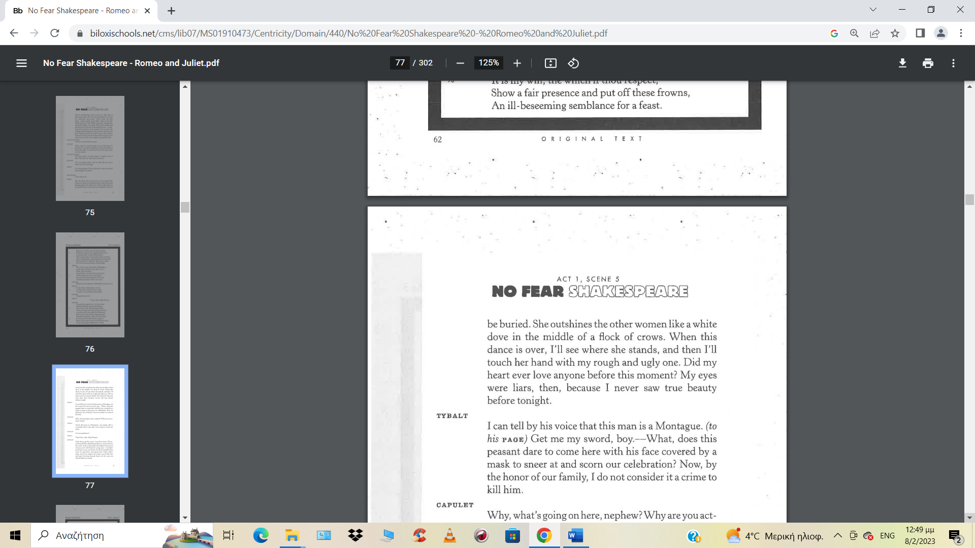
FIRST KISS SCENE
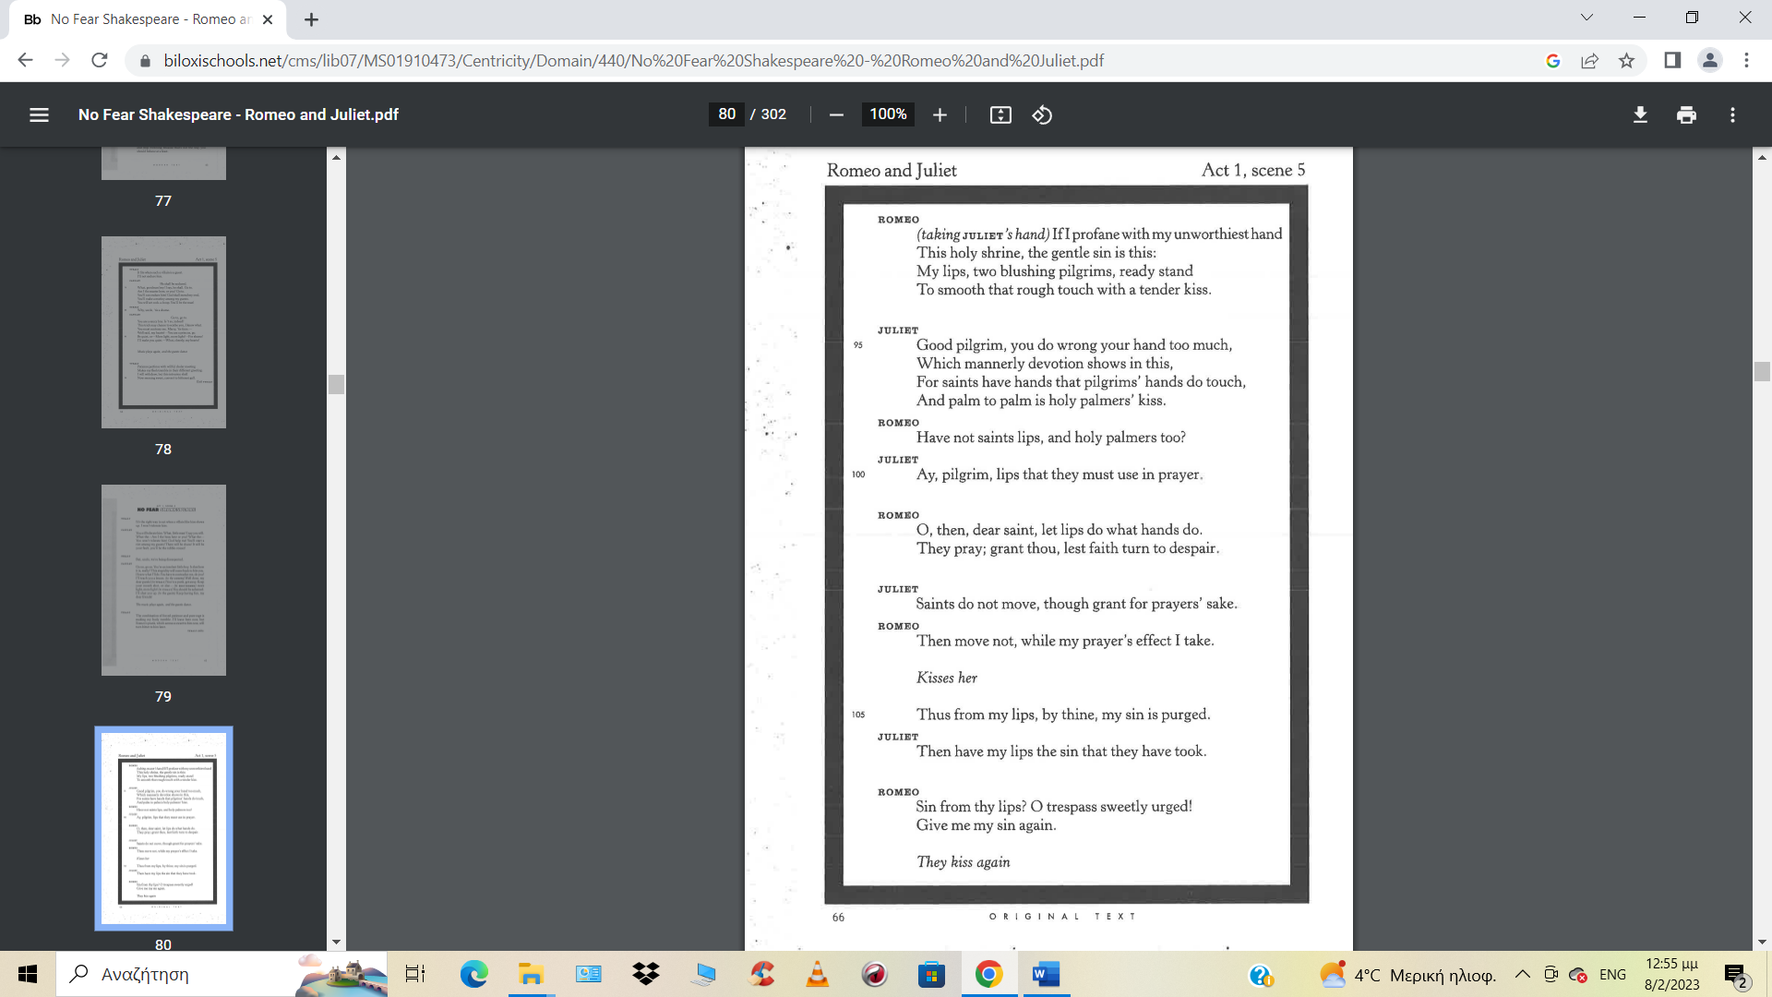
MODERN TEXT
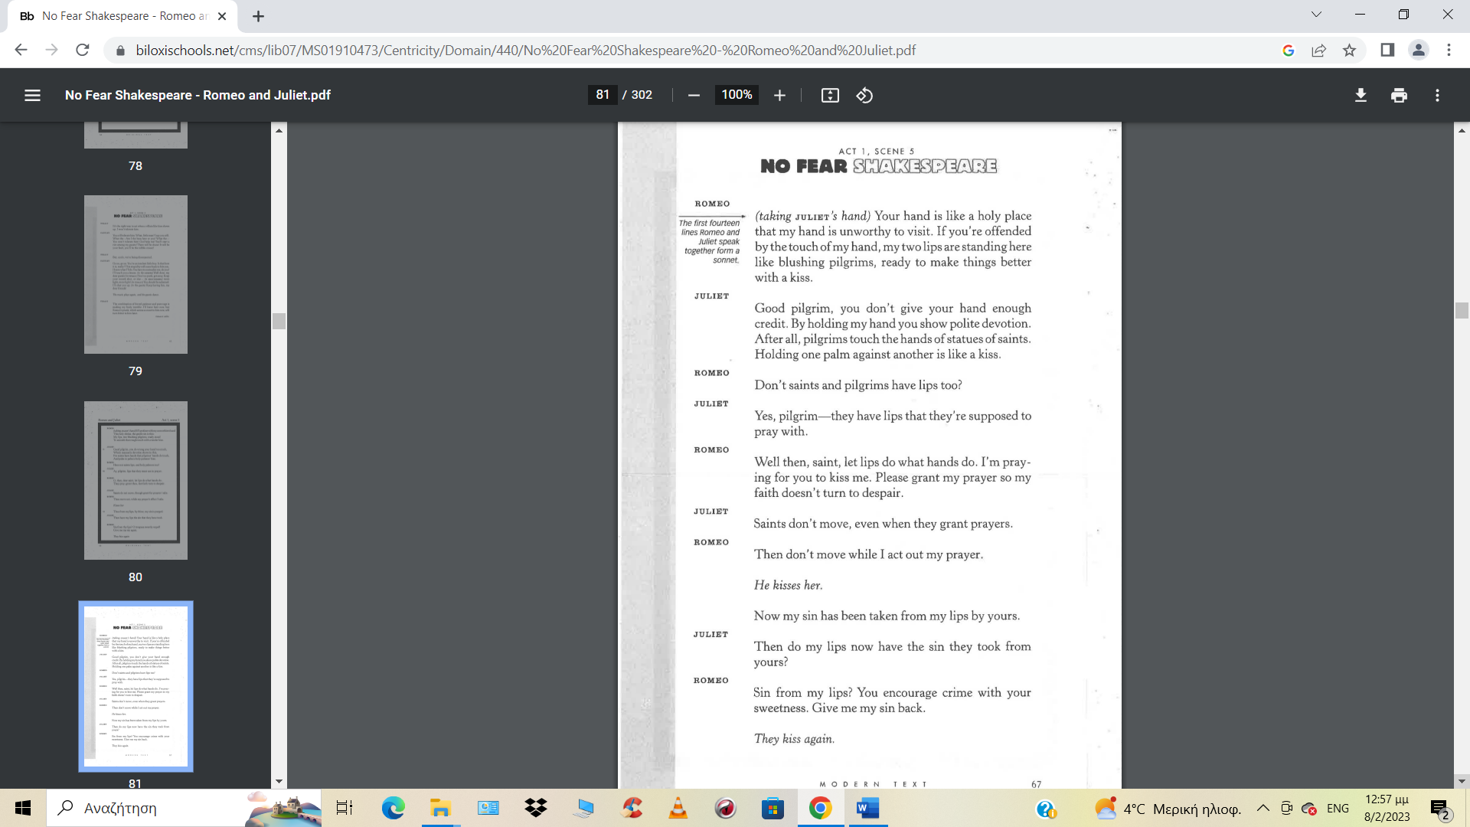

Until now they have been unaware of each other’s identity. But soon they realise that their families are enemies and then…
THE BALCONY SCENE
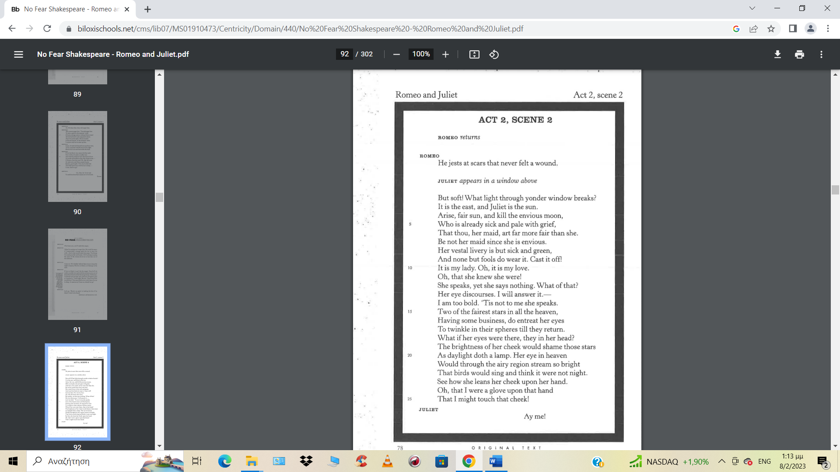

MODERN TEXT

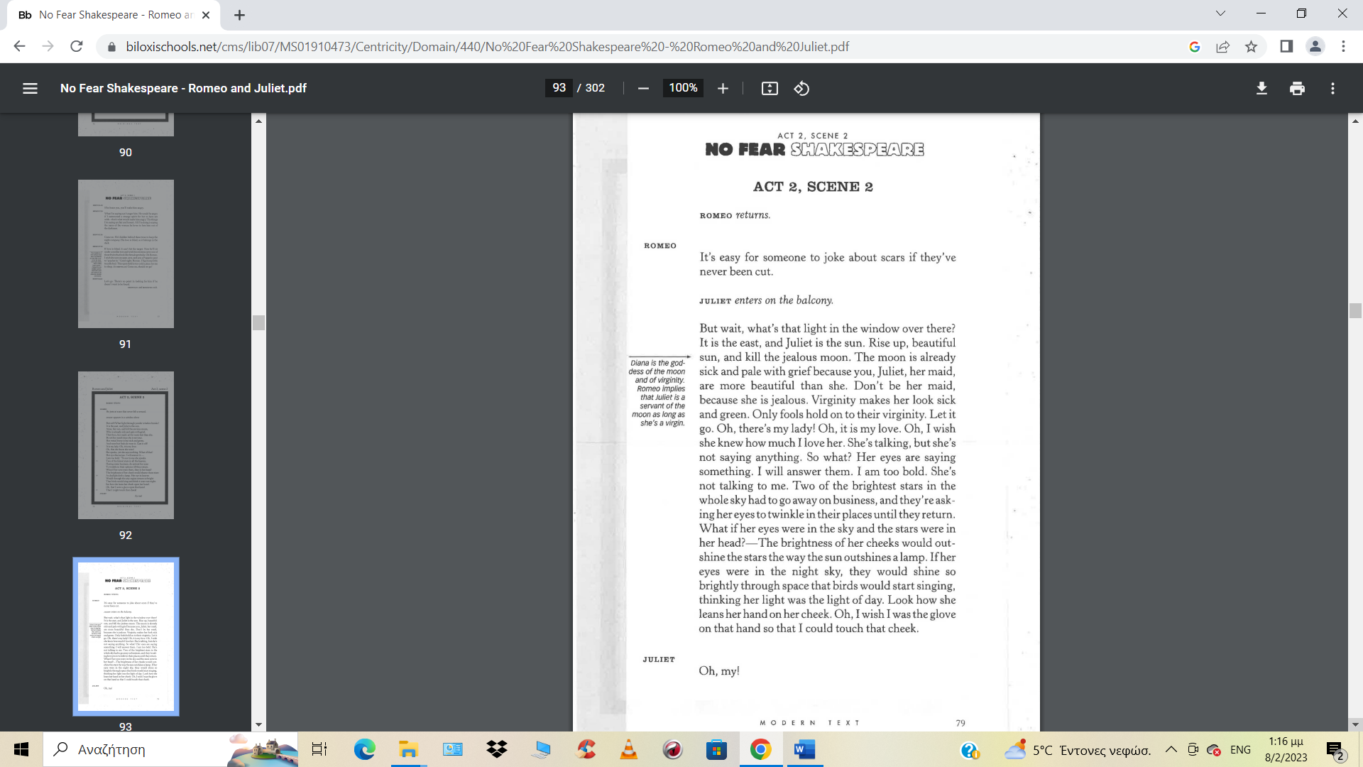
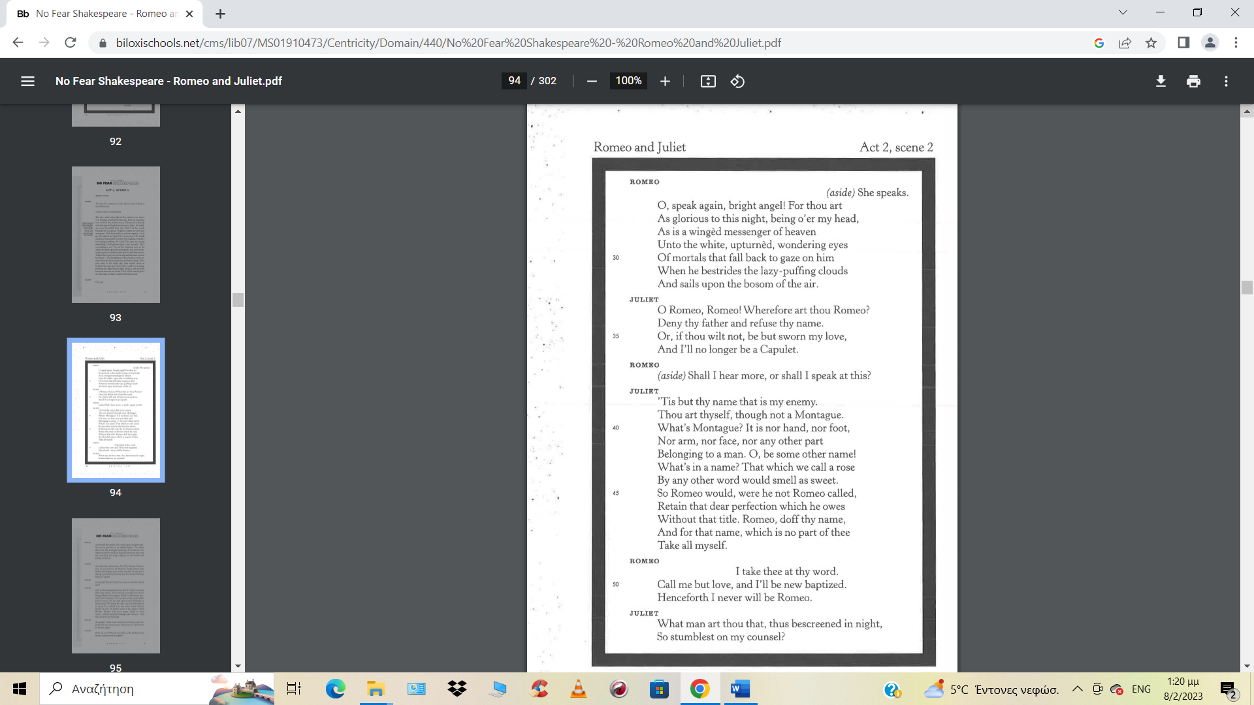

MODERN TEXT
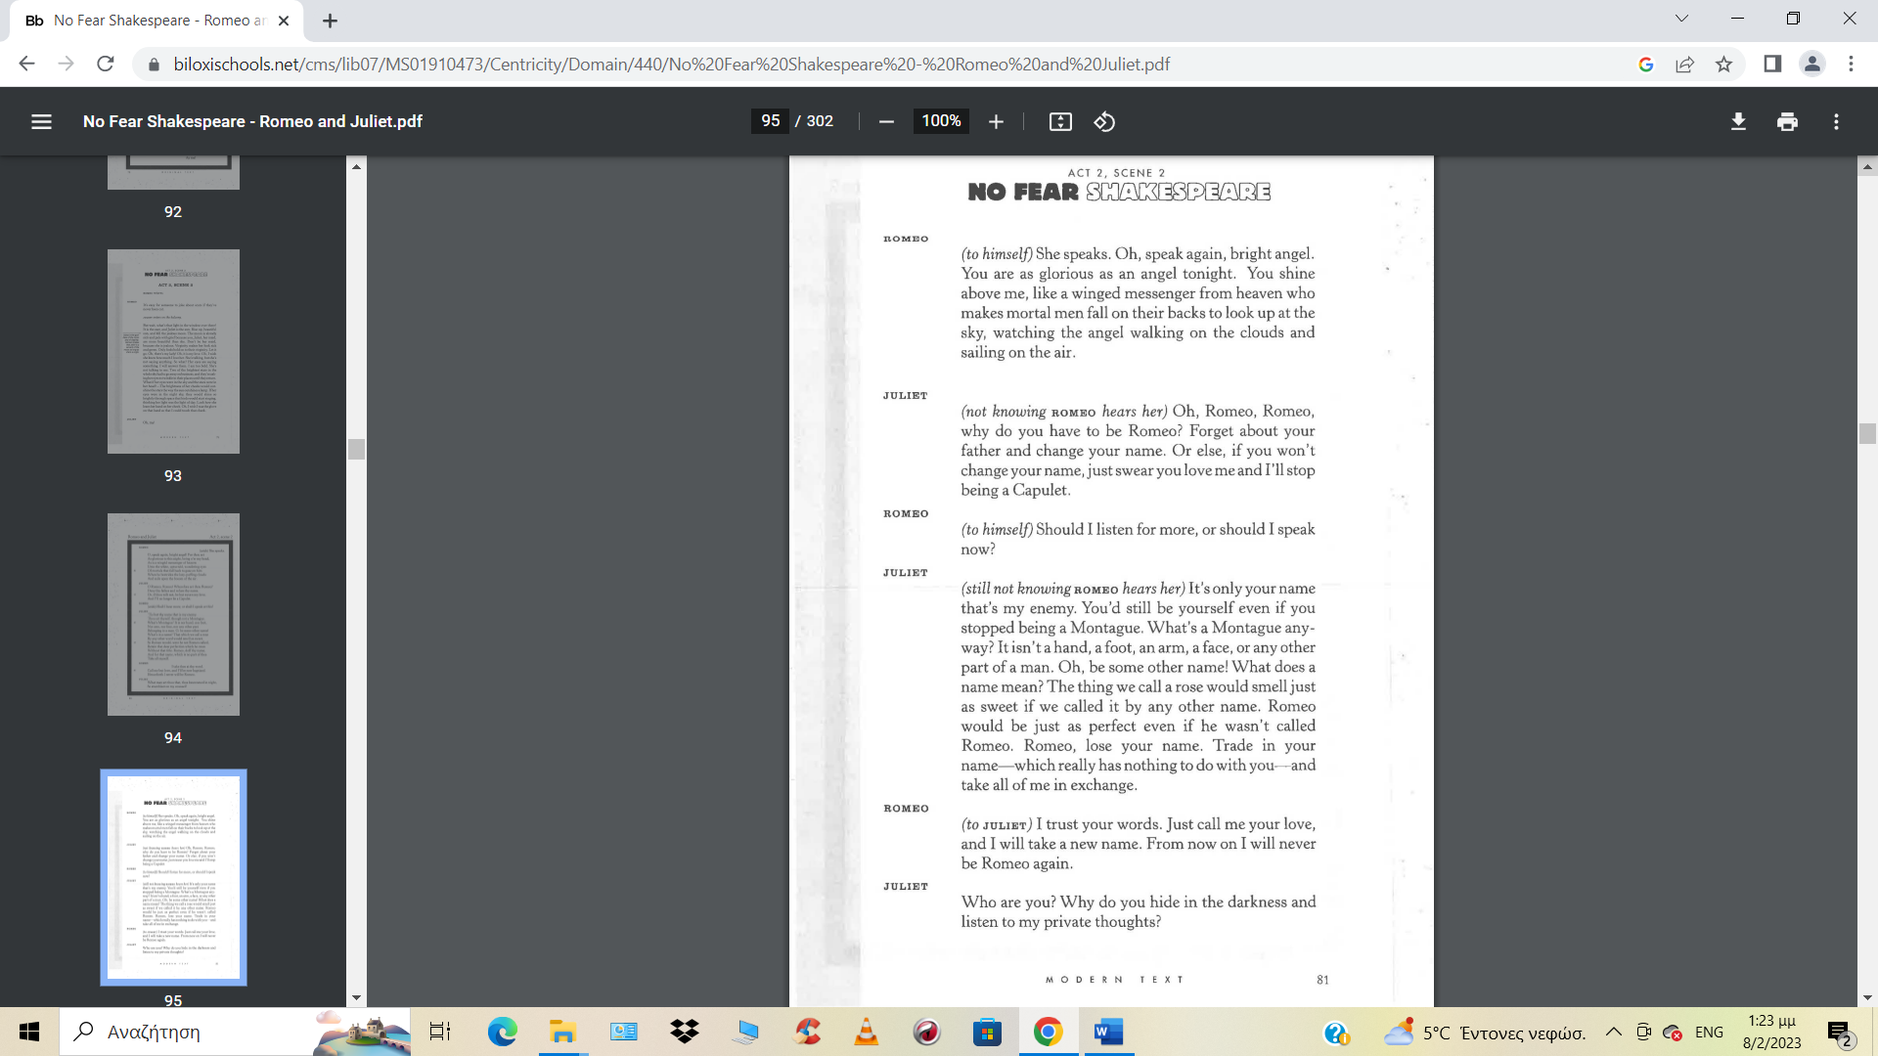
The events that lead to the two lovers’ tragic deaths…
Romeo and Juliet get married in secret with the help of Juliet’s nurse and Friar Laurence. Another fight breaks out in Verona and Tybalt kills Romeo's friend Mercutio. Romeo had tried to prevent the fight but, after Mercutio's death, he kills Tybalt. The Prince banishes Romeo from Verona because of what he has done. Juliet is distraught by the news of Tybalt’s death and Romeo being banished. Lord Capulet tells Juliet she must marry a man called Paris, not knowing she is already married. Friar Laurence gives Juliet a potion that will make her appear dead, so she does not have to marry again. He sends Romeo a note to explain the plan and Juliet takes the potion. Her body is moved to the family tomb. Romeo does not receive the note about the potion from Friar Laurence and thinks Juliet is really dead. He buys some poison and goes back to Verona, planning to die alongside Juliet's body.
THE DEATH SCENE
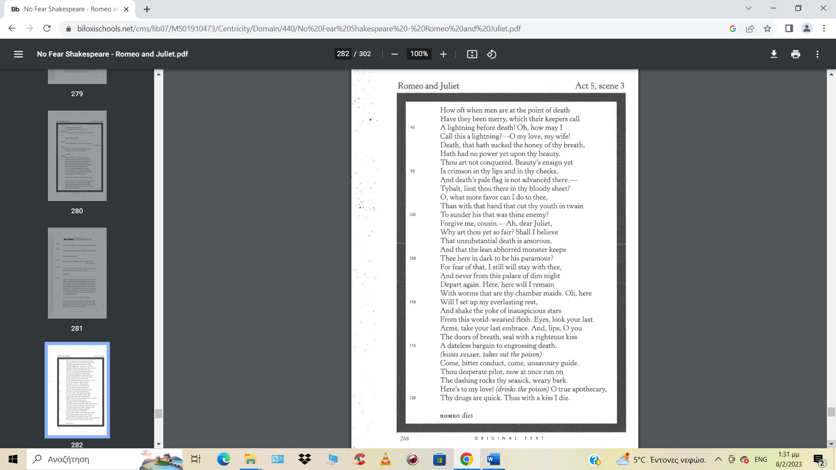
MODERN TEXT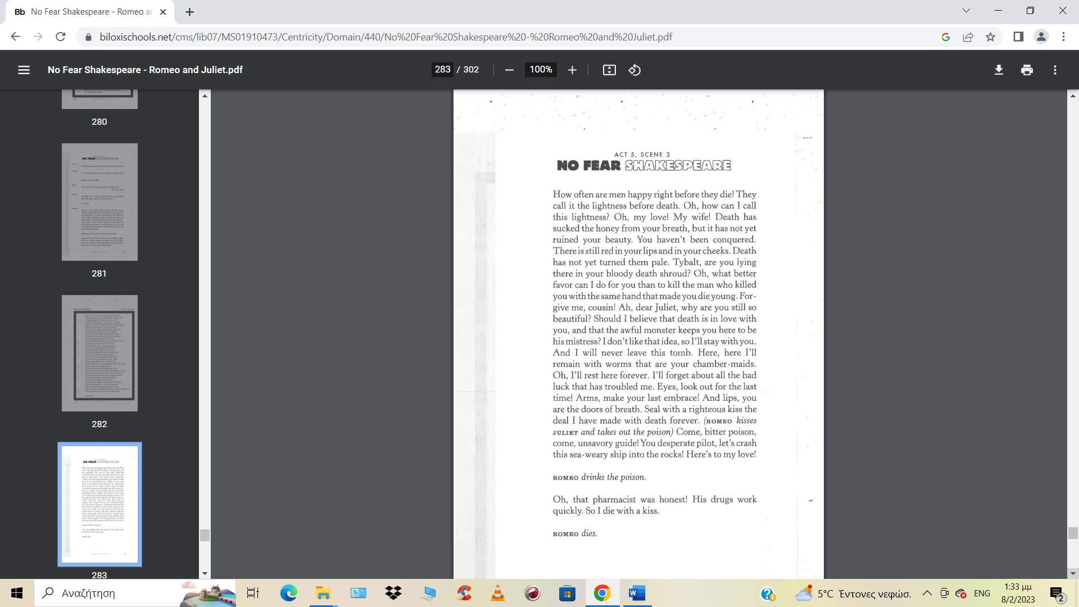
In the meantime, having learned that Romeo never received his message, the Friar comes to the crypt and reaches Juliet just as she revives. He cannot persuade her to leave her dead husband, and runs away in fear. Juliet realises what has happened, takes Romeo's knife and…
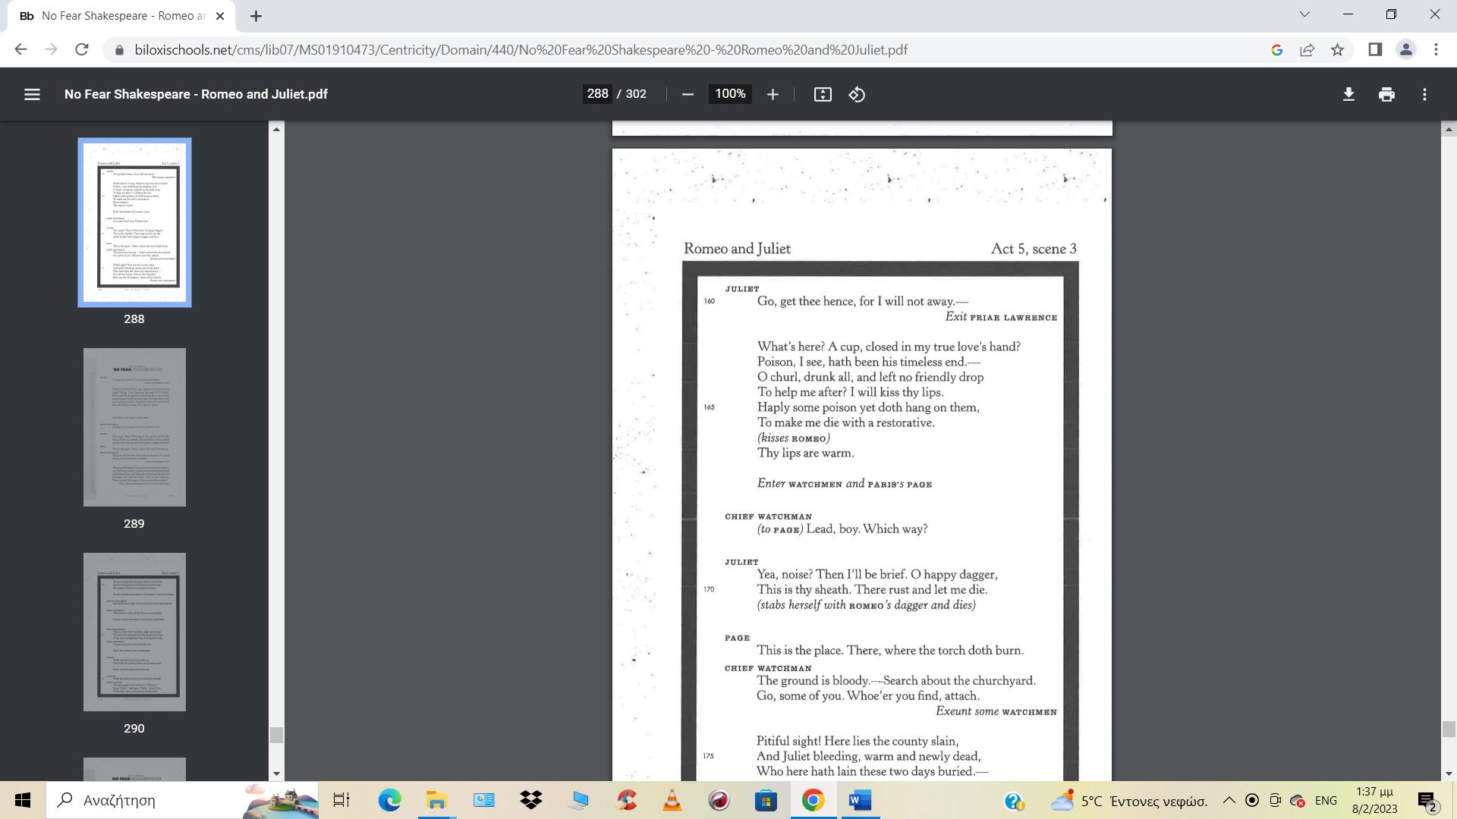

MODERN TEXT

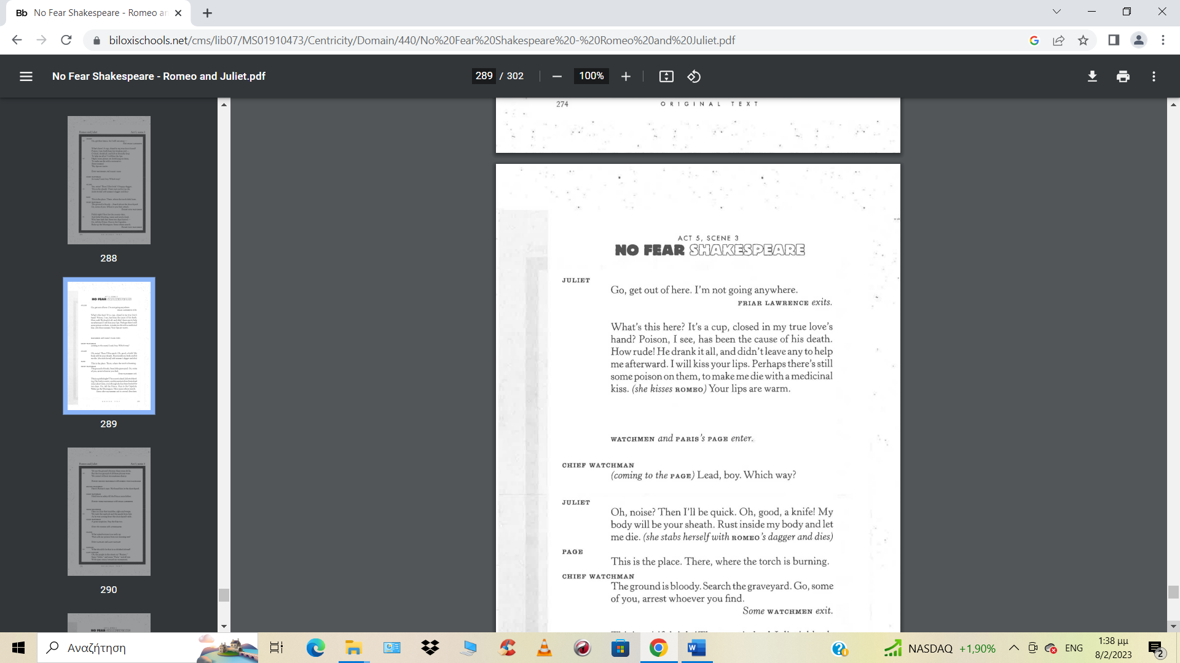

FINAL SCENE

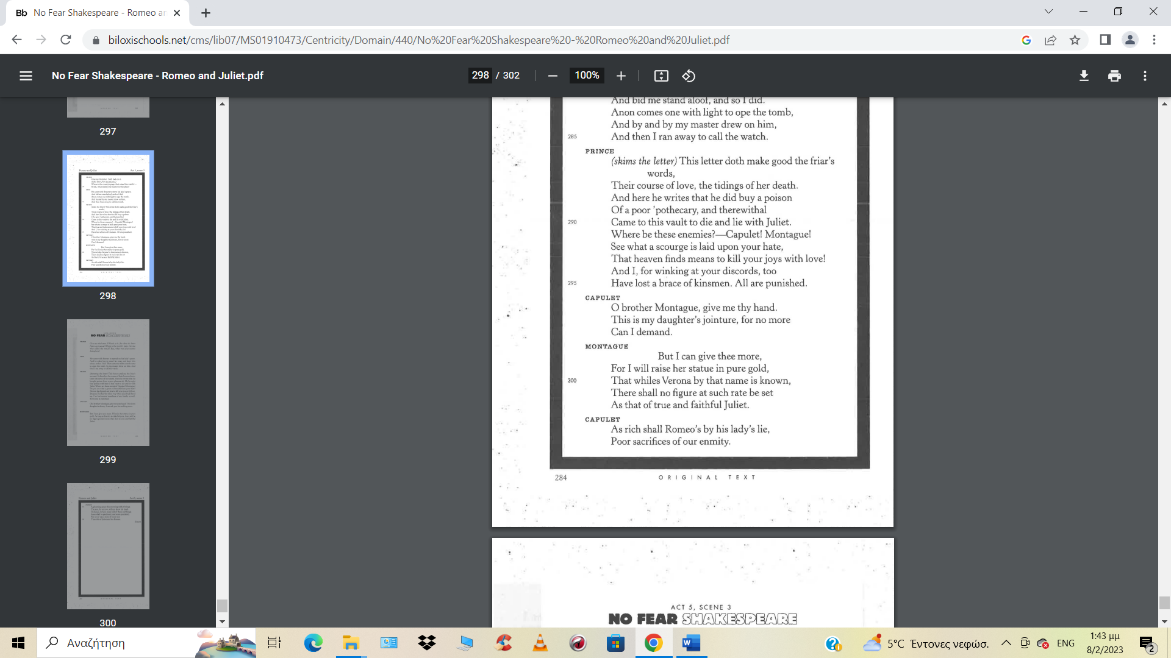
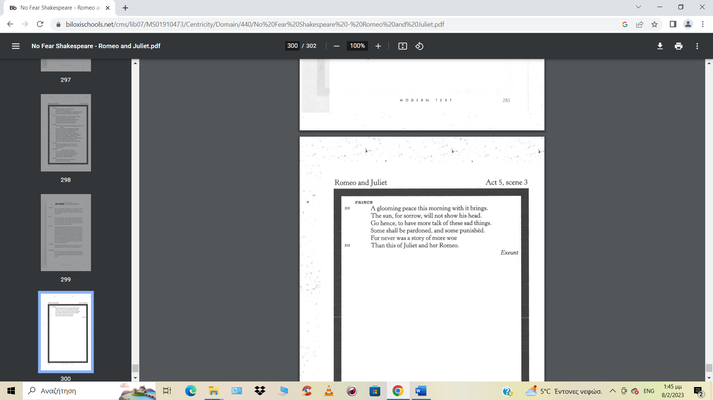

MODERN TEXT

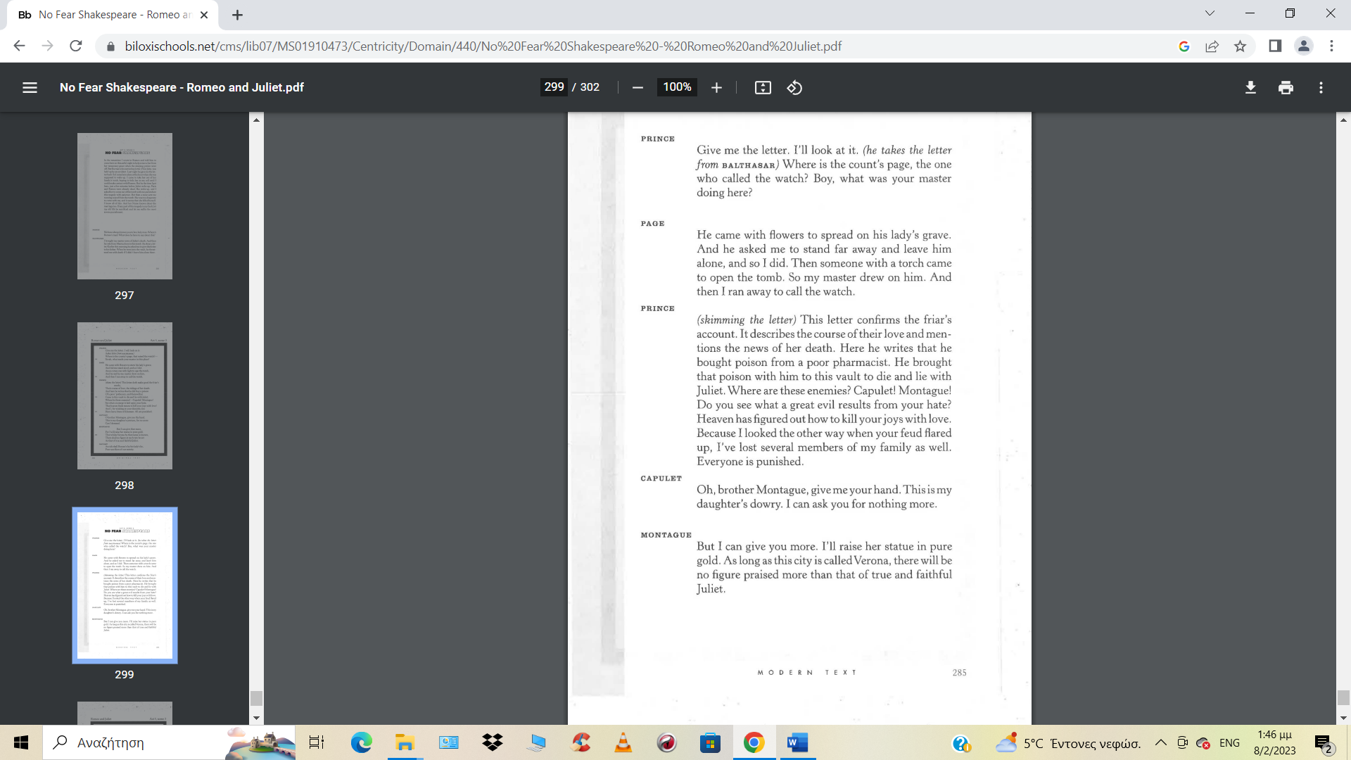
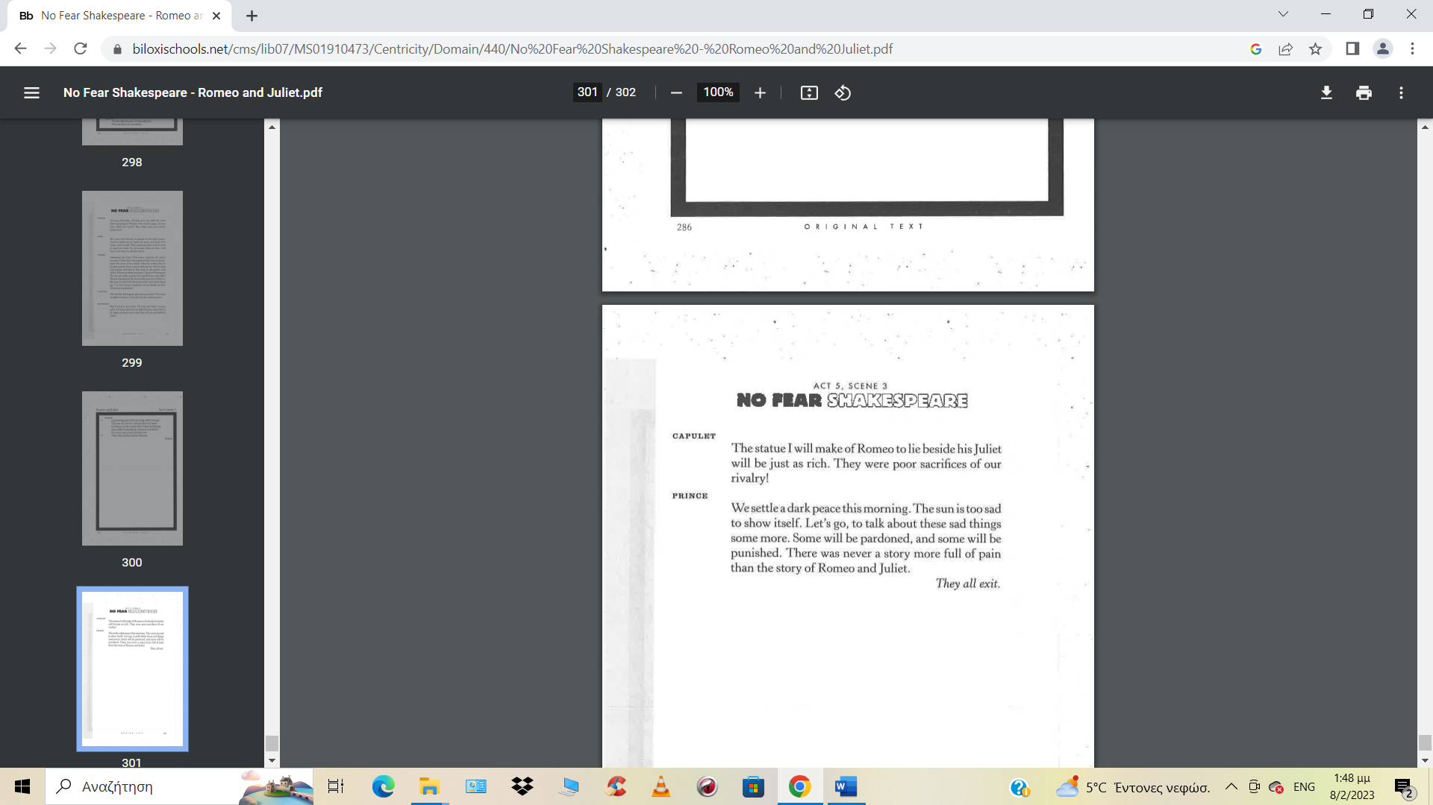

THE END

