
THE SPACE RACE (1955-75)

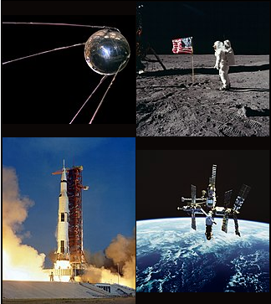

CONTENTS:
- Causes of the Space Race
- NASA Is “born” (29/07/1958)
- Space Race Heats Up: Men (And Chimps) Orbit Earth
- The first Space Walk! (18/03/1965)
- The Apollo Program
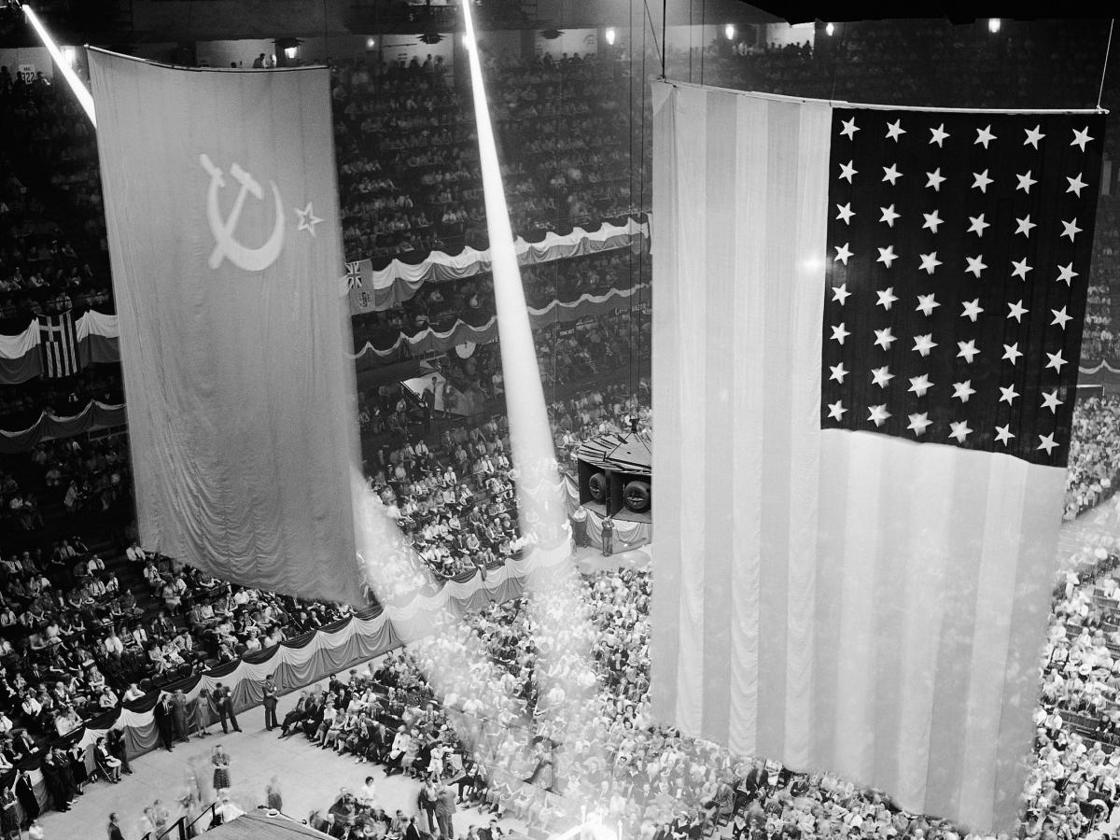
- Who Won the Space Race?
- Bibliography

1.Causes of the Space Race
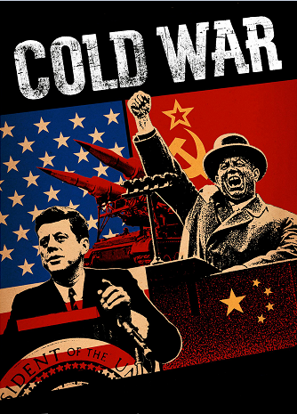
By the mid-1950s, the U.S.-Soviet Cold War had worked its way into the fabric of everyday life in both countries, fueled by the arms race and the growing threat of nuclear weapons, wide-ranging espionage and counter-espionage between the two countries, war in Korea and a clash of words and ideas carried out in the media. These tensions would continue throughout the space race, exacerbated by such events as the construction of the Berlin Wall in 1961, the Cuban missile crisis of 1962 and the outbreak of war in Southeast Asia. Space exploration served as another dramatic arena for Cold War competition. On October 4, 1957, a Soviet R-7 intercontinental ballistic missile launched Sputnik (Russian for “traveler”), the world’s first artificial satellite and the first man-made object to be placed into the Earth’s orbit. Sputnik’s launch came as a surprise, and not a pleasant one, to most Americans. In the United States, space was seen as the next frontier, a logical extension of the grand American tradition of exploration, and it was crucial not to lose too much ground to the Soviets. In addition, this demonstration of the overwhelming power of the R-7 missile–seemingly capable of delivering a nuclear warhead into U.S. air space–made gathering intelligence about Soviet military activities particularly urgent.

2.NASA Is “born” (29/07/1958)
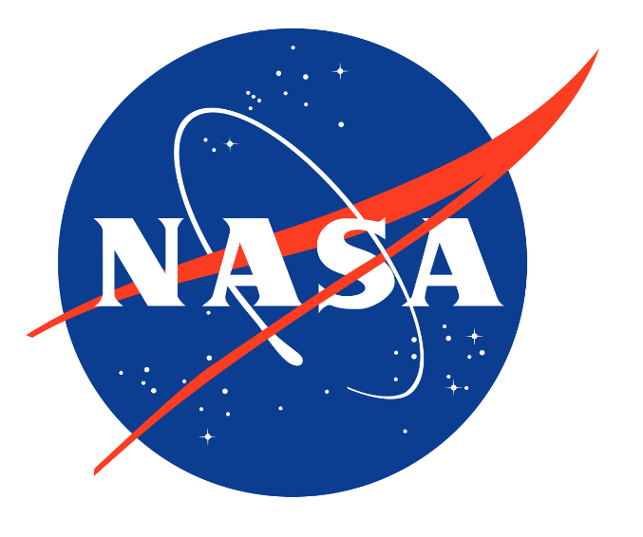
In 1958, the U.S. launched its own satellite, Explorer I, designed by the U.S. Army under the direction of rocket scientist Wernher von Braun. That same year, President Dwight D. Eisenhower signed a public order creating the National Aeronautics and Space Administration (NASA), a federal agency dedicated to space exploration. Eisenhower also created two national security-oriented space programs that would operate simultaneously with NASA’s program. The first, spearheaded by the U.S. Air Force, dedicated itself to exploiting the military potential of space. The second, led by the Central Intelligence Agency (CIA), the Air Force and a new organization called the National Reconnaissance Office (the existence of which was kept classified until the early 1990s) was code-named Corona; it would use orbiting satellites to gather intelligence on the Soviet Union and its allies.

3.Space Race Heats Up: Men (And Chimps) Orbit Earth
In 1959, the Soviet space program took another step forward with the launch of Luna 2, the first space probe to hit the moon. In April 1961, the Soviet cosmonaut Yuri Gagarin became the first person to orbit Earth, traveling in the capsule-like spacecraft Vostok 1. For the U.S. effort to send a man into space, dubbed Project Mercury, NASA engineers designed a smaller, cone-shaped capsule far lighter than Vostok; they tested the craft with chimpanzees and held a final test flight in March 1961 before the Soviets were able to pull ahead with Gagarin’s launch. On May 5, astronaut Alan Shepard became the first American in space (though not in orbit).Later that May, President John F. Kennedy made the bold, public claim that the U.S. would land a man on the moon before the end of the decade. In February 1962, John Glenn became the first American to orbit Earth, and by the end of that year, the foundations of NASA’s lunar landing program–dubbed Project Apollo–were in place.

4.The first Space Walk! (18/03/1965)
18 March 1965: Alexei Leonov leaves his spacecraft, the Voskhod 2, in a specialized spacesuit and conducts a twelve-minute spacewalk, the first of its kind.

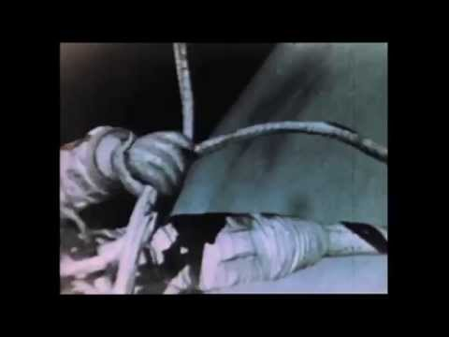

https://youtu.be/c5ZtBhQQPjM

5. The Apollo Program
The U.S public's perception of the Soviet lead in the Space Race (by putting the first man into space) motivated President John F. Kennedy to ask the Congress on May 25, 1961, to commit the federal government to a program to land a man on the Moon by the end of the 1960s, which effectively launched the Apollo program.
Apollo was one of the most expensive American scientific programs ever. It cost more than $20 billion in 1960s dollars or an estimated $225 billion in present-day US dollars. (In comparison, the Manhattan Project cost roughly $28.8 billion, accounting for inflation.) It used the Saturn rockets as launch vehicles, which were far bigger than the rockets built for previous projects. The spacecraft was also bigger; it had two main parts, the combined command and service module (CSM) and the Apollo Lunar Module (LM). The LM was to be left on the Moon and only the command module (CM) containing the three astronauts would return to Earth.
The second crewed mission, Apollo 8, brought astronauts for the first time in a flight around the Moon in December 1968. Shortly before, the Soviets had sent an uncrewed spacecraft around the Moon. On the next two missions docking maneuvers that were needed for the Moon landing were practiced and then finally the Moon landing was made on the Apollo 11 mission in July 1969.
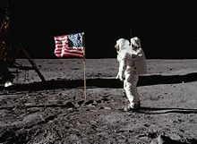
The first person to walk on the Moon was Neil Armstrong, who was followed 19 minutes later by Buzz Aldrin, while Michael Collins orbited above. Five subsequent Apollo missions also landed astronauts on the Moon, the last in December 1972. Throughout these six Apollo spaceflights, twelve men walked on the Moon. These missions returned a wealth of scientific data and 381.7 kilograms of lunar samples. Topics covered by experiments performed included soil mechanics, meteoroids, seismology, heat flow, lunar ranging, magnetic fields, and solar wind. The Moon landing marked the end of the space race; and as a gesture, Armstrong mentioned mankind when he stepped down on the Moon.

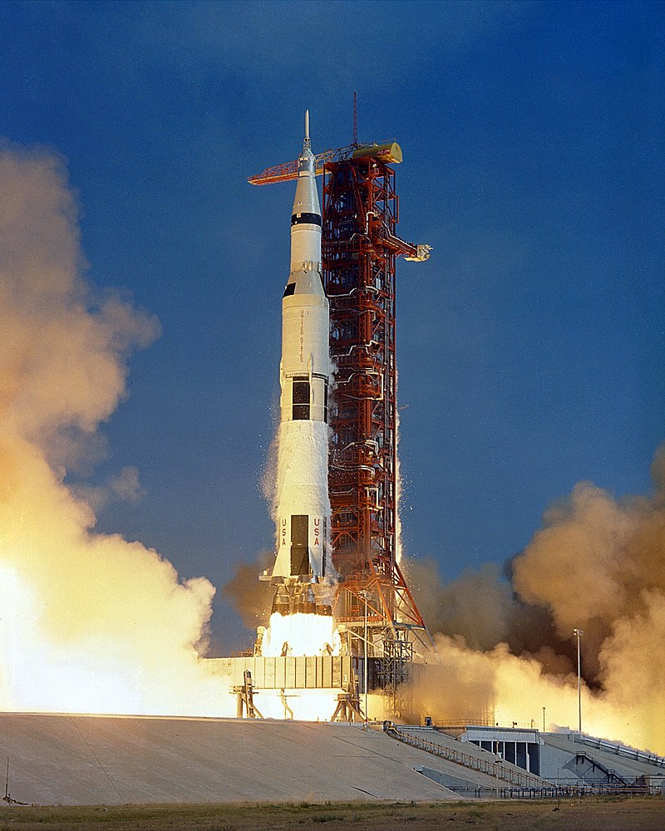
The Apollo 11 Rocket

6.Who won the space race?
By landing on the moon, the United States effectively “won” the space race that had begun with Sputnik’s launch in 1957. For their part, the Soviets made four failed attempts to launch a lunar landing craft between 1969 and 1972, including a spectacular launch-pad explosion in July 1969. From beginning to end, the American public’s attention was captivated by the space race, and the various developments by the Soviet and U.S. space programs were heavily covered in the national media. This frenzy of interest was further encouraged by the new medium of television. Astronauts came to be seen as the ultimate American heroes, and earth-bound men and women seemed to enjoy living vicariously through them. Soviets, in turn, were pictured as the ultimate villains, with their massive, relentless efforts to surpass America and prove the power of the communist system.
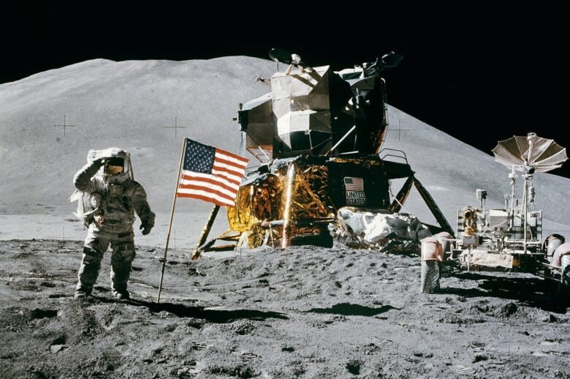
With the conclusion of the space race, U.S. government interest in lunar missions waned after the early 1970s. In 1975, the joint Apollo-Soyuz mission sent three U.S. astronauts into space aboard an Apollo spacecraft that docked in orbit with a Soviet-made Soyuz vehicle. When the commanders of the two crafts officially greeted each other, their “handshake in space” served to symbolize the gradual improvement of U.S.-Soviet relations in the late Cold War era.
7.Bibliography
https://www.history.com/topics/cold-war/space-race#who-won-the-space-race
https://www.rmg.co.uk/stories/topics/space-race-timeline
https://en.wikipedia.org/wiki/NASA
https://en.wikipedia.org/wiki/Space_Race

