The Bermuda Triangle
The Bermuda Triangle is a strange triangular area where many ships and planes that passed by disappeared mysteriously without leaving a trace. Οn some occasions when the wrecks were found the crew had disappeared. Such events take place there for centuries. More than a thousand ships and planes have disappeared in this triangular area over the last five centuries and such events continue to occur in the Atlantic Ocean to this day. Because of all these unexplained disappearances the area has been given the name the devil triangle. 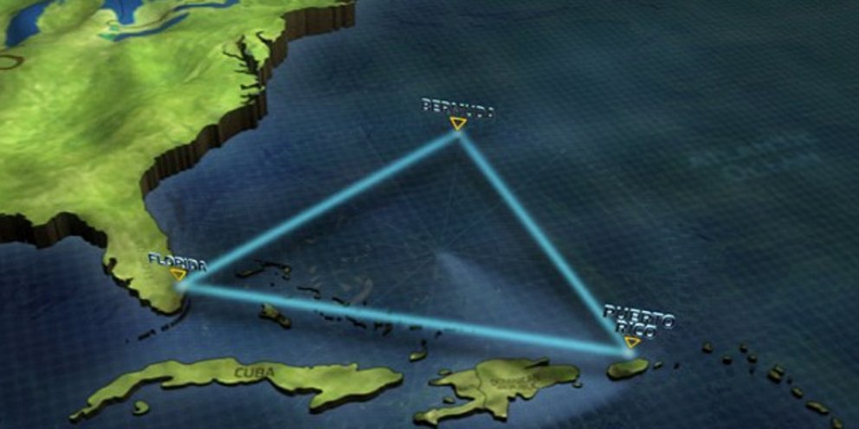 Known to almost all of us. This particular mystery has created many theories. Many stories and myths have been created by writers directly from their imagination which they use to become famous by changing some things and creating theories. Many theories have been put forward over the years that cause the mystery that has frightened people for so many generations. These strange phenomena of the sea were first recorded in 1950 by Edward Jones in a Florida daily newspaper. However, the mystery began to take hold in 1952 when George Saint wrote in a magazine about events such as “Flight Nineteen”. A training flight of five planes that went missing in 1945. As it was natural many more writers wrote about other mysterious events in the triangular area. While some descriptions did not have much substance, other incidents have occurred there that remain a mystery. The stories of the mystery were quickly picked up and the Bermuda Triangle became a reality in the minds of at least thousands of people. The Bermuda Triangle is located in Atlantic Ocean. It’s three peaks are Miami in Florida, San Juan in Puerto Rico and Bermuda, an island in North Atlantic. The American writer Vincent Gantis was the first to set the boundaries in 1964. 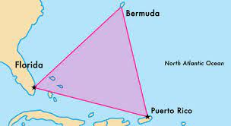 Later, however, many other writers continued to expand the area because other disappearances happened in other nearby areas. Many researches have taken part in the attempt to reveal the mystery. However, there is not a single theory that can explain all these disappearances. A well-known theory says that a cloud of fog appears out of nowhere and somehow "swallows" ships and planes. Ever since a magazine coined the phrase Bermuda Triangle in 1950, the mystery has continued to attract attention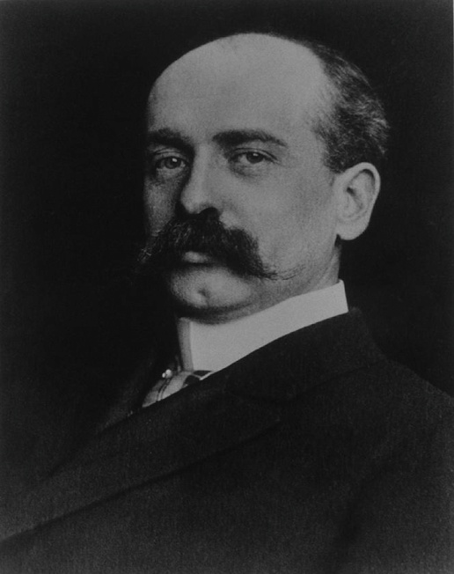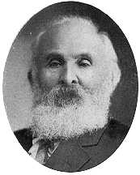
[Edward Jones] [George Saint]

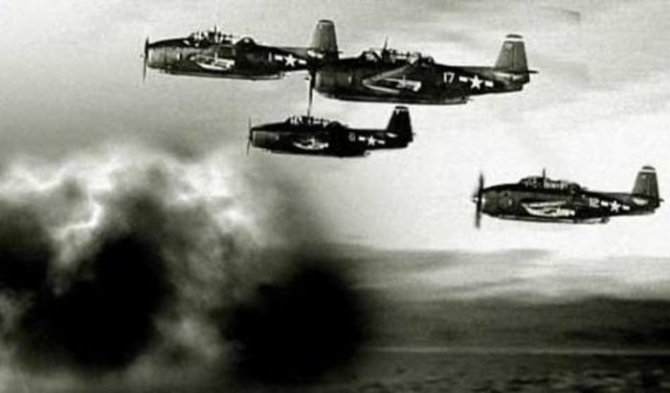 [Flight Nineteen]

QUIZ
- Vincent Gantis was the first who recorded the strange phenomena of the see. [True] [False]

- The training flight of five planes went missing in 1945.
[True] [False]
- The three peaks of Bermuda are Miami in Florida, San Juan in Puerto Rico and Bermuda. [True] [False]

- The American writer Vincent Gantis was the first to set the boundaries in 1968. [True] [False]

- The flight that went missing was named ‘‘Flight nineteen’’
[True] [False]

SOURCES:
https://www.history.com/topics/folklore/bermuda-triangle
https://www.britannica.com/place/Bermuda-Triangle
https://oceanservice.noaa.gov/facts/bermudatri.html
https://www.public.gr/product/books/english/literature/modern-literat

